Meeting of the Fa’side Area Partnership
Tuesday 8th March 2016, 7-9pm, Trevelyan Hall, Penciatland.
(Address and picture on second page)

Agenda

- Welcome and apologies
- Approval of Minutes
A/ Check for accuracy/Seek approval
- Matters Arising

- Area Manager’s update

A/ Update on ongoing project work
B/ Patron’s Lunch

- Area Plan

A/ Confirmation that Working Area Plan meets requirements
B/ Confirmation that Annual Project programme meets requirements *

- Budget update

A/ ELC budget update 2016/17
B/ Summary update for Area Partnership 2015/16

- Twinning

- AOCB

- Date of next Area Partnership meetings

Day | Date | Time | Location
Tuesday | 14th June 2016 | 7.00-9.00pm | TBC
Tuesday | 13th September 2016 | 7.00-9.00pm | Annual Meeting, Ross High, School Tranent
Tuesday | 8th November 2016 | 7.00-9.00pm | TBC
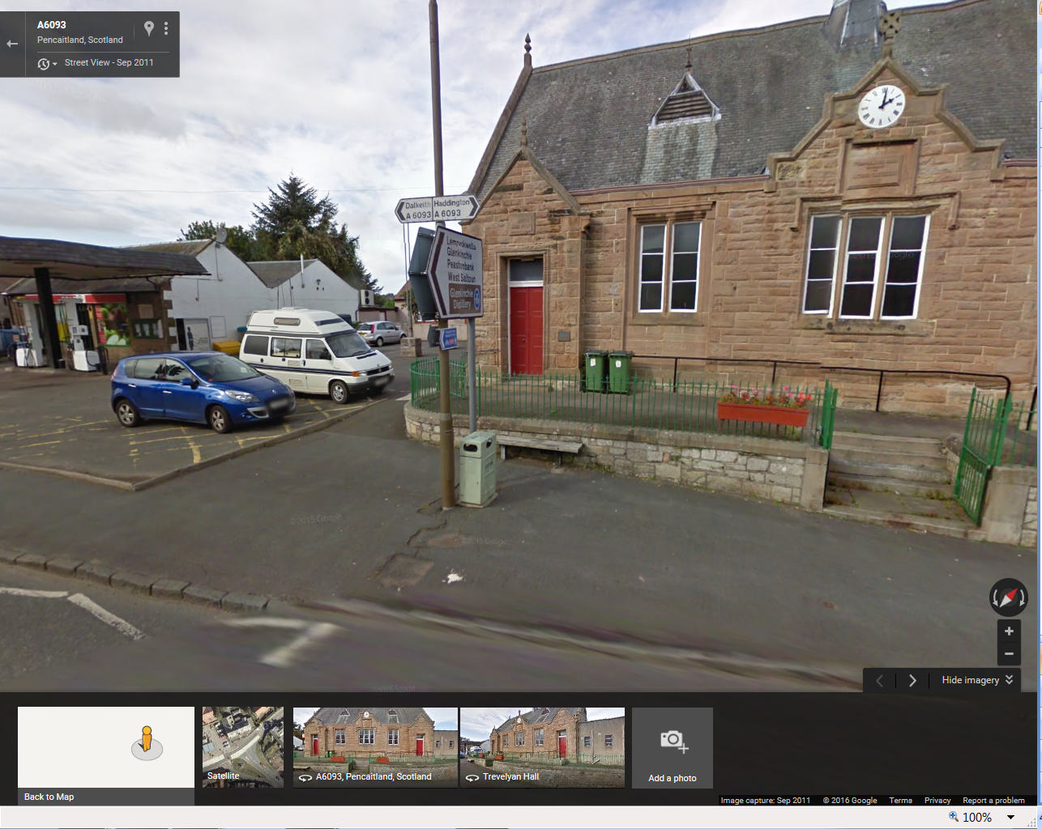
Trevelyan Hall, Pencaitland, EH34 5DB

