Amisfield Walled Garden
Community Education Building

EVIDENCE OF LOCAL SUPPORT

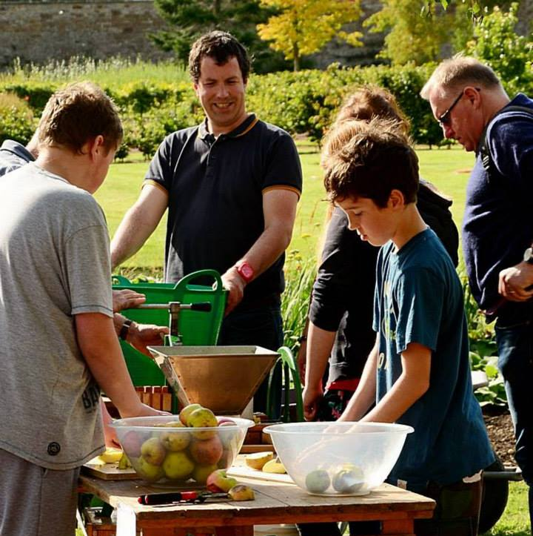

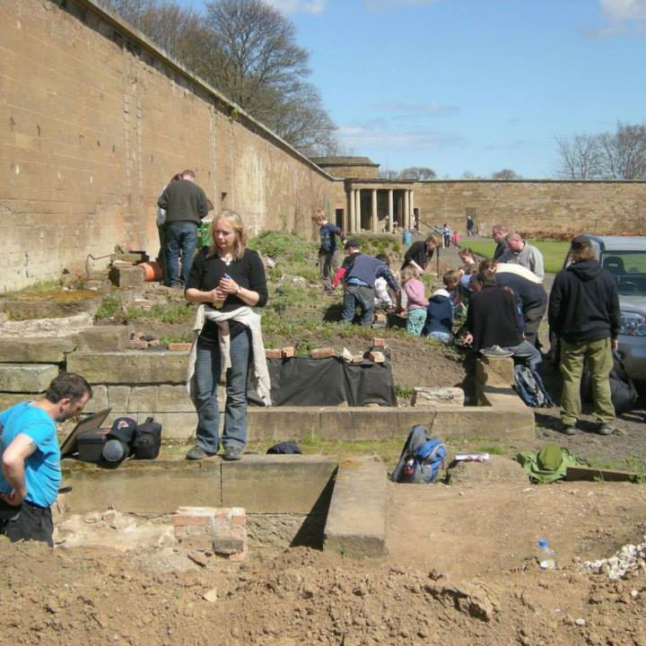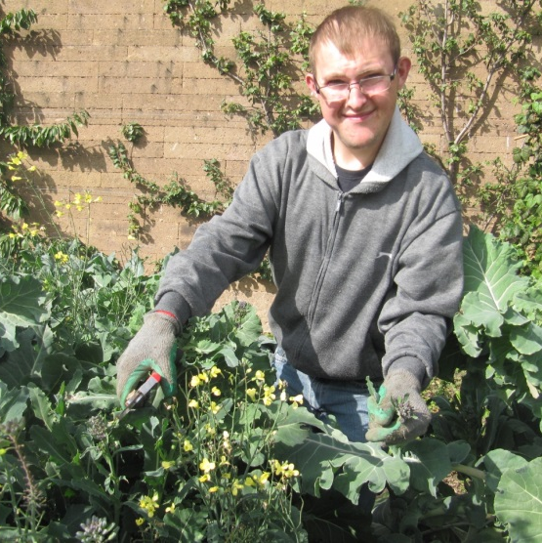

Amisfield Walled Garden, Haddington
Community Education Building: Evidence of Local Support

Background

Amisfield Walled Garden is located on the eastern outskirts of Haddington in East Lothian, and within easy walking distance of the town centre. The town of Haddington has a population of approximately 9,000.

Within Haddington there exists a wide range of employment levels and family income. East Lothian Council’s Statistical Profile 2014 classes 9% of Haddington’s population as being income deprived. The town has recently suffered job losses from the closure of Gateside Commerce Park and Haddington Sheriff Court. Retail businesses in the town centre have struggled with the economic downturn and loss of trade to major supermarket chains. Haddington has a higher percentage of young people unemployed and seeking work upon leaving school than elsewhere across East Lothian or Scotland (East Lothian Council Haddington Early Years Profile 2012).

The Amisfield Preservation Trust aims to benefit the health, wellbeing and education of the local community through the restoration and development of Amisfield walled garden.

Evidence of support for our project has been gathered through consultation with the following groups:
- Existing garden volunteers
- User groups eg adult education, additional support service providers
- Garden visitors
- Local Community organisations
- East Lothian Council
- Local politicians

Garden Volunteers

We run a thriving volunteer project which has been established for around seven years. With the employment of a full-time volunteer co-ordinator for the past three years, the volunteer project has expanded rapidly. We now employ a second, part-time member of staff to help with our volunteers, particularly those with learning difficulties.
Over the past year, a total of 73 individuals have volunteered with us, of which around 50 individuals volunteer regularly at one or more of our four half-day sessions per week. Volunteers contribute over 6,000 man hours per year, working to develop and maintain the garden. We run a series of training courses for volunteers and members of the public in horticulture and related activities such as wildlife identification and willow crafts.
Of our regular volunteers, 11 individuals have been referred to us from service providers as people with additional support needs. These individuals are offered the chance to participate in the Royal Caledonian Horticultural Society’s Grow and Learn programme which is a specially adapted horticulture course for people with learning difficulties.
Indoor facilities to provide shelter and meeting space are currently very limited. We have a small timber shed under a temporary planning permission, and this can hold no more than a dozen people at one time. The shed and toilet facilities are inaccessible to people with restricted mobility.
We hold annual reviews with each of our volunteers, and it is commonly identified in these reviews that there is an urgent need for suitable fully accessible indoor space to provide shelter from inclement weather, space for meetings and training courses, and adequate toilet and handwashing facilities. Although we run the volunteer programme all year round, the lack of shelter limits the participation of certain groups during the winter months, particularly the elderly, the young and those with additional support needs.
User Groups
In addition to individual volunteers, we have a growing number of groups who use the garden facilities on a regular basis or for one off events. These include:
- Spark of Genius School, who use the garden facilities for teaching young people who are unable to cope in mainstream education
- East Lothian Adult Education art class
- U3A walking group and art group
- Local cub scout and brownie groups
- The Action Group, a support organisation for adults and children with additional support needs
- BAJR - an archaeology consultancy which runs hands on archaeological and heritage workshops
- Local primary schools visiting as part of their John Muir Award
- Local secondary school pupils studying for Rural Skills qualifications
In total, over 400 individuals participated in group events at the garden last year, many of these returning on a regular basis.
Garden Visitors
The garden is open to the public free of charge, and is open six days per week in the summer months, and five days in the winter. The garden is becoming increasingly popular as a visitor destination, with well over 1,000 people visiting in the past year.
In the spring of 2015, we upgraded the surface of our footpaths (funded by Viridor Credits), and as a result we have witnessed a marked increase in visitors with restricted mobility who are now able to access the garden. However, as we are currently unable to provide accessible indoor space, these visitors are excluded should they require shelter or toilet facilities.
Community Organisations
Our project has built strong links with the local community in Haddington. For the past two years we have been an integral part of the Blooming Haddington entry in the ‘Beautiful Scotland’ competition run by Keep Scotland Beautiful. We were delighted to have contributed to the Blooming Haddington entry which won a gold medal in the best medium town category earlier this summer.
Together with Blooming Haddington and the Haddington Community Development Trust, we are in early discussion about setting up a Haddington Gardens Trail which would include Amisfield Walled Garden. This type of initiative would benefit from the provision of suitable facilities for visitors at the garden, as well as space for an exhibition of interpretation material relating to heritage and horticulture.
East Lothian Council and Local Politicians
Amisfield Walled Garden is owned by East Lothian Council and leased to the Amisfield Preservation Trust under a 99 year lease. The Trust is committed under the lease agreement to work in partnership with the Council and local voluntary and community organisations to develop the garden for public benefit.
The Trust has regular contact with officers at East Lothian Council, in particular in Community Wellbeing and Adult Education departments, to ensure that we are meeting our lease obligations. The Council is supportive of our work and provides partnership funding to contribute to the salary costs of our volunteer co-ordinator.
We also enjoy the support of our local politicians. In the past year we have welcomed Iain Gray MSP, Fiona O’Donnell (former MP) and George Kerevan MP to the garden to show them our project.

