Meeting of the Fa’side Area Partnership
Tuesday 26th January 2016, 7-9pm, Ormiston Community Centre
(map & link below)

Agenda

- Welcome and apologies
- Approval of Minutes
A/ Check for accuracy/Seek approval
- Matters Arising

- Area Manager’s update

A/ Update on ongoing project work

- Area Plan

A/ Update area plan and breakdown priorities into short, medium and long term.
B/ Agree content of Working Area Plan for short, medium and long terms priorities.
C/ Seek to prioritise the short term priorities for 2016/17

- Budget update

A/ Summary update
B/ New Funding Submissions

- Standing Orders

- AOCB

- Date of next Area Partnership meetings
Day | Date | Time | Location
Tuesday | 8th March 2016 | 7.00-9.00pm | TBC
Tuesday | 14th June 2016 | 7.00-9.00pm | TBC
Tuesday | 13th September 2016 | 7.00-9.00pm | Annual Meeting, Ross High, School Tranent
Tuesday | 8th November 2016 | 7.00-9.00pm | TBC

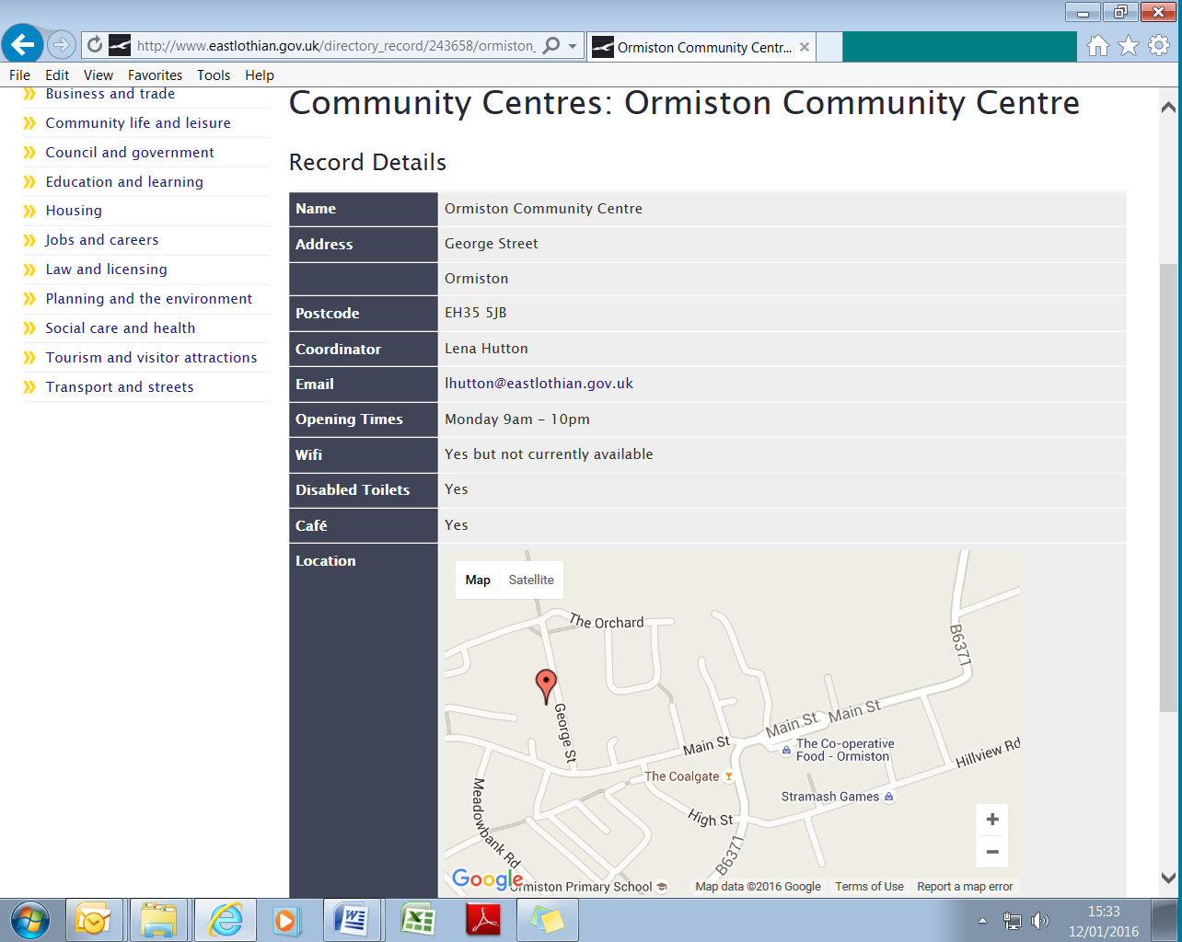
http://www.eastlothian.gov.uk/directory_record/243658/ormiston_community_centre

