
IDENTIFYING AND REPLACING LEAD PIPES

This leaflet will help you to identify if you have lead pipes, what do if you have a problem with a lead pipe and how to replace them.

Identifying lead pipes
Lead pipes are generally thicker than copper or steel pipes. They are a grey and a silvery colour when scratched. Joints in lead pipes or between lead and another metal are usually rounded. Lead water tanks are always found inside a timber casing. A lead water tank should not be confused with a zinc tank which may also be silver in colour but will not be in a timber casing.

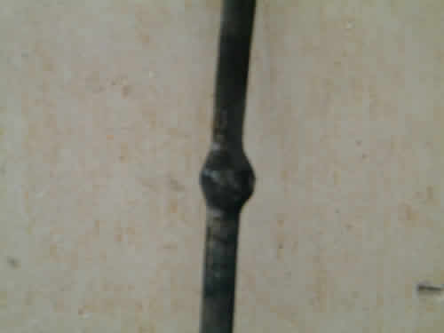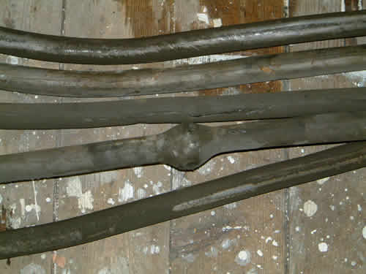

Repairing lead pipes and tanks
If you have a leak in a lead pipe of tank it must be dealt with straight away. A plumber can make temporary repairs. If you are calling a plumber make sure you tell them that the problem is with a lead pip, as lead plumbing requires special skills.

Replacing a lead rising main
If you think the pipe connecting the mains water supply to your home is lead you should consider replacing the pipe with a plastic or copper pipe. If you are replacing a lead pipe you should contact Scottish Water for further advise on replacing any section of pipe they own.

Various companies specialise in lead pipe replacement work. Some use an underground moling system which avoids the need to dig up your garden. Get quotes from at least two different contractors before choosing one. The Council are unable to recommend contractors.

If you live in a flat it is likely that the lead mains water pipe will connect all the properties in the building. If this is the case you should discuss replacing the pipe with your neighbours.

Before you begin the work you should get estimates from at least two plumbers. If the cost is to be shared with other owners everyone must agree.

THE PRIVATE SECTOR HOUSING TEAM

East Lothian Council’s Scheme of Assistance aims to help homeowners, private landlords and private tenants to repair, maintain, improve and adapt their properties. Information, advice and practical assistance is provided by the Private Sector Housing Team.

A full copy of the Scheme of Assistance can be obtained from the Private Sector Housing Team or downloaded from the website, www.eastlothian.gov.uk/privatehousing.

The Private Sector Housing Team can be contacted by telephone, email or in writing:

Private Sector Housing Team
Community Housing and Property Management
Penston House
Macmerry Industrial Estate
Macmerry
EH33 1EX

Telephone: 01620 827537 (Monday to Thursday 9am-5pm and Friday 9am-4pm)
Email: privatehousing@eastlothian.gov.uk
Website: www.eastlothian.gov.uk/privatehousing

This leaflet has been produced with the assistance of the City of Edinburgh Council

