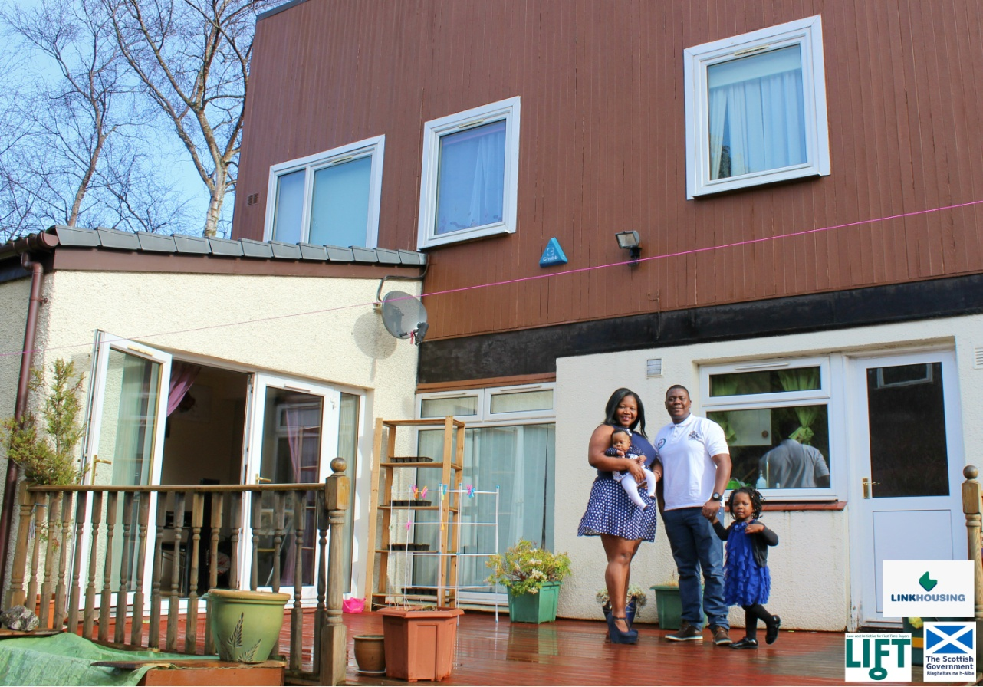

Need a LIFT to buy a home?

Owning your own home doesn’t have to be an unreachable goal. The Scottish Government runs the LIFT Open Market Shared Equity (OMSE) scheme, which funds people with up to 40% of the purchase price of a property that has been advertised on the open market.

The deposit for a property through LIFT can be as little as 5%, opening up the opportunity to buy a home to first-time buyers and priority group individuals throughout Scotland.

Many people may think they are unable to afford a mortgage to buy a home, but this scheme offers an interest free loan toward the cost of a property, giving people a “lift” onto the property ladder.

Who is eligible for the LIFT scheme?

The LIFT Open Market Shared Equity Scheme is open to:

- first-time buyers
- social rented tenants
- armed forces personnel
- veterans who have left within the last two years
- partners of service personnel for up to two years after their partner has been killed while serving in the armed forces
- disabled people

Samantha McLaughlin, who purchased her home through the LIFT scheme said, “I would like to thank Link for giving my family the opportunity to finally have a family home after 10 years.”

How do you apply?

First, speak to a financial advisor about securing a shared-equity mortgage. Then apply online at www.linkhousing.org/LIFT
For more information, please call Link Housing’s LIFT team on 0330 303 0125 or email us at lift@linkhaltd.co.uk

