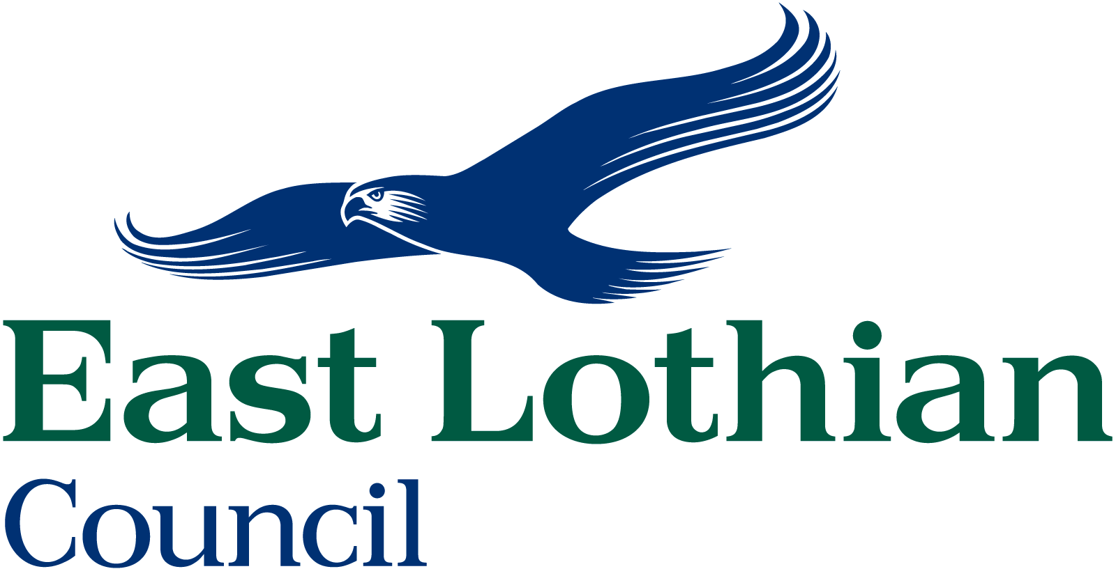

GAMBLING ACT 2005
PARAGRAPH 39 OF SCHEDULE 11

SMALL SOCIETY LOTTERY RETURN FORM

REGISTRATION NO. …………………………….

PLEASE READ THE NOTES OVERLEAF BEFORE COMPLETING THIS FORM

NAME OF SOCIETY: ………………………………………………………………………

PURPOSE OF SOCIETY: ………………………………………………………….. ……

………………………………………………………………………………………….. ……
Tickets available  To From | Date of lottery  draw | Value of prizes (incl. donated)  £ | Total proceeds of ticket sales  £ | Expenses  £ | Proceeds allotted to (name of benefiting organisation)  £(must be at least 20%)

Please declare below any expenses paid for by means other than out of the proceeds of the lottery and confirm who paid these expenses.

…………………………………………………………………………………………….

Please Read note 9 overleaf
Promoter……………………………… Certified by (1): …………………………..

Home Address: ……………………… Home Address: …………………………..
………………………………………… ………………………………………………
………………………………………… Signed: …………………………………….

Signed: ……………………………… Certified by (2): ……………………………
Home Address: …………………………...
……………………………………………...
Signed: …………………………………….

NOTES
The information that must be submitted within ‘a return form’ is as follows:
- 1.  the arrangements for the lottery – specifically the date on which tickets were available for sale or supply, the dates of any draw and the value of prizes, including any donated prizes and any rollover;
- 2.  the proceeds of the lottery;
- 3.  the amounts deducted by the promoters of the lottery in providing prizes, including prizes in accordance with any rollovers;
- 4.   the amounts deducted by the promoters of the lottery in respect of costs incurred in organizing the lottery;
- 5. the total of 3 and 4 above must not exceed 80% of the proceeds of the lottery
- 6. whether any expenses incurred in connection with the lottery were not paid for by deduction from the proceeds, and, if so, the amount of expenses and the sources from which they were paid; and
- 7.  the amount applied to the purpose for which the promoting society is conducted (this must be at least 20% of the proceeds).

The returns must also:
- 8. be sent to us no later than three months after the date of the lottery draw, or in the case of ‘instant lotteries (scratch cards) within three months of the last date on which tickets were on sale; and
- 9.   be signed (electronic signatures are acceptable if the return is sent electronically) by two members of the society, who must be aged eighteen or older, are appointed for the purpose in writing by the society or, if it has one, its governing body, and accompanied by a copy of their letter or letters of appointment.
- 10. the total proceeds from all the lotteries held in one year must not exceed £250,000 in one year. If this total is exceeded the Authority has to notify the Gambling Commission.

Please be aware that the Gambling Commission may inspect a society’s lottery returns for 3 years following the date of the draw. The public can also inspect returns for 18 months following the date of the draw.

