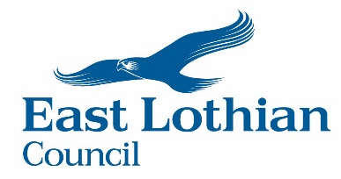

EAST LOTHIAN COUNCIL
COMMUNITY EMPOWERMENT (SCOTLAND) ACT 2015
COMMUNITY ASSET TRANSFER
INITIAL EXPRESSION OF INTEREST FORM

The Council has prepared Policy and Guidance information to assist community bodies who may be interested in leasing or owning an asset belonging to East Lothian Council. We encourage groups to discuss their ideas and proposals in the first instance with the Council’s Connected Communities Service who will provide guidance with the preparation of a request and the completion of this initial Expression of Interest Form. They can be reached by emailing connectedcommunities@eastlothian.gov.uk The Scottish Government has also published Guidance for Community Transfer Bodies which describes how organisations should apply for transfer or control of assets. (Asset Transfer Guidance for Community Transfer Bodies.)
When completed, this form should be emailed to assettransfers@eastlothian.gov.uk

- Name of Organisation:

What type of organisation are you? e.g. charity, social enterprise, cooperative:

What is the organisation’s objectives or core business?

- Contact Details – for enquiries relating to this request:

Name: __________________________________ Telephone: __________________________

Email: ___________________________________________________________________________

- Council Asset(s) – Please identify below the building(s) and/or land in which you are expressing an interest:

- Using the Asset(s) – Please describe below your proposals for use of the land and/or building and outline
the benefits:

- Maintaining/Developing the Asset(s) – please describe how resources would be obtained to maintain
and/or develop the building/land:

Signature

Date

