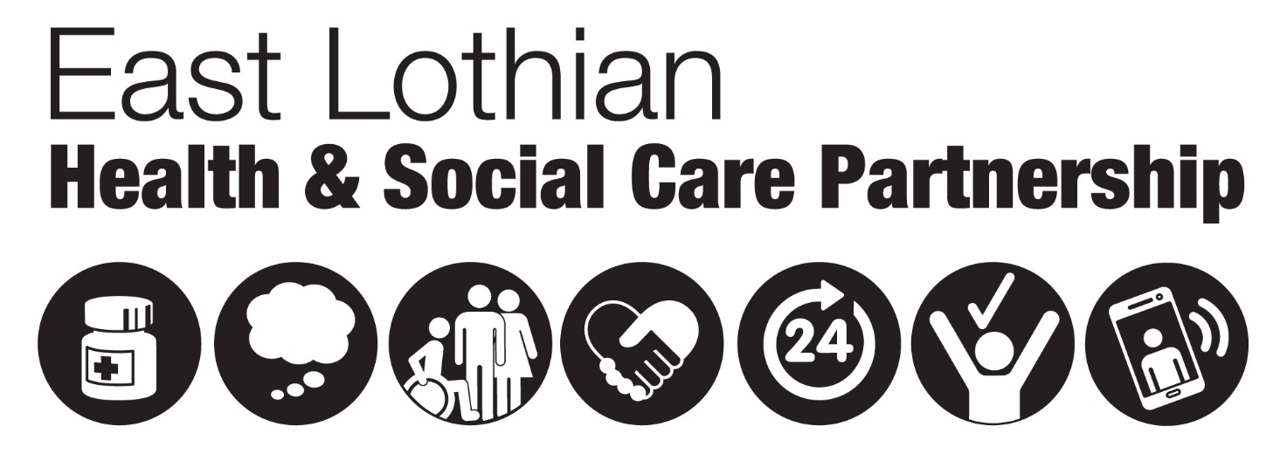

Growing Older

What do you want from YOUR life?

In 2017, East Lothian Health and Social Care Partnership was asked to develop a strategy for the reprovision of Belhaven and Edington Community Hospitals and Abbey and Eskgreen Care Homes. All the facilities have physical challenges and need significant upgrades to meet the expectations for modern care standards. We’ve reached a crossroads and want to find out what people of all ages across the community want to do now. We want everyone to think how and where they would like to live as they grow older. To take part in our consultation, come to one of our Open Forum Meetings.

**North Berwick Open Forum/Workshop**

21st May 2018 – 6.30pm to 8pm – Hope Rooms, 34 Forth Street,

North Berwick EH39 4JD

**Musselburgh Open Forum**

22nd May 2018 – 6.30- 8pm - Esk Rooms 1 & 2, Brunton Hall

Musselburgh EH21 6AA

**Dunbar Open Forum**

23rd May 2018 – 6.30- 8pm - After School Room, Bleachingfield Centre,

Dunbar EH42 1DX

**Coming to a High Street near you!** We’ll also be doing pop-up engagements Dunbar, Musselburgh and North Berwick so look out for us.

**Touring exhibition –** we have three exhibition boards, one for each area, which will be going around public centres in your area.

**Take part in our online consultation by searching ‘Growing Older’ on** [**https://eastlothianconsultations.co.uk/**](https://eastlothianconsultations.co.uk/)

For more information, email [elhscp@eastlothian.gov.uk](mailto:elhscp@eastlothian.gov.uk) or phone 01620 827 755