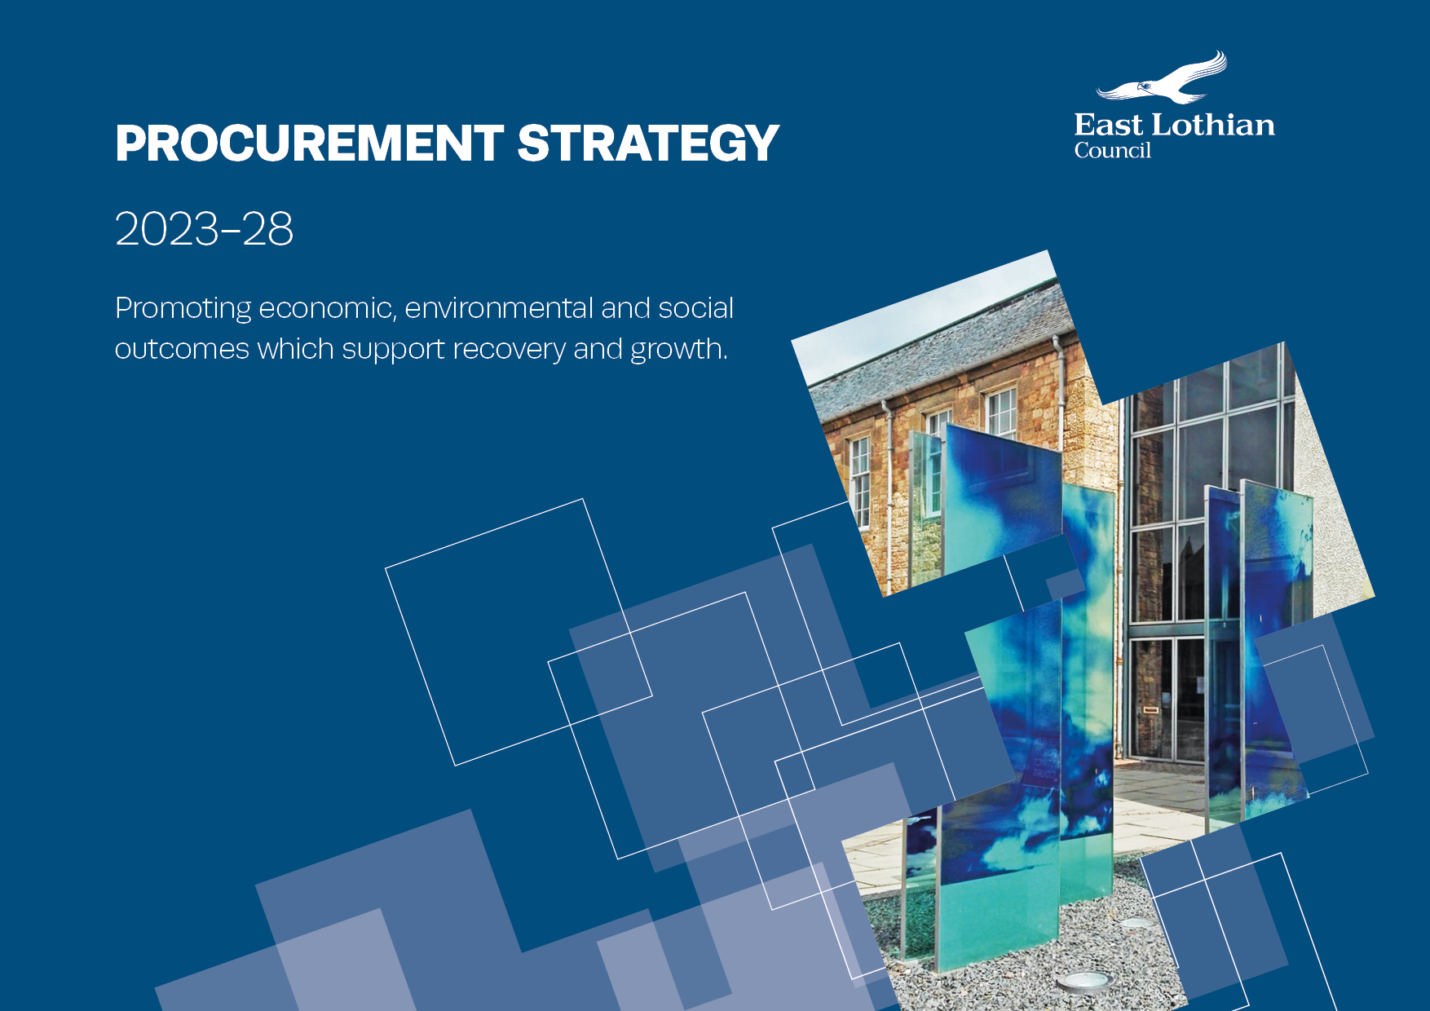

Contents

|  |  |
| --- | --- |
| Foreword | 3 |
| Introduction and Procurement Vision | 4 |
| Strategy rationale and context | 5-9 |
| Supporting council objectives | 10 |
| Enablers | 11-14 |
| Objectives | 15-22 |
| Regulations, Policies, Guidance and Tools | 23 |
| Council spend profile | 24 |
| Reporting | 25 |
| Resources | 26 |
| Ownership and contact details | 27 |
| Appendix 1 – Procurement Strategy Action Plan 1 April 2023 until 31 March 2024 | 28-35 |
| Appendix 2 – East Lothian Council Corporate Procurement Strategy 2017-2022: Successful Outcomes Delivered | 36-38 |
| Appendix 3 – Glossary | 39-41 |
| Appendix 4 – Procurement Strategy Map | 42 |

Foreword

East Lothian is widely recognised as a fantastic place to live, work and study. However, pressure on public finances means that the council must also make significant savings and ensuring that the council uses its considerable spending power to maximise value for its communities is key.

The launch of the council’s new Procurement Strategy will help promote the economic, environmental, and social outcomes that support growth, and address those challenges the council is facing.

Closer working relationships with key stakeholders is central to the successful delivery of the strategy, building on existing networks to improve engagement with communities, businesses, third sector organisations and strategic partners.

The strategy also builds on a strong foundation of achievements delivered in previous years. These achievements will still be important in the coming years, and the principles remain a core element of the strategy, but as the council looks to address key challenges of poverty, citizen well-being and climate change the central priorities for the council’s procurements must align and support wider outcomes.

A new Procurement Strategy for Scotland was published in April 2023, which public sector bodies can align to and deliver against. This Strategy aligns to the Enablers and Objectives set out in the Procurement Strategy for Scotland.

|  |  |
| --- | --- |
| **Enablers** | **Outcomes** |
| Procurement Capability | Good for Businesses and their Employees |
| Supplier Development | Good for Places and Communities |
| Engagement | Good for Society |
| Collaboration | Open and Connected |

By delivering on these enablers and outcomes and continuing to seek financial savings and Best Value outcomes, the council can be confident that its procurement activity will benefit our stakeholders.

**Monica Patterson**

East Lothian Council Chief Executive



Introduction and procurement vision

East Lothian is one of the fastest growing council areas in Scotland with a population increase between 1998 and 2020 of 22%. The county is widely recognised as a desirable place to live with a beautiful coast and countryside, attractive and distinctive towns, good quality housing, schools and services, and proximity to Edinburgh’s jobs, businesses and attractions. East Lothian is part of the Edinburgh city region and its key economic sectors include tourism, agriculture, food and drink, power generation, manufacturing, and education. Over the next 10 years it is anticipated that East Lothian will undergo further significant change.

Population and housing growth means that the demand for council services is increasing at a time when the pressure on public finances requires us to make significant savings. The procurement service must continue to ensure the council secures Best Value by purchasing only what we need and managing our suppliers effectively through robust contract management.

Following the Covid-19 pandemic and post-Brexit, the procurement service is evolving to change its focus from operational to strategic procurement. We will support the transition to a low carbon economy and manage the impacts and opportunities arising from technological change and a fast-growing local authority area.

This strategy takes account of that wider context, and recent developments in the local and national policy framework, that now more clearly recognise the important role that public sector procurement has in delivering key outcomes.

The procurement service has a strong focus on compliance with the regulatory framework and the council’s internal controls, and this strategy will help ensure the council’s purchasing activity supports sustainable growth and protects our environment, while also confronting the challenges that East Lothian is facing.

**Council Vision**

*An even more prosperous, safe and sustainable East Lothian, with a dynamic and thriving economy, that enables our people and communities to flourish.* Council Plan 2022-2027

|  |
| --- |
| **Vision** |
| To provide excellent services that deliver best value procurements with Community Benefits that support recovery and renewal, reduce poverty and inequality and respond to the climate emergency. |

|  |
| --- |
| **Mission** |
| The procurement team will strive to deliver effective, efficient and excellent services to support the council’s strategic vision and aims, by contributing to the councils net zero climate change targets, delivering best value and continuous improvement, ensuring compliance and good governance, increasing sustainability, Community Benefits and supporting economic recovery. |

**Sarah Fortune**

Executive Director of Resources, East Lothian Council

Strategy rationale and context

Recent changes to procurement regulations and statutory duties are now embedded and public sector procurement has a greater role than ever before in supporting delivery of key social, economic and environmental outcomes. The potential impact of Brexit will not bring immediate change to these regulations and duties but may have a bearing on markets we engage with.

This strategy has been developed to enable us to respond and adapt to changes in our environment. However, during its life changes are expected, for example, development of a National Procurement Strategy for Scotland. In line with the Reform Act and to ensure our Annual Procurement report details our performance against strategy, this strategy will be subject to annual reviews. This will take account of any changes to organisational objectives and Scottish Government policies and strategies.

The council currently spends an average of £140million per annum on goods, services and works. In supporting this programme it is critical that the spending power of the council is utilised to influence and actively promote positive change.

Enabling Good Growth is a key area of our Economy Strategy. Where procurement has potential influence, we will include the council’s commitments to Fair Work practices, low carbon economy, supporting benefits through City Region Deal and other capacity building projects.

The previous Corporate Procurement Strategy 2017-2022 was aligned to the Council Plan 2017-2022 and the Procurement Improvement Programme (PIP). Many improvements and benefits were delivered and are detailed in Appendix 2.

Key successful outcomes include:

* Increased engagement with local Small to Medium Enterprises (SMEs) and awareness of our tendering opportunities
* Applying prompt payment in the supply chain, as appropriate
* Successful and targeted people and Community Benefits delivered in line with the needs of our communities
* Added value obligations included in contracts to support ELC Climate Change Strategy (2020-2025)
* Increased capacity (resource levels) aligning with strategic procurement priorities, contracted expenditure and business needs
* Contract and Supplier Management (CSM ) training delivered to Service Users across the council
* Annual surveys to capture the views and understand levels of satisfaction of internal customers and suppliers
* New software for contract register and recording and reporting on contract obligations, benefits and performance
* £1.3m cash savings delivered by the Procurement Improvement Programme (PIP)
* Procurement team developed skills in relevant areas e.g. negotiation, project management, Chartered Institute of Procurement & Supply (CIPS) qualifications, Contract and Supplier Management (CSM), Competition and Markets Authority (CMA) e-learning on bid rigging and Climate Literacy Training
* Procurement training included in Elected Member Induction
* Review and update of the council’s standing orders and procurement procedures.

Areas for on-going improvement include:

* Optimising systems / identification of gaps in tracking spend
* Utilising the new Contract Register to detail contract obligations
* Implementing contract management into lifecycle of key contracts
* Supporting the P2P (purchase-to-pay) project to deliver consistency and accuracy related to downstream processes
* Collaborating with Service Managers to plan value added procurements
* Digitising procurement processes
* Embedding the sustainable procurement duty - continual improvement of the economic, social and environmental wellbeing of East Lothian people

**Community Wealth Building**

The Centre for Economic Strategies (CLES) states that Community Wealth Building (CWB) is based on five key principles:

* Plural ownership of the economy
* Making financial power work for local places
* Fair employment and just labour markets
* Socially productive use of land and property
* Progressive procurement of goods and services

Anchor Institutions are central to the concept of CWB Building as a result of the scale of the jobs they provide, the scale of spend through procurement, their land and assets.

The Lothian Strategic Development Framework sets out aspirations for the Lothian Health and Care System (LHCS) to work as an anchor institution. The LHCS includes East Lothian Integration Joint Board; Edinburgh Integration Joint Board; Midlothian Integration Joint Board; NHS Lothian; and West Lothian Integration Joint Board.

The Scottish Model of Procurement (procurement that is business friendly and socially responsible) aligns well with these principles and is already at the core of procurement practices across the Scottish public sector.

In line with the Council Plan 2022-2027, we will support CWB Building through an approach to procurement that prioritises local jobs and promotes diversity.

We will work across the council and with our partners to develop and implement the council’s CWB Building approach and action plan and ensure continued alignment with the LHCS anchor institution aspirations set out above.

**East Lothian Health and Social Care Partnership (ELHSCP)**

East Lothian Health and Social Care Partnership (ELHSCP) has developed its Commissioning Strategy 2023 – 2025. Their Commissioning Strategy will be future proofed in line with the Independent Review of Adult Social Care which recommends that Integration Joint Boards should continue to develop strategic commissioning plans, and should be given direct responsibility for procurement, holding contracts and contract monitoring.

The council’s procurement service, through the work of the Commissioning Board, will be involved in this work to support colleagues to commission and procure services in a way that gives the best chance of achieving the desired outcomes and in line with the principles of the ELHSCP Commissioning Strategy.

ELHSCP procurements will comply with guidance on the Procurement of Care and Support Services 2016 (Best Practice), making use of the provisions of the Light Touch Regime (LTR), where appropriate, under the Public Contract (Scotland) Regulations 2015. The LTR allows consideration of wider factors when sourcing Health, Social Care and Education and legitimises their influence in decision making. ELHSCP procurements will be in line with and be sensitive to the expected national direction from the Scottish Government and the National Care Service.

**Children and Young People**

We will ensure that council commitments to the Children and Young People (Scotland) Act 2014 (Corporate Parenting responsibilities) and Article 12 of the UN convention on the Rights of the Child are reflected in our commodity strategies.

This will include, where relevant, that the voice of children and young people is reflected in our commodity strategies (requirements gathering) and / or Community Benefits that support Corporate Parenting are included in our wish list.

**Procurement equality duties**

All public bodies are legally required in the exercise of their functions, to have due regard to the need to:

* eliminate unlawful discrimination, harassment and victimisation and other prohibited conduct
* advance equality of opportunity between people who share a relevant protected characteristic and those who do not
* foster good relations between people who share a protected characteristic and those who do not

These duties are set out in The Equality Act 2010 and The Equality Act 2010 (Specific Duties) (Scotland) Regulations 2012.

**Specific duties on procurement**

Specific duties apply when a public authority awards a contract or framework agreement which is covered by the Public Contracts (Scotland) Regulations 2015. These are:

* when a public authority awards a contract or framework agreement on the basis of the most economically advantageous offer, it must have due regard to whether the award criteria should include considerations to enable it to better perform the equality duty
* when a public authority proposes to stipulate performance conditions in a contract or framework agreement, it must have due regard to whether the conditions should include considerations to enable it to better perform the equality duty

The Fairer Scotland Duty, Part 1 of the Equality Act 2010, came into force in Scotland in April 2018. This requires public authorities, in the exercise of their functions, to have due regard to how they can reduce inequalities of outcome caused by socio-economic disadvantage, when making strategic decisions.

**Scottish Government National Performance Framework**

The National Performance Framework provides a common purpose and values for all of Scotland. It aims to:

* create a more successful country
* give opportunities to all people living in Scotland
* increase the wellbeing of people living in Scotland
* create sustainable and inclusive growth
* reduce inequalities and give equal importance to economic, environmental, and social progress

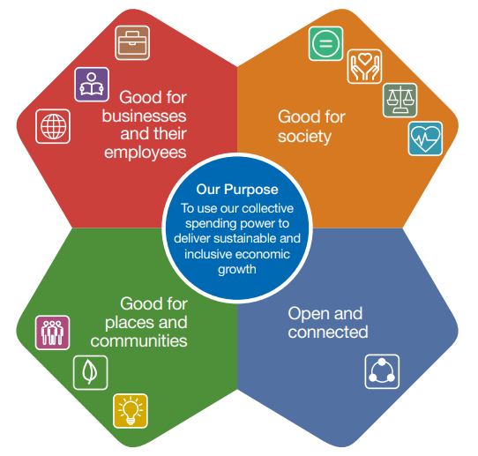

Within Procurement there are outcomes outlined by the Sustainable Procurement Duty, which requires us to buy in a way which is:

* good for businesses and employees
* good for society
* good for places and communities
* open and connected

These outcomes, which are supported by Scottish Government policies and guidance as well as sectorial and organisational policies and guidance, underpin and enable our work. To further support this, the Public Procurement Strategy for Scotland and this strategy are structured around these areas, as well as acknowledging enablers to help achieve our aims.

This new strategy builds on what was achieved under the previous version, reflecting the evolving nature of public sector procurement and the council’s current priorities.

Supporting Council Objectives

The 2022-27 Council Plan outlines how East Lothian council will strive to meet our Vision of: ***An even more prosperous, safe and sustainable East Lothian, with a dynamic and thriving economy, that enables our people and communities to flourish.***

This high level statement of objectives, priorities and strategic goals aims to meet the challenges the Council, East Lothian, its residents and communities face. It sets out the values, principles and behaviours that guide how the council and its staff operate.

The 2022-2027 Council Plan is based around three overarching objectives that have been set in response to three fundamental challenges we face.

* ***Recovery and Renewal*** *– recovering from the COVID pandemic by investing in regeneration and a sustainable future*
* ***Reduce poverty and Inequality*** *– supporting our communities to deal with the growing levels of poverty and inequality*
* ***Respond to the Climate Emergency*** *– meeting our net zero climate change targets*

Beyond these three fundamental challenges we continue to face systemic, long-term challenges. In response to these challenges the previous Council Plan set out four thematic objectives which remain relevant.

* ***Grow our Economy*** *– increase sustainable and inclusive growth as the basis for a more prosperous East Lothian*
* ***Grow our People*** *– give our children the best start in life and protect vulnerable and older people*
* ***Grow our Communities*** *– give people a real say in the decisions that matter most and provide communities with the services, infrastructure and environment that will allow them to flourish*
* ***Grow our Capacity*** *– deliver excellent services as effectively and efficiently as possible within our limited resources*

The council has a well-established set of behaviours that help to drive continuous improvement towards the achievement of the Council Plan. These are known as The East Lothian Way:

* ***Focus on service*** – putting the customer first; providing excellent customer service; and, contributing to improvements in service
* ***Explore the bigger picture*** – working together for a better East Lothian; understanding how our daily activities are linked to the council’s vision and priorities
* ***Initiate solutions*** – striving for excellence; taking personal responsibility and ownership to be effective in our jobs
* ***Share knowledge*** – demonstrating regular and effective team working; being open and honest
* ***Deliver outstanding results*** – taking responsibility and seeing tasks through to successful completion

|  |
| --- |
|  |
| **Procurement’s Role in Delivering These** |
| Procurement will support services across the council by ensuring the requirements for goods, services and works are procured in a way that supports the council objectives and delivers the solutions that work best for East Lothian and deliver Best Value. |

Enablers

The enablers to this Strategy are fundamental to the success of the strategic aims and objectives. The enablers have been identified as underpinning the successful delivery across all elements of the Strategy.

|  |
| --- |
| Procurement Capability:  People are key. We must ensure the Procurement profession is developing individuals and teams. As well as attracting, developing and retaining new and existing procurement talent, leadership is essential. |
| We will do this by: |
| * Providing opportunities to develop the skills of our service users * Providing graduate opportunities where possible * Supporting continuing professional development of professionals to ensure expertise is relevant and current * Continuing to develop and implement training and guidance to support compliance and excellence in procurement * Continuing to participate in the PCIP to support continuous improvement and identification of areas for improvement * Continuing to use the national procurement competency framework and associated online tool to assess team skills, identify training needs and support career planning. This will be carried out annually as part of the Performance Review and Development (PRD) process * Using workforce and succession planning to develop our people * Ensuring capacity (resource levels) align with strategic procurement priorities, contracted expenditure and business needs * Ensuring workloads (contract requirements) are managed using a consolidated work plan and prioritisation tool ensures work addresses business needs and meets demand across the council |
| What success looks like: |
| * Attracting, developing and retaining new and existing procurement people * Areas for improvement are understood and actions plans are in place to address them * Successful delivery of Annual Service and Action Plans to address business needs and meets demand across the council |

|  |
| --- |
| Supplier Development:  The supply chains we work with are fundamental to our success. Providing support and opportunities for suppliers to develop and to navigate the evolving landscape will contribute to positive outcomes for communities, society, and organisations. |
| We will do this by: |
| * Increasing engagement, working with suppliers and the Supplier Development Programme to support ‘meet the buyer’ and ‘meet the supplier’ events and in raising awareness of contract and sub-opportunities, including access to national frameworks * Provide information to those interested in doing business |
| What success looks like: |
| * Increase the number of and spend with local Small to Medium Enterprises (SMEs) and third sector businesses being awarded council contracts |

|  |
| --- |
| Engagement:  Having appropriate shared processes and tools to provide consistency to both Procurement Professionals and suppliers. This will allow for efficient and effective delivery of Procurement services. |
| We will do this by: |
| * Improving representation of Procurement at senior leadership level with increased influence over procurement activity * Annually reviewing and updating Procurement Service Plan (Action and Improvement Plan), reporting progress to CMT * Working with communications team to raise the profile and ensure key procurement messages and updates are communicated * Ensuring that all leaders understand their role in driving and enabling impactful procurement * Undertaking annual surveys to capture feedback and satisfaction levels from internal customers and suppliers * Using a business partnering approach, understand the influence we have and identify mutually beneficial opportunities, target our efforts, and drive best value * Transitioning towards digital procurement forms, process and procedures * Develop procurement performance reports for Heads of Service and Service Managers * Supporting P2P (purchase-to-pay) project and the wider council in delivering consistency and accuracy related to downstream processes * Sharing and using post-project and lessons learned to implement required improvements to our forms, processes and procedures * Optimising current systems   + Evaluating needs to track on / off contract spend   + Implementing related recommendations * Develop, improve and automate procedure for creation of Annual Procurement Report; Publish Annual procurement Report * Horizon scanning: on-going analysis of the public procurement environment to identify important developments, e.g. emerging Scottish Government policy and ensure the council is prepared for potential opportunities and threats, and where relevant developments are embedded in Procurement policies, objectives and actions * Annually reviewing and updating council standing orders and procurement procedures to ensure appropriate internal controls and awareness of the procurement and financial rules * Annually reviewing and updating (as required) our forms, processes and procedures, including checking for accessibility * Developing and implementing e-learning module to provide council staff with an introduction to procurement, policies and procedures * Implementing and reporting on improvements plans that flow from The Procurement & Commercial Improvement Programme (PCIP) |
| What success looks like: |
| * Leaders and stakeholders are more engaged with procurement * Increased use of category management, where relevant |

|  |
| --- |
| Collaboration:  Collaboration will assist us in achieving our shared goals and anchoring our success in our communities, people and organisations. Strengthening collaboration and engagement across the Public Procurement landscape will allow consistent approaches where practical, and facilitate development and sharing of best practice |
| We will do this by: |
| * Using collaborative frameworks by default: Continuing to use pre-existing contracts / frameworks, where there is one unless an alternative route represents best value * Applying Community Wealth Building principles to collaborate with other anchor Institutions to identify and share information on collaborative procurement opportunities and best practice * Participate in ELC CWB Working Group * Establishing a procurement specific working group across anchor institutions * Development and approval of the CWB Action plan * Maximize opportunities for innovation and collaboration to enable delivery of the council’s key corporate projects, e.g. Transformation, Digital and Asset Review |
| What success looks like: |
| * Increasing spend, savings and Community Benefits through use of collaborative frameworks * New opportunities available for the East Lothian suppliers and third sector within East Lothian and the wider City-Region. * Improved awareness of what is being procured and what types of goods and services are available locally |

Objectives

|  |
| --- |
| Good for businesses and their employees:  Maximise the impact of procurement to boost a green, inclusive and wellbeing economy, promoting and enabling innovation in procurement.  By Business we include any organisation or enterprising entity engaged in commercial, industrial, or professional activities including, voluntary, charity, for – profit and non-profit entities. |
| Suppliers  Promoting early supplier engagement to foster innovative and entrepreneurial responses to Public Sector needs and requirements. Collaborating with organisations to deliver positive, green and inclusive social impacts within public contracts. Having a holistic approach with key suppliers.  Supply Chain and Resilience  Encouraging a sustainable supply base that can support the work of the Public Sector to provide resilient and robust supply chains. Developing appropriate relationships and putting forward looking plans in place to support the development of the Supply Markets, improving security of supply and reducing risk.  SMEs, Third Sector and Supported Businesses  Consider how procurements are conducted and contracts are developed, to reduce barriers and enable participation for SMEs, Third Sector organisations, and Supported Business, in Public Sector Procurement.  Contract Management  Carrying out ongoing proportional contract management to ensure the right outcomes are delivered and the performance of contracts is maximised. |
| We will do this by: |
| Suppliers   * Using supplier feedback from annual surveys to continually improve access to our tendering opportunities * Actively participating in collaborative working opportunities that supports the delivery of a sustainable economic recovery   Supply Chain and Resilience   * Providing guidance and support to stakeholders to identify, assess and manage risks within procurement activity * Considering procurement risks early during commodity strategy development, as part of market condition analysis * Learning from the Competition and Markets Authority (CMA) e-learning on bid rigging in public procurement is used to flag any specific risks arising from the supply chain * Capturing procurement risks in the procurement service risk register and feeding into the corporate risk register, where relevant * Monitoring, managing and reporting on corporate risks using the council’s new risk management software * For Regulated Procurements, the Council will detail in each commodity strategy document, the approach to be taken regarding:   + Promoting compliance by contractors and subcontractors with the Health & Safety at Work Act 1974 and any provision under that Act   + The procurement of fairly and ethically traded goods and services   + How we can promote the highest standards of animal welfare for procurements involving the provision of food.   + Ensuring prompt payment for contractors and sub-contractors in the supply chain.   SMEs, Third Sector and Supported Businesses   * Increasing % of spend with local suppliers * Develop recommendation on signing up to Buy Social Pledge * Develop recommendation on Social Enterprise Scotland membership   Contract Management   * Implementing new Procurement Software to support and document contract and supplier management * Implementing contract management into the lifecycle of key contracts across the council * Embedding Contract and Supplier Management: Ongoing analysis and feedback to / from suppliers to enhance the working relationships |
| What success looks like: |
| Suppliers   * Improved access to our tendering opportunities   Supply Chain and Resilience   * Risks are monitored, managed and reported on procurement activity * Risks and impacts to the council are mitigated * Compliance with the Health & Safety at Work Act 1974 and any provision under that Act * Increased procurement of fairly and ethically traded goods and services * Promotion of the highest standards of animal welfare (for procurements involving the provision of food) * Improved prompt payment in the supply chain.   SMEs, Third Sector and Supported Businesses   * Increase the number of, and spend, with local Small to Medium Enterprises (SMEs) and third sector and supported businesses being awarded council contracts   Contract Management   * Embedded contract and supplier management approach * Report on performance and value delivered by our contract and supplier management approach |

|  |
| --- |
| Good for places and communities:  Maximising the impact of procurement with strong community engagement and development to deliver social and economic outcomes as a means to drive wellbeing by creating quality employment and skills. |
| Community Wealth Building – Fair Work First and Community Benefits  Maximising economic and social benefits through procurement and commissioning, applying fair work practices, developing good enterprises, and secure supply chains.  Supporting a sustainable built environment  Maximising opportunities in procurement to develop, enhance and maintain a sustainable built environment. Creating a portfolio of frameworks delivering a range of construction activity across the public sector which considers the economic impact and the sustainability of the construction industry, and the requirement for inclusive growth and climate change targets. Ensure construction projects reflect and help deliver all pertinent Scottish Government obligations including Fair Work First and Net Zero. Actively consider issues including but not limited to Fair Work First and Net Zero early in procurements and commissioning activity.  Whole life costing  Promoting sustainable procurement through routine consideration of whole life costing to ensure value for money in procurement, minimise environmental damage and maximise socio-economic benefits.  Community Participation  Engaging with communities to understand local needs and requirements to help shape procurement policies, initiatives and contracts.  Climate Crisis and Environment  Making informed decisions as we engage early with suppliers to create innovative solutions to positively respond to the climate crisis. Eliminating waste throughout the supply chain where possible. Act in a way that will secure net zero emissions through a Just Transition and promote a circular economy. |
| We will do this by: |
| Community Wealth Building – Fair Work First and Community Benefits / Supporting a sustainable built environment   * Applying CWB Building principles to develop and maximise spend with local businesses * Delivery of the CWB Action plan * Considering children, young people, procurement equality duties, equality impact and sustainability at an early stage as part of commodity strategy development * Implementing and embed sustainable procurement tools that support a sustainable economic recovery * Using the tools detailed below to support the delivery of prioritised sustainable outcomes   + Flexible Framework assessment tool   + Prioritisation Tool   + Sustainability Test   + Capturing, monitoring and reporting on key sustainable priorities * Improving awareness for council staff and suppliers of Fair Work First * Continuing to include Fair Work First Criteria within tenders where proportionate and relevant * Using the new Procurement software to capture, monitor and report on fair work first obligations and their delivery * Engaging with suppliers to meet requirements of becoming an accredited Living Wage Employer * Enhancing the council’s approach to Community Benefits to build on what has been delivered to date: continuing to contribute to outcomes relating to employability, skills and tackling inequalities by focusing on under-represented groups * Including commitments to Article 12 of the UN convention on the Rights of the Child and the Children and Young People (Scotland) Act 2014 Corporate Parenting responsibilities in wish list * Continuing to improve information on our Community Benefits approach to share with communities and suppliers on our website showing where the benefits go / who receives them * Using new procurement software to increase and improve monitoring and reporting of Community Benefits obligations and their delivery as part of CSM * Increasing awareness of Community Benefits through tender opportunities   Supporting a sustainable built environment   * Updating our policies, objectives and actions to reflect Construction Policy Notes from Scottish Government, e.g. Sustainability in construction projects: CPN 1/2023 * Considering Fair Work First and Net Zero for council construction contracts at an early stage as part of commodity strategy development (using the Sustainable Prioritisation tool for construction)   Whole life costing   * Considering whole life costing approach for key council contracts, e.g. for environmental and goods contracts at an early stage as part of commodity strategy development * In line with the councils Standing Orders, we will use Centres of Expertise (CoE) frameworks where there is a suitable pre-existing contract to fulfil our requirements. Whole life costing is considered, where relevant, within tender evaluations for these frameworks   Community Participation   * Considering stakeholder engagement activities, involving communities and service users at an early stage as part of commodity strategy development, for example as part of our Social Care and ethical commissioning activities * Identifying what the community wants when it comes to Community Benefits * Improving the measurement of the impact of Community Benefits on our communities * For Regulated Procurements, the Council will detail in each commodity strategy document, the approach to be taken regarding:   + consulting and engaging with those affected by the procurement   + how we can improve the health, wellbeing, and education of communities in our area (for procurements involving the provision of food)   Climate Crisis and Environment   * Using learning from climate and carbon literacy training to transfer knowledge to and support service users when progressing procurement projects * Working with the council’s Sustainability and Climate Change Officer to deliver ELC climate emergency e-learning to service users * Collaborating with the council’s Sustainability and Climate Change Officer and service users to implement and embed Sustainable Prioritisation tool for social care, construction, ICT, waste and transport * Considering climate change mitigation and adaptation, and circular economy at an early stage as part of commodity strategy development * Supporting the council to deliver opportunities that help tackle the climate emergency, progress towards Net Zero and the circular economy agenda, e.g. by including obligations in relation to the environment and sustainability, i.e. reducing waste, etc. to meet the obligations of our council’s Climate Change Strategy (2020-2025) * Considering sustainability and circular economy at an early stage as part of commodity strategy development |
| What success looks like: |
| Community Wealth Building – Fair Work First and Community Benefits / Supporting a sustainable built environment   * Sustainability test embedded and used in all relevant and proportionate contracts and frameworks * Supporting delivery of the Fair Work and the Real Living Wage obligations of our East Lothian Poverty Plan 2021-2023: Fair Work First Criteria included within tenders where proportionate and relevant * Completion of procurement actions associated with our aim to become an accredited Living Wage Employer * Refreshed approach to Community Benefits adopted, implemented and embedded * Increasing the number of Community Benefits secured and delivered through contracts * Community Benefits are more aligned to what the community wants * Impact of Community Benefits on our communities is measured and reported   Whole life costing   * Whole life costing is used in all relevant and proportionate contracts and frameworks   Community Participation   * Communities and service users are engaged in all relevant and proportionate contracts and frameworks * Health, wellbeing, and education of our communities and service users is considered for procurements involving the provision of food   Climate Crisis and Environment   * Annual reporting of procurements influence and contribution that supports Net Zero, mitigation and adaptation of climate change and the circular economy agenda |

|  |
| --- |
| Good for society:  Ensure that we are efficient, effective and forward thinking through continuous improvement to help achieve a fairer and more equal society. |
| Economic Wellbeing  Make conscious and considered decisions that achieve best value and aims to establish practices and contracts that support the people and organisations of Scotland.  Emergency situations  Procurement has been critical in responding to previous emergencies and humanitarian situations, and will strive to provide innovative, effective and efficient responses to future emergency situations.  Food security  Ensuring high standards of animal welfare and sustainable production and waste reductions through the procurement process to improve community health, wellbeing and education. |
| We will do this by: |
| Economic Wellbeing   * Strategic Sourcing: market analysis and scoping to identify critical supply routes that support the council and procurement strategy * Ensuring market engagement & understanding   + Monitoring supply markets and trends   + Market testing of / for commodity strategy   + Share market intelligence with finance colleagues to help with budget development & monitoring * Continuing to deliver collaborative procurements and achieve best value * Driving efficiencies and best value to support the financial sustainability of the council * Understanding and challenging the need to buy * Continuing to identify / reduce spend which doesn't follow the defined purchasing policies and manage demand * Using a category management approach to monitor, manage and report to senior leaders on spend for dedicated areas / commodities   Emergency Situations   * Including obligations (Terms & Conditions and / or specifying requirements) related to emergency situations for key council contracts, e.g. allowing for appropriate response in emergencies, business continuity, etc   Food Security   * Considering food security (e.g. local sourcing) at an early stage as part of commodity strategy development * In line with the council’s Standing Orders, we will use CoE frameworks where there is a suitable pre-existing contract to fulfil our requirements. Food Security and local sourcing is considered, where relevant in these frameworks * Increasing engagement, working with suppliers and the Supplier Development Programme to raise awareness of contract and sub-opportunities, including access to national frameworks |
| What success looks like: |
| Economic Wellbeing   * Ensuring spend is within council budgets * Increasing participation in collaborative opportunities (National Frameworks, sector-based Collaboration Frameworks and working with other councils with a similar requirements) * Report on procurements contribution to identifying, securing and delivering savings / efficiencies * Forms, processes and procedures take account of any changes to our objectives and Scottish Government policies and strategies * Improvement against The Procurement & Commercial Improvement Programme (PCIP)   Emergency Situations   * Emergency situation obligations / requirements are included in all relevant and proportionate contracts and frameworks   Food Security   * Food security, in particular local sourcing is used in all relevant and proportionate contracts and frameworks * Increased number of and spend with local Small to Medium Enterprises (SMEs) and third sector businesses being awarded council contracts for food |

|  |
| --- |
| Open and connected:  Ensure procurement in Scotland is open, transparent and connected at local, national and international levels. |
| Global Reach  Remain connected to support development of best practice.  Connectivity  We will strive for an ease of doing business with the Public Sector and for the Public Sector to be able to easily do business with our suppliers. Take advantage of opportunities to develop and improve the data, management information and systems, while leveraging automation and future technologies.  Consistency  Promoting consistent use of tools, platforms and systems, processes, guidance and templates. |
| We will do this by: |
| Global Reach   * Updating our policies, objectives and actions to reflect emerging policy from Scottish Government. For example, Public procurement – Australia and New Zealand Free Trade Agreements: SPPN 1/2023, Public procurement - supporting innovation through procurement: SPPN 3/2023, etc   Connectivity   * Publishing our opportunities via social and other media * Publishing our Annual Procurement Reports, including details of future regulated procurements * Publishing our Contract Register * On-going improvement to our data, management information and use of systems   Consistency   * Publishing all our opportunities via the national advertising portal for all public sector contracts - Public Contracts Scotland (PCS and / or PSC-Tender) |
| What success looks like: |
| Global Reach   * Our policies, objectives and actions take account of Scottish Government policies and strategies   Connectivity   * Increased participation in contracting opportunities * Positive feedback from suppliers in relation to ease of doing business with us   Consistency   * Supplier experience in doing business with us is consistent and improves over time |

Regulations, Policies, Guidance and Tools

The council requires to use UK and Scottish regulations, policies, guidance and tools concerning public procurement activity, in conjunction with the council’s own regulations, policies, guidance and tools concerning procurement activity including but not limited to:

|  |  |  |
| --- | --- | --- |
| UK and Scottish regulations, policies, guidance and tools | Scottish Government’s tools | Council’s regulations, policies, guidance and tools |
| * Procurement Reform (Scotland) Act 2014 * Public Contracts (Scotland) Regulations 2015 * Procurement (Scotland) Regulations 2016 * Utilities Contracts (Scotland) Regulations 2016 * Concessions Contracts (Scotland) Regulations 2016 * Case law * Scottish Procurement Policy Notes (SPPN’s) and Construction Policy Notes * Sustainable procurement duty * Fair Work First * Procurement equality duties set out in The Equality Act 2010 and The Equality Act 2010 (Specific Duties) (Scotland) Regulations 2012 | * Public Contracts Scotland * Public Contract Scotland - Tender Portal * Procurement Journey * Supplier Journey * Sustainable Procurement Tools * Climate Literacy For Procurers | * Scheme of Delegation * Standing Orders * Financial Regulations * Risk Management, Monitoring and Reporting Process * East Lothian Council Plan 2022-2027 * ELC_Recovery__Renewal_Plan_2021 * East Lothian Council Poverty Plan 2021-2023 * East Lothian Council Equality Plan 2021-2025 * Climate Change Strategy 2020-2025 * Sustainable Procurement Charter and Policy * Financial and Capital Strategy 2022/23-2026/27 * East Lothian Economic Development Strategy 2012-2022 * East Lothian Health and Social Care Partnership Commissioning Strategy 2023 – 2025 * East Lothian Council Digital Strategy 2022-2027 * East Lothian Way * Lothian Strategic Development Framework |

Procurement is governed by many legal sources, principally derived from the EU Treaty principles. The “Fundamental Principles” (Proportionality, Mutual Recognition, Non-discrimination, Equal treatment and Transparency) apply to all procurement activity regardless of the value. All contracts let by or on behalf of the council must be done so in a proportionate manner that demonstrates compliance with the above principles to all parties having an interest in that procedure. All contracts let by or on behalf of the council must also follow the council’s Procurement Procedures (Standing Orders) and internal Working Instructions.

Council spend profile

The information below details the council’s overall spend profile for 2021-2022. The highest areas of spend are social care and construction.

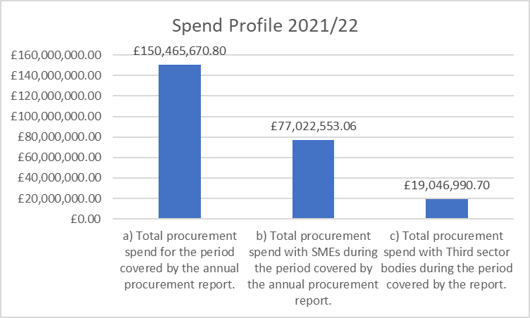

** Figures taken from Spend Analysis Hub

|  |  |
| --- | --- |
| East Lothian Council Procurement Spend Profile 2021-2022 | |
| **Total Procurement Spend** | **£150,465,670.80 \*\*** |
| SME Spend | £77,022,553.06 (217 suppliers)** |
| Third Sector Spend | £19,046,990.70 (32 suppliers)** |
| Total Local Spend | £30,111,584.08 (99 suppliers)** |

** Figures taken from Spend Analysis Hub

**Savings, Benefits and Added Value**

Delivering value through procurement is a key element and driver of continual Service Improvement. Savings and benefits definitions are defined as follows:

Savings

* Cashable Savings
* Cost Avoidance
* Commercial and Operational Efficiencies

Benefits and Added Value

* Community Benefits
* Sustainability
* Innovation

A more formal approach to tracking cost savings has been introduced. Our new procurement software will be used to enhance our ability to capture, monitor and report on contract obligations, performance, savings and benefits (added value) delivered by procurement from April 2023.

|  |  |
| --- | --- |
| Total delivered cash savings for the period covered by the Annual Procurement Report (2021/2022) | £2,105,888.00 |

Reporting

We are committed to being transparent about how we spend public money and improving accountability, by publishing information about our procurement activity.

This is in line this commitment, we:

* have developed this strategy in consultation with key internal stakeholders (staff, service users, senior management and elected members) and external partners Scotland Excel (the Centre of Procurement Expertise for the local government sector) to gain a national perspective
* will monitor the strategic aims, objectives, priorities and targeted outcomes using the Action Plan in Appendix 1
* performance against the Action Plan will be monitored by the procurement service manager and reported to CMT. Reporting will include Performance Indicators’ linked to the Action Plan and the Performance Indicators will monitor, track and measure continuous improvement
* will publish this procurement strategy
* will review and update the strategy on an annual basis, to ensure continued alignment with supporting the delivery of the council’s priorities and outcomes
* will refresh the Procurement Strategy and the associated Action Plan and these will be reported to and approved by Cabinet
* will produce an annual procurement report that records the performance against the Procurement Strategy. This will be reported to Cabinet and will include:
  + a summary of the regulated procurements completed during the year
  + a summary of Community Benefits and Fair Work First performance; and
  + a summary of future regulated procurements
* will publish annual procurement reports
* use the Public Contracts Scotland website to advertise regulated contracts and publish award notices
* promote transparency and greater openness through, for example, the use of procurement strategies

The council’s procurement performance is also subject to PCIP assessments.

Please note that due to the impact of covid-19 PCIP assessments were put on hold, with a view to recommencement in 2023.

The procurement actions detailed within this strategy and Appendix 1 are aligned to both the national procurement objectives and the PCIP programme which supports continuity and continuous improvement.

Resources

Information is provided on the council’s website <https://www.eastlothian.gov.uk/info/210594/procurement> and in related downloads to support those interested in doing business with the council. The website contains key information including:

* Information on how to do business with the council
* Links to Public Contracts Scotland, the main portal used to advertise contract opportunities
* Details of contract authorities for collaborative framework agreements and dynamic purchasing systems
* The council contract register
* Community Benefits in Procurement
* Sustainable Procurement
* The Supplier Development Programme (SDP)
* Details about the standard terms and conditions of contract

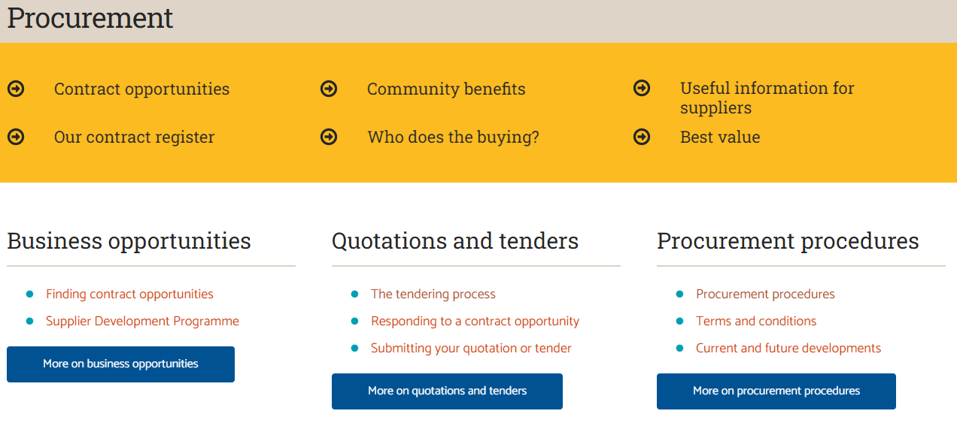

External organisations support for those looking to do business with the council can be sought from [Business Gateway](https://www.bgateway.com/local-offices/east-lothian/local-support) and the [Supplier Development Programme](https://www.sdpscotland.co.uk) (SDP).

The council’s Procurement team will continue to attend Scotland Excel and SDP Meet the Buyer events; as well as identifying more local events which target support aligned to the delivery of the council’s priorities.

The [Supplier Journey](https://www.supplierjourney.scot) provides guidance for suppliers on how to bid for public sector contracts.

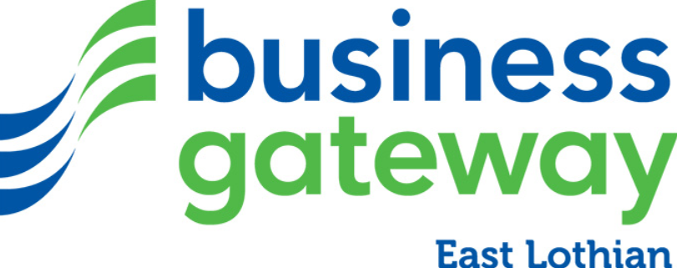

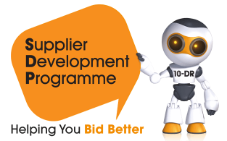

Ownership and contact details

This Corporate Procurement Strategy has been approved by the Corporate Management Team (CMT) and full council. It reflects the Council Plan, Scottish Model of Procurement, Local Economic Agenda and National Outcomes. An initial Action Plan is included in Appendix 1 and will be managed and updated annually. Progress reports will be provided to CMT quarterly with priorities agreed with Heads of Service / CMT, as required.

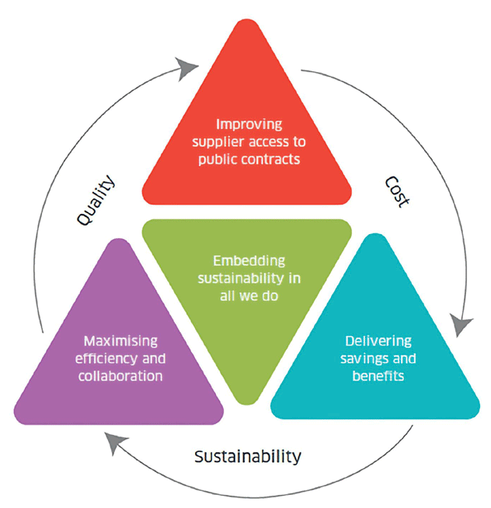

All staff within the council have a role in ensuring compliance with the Procurement Strategy’s objectives. Key internal stakeholders in East Lothian Council are:

* **Corporate Management Team (CMT):** This group will oversee implementation and delivery of the Procurement Strategy
* **Service Managers:** The central Procurement Team cannot fulfil the critical roles of savings identification /contract management / CBIP opportunities without the support and co-operation of staff in service areas. Service Managers are essential to the successful implementation of the Procurement Strategy and for providing relevant and timely information regarding their future procurement requirements. After contract award, both Contract and Supplier Management are critical activities that rely heavily upon effective Service Manager Engagement
* **Service Users:** A well-informed and adequately skilled user base is another vital component for successful delivery of the Procurement Strategy

**Michelle Coyle**

Service Manager Procurement, East Lothian Council

[procurement@eastlothian.gov.uk](mailto:procurement@eastlothian.gov.uk)

[www.eastlothian.gov.uk](http://www.eastlothian.gov.uk)

Appendix 1 – Procurement Strategy Action Plan 1 April 2023 until 31 March 2024

Enablers

|  |  |  |  |
| --- | --- | --- | --- |
| Enabler | Action | Target Date | Status  (On Target, Delayed, Off-Target, Closed) |
| Procurement Capability | Providing opportunities to develop the skills of our service users | On-going | On Target |
| Procurement Capability | Providing graduate opportunities where possible | On-going | On Target |
| Procurement Capability | Supporting continuing professional development of professionals to ensure expertise is relevant and current | On-going | On Target |
| Procurement Capability | Continuing to develop and implement training and guidance to support compliance and excellence in procurement | On-going | On Target |
| Procurement Capability | Continuing to participate in the PCIP to support continuous improvement and identification of areas for improvement; | March 2024 | On Target |
| Procurement Capability | Continuing to use the national procurement competency framework and associated online tool to assess team skills, identify training needs and support career planning. This will be carried out annually as part of the Performance Review and Development (PRD) process | March 2024 | On Target |
| Procurement Capability | Using workforce and succession planning to develop our people | September 2023 | Closed |
| Procurement Capability | Ensuring capacity (resource levels) align with strategic procurement priorities, contracted expenditure and business needs. | On-going | On Target |
| Procurement Capability | Ensuring workload (contract requirements) are managed using a consolidated work plan and prioritisation tool ensure work addresses business needs and meets demand across the council | On-going | On Target |
| Supplier Development | Increasing engagement, working suppliers and the Supplier Development Programme to support ‘meet the buyer’ and ‘meet the supplier’ events and in raising awareness of contract and sub-opportunities, including access to national frameworks | On-going | On Target |
| Supplier Development | Provide information to those interested in doing business | On-going | On Target |
| Engagement | Improving representation of Procurement at senior leadership level with increased influence over procurement activity | March 2023 | Closed |
| Engagement | Annually reviewing and updating Procurement Service Plan (Action and Improvement Plan), reporting progress to CMT | March 2024 | On Target |
| Engagement | Working with communications team to raise the profile and ensure key procurement messages and updates are communicated | On-going | On Target |
| Engagement | Ensuring that all leaders understand their role in driving and enabling impactful procurement | On-going | On Target |
| Engagement | Undertaking annual surveys to capture feedback and satisfaction levels from internal customers and suppliers, identifying areas for improvement | November 2023 | On Target |
| Engagement | Using a business partnering approach, understand the influence we have and identify mutually beneficial opportunities, target our efforts, and drive best value | On-going | On Target |
| Engagement | Transitioning towards digital procurement forms, process and procedures | September 2023 | Delayed |
| Engagement | Develop procurement performance reports for Heads of Service and Service Managers | July 2023 | Closed |
| Engagement | Supporting P2P (purchase-to-pay) project and the wider council in delivering consistency and accuracy related to downstream processes | On-going | On Target |
| Engagement | Sharing and using post-project and lessons learned to implement required improvements to our forms, processes and procedures | On-going | On Target |
| Engagement | Optimising current systems   * Evaluating needs to track on / off contract spend * Implementing related recommendations | March 2024  March 2024 | On Target  Not Started |
| Engagement | Develop, improve and automate procedure for creation of Annual Procurement Report; Publish Annual procurement Report | Sept 2023 | Closed |
| Engagement | Horizon scanning: on-going analysis of the public procurement environment to identify important developments, e.g. emerging Scottish Government policy and ensure the council is prepared for potential opportunities and threats and where relevant developments are embedded in Procurement policies, objectives and actions | March 2024 | On Target |
| Engagement | Annually reviewing and updating council standing orders and procurement procedures to ensure appropriate internal controls and awareness of the procurement and financial rules | March 2024 | On Target |
| Engagement | Annually reviewing and updating (as required) our forms, processes and procedures, including checking for accessibility | March 2024 | On Target |
| Engagement | Developing and implementing e-learning module to provide council staff with an introduction to procurement, policies and procedures | Jan 2023 | Closed |
| Engagement | Implementing and reporting on improvements plans that flow from The Procurement & Commercial Improvement Programme (PCIP) | March 2024 onwards | On Target |
| Collaboration | Using collaborative frameworks by default: Continuing to use pre-existing contracts / frameworks, where there is one unless an alternative route represents best value | On-going | On Target |
| Collaboration | Applying CWB principles to collaborate with other anchor Institutions to identify and share information on collaborative procurement opportunities and best practice | March 2023 onwards | On Target |
| Collaboration | Participate in ELC CWB Working Group | March 2023 onwards | On Target |
| Collaboration | Establishing a procurement specific working group across anchor institutions | March 2024 | On Target |
| Collaboration | Development and approval of the CWB Action plan | March 2024 | On Target |
| Collaboration | Maximize opportunities for innovation and collaboration to enable delivery of the council’s key corporate projects, e.g. Transformation, Digital and Asset Review | March 2024 | On Target |

Objective

|  |  |  |  |
| --- | --- | --- | --- |
| Objective | Action | Target Date | Status  (On Target, Delayed, Off-Target, Closed) |
| Good for businesses and their employees: **Suppliers** | Using supplier feedback from annual surveys to continually improve access to our tendering opportunities | March 2024 | Closed |
| Good for businesses and their employees: **Suppliers** | Actively participating in collaborative working opportunities that supports the delivery of a sustainable economic recovery | On-going | On Target |
| Good for businesses and their employees: **Supply Chain and Resilience** | Providing guidance and support to stakeholders to identify, assess and manage risks within procurement activity | On-going | On Target |
| Good for businesses and their employees: **Supply Chain and Resilience** | Considering procurement risks early during commodity strategy development, as part of market condition analysis | On-going | On Target |
| Good for businesses and their employees: **Supply Chain and Resilience** | Learning from the Competition and Markets Authority (CMA) e-learning on bid rigging in public procurement is used to flag any specific risks arising from the supply chain | On-going | On Target |
| Good for businesses and their employees: **Supply Chain and Resilience** | Capturing, procurement risks in the Procurement Service risk register and feeding into the corporate risk register, where relevant | On-going | On Target |
| Good for businesses and their employees: **Supply Chain and Resilience** | Monitoring, managing and reporting on corporate risks using the councils new risk management software | On-going | On Target |
| Good for businesses and their employees: **Supply Chain and Resilience** | Detailing in each commodity strategy document, the approach to be taken regarding:   * Promoting compliance by contractors and subcontractors with the Health & Safety at Work Act 1974 and any provision under that Act * The procurement of fairly and ethically traded goods and services * How we can promote the highest standards of animal welfare for procurements involving the provision of food. * Ensuring prompt payment for contractors and sub-contractors in the supply chain. | On-going | On Target |
| Good for businesses and their employees: **SMEs, Third Sector and Supported Businesses** | Increasing % of spend with local suppliers | March 2024 | On Target |
| Good for businesses and their employees: **SMEs, Third Sector and Supported Businesses** | Develop recommendation on signing up to Buy Social Pledge | March 2024 | On Target |
| Good for businesses and their employees: **SMEs, Third Sector and Supported Businesses** | Develop recommendation on Social Enterprise Scotland membership | March 2024 | On Target |
| Good for businesses and their employees: **Contract Management** | Implementing new Procurement Software to support and document contract and supplier management | March 2023 | Closed |
| Good for businesses and their employees: **Contract Management** | Implementing contract management into the lifecycle of key contracts across the council | March 2024 | On Target |
| Good for businesses and their employees: **Contract Management** | Embedding Contract and Supplier Management: Ongoing analysis and feedback to / from suppliers to enhance the working relationships | March 2024 | On Target |
| Good for places and communities: **Community Wealth Building – Fair Work First and Community Benefits** | Applying community wealth building principles to develop and maximise spend with local businesses | March 2024 | On Target |
| Good for places and communities: **Community Wealth Building – Fair Work First and Community Benefits** | Delivery of the CWB Action plan | March 2025 | Not Started |
| Good for places and communities: **Community Wealth Building – Fair Work First and Community Benefits** | Considering children, young people, procurement equality duties, equality impact and sustainability at an early stage as part of commodity strategy development | On-going | On Target |
| Good for places and communities: **Community Wealth Building – Fair Work First and Community Benefits** | Implementing and embed sustainable procurement tools that support a sustainable economic recovery | On-going | On Target |
| Good for places and communities: **Community Wealth Building – Fair Work First and Community Benefits** | Using the tools detailed below to support the delivery of prioritised sustainable outcomes   * Flexible Framework assessment tool * Prioritisation Tool * Sustainability Test * Capturing, monitoring and reporting on key sustainable priorities | On-going | On Target |
| Good for places and communities: **Community Wealth Building – Fair Work First and Community Benefits** | Improving awareness for council staff and suppliers of Fair Work First | On-going | On Target |
| Good for places and communities: **Community Wealth Building – Fair Work First and Community Benefits** | Continuing to include Fair Work First Criteria within tenders where proportionate and relevant | On-going | On Target |
| Good for places and communities: **Community Wealth Building – Fair Work First and Community Benefits** | Using the new Procurement software to capture, monitor and report on fair work first obligations and their delivery | On-going | On Target |
| Good for places and communities: **Community Wealth Building – Fair Work First and Community Benefits** | Engaging with suppliers to meet requirements of becoming an accredited Living Wage Employer | On-going | On Target |
| Good for places and communities: **Community Wealth Building – Fair Work First and Community Benefits** | Enhancing the council’s approach to community benefits to build on what has been delivered to date: continuing to contribute to outcomes relating to employability, skills and tackling inequalities by focusing on under-represented groups. | October 2023 | Closed |
| Good for places and communities: **Community Wealth Building – Fair Work First and Community Benefits** | Including commitments to Article 12 of the UN convention on the Rights of the Child and the Children and Young People (Scotland) Act 2014 Corporate Parenting responsibilities in wish list | On-going | On Target |
| Good for places and communities: **Community Wealth Building – Fair Work First and Community Benefits** | Continuing to improve information on our Community Benefits approach to share with communities and suppliers on our website showing where the benefits go/who receives them | March 2024 | On Target |
| Good for places and communities: **Community Wealth Building – Fair Work First and Community Benefits** | Using new procurement software to increase and improve monitoring and reporting of community benefits obligations and their delivery | March 2024 | On Target |
| Good for places and communities: **Community Wealth Building – Fair Work First and Community Benefits** | Increasing awareness of community benefits through tender opportunities | On-going | On Target |
| Good for places and communities: **Supporting a sustainable built environment** | Updating our policies, objectives and actions to reflect Construction Policy Notes from Scottish Government, e.g. Sustainability in construction projects: CPN 1/2023 | March 2024 | Not Started |
| Good for places and communities: **Supporting a sustainable built environment** | Considering Fair Work First and Net Zero for council construction contracts at an early stage as part of commodity strategy development (using the Sustainable Prioritisation tool for construction) | On-going | On Target |
| Good for places and communities: **Whole life costing** | Considering whole life costing approach for key council contracts, e.g. for environmental and goods contracts at an early stage as part of commodity strategy development | On-going | On Target |
| Good for places and communities: **Whole life costing** | In line with the councils Standing Orders, we will use CoE frameworks where there is a suitable pre-existing contract to fulfil our requirements. Whole life costing is considered, where relevant, within tender evaluations for these frameworks. | On-going | On Target |
| Good for places and communities: **Community Participation** | Considering stakeholder engagement activities, involving communities and service users at an early stage as part of commodity strategy development, for example as part of our Social Care and ethical commissioning activities. | On-going | On Target |
| Good for places and communities: **Community Participation** | Identifying what the community wants when it comes to Community Benefits | March 2024 | On Target |
| Good for places and communities: **Community Participation** | Improving the measurement of the impact of Community Benefits on our communities | March 2024 | On Target |
| Good for places and communities: **Community Participation** | Detailing in each commodity strategy document, the approach to be taken regarding:   * consulting and engaging with those affected by the procurement * o how we can improve the health, wellbeing, and education of communities in our area (for procurements involving the provision of food) | On-going | On Target |
| Good for places and communities: **Climate Crisis and Environment** | Using learning from climate and carbon literacy training to transfer knowledge to and support service users when progressing procurement projects | On-going | On Target |
| Good for places and communities: **Climate Crisis and Environment** | Working with the council’s Sustainability and Climate Change Officer to deliver ELC climate emergency e-learning to service users | March 2024 | On Target |
| Good for places and communities: **Climate Crisis and Environment** | Collaborating with the council’s Sustainability and Climate Change Officer and service users to implement and embed Sustainable Prioritisation tool for social care, construction, ICT, waste and transport. | March 2023 | Closed |
| Good for places and communities: **Climate Crisis and Environment** | Considering climate change mitigation and adaptation, and circular economy at an early stage as part of commodity strategy development | On-going | On Target |
| Good for places and communities: **Climate Crisis and Environment** | Supporting the council to deliver opportunities that help tackle the climate emergency, progress towards Net Zero and the circular economy agenda, e.g. by including obligations in relation to the environment and sustainability, i.e. reducing waste, etc. to meet the obligations of our council’s Climate Change Strategy (2020-2025). | On-going | On Target |
| Good for places and communities: **Climate Crisis and Environment** | Considering sustainability and circular economy at an early stage as part of commodity strategy development | On-going | On Target |
| Good for society: **Economic Wellbeing** | Strategic Sourcing: market analysis and scoping to identify critical supply routes that support the council and procurement strategy | March 2024 | On Target |
| Good for society: **Economic Wellbeing** | Ensuring market engagement & understanding:   * monitoring supply markets and trends * market testing of/for commodity strategy * share market intelligence with finance colleagues to help with budget development and monitoring | On-going | On Target |
| Good for society: **Economic Wellbeing** | Continuing to deliver collaborative procurements and achieve best value | On-going | On Target |
| Good for society: **Economic Wellbeing** | Driving efficiencies and best value to support the financial sustainability of the council | On-going | On Target |
| Good for society: **Economic Wellbeing** | Understanding and challenging the need to buy | On-going | On Target |
| Good for society: **Economic Wellbeing** | Continuing to identify / reduce spend which doesn't follow the defined purchasing policies and manage demand | On-going | On Target |
| Good for society: **Economic Wellbeing** | Using a category management approach to monitor, manage and report to senior leaders on spend for dedicated areas / commodities | March 2024 | Not Started |
| Good for society: **Emergency Situations** | Including obligations (Terms & Conditions and/or specifying requirements) related to emergency situations for key council contracts, e.g. allowing for appropriate response in emergencies, business continuity, etc. | On-going | On Target |
| Good for society: **Food Security** | Considering food security (e.g. local sourcing) at an early stage as part of commodity strategy development. | On-going | On Target |
| Good for society: **Food Security** | In line with the councils Standing Orders, we will use CoE frameworks where there is a suitable pre-existing contract to fulfil our requirements. Food Security and local sourcing is considered, where relevant in these frameworks. | On-going | On Target |
| Good for society: **Food Security** | Increasing engagement, working suppliers and the Supplier Development Programme to raise awareness of contract and sub-opportunities, including access to national frameworks. | On-going | On Target |
| Open and connected: **Global Reach** | Updating our policies, objectives and actions to reflect emerging policy from Scottish Government. For example, Public procurement – Australia and New Zealand Free Trade Agreements: SPPN 1/2023, Public procurement - supporting innovation through procurement: SPPN 3/2023, etc. | March 2024 | Not Started |
| Open and connected: **Connectivity** | Publishing our opportunities via social and other media | On-going | On Target |
| Open and connected: **Connectivity** | Publishing our Annual Procurement Reports, including details of future regulated procurements | On-going | On Target |
| Open and connected: **Connectivity** | Publishing our Contract Register | On-going | On Target |
| Open and connected: **Connectivity** | On-going improvement to our data, management information and use of systems | On-going | On Target |
| Open and connected: **Consistency** | Publishing all our opportunities via the national advertising portal for all public sector contracts - Public Contracts Scotland (PCS and/or PSC-Tender) | On-going | On Target |

Appendix 2 – East Lothian Council Corporate Procurement Strategy 2017-2022: Successful Outcomes Delivered

|  |  |
| --- | --- |
| **Growing Our Economy** | **Successful Outcome** |
| Improve ability of local businesses to access East Lothian Council contracts | * Increased engagement with local SMEs, and awareness of our tendering opportunities * Participated in full-day national meet the buyer events * ELC ‘Meet the Council’ event (Nov 22) * Improvement of payment terms within supply chains * Use of lots to enable SME and local contractor engagement * 81 Local suppliers contracting with ELC (as of August 2023) * ELC contract register and contracting opportunities are published * Enhanced guidance to buyers to increase the number of local suppliers participating in our tendering opportunities * Supplier Development Programme promoted as resource for suppliers |
| Assisting the supply chain | * Mapping the supply chain using Government’s ‘Grow Local platform’ to see which local companies are available to provide services / products in demand by the council * Applying prompt payment in the supply chain public procurement policy as appropriate (SPPN 2/2022) |
| **Growing our Communities** | **Successful Outcome** |
| Consult with the communities concerning our procurement actitivity | * Community benefit wish list developed for proportionate use in contracts over £50k. Wish list populated by community councils to reflect needs of the local community and widens the scope of assistance contracted suppliers can offer. This forms part of tender requirements for potential bidders used on a proportinate basis * Successful and targeted Community Benefits are delivered in line with the need of communities in East Lothian |
| Enhance recording of Community Benefits | * Improved management information, e.g. where CBIP has taken place and where gaps in provision lie |
| **Growing our People** | **Successful Outcome** |
| Ensure Best Value in contracts let for our Adult and Children’s wellbeing directorate | * Commodity strategies signed off identifying spend and potential savings |
| **Growing the Capacity of our Council** | **Successful Outcome** |
| Ensure all contract requirements are known for the next 3 years | * Majority of contract requirements known and are captured in a team work plan * Ability to highlight Risk of Overdue Procurements and to resource appropriately * Recognition of collaborative opportunities and allowing identification of savings * ELC Public Contracts Register on Public Contracts Scotland is available and updated * Added value obligations in contracts in relation to the environment and sustainability, e.g. reducing waste to support delivery against ELC Climate Change Strategy (2020-2025) * Increased capacity (resource levels) aligning with strategic procurement priorities, contracted expenditure and business needs * Clarity on roles and responsibilities, career pathways and succession planning |
| Initiate improved Contract and Supplier Management | * Contract and Supplier Management (CSM ) training delivered to Service Users across the council to enable:   + Early identification of risks to contract provision, and ability to react to those   + Achieve better value from contracts by proper management   + Enhanced relationships with suppliers and stakeholders * Annual surveys to capture the views and understand levels of satisfaction of internal customers and suppliers * New software for contract register and recording and reporting on contract obligations, benefits and performance |
| Introduce benefits tracking into contracts | * The contribution procurement has made to services and their budgets are quanified and recorded |
| Review and improve on the current systems to allow better tracking of on/off contract spend throughout the council | * Greater representation of procurement at senior leadership level with increased influence over procurement activity * Improved knowledge of on / off contract spend allowing the Contracts Register to be more up to date * More opportunities for local suppliers to compete for * Improved controls on spend allowing for more targetted savings objectives to be set * £1.3m cash savings were delivered by the Procurement Improvement Programme (PIP) * Contract coverage is above 80% and we continue to identify and reduce maverick spend as well as manage demand * Calling off from National Frameworks, utilising Sector based Collaboration Frameworks, working with other councils with similar requirements and procuring as a single organisation. In 2021/22 ELC participating in 61 of 69 Scotland Excel Frameworks |
| Training delivered across all service departments, Elected Members and new employees | * Procurement awareness and compliance for all departments * Education of risks of non-compliance, highlighting procurement requirements from service users * Using national procurement competency framework to assess team skills, identify training needs and support career planning as part of the annual Performance Review and Development (PRD) process * Procurement team continue to access training resources to maintain and develop skills in relevant areas e.g. negotiation, project management, CIPS qualifications, Contract and Supplier Management (CSM), Competition and Markets Authority (CMA) e-learning on bid rigging and Climate Literacy Training * Procurement training delivered as part of Elected Member Induction * CSM and general ad-hoc procurement training delivered to Service Users across the council * Review and update of the council’s standing orders and procurement procedures * Knowledge transfer to service users:   + Risks considered in commodity strategies, as part of market condition analysis and, where relevant, captured in the procurement service risk register / corporate risk register, as required   + Development of a Sustainable Prioritisation tool for social care, construction, ICT, waste and transport * Post-project review: lessons shared with team, documented in central log and shared wider (with service users) where appropriate. As well as implementing any required improvements / simplifications to forms, processes and procedures * Commodity strategies align with good practice, legislative requirements and ensure consideration of market intelligence, previous lessons learned, exit strategies, evaluation criteria and the sustainable procurement duty * Facilitating tender evaluation (moderation / consensus) panels, as required and for high-value, high-risk procurements evaluator guidance is supported by a facilitated training session |

Appendix 3 – Glossary

| Term | Definition |
| --- | --- |
| Award | A decision to accept a tenderer’s offer to supply / provide specified goods / services / works according to agree terms & conditions thereby creating a legally binding contract. |
| Best Value | The duty under the Local Government Act in Scotland 2003 to secure continuous improvement in the economy, efficiency and effectiveness with which they exercise their functions. |
| Bid | Another word for a tender submission. Can also mean an in-house tender. |
| Call-off contracts | Agreements, sometimes called framework contracts, without full commitment. The undertaking is that all requirements of the specified nature which are required during the duration of the agreement, will order from these contracts / agreements. Also known as preferred supplier list. |
| Category Management | Category management involves applying the end-to-end procurement process to a specific range of goods or services. This involves pre-award processes such as category analysis and demand management, sourcing and contract negotiation, and the post-award processes such as performance management. |
| Circular economy | A circular economy is an alternative to a traditional linear economy (make, use, dispose) in which we keep resources in use for as long as possible, extract the maximum value from them whilst in use, then recover and regenerate products and materials at the end of each service life. |
| Climate change mitigation | Reducing the amount of greenhouse gases in the atmosphere that leads to global warming and climate change. |
| Climate change adaptation | Adjusting and building resilience to the current and expected impacts of climate change. |
| Collaboration | When two or more groups of people or organisations engage in procurement work together for mutual benefit. |
| Commodity | Taxonomy (classification) for the entire council, to give the council the ability to accurately describe the primary business activities of its suppliers. |
| Commodity [or Service] Strategy | A document that shows the preparatory thinking that is done about a procurement process, including sustainability considerations, stakeholders to be involved, risks etc. |
| Community Benefits | Requirements which deliver wider benefits in addition to the core purpose of a contract. These can relate to jobs, training and other social-economic and / or environmental benefits. |
| Continuous Improvement | Continuous improvement is encouraging all employees to look for ways to enhance the business’s operations. This includes suggesting ideas to improve efficiencies, evaluating current processes, and finding opportunities to cut unproductive work. |
| Contract | An agreement concluded between the council and the supplier that is legally binding, containing terms of the agreement, any schedules and appendices, the Tender Specification and any other specifications, drawings, official purchase order(s) and other documents which are relevant to the Contract. |
| Contract Management | The process of monitoring the performance of a supplier to contract. |
| Fair Work First | Working with employers and partners to deliver investment in skills and training, no inappropriate use of zero hours contracts, action on gender pay, genuine workforce engagement, including with trade unions, and payment of the Real Living Wage. |
| Framework agreements | Arrangements (sometimes referred to as standing offers) in which terms & conditions are agreed, and the client may or may not subsequently place orders (no commitment). Also a consortium can agree terms & conditions and the members may subsequently place orders. |
| Framework contracts | Agreements (sometimes called call-off contracts) in which clients accept some commitment without immediately placing orders, e.g. by undertaking to order, later, all jobs of a specified type from that contract. |
| Horizon scanning | The systematic analysis of potential threats and opportunities and likely future developments. |
| Local SMEs | Local means East Lothian first, expanding to the Lothians, which includes Edinburgh, Midlothian and West Lothian and finally expanding to the Edinburgh and South-East Scotland City Region, which includes Fife and Scottish Borders local authorities. |
| National Outcomes | Describe what the Government wants to achieve over the next ten years, articulating more fully this Government's purpose. They help to sharpen the focus of government, enable our priorities to be clearly understood and provide a clear structure for delivery. [National Outcomes | National Performance Framework](https://nationalperformance.gov.scot/national-outcomes) |
| Net Zero | The term net zero means achieving a balance between the carbon emitted into the atmosphere, and the carbon removed from it. This balance – or net zero – will happen when the amount of carbon we add to the atmosphere is no more than the amount removed. |
| Public Contracts Scotland (PCS) | The advertising portal provided by the Scottish Government for the advertising of public contract opportunities using a Contract Notice, and for the award of contracts via a Contract Award Notice. |
| Procurement Legislation | [The Procurement (Scotland) Regulations 2016](http://www.legislation.gov.uk/ssi/2016/145/contents/made), [The Public Contracts (Scotland) Regulations](http://www.legislation.gov.uk/ssi/2015/446/contents/made) 2015 and the [Procurement Reform (Scotland) Act 2014 (“The Act”).](http://www.legislation.gov.uk/asp/2014/12/contents) |
| Procurement Strategy | A document required as part of Scottish Procurement Regulations that sets out how the council intends to carry out its regulated procurements i.e. procurements with an estimated value equal to or greater than £50,000 (excluding VAT) for supplies for goods & services (or £2,000,000 excluding VAT for a public works contract). |
| Real Living Wage | A wage rate per hour that is based on the cost of living and is currently voluntarily paid by UK organisations. The rates are reviewed and updated annually, each April. Organisations can grain accreditation of this with the Living Wage Foundation. |
| Regulated Procurements | Contracts above the GPA contract threshold values where the relevant GPA regulations apply (greater than £50,000 (excluding VAT) for supplies for goods & services, or £2,000,000 excluding VAT for a public works contract). |
| Regulated Spend | Spend above the GPA contract threshold values where the relevant GPA regulations apply (above £50,000 for supplies for goods and services contracts and above £2,000,000 for works contracts). |
| Small to Medium Enterprise (SME) | Enterprises which employ fewer than 250 persons and which have an annual turnover not exceeding 50 million euro and / or an annual balance sheet total not exceeding 43 million euro. |
| Social Enterprise | A revenue-generating business with primarily social objectives whose surpluses are reinvested for that purpose in the business or in the community, rather than being driven by the need to deliver profit to shareholders and owners. |
| Stakeholder | Any person or group who has a vested interest in the success of the procurement activity, i.e. either provides services to it, or receives services from it. |
| Supplier / Contractor | An entity who supplies goods or provides services or execution of works. |
| Supported Business | Either the organisation's main aim should be the social and professional integration of disabled or disadvantaged persons, or the contract should be performed within a sheltered employment programme. |
| Sustainability | Supporting economic, social and environmental health to meet the present needs without compromising the ability of future generations to meet their needs. |
| Sustainable procurement | A process whereby organisations meet their needs for supplies for goods, services, works and utilities in a way that achieves value for money on a whole life basis and generates benefits, not only for the organisation but also to society, the economy and the environment. |
| Tender | An offer, or bid, by a tenderer in response to an invitation to tender (ITT) or a mini-tender in a framework agreement. |
| Third Sector | Part of an economy or society comprising non-governmental and non-profit-making organisations or associations. |
| Work plan | List of upcoming procurement activity including re-tenders, extensions, and new activity |
| Works | The term used in the Procurement Legislation for a building or civil engineering project or piece of work and as defined by CPV codes in Schedule 1 of [The Public Contracts (Scotland) Regulations](http://www.legislation.gov.uk/ssi/2015/446/contents/made) 2015 |

Appendix 4 – Procurement Strategy Map

|  |  |  |  |  |  |  |  |
| --- | --- | --- | --- | --- | --- | --- | --- |
| **Vision** | | | | | | | |
| To provide excellent services that deliver best value procurements with Community Benefits that support recovery and renewal, reduce poverty and Inequality and respond to the climate emergency. | | | | | | | |
| **Mission** | | | | | | | |
| The procurement team will strive to deliver effective, efficient and excellent services to support the council’s strategic vision and aims, by contributing to the council’s net zero climate change targets, delivering best value and continuous improvement, ensuring compliance and good governance, increasing sustainability, Community Benefits and supporting economic recovery. | | | | | | | |
| **East Lothian Way (Behaviours)** | | | | | | | |
| Focus on service | Explore the bigger picture | | Initiate solutions | | Share knowledge | | Deliver outstanding results |
| **Enablers** | | | | | | | |
| Procurement Capability | | Supplier Development | | Engagement | | Collaboration | |
| **Objectives** | | | | | | | |
| Good for businesses and their employees | | Good for places and communities | | Good for society | | Open and connected | |

