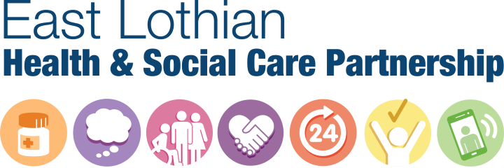

Children and Adult Services  
John Muir House  
Haddington  
EH41 3HA  
T: 01620 827755  
E: elhscp@eastlothian.gov.ukwww.eastlothian.gov.uk

Dear Sir/Madam

**What I want from my life – a project to develop community support services**

We want to tell you about an opportunity we have to work together, to develop and improve community support services.

As part of this project we want to work in partnership with you to build new models of community support that deliver good outcomes for everyone. This includes adults with disabilities and people with mental health problems. We are planning to have our new models of community support in place by April 2020.

We will be looking at the services that the East Lothian Health and Social Care Partnership buys from other organisations and charities. We will also be including services provided by East Lothian Council, which are Tynebank, Port Seton and the Fisherrow Hub.

We are going to use a wide range of consultation and engagement methods to make sure that as many people as possible can be involved. The consultation, engagement and development period will run from August 2018 to March 2019.

We invite you to join us from 24th September to 4th October 2018, where we will hold a number of initial information and engagement events throughout the day and evening.

Tuesday 25th September 1.30 to 3pm MECA, Musselburgh

Wednesday 26th September 6.30 to 8pm Tynebank Resource Centre, Haddington

Thursday 27th September 1.30 to 3pm The Fisherrow centre, Musselburgh

Thursday 4th October 12.30 to 2pm The Bleaching Field Centre, Dunbar

We are not changing anything at short notice or without full consultation.  We will build on what you have already told us about the sort of community supports that would help you achieve your personal outcomes. We will be starting with a blank canvas about what these might look like and we also want to learn about what is working well in other places.

The attached newsletter will explain more about what the next steps are and how you can become involved.

If you would like to attend one of the above events and/or have any specific needs, please fill in the attached form, and return in the prepaid envelope.

If you need to contact us before the events or have any questions about the project and consultation, please refer to the contact information detailed within the newsletter and we will get back to you within 2 working days.

East Lothian Council is committed to providing accessible information to advance equality and reduce discrimination. You can also contact us if you require alternative formats of this information, including Foreign Language, Braille, BSL, Audio, Easy Read, Large Print.

Yours faithfully,



Alison MacDonald

Interim Director Health and Social Care Partnership