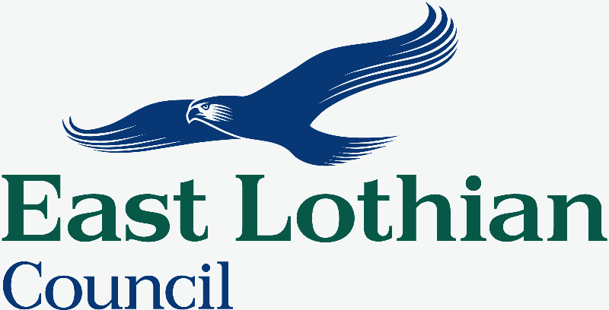
East Lothian Council Participation Request Form

*** PLEASE REFER TO THE SCOTTISH GOVERNMENT’S GUIDANCE ON PARTICIPATION REQUESTS BEFORE COMPLETING THIS FORM***

Section 1 - Details of Community Participation Body
1. Name of Community Body:

2. Contact name:

3. Contact postal address:

4. Contact telephone number:

5. Contact email:

6. Website address (if available):

7. What type of community participation body are you? (See Note 1 below)

- A community controlled body ☐

- A community council ☐

- A body designated by the Scottish Ministers as a community participation body ☐

- A group without a written constitution ☐

Section 2 – Details of Request
7. Name of public service authority to which the request it being made (see Note 2 below):

8. Name of any other public service authority requested to participate in the outcome improvement process (see Note 2):

9. Details of the outcome that the community participation body wants to improve (see Note 3):

10. The reasons why the community participation body should participate in an outcome improvement process:

11. Knowledge, expertise and experience the community participation body has in relation to this outcome:

12. How the outcome will be improved because of the involvement of the community participation body:

13. Please provide any additional information to support your application here (see Note 4 below):

PLEASE REMEMBER TO INCLUDE A COPY OF YOUR WRITTEN CONSTITUTION OR GOVERNANCE DOCUMENTATION IF AVAILABLE.
Return all completed forms to participationrequests@eastlothian.gov.uk

Notes for Applicants
(Please also see the Scottish Government’s Guidance on Participation Requests)
Note 1
The Community Empowerment (Scotland) Act 2015 provides that certain bodies can make a Participation Request. The community participation body should provide the necessary information to demonstrate that it is valid body who can make a participation request.

For more information on different types of community participation bodies please refer to xxx of the Scottish Government Guidance (add link)
Note 2
The public service authorities to whom a request can be made are listed in Schedule 2 in the Community Empowerment (Scotland) Act 2015 these are:
- A local authority
- A health Board
- The Board of management of a college of further education
- Highlands and Islands Enterprise
- A National Park Authority
- Police Scotland
- The Scottish Environmental Protection Agency
- Scottish Enterprise
- The Scottish Fire and Rescue Service
- Scottish Natural Heritage
- A regional Transport Partnership

A request can be made to either just one or to multiple public service authorities from this list.

Note 3
A participation request can be submitted in relation to any outcome that relates to a service provided by the public service authority (in this case, any service provided by East Lothian Council). A useful explanation of outcomes and examples can be found in section 3.48 of the Scottish Government Guidance.

Note 4
Any other information in support of the participation request can be included in this section or attached separately should the community body wish to do so. It may be helpful for the community participation body to outline if they have previously been in contact with the public service authority regarding the outcome. The community participation body may also want to provide information on any additional support they may require to be able to participate in an outcome improvement process.

