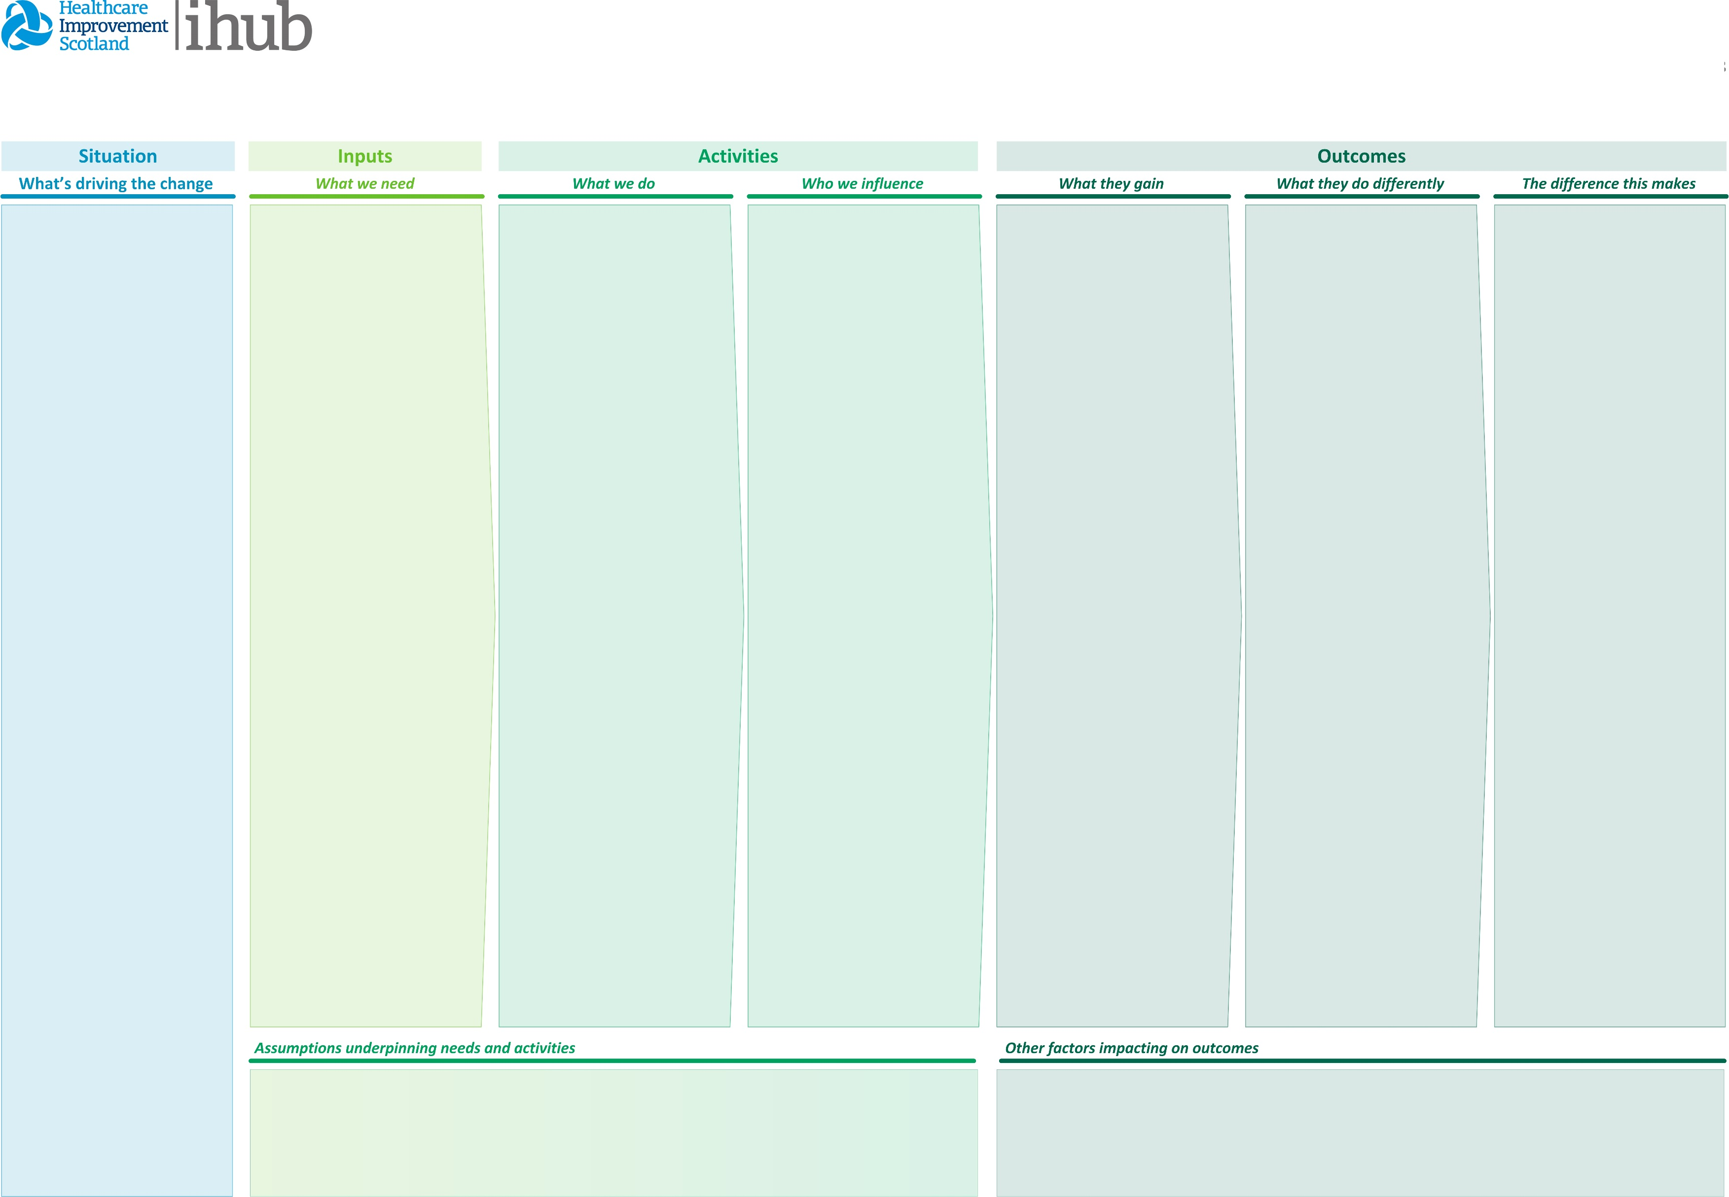

*00 XXX 0000*

Click here to enter assumptions you have made that may stop you delivering your activities if they do not happen.

Funding from Primary Care Improvement Fund

Click here to enter other factors which may also deliver these outcomes or that may stop your outcomes from being achieved.

Long term outcomes

Patients/People:

Improved health outcomes

Longer healthy life expectancy

Staff:

Improved retention and recruitment in primary care

System

Reduced health inequalities

Increased numbers of people in employment, training or volunteering roles

Click here to enter what the impact on the system that your stakeholders have caused because you influenced them.

This normally includes a statement from the National Health and Wellbeing Outcomes or an Integration Authority’s local Strategic Plan.

Try to have a statement to describe the impact the change has on the lives of people and their carers, the impact on the workforce delivering services and the impact on the performance of the health and social care system.

Medium term outcomes

Patients/People:

Improved personal resilience

Staff:

Improved collaborative working across interfaces and within teams

Increased staff numbers working in third sector organisations

System

Reduced pressure on primary care

Increased provision of community support - more groups, more attendees

Improved health and wellbeing of unpaid carers

Improved resilience of the Third Sector

Click here to enter what the stakeholder you influence do differently because of the learning, skills, knowledge, physical resources, etc that they gain.

Each statement should state with a stakeholder group and then use a verb to describe what they are doing differently because of what the gain from you.

Short term outcomes

Patients/People:

Improved wellbeing

Improved personal activation levels

Improved social connections

More people are claiming appropriate benefits

Staff:

Improved staff satisfaction

Improved awareness of local services

System:

Increased capacity within primary care

Click here to enter what the stakeholders you influence gain from your activities.

Each statement should start with a stakeholder group and then state what learning, skills, knowledge, physical resource, etc that they gain from you.

Patients/residents aged 18 and over.

Staff in Primary care

Staff in Secondary care

Third sector organisations

Social Work/Council

East Lothian HSCP

Community groups

Volunteers

Click here to enter the key stakeholder groups you are trying to influence with the outputs of your activities.

You should only include groups of people that you are influencing and you would be expected to have activities related to any group in this column.

To develop a person centred service proportionate to individual need. The focus will be on "more than medicine"

The CLW will have good local knowledge of services which are available to signpost to.

There will be a variety of specialist knowledge within the CLW team including knowledge of welfare rights

The CLW will work in partnership with primary and secondary care, the wider third sector, community based organisations and the HSCP

The CLW service will identify gaps in local provision of services and focus on building community resilience

The CLW will link with the Health and Wellbeing subcommittees of the Area Partnerships

Reporting requirements around statistics and person centred outcome measures will be agreed

Click here to enter what you are going to do.

Briefly describe your key activities. Make sure you use a clear verb to describe your team’s actions, you delivery partner's actions and your supplier’s actions.

Try to avoid ambiguous terms like support and use verbs that your audience will understand.

Funding via the Primary Care Improvement Fund

Support from Scottish Government

Support from East Lothian HSCP

Third sector support

Suitable premises

Information Technology support

Information Governance

Professional Governance

Support from Primary Care

Support with training

Click here to enter what you need.

Think about the team that will deliver the activities, the partners needed to support delivery, he suppliers to support delivery, funding and other resources.

New GP Contract for Scotland and East Lothian Health and Social Care Partnership's (HSCP) Primary Care Improvement Plan

A need to reduce health inequalities in East Lothian and nationally

The increasing population of East Lothian

An increasing demand on health and social care services and restricted resources

A need to take a holistic approach to care and to ensure people achieve the goal of seeing the right person at the right time in the right place

A need for improved collaborative working with expanded teams and across sectors.

Click here to enter drivers for change.

Drivers can include changes in policy, issues that need address, challenges impacting on local services, new evidence that has emerged, etc.

Aim - To deliver a Community Links Worker (CLW) service across East Lothian which all appropriate residents can access. This service aims to reduce health inequalities and improve the health and wellbeing of East Lothian residents. The provision of Links Workers is a stated goal of the new GP Contract in Scotland. This logic model was created in April 2019 by the Links Worker Working Group for the East Lothian Primary Care Improvement Plan.

Draft East Lothian Community Links Worker Model