Integrated Impact Assessment Form
Promoting Equality, Human Rights and Sustainability

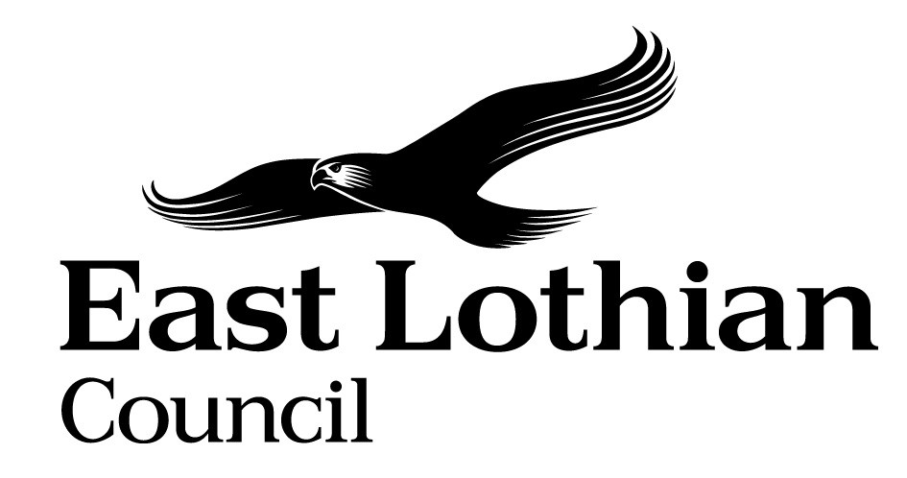


Integrated Impact Assessment Form
Promoting Equality, Human Rights and Sustainability

Title of Policy/ Proposal | CODE OF CONDUCT POLICY
Completion Date | 6 February 2020
Completed by | Gail Scott, HR Adviser
Lead officer | Paul Ritchie, HR Business Partner

Type of Initiative:
Policy/Strategy x
Programme/Plan New or Proposed
Project Changing/Updated x
Service Review or existing
Function
Other ……………………..

- Briefly describe the policy/proposal you are assessing.
Set out a clear understanding of the purpose of the policy being developed or reviewed (e.g. objectives, aims) including the context within which it will operate.
This policy outlines East Lothian Council’s expectation of all employees in relation to maintaining official and professional conduct of the highest standard such that public confidence in their integrity is sustained. The council and employees are expected to promote and adhere to all relevant professional codes of practice.
These include the ‘Seven Principles of Public Life’ identified by the Nolan Committee; Selflessness, Integrity, Objectivity, Accountability, Openness, Honesty and Leadership. Additionally, employees are expected to align with the values and behaviours outlined in the East Lothian Way.
The policy sets out the need for all employees to make annual declarations of any conflicts or potential conflicts of interest, and outlines the consequences of non-disclosure. The policy provides the overarching framework to ensure a co-ordinated approach in identifying, monitoring and managing employee conflicts of interest.

- What will change as a result of this policy?
The council’s previous Code of Conduct policy outlined the Seven Principles of Public Life (i.e. the Nolan Committee principles) and was not explicit in relation to employee responsibilities relating to conduct, declaring conflicts of interests and the consequences of non-disclosure.
The introduction of this more explicit policy ensures that there will be a framework of recording, monitoring and reporting of this information which, in turn, meets audit requirements therefor safeguarding employees and key stakeholders including service users, colleagues, and contractors.
The policy introduces a more structured approach to identifying, recording, monitoring and reporting on employee conflicts of interests, outlining consequences of wilful non-disclosure by employees and chief officials.

- Do I need to undertake an Integrated Impact Assessment?

High Relevance | Yes/no
- The policy/ proposal has consequences for or affects people | Yes
- The policy/proposal has potential to make a significant impact on equality | Yes
- The policy/ proposal has the potential to make a significant impact on the economy and the delivery of economic outcomes | No
- The policy/proposal is likely to have a significant environmental impact | No
Low Relevance
- The policy/proposal has little relevance to equality | No
- The policy/proposal has negligible impact on the economy | Yes
- The policy/proposal has no/ minimal impact on the environment | Yes
If you have identified low relevance please give a brief description of your reasoning here and send it to your Head of Service to record.
The policy applies to everyone regardless of job roles or whether an employee has a protected characteristic.

If you have answered yes to 1, 2, or 3 above, please proceed to complete the Integrated Impact Assessment.

If you have identified that your project will have a significant environmental impact (4), you will need to consider whether you need to complete a Strategic Environmental Assessment.

- What information/data/consultation have you used to inform the policy to
date?
Evidence | Comments: what does the evidence tell you?
Data on populations in need | East Lothian Council Workforce Plan 2018 – 2022 confirms the council has 4,800 employees, equating to 3,538 full-time equivalent.
Data on service uptake/access | Internal Audit Report dated January 2019
Data on quality/ outcomes
Research/literature evidence | COSLA Code of Conduct for Local Government Employees, SNCT Conditions of Service handbook, Seven Principles of Public Life (the 7 Nolan Principles for Local Government), Benchmarking against seven Local Authorities policies.
Service user experience information
Consultation and involvement findings | Consultation meetings with both Joint Trade union Secretary and Teachers Union with suggestions considered and incorporated as appropriate.  Employee consultation and minor amendments have been considered/incorporated.
Good practice guidelines | XpertHR on-line, Advisory Conciliation and Arbitration Service (ACAS), Gov.uk, Chartered Institute for Personnel and Development, COSLA
Other (please specify) | Other Scottish Local Authority policies, COSLA Code of Conduct for Local Government Employees, SNCT Handbook
Is any further information required? How will you gather this? | Recording, monitoring, review and reporting of declarations going forward to the appropriate council committee.

- How does the policy meet the different needs of groups in the community?

 | Issues identified and how the strategy addresses these
Equality Groups  - Older people, people in the middle years,  - Young people and children  - Women, men and transgender people (includes issues relating to pregnancy and maternity)  - Disabled people (includes physical disability, learning disability, sensory impairment, long-term medical conditions, mental health problems)  - Minority ethnic people (includes Gypsy/Travellers, migrant workers, non-English speakers)  - Refugees and asylum seekers  - People with different religions or beliefs (includes people with no religion or belief)  - Lesbian, gay, bisexual and heterosexual people  - People who are unmarried, married or in a civil partnership | In relation to all equality groups outlined, this policy clearly outlines the council’s expectations that all employees maintain official and professional conduct of the highest standard when engaging with members of the public, colleagues, chief officials and key stakeholders.  The policy outlines the requirement of all employees and chief officials to adhere to the behaviours as outlined in the 7 Nolan Principles and the East Lothian Way along with the actions that will be taken where employee conduct does not meet these requirements.  In addition the policy places responsibilities on all employees to declare anything that could reasonably be considered to be a conflict of interest.
Those vulnerable to falling into poverty

- Unemployed

- People on benefits
- Single Parents and vulnerable families

- Pensioners

- Looked after children

- Those leaving care settings (including children and young people and those with illness)

- Homeless people

- Carers (including young carers)

- Those involved in the community justice system

- Those living in the most deprived communities (bottom 20% SIMD areas)

- People misusing services

- People with low literacy/numeracy

- Others e.g. veterans, students
Geographical communities  - Rural/ semi rural communities  - Urban Communities  - Coastal communities | There would be no difference in the impact of the policy in any of these geographical areas.

- Are there any other factors which will affect the way this policy impacts on the community or staff groups?

No

- Is any part of this policy/ service to be carried out wholly or partly by contractors?
If yes, how have you included equality and human rights considerations into the contract?
No

- Have you considered how you will communicate information about this policy or policy change to those affected e.g. to those with hearing loss, speech impairment or English as a second language?

This Policy will be communicated on the Intranet, MyHR and by an email alert to all employees. Managers will also be encouraged by HR Advisers to assist staff who are eligible for increments where possible. Alternative formats will be made available upon request.

- Please consider how your policy will impact on each of the following?
Objectives | Comments
Equality and Human rights
Promotes / advances equality of opportunity e.g. improves access to and quality of services, status | Yes. The Policy promotes professional conduct in dealings with all service users, colleagues and stakeholders in the way services are offered. The policy also outlines requirements for all employees to declare anything that could reasonably be considered a conflict of interest.
Promotes good relations within and between people with protected characteristics and tackles harassment | This policy sets out the standards of conduct and behaviour expected of all employees, promoting good relations and ensuring fair treatment of all. The policy outlines remedies relating to wilful misconduct and non-disclosure of what could reasonably be considered a conflict of interest.
Promotes participation, inclusion, dignity and self control over decisions | Yes – the policy sets out the standards of conduct and behaviour including the 7 Nolan Principles; selflessness, integrity, objectivity, accountability, openness, honesty and Leadership.
Builds family support networks, resilience and community capacity | No
Reduces crime and fear of crime | No
Promotes healthier lifestyles including  - diet and nutrition,  - sexual health,  - substance misuse  - Exercise and physical activity.  - Life skills | Not directly
Environmental
Reduce greenhouse gas (GHG) emissions in East Lothian (including carbon management) |  | n/a  n/a  n/a  n/a  n/a  n/a  n/a  n/a
Plan for future climate change |  | n/a  n/a  n/a  n/a  n/a  n/a  n/a  n/a
Pollution: air/ water/ soil/ noise |  | n/a  n/a  n/a  n/a  n/a  n/a  n/a  n/a
Protect coastal and inland waters |  | n/a  n/a  n/a  n/a  n/a  n/a  n/a  n/a
Enhance biodiversity |  | n/a  n/a  n/a  n/a  n/a  n/a  n/a  n/a
Encourage resource efficiency (energy, water, materials and minerals) |  | n/a  n/a  n/a  n/a  n/a  n/a  n/a  n/a
Public Safety: Minimise waste generation/ infection control/ accidental injury /fire risk |  | n/a  n/a  n/a  n/a  n/a  n/a  n/a  n/a
Reduce need to travel / promote sustainable forms or transport |  | n/a  n/a  n/a  n/a  n/a  n/a  n/a  n/a
Improves the physical environment e.g. housing quality, public and green space |  | n/a  n/a  n/a  n/a  n/a  n/a  n/a  n/a
Economic
Maximises income and /or reduces income inequality | n/a  n/a  n/a  n/a  n/a  n/a
Helps young people into positive destinations
Supports local business
Helps people to access jobs (both paid and unpaid)
Improving literacy and numeracy
Improves working conditions, including equal pay
Improves local employment opportunities | n/a

- Action Plan

Identified negative impact | Mitigating circumstances | Mitigating actions | Timeline | Responsible person
No negative impact identified.

- Sign off by Head of Service

Name: Jim Lamond Signature:

Designation: Head of Council Resources

Date: 26 February 2020

