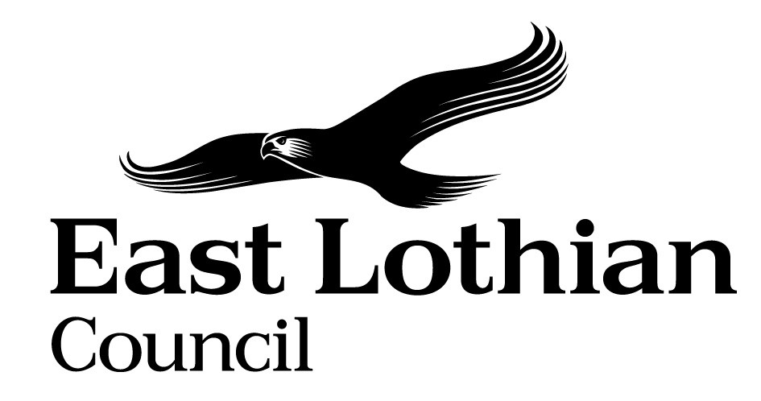

Supporting Good Decisions
Promoting Equality & Human Rights, Reducing Inequality and Protecting the Environment

Integrated Impact Assessment Form

Integrated Impact Assessment Form
Promoting Equality, Human Rights and Sustainability

Title of Policy/ Proposal | Energy Transformation Project
Timescale for Implementation | From Summer 2020 (approx.)
IIA Completion Date | April 2020
Completed by | C Rodgers
Lead officer | D Proudfoot

Section 1: Screening

1.1 Briefly describe the policy/proposal/activity you are assessing.
Set out a clear understanding of the purpose of the policy/ proposal/ activity being developed or reviewed (e.g. objectives, aims) including the context within which it will operate.

The Energy Transformation Project forms part of the Council’s Transformation Programme. The project was originally developed to consider opportunities for income generation however the focus of the project is now primarily the intention to reduce fuel poverty for residents of East Lothian, along with the exploration of renewable energy opportunities.
This is a long term project which will operate in stages. In the short term there is the potential to generate recurring annual savings from energy efficiency projects and to create an affordable energy tariff for residents of East Lothian. The expansion of the opportunity for energy generation via the Council’s housing stock is a short to medium term goal.
In the longer term there is the potential to generate renewable energy on a larger scale through a solar farm.
The project operates within the context of climate change, with East Lothian Council declaring a climate emergency in 2019, and within the commitment of the Scottish Government to tackle fuel poverty and climate change.

  - What will change as a result of this policy?
There are three overarching objectives for this project:
1 Combatting fuel poverty
2 Promoting energy efficiency
3 Achieving a reduction in energy consumption

  - Deciding if a full Impact Assessment is needed.

Please answer the following questions:

 | Yes | No
- The policy/ proposal has consequences for or affects people e.g. how they can access a service? | X
- The policy/proposal has potential to make a significant impact on equality? | X
- The policy/proposal is likely to have a significant environmental impact? | X
- The policy/ proposal has implications for the storage/ collection of personal data? |  | X

- If you have answered yes to questions 1 and 2 above, please proceed to complete the Integrated Impact Assessment. If you have answered No then an IIA does not need to be completed. Please keep a copy of the screening paperwork.

- If you have identified that your project will have a significant environmental impact, please proceed to complete the Integrated Impact Assessment. You will also need to consider whether you need to complete a Strategic Environmental Assessment. Please contact

- If you have answered yes to question 4, please seek further advice from the Data Protection Officer.

__________________________________________________________________

Section 2: Integrated Impact Assessment

  - Have those who are affected by the policy had the opportunity to comment on new proposals?
Not yet – the proposals are at an early stage and so there has not yet been any direct public consultation relating to the project. However there has been extensive consultation during the development of the Climate Change Strategy which has informed thinking. Those who will be affected will be invited to comment as part of the communications plan for the project.

  - What information/data have you used to inform the development of the policy to date?
In East Lothian almost a third (31%) of households are fuel poor compared with 34% nationally. Fuel poverty is defined as fuel costs being greater than 10% of income.
East Lothian has a figure of 7% of the population who are in extreme fuel poverty with pensioners (16%) most likely to experience his.
Fuel poverty particularly affects households headed by pensioners with a high proportion headed by a young person. Those living in social housing are more likely to experience fuel poverty. Fuel poverty is concentrated in the east of the county with lower levels in the west (due to lack of connection to the gas network, more rural dwellings and harder to heat properties). There is a strong correlation between fuel poverty in areas of concentrated deprivation where the use of prepaid meters with higher tariffs is common.
Data on the levels of fuel poverty are captured through the Scottish Household Condition Survey including data from 2015-2017
https://www2.gov.scot/Topics/Statistics/SHCS/keyanalyses/LATables1517

  - What does the evidence/ research suggest about the policy’s actual or likely impact on equality groups and those vulnerable/ or experiencing socio-economic disadvantage?
Evidence | Comment
Which groups are in in particular need of this service? | Individuals and households who are already in fuel poverty or who are vulnerable to falling in to poverty are particularly in need of the affordable tariff. This along with information and advice on how to minimise energy consumption will help reduce expenditure on energy and therefore alleviate some of the financial burden. The affordable tariff will include a specific tariff for prepayment meters which are generally more expensive to run.  At this time there is no uptake as there is no affordable tariff offered.  The service user experience in relation to switching to the affordable tariff or receiving advice on energy efficiency/minimising consumption will be jointly provided by the Energy Services Company, The People’s Energy Company, and ELC/partner organisations. ELC will ensues services and local advice agencies are aware so they can support clients who may benefit from the tariff but need support to change.  The proposals are at an early stage and so there has not yet been any direct consultation relating to the project. However there has been extensive consultation during the development of the Climate Change Strategy which has informed thinking. Those who will be affected will be invited to comment as part of the communications plan for the project.
What level of service uptake/ access is there from protected and vulnerable groups?
Can you identify positive outcomes for service users
What is the service user experience of those from protected or vulnerable groups?
What opportunity have those from protected groups had to co-produce or comment on the service/ plans?

  - How does the policy meet the different needs of groups in the community?

Equality Groups  - Older people, people in the middle years  - Children and young people children  - Women, men and transgender people (includes issues relating to pregnancy and maternity)  - Disabled people (includes physical disability, learning disability, sensory impairment, long-term medical conditions, mental health problems)  - Minority ethnic people (includes Gypsy/Travellers, migrant workers)  - Refugees and asylum seekers  - People with different religions or beliefs (includes people with no religion or belief)  - Lesbian, gay, bisexual and heterosexual people  - People who are unmarried, married or in a civil partnership | There will be an increase in the number of council assets, including council houses and council buildings, with solar PV (photo-voltaic) panels and other renewable energy-generation equipment. The assets impacted will be selected based on their suitability for energy generation. The benefits of energy generation will be pooled in such a way that all residents can benefit through the creation of an affordable tariff, not just those who live in or near a suitable property.  The creation of an affordable tariff for East Lothian residents will provide access to affordable energy for all residents including those in equality groups. Consideration will be given as to how the affordable tariff is publicised to ensure as many residents as possible are aware, for example a targeted campaign.  Consideration will also be given to the switching process to ensure the affordable tariff can be accessed by all residents, for example through the provision of support to help people switch.
Those vulnerable to falling into poverty  - Unemployed  - People on benefits  - Lone Parents  - Care experienced children and young people  - Carers (including young carers)  - Homeless people  - Those involved in the community justice system  - People with low literacy/numeracy  - Families with 3 or more children  - Those with a child/ children under 1 | The creation of an affordable tariff for East Lothian residents will provide access to affordable energy for all residents including those in fuel poverty and/or vulnerable to falling into poverty. There will be a specific affordable tariff for prepayment meters. Consideration will be given as to how the affordable tariff is publicised to ensure as many residents as possible are aware, for example a targeted campaign.  Consideration will also be given to the switching process to ensure the affordable tariff can be accessed by all residents, for example through the provision of support to help people switch.  Local advice agencies and the Council’s advice services will be made aware of the new tariffs to ensure that they can work with clients who may benefit from this. For example, the tenancy support service, CAB’s, Action Group etc. can all work with those who may need support to change, targeting equality groups, those with low literacy/ financial literacy.  It is intended that an outcome of the affordable tariff will be to alleviate some of the financial burden on households by reducing their energy costs.
Geographical communities  - Rural/ semi rural communities  - Urban Communities  - Coastal communities  - Those living in the most deprived communities (bottom 20% SIMD areas) | The affordable tariff will be available to all residents regardless of where in the county they live.
Communication Needs:  - Gaelic Language Speakers  - BSL users  - English as a Second Language  - Other e.g. DeafBlind, Plain English, Large Print | The communications plan will consider those with specific communication needs. East Lothian Council website meets accessibility standards.

  - Are there any other factors which will affect the way this policy impacts on the community or staff groups?

Yes. Fuel Poverty is linked with overall levels of poverty and income inequality. Pensioners, women and others on low income are more likely to depend on income from social security. Given extensive welfare reforms and the establishment of Social Security Scotland, levels of fuel poverty may be affected by these and other political developments.

  - Is any part of this policy/ service to be carried out wholly or partly by contractors?
During any tender process, the council will work with suppliers and contractors to deliver the workstreams within this project. The council, via use of the ESPD questionnaire, will ensure will any bidders comply and fulfil all obligations relevant under the Human Trafficking and Exploitation (Scotland) Act 2015 and the Modern Slavery Act 2015.

  - Have you considered how you will communicate information about this policy or policy change to those affected e.g. to those with hearing loss, speech impairment or English as a second language?

Communications will be handled via newsletters, meetings, workshops, letters and/or via the Council website, as appropriate for the workstream. Where required, we will make reasonable adjustments, i.e. providing written updates and or translations, etc.

  - Please consider how your policy will impact on each of the following?
Equality and Human rights
- Promotes / advances equality of opportunity e.g. improves access to and quality of services
- Promotes good relations within and between people with protected characteristics and tackles harassment
- Promotes participation, is inclusive and gives people control over decisions which affect them
- Preserves dignity and self-respect of individuals (does not lead to degrading treatment or stigma)
- Builds support networks, resilience, community capacity
Comments:
Opportunities may be enhanced by an affordable tariff alleviating some financial pressures on residents.
The affordable tariff will be available to all and accessible to all who chose to switch.
Reduces Poverty
- Maximises income and/or reduces income inequality
- Helps young people into positive destinations
- Aids those returning to and those progressing within the labour market
- Improves employability skills, including literacy and numeracy
- Reduces the costs of taking part in activities and opportunities
- Reduces the cost of living

Comments :
The availability of a cheaper tariff could potentially increase the disposable income available to families as they pay less in fuel costs.
Protecting the Environment and Improving Sustainability:
- Reduces the need to travel or increases access to sustainable forms of transport
- Minimises waste / encourages resource efficiency / contributes to the circular economy
- Ensures goods / services are from ethical, responsible and sustainable sources
- Improves energy efficiency / uses low carbon energy sources
- Protects and/or enhances natural environments / habitats / biodiversity
- Promotes the transition to a low carbon economy
- Prepares and/or adapts communities for climate change impacts

Comments:
The project aims to reduce energy usage by improving energy efficiency of council assets and advising service users on energy efficiency.
The project also intends to increase the level of renewable energy generated in East Lothian, thereby reducing carbon emissions.

Section 3.Action Plan

What, if any changes will be made to the proposal/ policy as a result of the assessment?
Changes to be made | Expected outcome of the change | Resources Required | Timeline | Responsible person

For consideration of the Head of Service

Can you identify any cumulative impacts on equality groups or vulnerable people arising from this policy, when considered alongside other changes across other services?

This is a pilot project that will hopefully develop into a longer term offer by proving concept through the pilot phase. This is part of much wider interventions that are identified in our Climate Change Strategy and Action Plan that seeks to ensure a “just” transition to the achievement of our longer term ambition and goals in respect of emissions reduction. Those in equality groups or vulnerable people should not be disproportionately adversely effected by such interventions rather ELC and its partners will seek to improve equality group outcomes.

Sign off by Head of Service

Name Douglas Proudfoot
Date 5 May 2020

