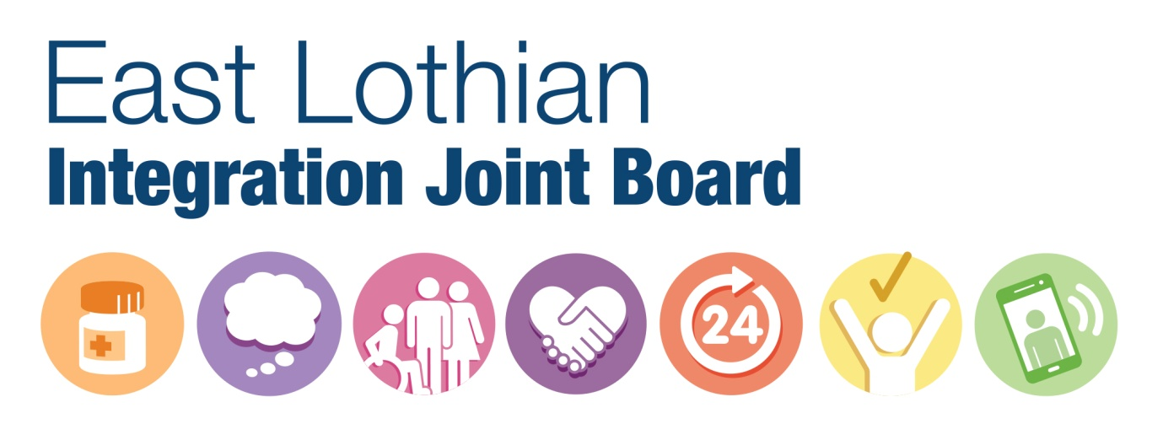
Become a representative on the East Lothian Integration Joint Board (IJB)
Play a vital role in shaping health and social care services in East Lothian
The East Lothian IJB is the body that oversees the work of the East Lothian Health and Social Care Partnership (ELHSCP). ELHSCP is reposnsible for ensuring that systems, procedures and resources are in place to improve adult health and social care services in East Lothian, shift the balance of care so that we are able to deliver more services in community settings, reduce inequalities and improve health and care outcomes for local people.
The IJB’s remit includes:
- having an overview of planning and commissioning integrated services for health and social care (including approving allocation of integrated budget)
- ensuring a successful partnership between the various stakeholders, for example, clinicians, housing, the third and independent sectors
- providing assurance to the NHS Board and East Lothian Council that the Health and Social Care Partnership is working within its delegated authority.
We need:
- a member who will represent the views of the independent health and care sector.
If you would like to be considered for membership as a representative, you will need to demonstrate that:
- you have a comprehensive understanding of the sector you wish to represent
- you can provide evidence of the networks you will be using to gauge the prevailing views in your sector
- you are able to articulate these views and represent the interests of your sector within a collective decision-making group.
For an information and application pack, please email elhscp@eastlothian.gov.uk
Applications must be received by midnight on 13th September 2020.

