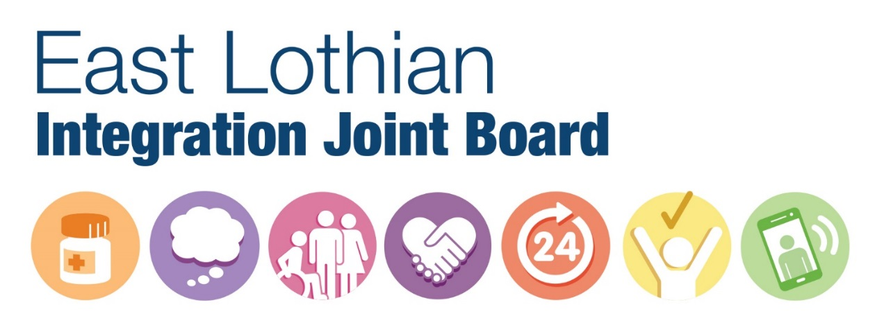
Role Description: | Member of East Lothian Health and Social Care Partnership Integration Joint Board representing the independent and health care sector
Reimbursement: | Travel and agreed out of pocket expenses
Period of appointment: | 2 years in the first instance

1. Introduction

The independent sector (defined as Care at Home and Care Homes) has become a significant provider of health and social care in Scotland. Health and social care integration and the wider reshaping care strategies in part depend on the development of care homes and care at home provision to deliver flexible services and improved outcomes in a sustainable environment.

Scottish Government has acknowledged the positive role of the independent sector in delivering better and more equal public services and there is a recognised need in East Lothian to identify how the sector can be engaged more effectively in our planning and delivery of local services. For this reason the Integration Joint Board of East Lothian Health and Social Care Partnership are seeking a board member from the independent sector. The main aim of this role is to help ensure that in all aspects of East Lothian Health and Social Care Partnership’s business, the voice and experience of the sector is heard. This role description is also developmental: fundamental to the partnership’s ultimate success are your learning and development within the role, and the partnership’s remit to develop from the learning.

2. What is the East Lothian Integration Joint Board?
In accordance with the Public Bodies (Joint Working) (Scotland) Act 2014, Health and Social Care Partnerships (HSCPs) have been established as separate legal entities and will be accountable for delivering a range of nationally agreed outcomes across adult health and social care services.
The Integration Joint Board (IJB) has responsibility for the governance of the Health and Social Care Partnership. Integration is about improving our population’s experience of the whole system of health and social care and within this broad framework local leaders in East Lothian will decide upon the planning and delivery of services mechanisms and structures that best suit our local needs and priorities.
The arrangements for the operation, remit, scope and governance of the IJB are set out in the Integration Scheme approved by Scottish Ministers, East Lothian Council and NHS Lothian.
Our mission is to transform local services so that we support everyone to have access to high-quality sustainable services that promote wellbeing and care when people are unwell. We also want to design services that can, wherever possible, be delivered when, where and how people choose. Through our vision, mission and core strategies we will place patients and public at the heart of our planning and commissioning.

Further information on the IJB can be found at https://www.eastlothian.gov.uk/info/210558/social_care_and_health/12236/integrating_health_and_social_care_in_east_lothian

3. Who sits on the Integration Joint Board?

The IJB in East Lothian has eight voting members appointed equally between elected members of East Lothian Council and non-executive Directors of NHS Lothian. In addition to voting members, there are a number of other non-voting appointees representing service users, third and independent sector organisations, clinicians and staff. In recognition of the vitally important role unpaid carers play in our health and social care systems, the IJB are seeking nominations for a carer representative who will provide an advisory and influencing role. The IJB is also advised by a range of officers and professionals including the Chief Officer, Chief Finance Officer, Chief Social Work Officer, Clinical Director and Chief Nurse

4. What is the role of an independent sector representative?

Contribute to good governance:
- Contribute to discussions and provide advice and scrutiny from their sector’s perspective.
- Contribute to ensuring that Integration Authorities implement their statutory obligations.
- Add relevant items to the meeting agenda, to be discussed and minuted. Mechanisms should be in place for this.
- Be prepared to raise relevant points and question meeting papers and accompanying
- Evidence appropriately, for example, about the extent to which the recommendation takes account of the needs of or impacts on the sector.

Represent the sector – and the IJB:
- Champion sector involvement at all levels and link in with other partners and organisations to enlarge the pool of views being collected and represented locally.
- Access their ‘constituency’ of providers through their networks and local forums (including social media where appropriate) to encourage and maintain links with the IJB.
- Nominate a Depute to represent the role in the case of absence.
- Ensure their involvement is reflective of the views of the widest range of providers by engaging as fully as possible with other provider/sector representatives.

Have roles outwith IJB meetings:
- Join one or more sub committees/working groups (such as Audit and compliance committees), where appropriate. These give a different insight into the IJB and often provide opportunities to influence and inform agendas, strategies and practice.
- Take part in appropriate training and induction.
- Play an active role in IJB & HSCP events.
- Be active in local provider forum(s).

The IJB will provide:
- A clear and transparent recruitment policy.
- A clear indication of the time (and other) commitments involved.
- Induction and continuous awareness training.
- Mentoring for the first 12 months.
- Timely and easy access to all relevant information.
- Compensation for expenses incurred in preparing for and attending meetings.
- Awareness, acknowledgement and respect for the carer’s experience.

5. What skills and qualities does this role need?

Whilst no formal qualifications are required the following qualities are necessary:

CRITERIA | ESSENTIAL |  | DESIRABLE
Knowledge | Understanding of the principles of the Health and Social Care Integration programme.  Understanding of the health and social care systems within East Lothian  Understanding of the health and care needs of the East Lothian population  Demonstrable understanding and experience of working in an independent sector organisation (Care Home or Care at Home) or interfaces in the East Lothian community  Ability to understand the resource allocations and responsibilities devolved to NHS bodies and to local authorities |  | Have an understanding of effective involvement and engagement techniques and how these can be applied in practice
Experience | Experience of working in a collective decision making group such as a board or committee  Experience of, and confidence to work with, technical and complex data, and to assess and make (sometimes difficult) decisions relating to the commissioning of health and social care, often in the absence of conclusive evidence. |  | This position will not be appointed to act as a representative of a particular organisation but may have experience within a patient or service user or corporate organisation or team, and of committee work. An understanding of issues relating to equalities is important.  Collaborative working
Skills | Excellent interpersonal and communication skills  Ability to facilitate and encourage active engagement  Ability to articulate a balanced, objective view on patient and carer issues  Ability to communicate effectively and calmly in difficult and pressured situations  Ability to advocate for transparency and openness in all business activities  Ability to advocate balance in decision-making and manage tensions between patient-centredness and other considerations |  | Confident public speaker  Good mediation skills  Influence and lead change to improve outcomes for carers  Ability to provide encouragement and the opportunity for people to engage in decision-making and to challenge constructively
Circumstances |  | Must work within an independent sector organisation in the local East Lothian community  Time to attend and prepare for Board meetings on a regular basis.  Ability to communicate via email between meetings.

6. How will recruitment take place?

A selection panel will make appointments from a shortlisted field. Shortlisted applicants for this role will be those whose skills and experience most closely reflect the criteria set out in the person specification.

7. Length of Office

It is anticipated that a sector representative will be appointed for 6 months in the first instance and that a review will occur after this period to ensure suitability both to the organisation and to the individual.

8. Reporting and supporting arrangements

Reporting to the Chair of the Shadow Board and the Jointly Accountable Officer, the role will be supported by the senior management team of the HSCP.

9. Expenses

Expenses will be reimbursed as per rates on the expenses claim form to cover the cost of travel to meetings. Agreed out of pocket expenses will be clearly defined and agreed between you and the IJB.

10. Declarations of Interest or Conflict of Interest

A signed declaration of interest form will need to be completed. Should you experience tensions between your role as an independent sector representative and other roles you undertake, we ask that you disclose these and discuss them with the chair of the Shadow Board. He or she will advise and if necessary seek guidance from the Jointly Accountable Officer.

11. Confidentiality

All documents and draft recommendations should be treated as strictly confidential.

12. Dealing with the Media

All approaches directly from the media should be referred back to the relevant Communications Lead in either the NHS Board or East Lothian Council

13. Freedom of Information

Members of the Board should consider that created documents and comments on draft documents could be disclosed to the public. Marking documents as ‘confidential’ does not automatically mean they are exempt from disclosure as defined by the Freedom of Information (Scotland) 2002.

14. Review of Role Description

It is the responsibility of the Chair of the IJB and Chief Officer to routinely review this role description to ensure that it remains consistent and fit for purpose within emerging integrated structures and supports involvement, democratic processes, transparency and public accountability. You will be invited to take part in any review.

