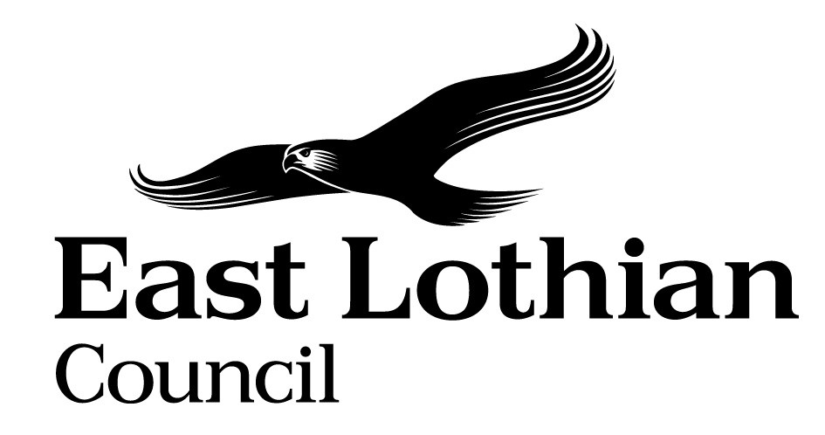

Supporting Good Decisions
Promoting Equality & Human Rights, Reducing Inequality and Protecting the Environment

Integrated Impact Assessment Form

Integrated Impact Assessment Form
Promoting Equality, Human Rights and Sustainability

Title of Policy/ Proposal | Annual Assurance Statement 2021 – Review and Implementation of new Guidance on Collecting equality Information (published SHN August 2021
Timescale for Implementation | March 2022
IIA Completion Date | 01/09/21
Completed by | Gillian Reid
Lead officer

Section 1: Screening

1.1 Briefly describe the policy/proposal/activity you are assessing.
Set out a clear understanding of the purpose of the policy/ proposal/ activity being developed or reviewed (e.g. objectives, aims) including the context within which it will operate.
In 2019, the Scottish Housing Regulator (SHR) revised its regulatory framework which places a requirement on all social landlords to submit an Annual Assurance Statement (AAS) to the SHR by the end of October each year. This statement must either confirm that the landlord is complying with all regulatory requirements and standards or alternatively highlight any areas of material non-compliance and how the landlord will address these.
Part of the requirement of the AAS is to promote the best interests of tenants and other service users by taking account of equalities, protected characteristics and human rights. The SHR were due to provide guidance for landlords on these requirements after the implementation of the initial AAS, however as a result of Covid 19, this was delayed until the production of the new guidance document in August 2021. This document is aimed at providing guidance for landlords to be compliant with these requirements.
In assessing whether we meet the guidance for the October 2021 return, we will advise the SHR that we plan to review the guidance which was produced in August 2021 and consider what changes need to be made to our processes. In our current assessment of the guidance we are confident that we meet the requirements around integrated impact assessments, GDPR legislation, equality training for staff, complaints handling processes and the consents for data handling. However, we will look at how we capture data around protected characteristics of our tenants and applicants through our housing systems and processes through various means and how we use this to inform our service provision.

  - What will change as a result of this policy?
We will work towards removing or minimising any disadvantage experienced by the particular groups identified
Implement actions to meet the need identified
  - Deciding if a full Impact Assessment is needed.

Please answer the following questions:

 | Yes | No
- The policy/ proposal has consequences for or affects people e.g. how they can access a service? | ‎ ✔
- The policy/proposal has potential to make a significant impact on equality? | ✔
- The policy/proposal is likely to have a significant environmental impact? |  | ✔
- The policy/ proposal has implications for the storage/ collection of personal data? | ✔

- If you have answered yes to questions 1 and 2 above, please proceed to complete the Integrated Impact Assessment. If you have answered No then an IIA does not need to be completed. Please keep a copy of the screening paperwork.

- If you have identified that your project will have a significant environmental impact, please proceed to complete the Integrated Impact Assessment. You will also need to consider whether you need to complete a Strategic Environmental Assessment. Please contact

- If you have answered yes to question 4, please seek further advice from the Data Protection Officer.

__________________________________________________________________
Section 2: Integrated Impact Assessment

  - Have those who are affected by the policy had the opportunity to comment on new proposals?
No

  - What information/data have you used to inform the development of the policy to date?
N/A

  - What does the evidence/ research suggest about the policy’s actual or likely impact on equality groups and those vulnerable/ or experiencing socio-economic disadvantage?
Evidence | Comment
Which groups are in in particular need of this service? | All those currently in council housing, applicants for local authority housing and those approaching our homeless service for assessment and or advice on their housing options.  It is our understanding that all protected and vulnerable groups are represented within our applicants, tenants and those approaching for housing options, In order for us to be able to capture a better understanding of numbers and individual circumstances the implementation of the guidance needs to be completed. This will also allow us to better inform our working practices and in certain circumstances better inform us of demand for certain types of properties eg. Medical applicants.  Our tenants and residents groups will be updated on the review and they will be invited to comment on any planned changes.
What level of service uptake/ access is there from protected and vulnerable groups?
Can you identify positive outcomes for service users
What is the service user experience of those from protected or vulnerable groups?
What opportunity have those from protected groups had to co-produce or comment on the service/ plans?

  - How does the policy meet the different needs of groups in the community?

Equality Groups  - Older people, people in the middle years  - Children and young people children  - Women, men and transgender people (includes issues relating to pregnancy and maternity)  - Disabled people (includes physical disability, learning disability, sensory impairment, long-term medical conditions, mental health problems)  - Minority ethnic people (includes Gypsy/Travellers, migrant workers)  - Refugees and asylum seekers  - People with different religions or beliefs (includes people with no religion or belief)  - Lesbian, gay, bisexual and heterosexual people  - People who are unmarried, married or in a civil partnership | The consideration of the guidance and implementation would allow us to better capture the data and tailor our service to all of the ‘equality groups’ who are service users of our housing service.  This more tailored service would encourage persons from the specified group to be able to participate and have their needs for housing etc. met.
Those vulnerable to falling into poverty  - Unemployed  - People on benefits  - Lone Parents  - Care experienced children and young people  - Carers (including young carers)  - Homeless people  - Those involved in the community justice system  - People with low literacy/numeracy  - Families with 3 or more children  - Those with a child/ children under 1 | Many of our service users will fall into multiple groups eg. Disability, poverty, homeless. We will look at how we can capture this data across tenants, applicants etc. and how we use this information to inform our practice.
Geographical communities  - Rural/ semi rural communities  - Urban Communities  - Coastal communities  - Those living in the most deprived communities (bottom 20% SIMD areas) | We have a varied range of incomes and circumstances in East Lothian, with deprived areas alongside areas with higher wage percentile.  Tenants and applicants may fall into multiple bands eg. may be living in poverty, socially isolated in a rural community and have other protected characteristics.
Communication Needs:  - Gaelic Language Speakers  - BSL users  - English as a Second Language  - Other e.g. DeafBlind, Plain English, Large Print | We will use this capture of data on our housing systems to ensure that applicants and tenants receive communication from us in their preferred method.

  - Are there any other factors which will affect the way this policy impacts on the community or staff groups?
None

  - Is any part of this policy/ service to be carried out wholly or partly by contractors?
If yes, how have you included equality and human rights considerations into the contract?
Yes – New housing IT system is out to tender

  - Have you considered how you will communicate information about this policy or policy change to those affected e.g. to those with hearing loss, speech impairment or English as a second language?

We will use this capture of data on our housing systems to ensure that applicants and tenants receive communication from us in their preferred method.

  - Please consider how your policy will impact on each of the following?
Equality and Human rights
- Promotes / advances equality of opportunity e.g. improves access to and quality of services
- Promotes good relations within and between people with protected characteristics and tackles harassment
- Promotes participation, is inclusive and gives people control over decisions which affect them
- Preserves dignity and self-respect of individuals (does not lead to degrading treatment or stigma)
- Builds support networks, resilience, community capacity
Comments:
Allows us to look at the demographic and specific needs of our service users and try to communicate and tailor our service to meet these needs. Work towards removing or minimising any disadvantage or barrier to accessing our services experienced by the particular groups identified.

Reduces Poverty
- Maximises income and/or reduces income inequality
- Helps young people into positive destinations
- Aids those returning to and those progressing within the labour market
- Improves employability skills, including literacy and numeracy
- Reduces the costs of taking part in activities and opportunities
- Reduces the cost of living

Comments :
N/A

Protecting the Environment and Improving Sustainability:
- Reduces the need to travel or increases access to sustainable forms of transport
- Minimises waste / encourages resource efficiency / contributes to the circular economy
- Ensures goods / services are from ethical, responsible and sustainable sources
- Improves energy efficiency / uses low carbon energy sources
- Protects and/or enhances natural environments / habitats / biodiversity
- Promotes the transition to a low carbon economy
- Prepares and/or adapts communities for climate change impacts

Comments:
N/A

Section 3.Action Plan

What, if any changes will be made to the proposal/ policy as a result of the assessment?
Changes to be made | Expected outcome of the change | Resources Required | Timeline | Responsible person
Working group set up to look at the guidance itself and how implementation will be managed. | Implementation of the guidance and satisfactory return of the AAS | Staff time to take part in working group | April 2022

For consideration of the Head of Service

Can you identify any cumulative impacts on equality groups or vulnerable people arising from this policy, when considered alongside other changes across other services?

Sign off by Head of Service

Name: Wendy McGuire
Date: 10/09/21

