DISHES AND THEIR ALLERGEN CONTENT – EAST LOTHIAN PRIMARY SCHOOLS – MAINS MEALS
DISHES | 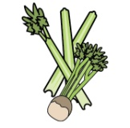 | 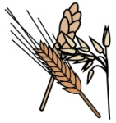 | 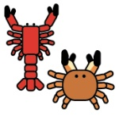 | 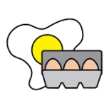 |  | 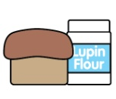 |  |  | 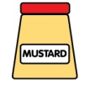 | 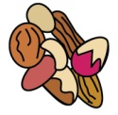 | 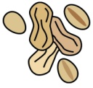 | 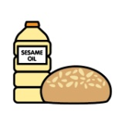 |  |  | 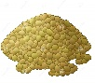
 | Celery | Cereals containing gluten | Crustaceans | Eggs | Fish | Lupin | Milk | Mollusc | Mustard | Nuts | Peanuts | Sesame seeds | Soya | Sulphur Dioxide | Lentils
VEGAN COTTAGE PIE
SINGAPORE RICE NOODLE |  |  |  |  |  |  |  |  |  |  |  |  | x
PORK SAUSAGES |  | x |  |  |  |  |  |  |  |  |  |  |  | x
GRAVY
VEGAN SAUSAGE ROLL |  | X
SALMON & SWEET POTATO FISHCAKE |  | x |  |  | x
PASTA |  | X
PITTA BREAD |  | X

DISHES
 | Celery | Cereals containing gluten | Crustaceans | Eggs | Fish | Lupin | Milk | Mollusc | Mustard | Nuts | Peanuts | Sesame seeds | Soya | Sulphur Dioxide | Lentils
Ve Dog |  | May Contain |  |  |  |  |  |  |  |  |  |  |  | may contain  <<10ppm
Hot Dog Roll |  | X |  |  |  |  |  |  |  |  |  | May contain
CHILLI CON CARNE |  |  |  |  |  |  |  |  |  |  |  |  |  |  | x
RICE
CORONATION CHICKPEA |  |  |  | x
PIZZA POWER |  | X |  |  |  |  | X
PORK MEATBALLS |  | <20ppm |  |  |  |  |  |  |  |  |  |  |  | X
VEGAN FISH FINGER WRAP |  | x
CHICKEN GOUJON |  | X
AMERICAN STYLE RICE

 | Review date: |  |  |  |  |  | Reviewed by: FMS
 | DISHES |  |  |  |  |  |  |  |  |  |  |  |  |  |  |  |  |  |  |  |  | 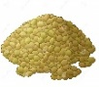
 |  | Celery |  | Cereals containing gluten | Crustaceans | Eggs |  | Fish | Lupin |  | Milk | Mollusc | Mustard | Nuts | Peanuts |  | Sesame seeds | Soya |  | Sulphur Dioxide |  | Lentils
 | POTATO & BEAN PIE
 | BBQ CHICKEN FILLET
 | MACARONI |  |  | X |  |  |  |  |  |  | X
 | POTATO WEDGES
 | 3 BEAN CHILLI
 | STEAK PIE |  |  | X  PUFF PASTRY
 | HOME-MADE TOMATO SAUCE
 | VEGETRAIN TACOS |  |  | Tacos may contain
 | THIS Isn’t Chicken |  |  | May contain |  |  |  |  |  |  |  |  |  |  |  |  |  | X
 | WRAP |  |  | x
DISHES
 |  | Celery |  | Cereals containing gluten | Crustaceans | Eggs |  | Fish | Lupin |  | Milk | Mollusc | Mustard | Nuts | Peanuts |  | Sesame seeds | Soya |  | Sulphur Dioxide |  | Lentils
SPANISH RICE
FISH FILLET |  |  |  |  |  |  |  | x
CHIPS
MASH POTATOES
BEEF BURGER |  |  |  | x
BURGER ROLL |  |  |  | x |  |  |  |  |  |  |  |  |  |  |  |  | MAY CONTAIN
SWEET POTATO CURRY
FISH FINGER WRAP |  |  |  | x |  |  |  | X
QUORN DIPPER |  |  |  | x
CHEESE |  |  |  |  |  |  |  |  |  |  | x
TUNA MAYO |  |  |  |  |  | x |  | x
HAM
GARLIC BREAD |  |  |  | x |  |  |  |  |  |  | x |  |  |  |  |  |  | May contain

DISHES
 | Celery | Cereals containing gluten | Crustaceans | Eggs | Fish | Lupin | Milk | Mollusc | Mustard | Nuts | Peanuts | Sesame seeds | Soya | Sulphur Dioxide | Lentils
DICED POTATOES
BABY POTATOES
CHIPS
ROAST POTATOES
50/50 BREAD |  | X |  |  |  |  |  |  |  |  |  | May contain | X
WHOLEMEAL BREAD |  | X |  |  |  |  |  |  |  |  |  | May contain | X
BROWN MORNING ROLL |  | X |  |  |  |  |  |  |  |  |  | May contain | X
MALTED WHEAT BAGUETTE |  | X |  |  |  |  |  |  |  |  |  | May contain
PHILADELPHIA  CHEESE |  |  |  |  |  |  | x
MULTI SEEDED BAGEL |  | X |  |  |  |  |  |  |  |  |  | May contain
PANINI |  | X |  |  |  |  |  |  |  |  |  | May contain
CHAPATI |  | X

