DISHES AND THEIR ALLERGEN CONTENT – EAST LOTHIAN HIGH SCHOOLS – MAINS MEALS

DISHES | 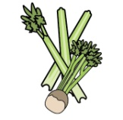 | 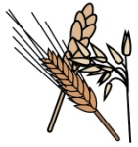 | 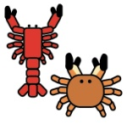 | 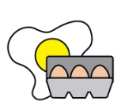 |  |  |  |  |  | 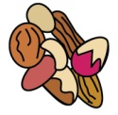 | 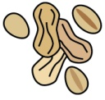 | 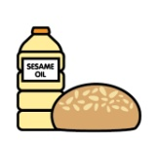
 | Celery | Cereals containing gluten | Crustaceans | Eggs | Fish | Lupin | Milk | Mollusc | Mustard | Nuts | Peanuts | Sesame seeds | Soya | Sulphur Dioxide
BREADED FISH |  | X |  |  | X
PASTA IN A TOMATO SAUCE |  | X
PORK & CARROT MEATBALLS |  |  |  |  |  |  |  |  |  |  |  |  |  | x
VEGETABLE CURRY
BEEF BOLOGNAISE |  | x |  |  |  |  | x
MACARONI CHEESE |  | X |  |  |  |  | X |  | X
CHICKEN WITH SWEET CHILLI SAUCE |  | <20PPM |  |  |  |  |  |  |  |  |  |  |  | X
VEG BIRYANI |  | X |  |  |  |  | X |  | X
PIZZA |  | X |  |  |  |  | X
SALMON FILLET |  |  |  |  | X
CHICKEN CURRY |  |  |  |  |  |  |  |  | X
VEGETARIN  TACOS |  | x |  | x

Review date: |  |  |  |  |  | Reviewed by: |  |  |  |  |  |  |  |  |  |  | You can find this template, including more information at www.food.gov.uk/all
DISHES
 | Celery |  | Cereals containing gluten | Crustaceans | Eggs |  | Fish |  | Lupin | Milk | Mollusc | Mustard | Nuts | Peanuts |  | Sesame seeds |  | Soya | Sulphur Dioxide
VEGAN DIPPERS |  |  | X
POTATO WEDGES
BEEF TERIYAKI |  |  | x |  |  |  |  |  |  |  |  |  | MAY CONTAIN |  |  |  |  | x
NOODLES |  |  | x |  | x
CHICKEN LASGANE |  |  | x |  |  |  |  |  |  | x
CREAM CHEESE &TOMATO PASTA |  |  | x |  |  |  |  |  |  | x
PIRI PIRI CHICKEN TACOS |  |  | x
CHICKEN KATSU CURRY |  |  | x |  |  |  |  |  |  |  |  |  |  |  |  |  |  | x
GAMMON STEAK
PLANT BASED CHICKEN FAJITA |  |  | x |  |  |  |  |  |  | x
GARLIC BREAD |  |  | X |  |  |  |  |  |  | X
CHAPATI |  |  | x

