Facilities Management Services
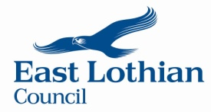

High School 2023 - 2024 Menu Week 1

WEEK 1 | MONDAY | TUESDAY | WEDNESDAY | THURSDAY
SOUP V | Cook’s Choice Selection Bread & Rolls:  Carrot & Coriander, Lentil, Vegetable, Leek & Potato, Tomato & Basil, Scotch Broth, Split Pea or Minestrone
MAIN COURSE | Breaded Fish & Chips | Pork Meatballs in Gravy with Mashed Potatoes | Beef Bolognaise with Pasta | Chicken with Sweet Chilli Sauce & Rice
VEGETARIAN  CHOICE V | Biryani with Chapatti Ve | Vegetable Curry V | Vegetarian Tacos | Cheese & Tomato Pizza V
SPECIALS *  See Specials Board | STREET FOOD/PASTA KING/CHICKEN/VEGGIE BURGERS/ROLL OVER HOT DOGS (NO RED MEAT)
Vegetables  Salad | Seasonal Vegetables/ Mixed Salad  Free with every Main Course/Vegetarian Option
BAKED POTATO  CHOICE: | Baked Potato with a Choice of Fillings: Tuna/ Cheese/ Baked Beans/Hot Fills
VARIOUS | Filled Baguettes, Rolls, Sandwiches, Flat Breads, Wraps  (Red Processed meat only on Tues/Wed/Thurs), Assorted Salads  Home Baking, Savoury Snacks, Fresh Fruit, Fresh Fruit Salad, Yogurt  Selection of Cold Drinks
Dessert Choices | Only those that meet the 10g sugar per portion
MEAL DEALS | ***Money-Saving Meal Deals ***  Option 1: Dish of the Day, soup, fruit and a drink  Option 2: Takeaway Special, soup, small salad pot, fruit and a drink  Option 3: Baguette/Baked Potato, soup, small salad pot, fruit and a drink

June 2023-May 2024 We use free range eggs & locally grown vegetables in our menus V Vegetarian Local produce when available
Week 1- Week commencing
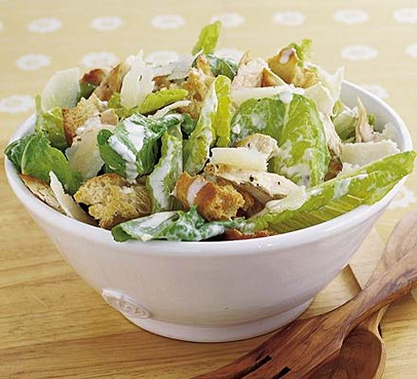
05/6/2023 | 23/10/2023 | 29/01/2024 | 13/05/2024
26/6/2023 | 13/11/2023 | 26/02/2024
28/8/2023 | 04/12/2023 | 18/03/2024
18/9/2023 | 08/01/2024 | 22/04/2024

Facilities Management Services

High School 2023 – 2024 Menu Week 2

WEEK 2 | MONDAY | TUESDAY | WEDNESDAY | THURSDAY
SOUP V | Cook’s Choice Selection Bread & Rolls:  Carrot & Coriander, Lentil, Vegetable, Leek & Potato, Tomato & Basil, Scotch Broth, Split Pea or Minestrone
MAIN COURSE | Chicken Curry  & Rice | Salmon Fillet, Potatoes & Veg | Beef Teriyaki with Noodles or Rice | Chicken & Vegetable Lasagne
VEGETARIAN CHOICE V | Cream Cheese &Cherry Tomatoes with Pasta V | Macaroni Cheese V | Tomato & Basil Pasta V | Quorn Dippers with Potato Wedges & Beans Ve
SPECIALS*  See Specials Board | STREET FOOD, PASTA KING, SUB SPECIALS, CHICKEN/VEGGIE BURGERS (No red meat)
Vegetables  Salad | Seasonal Vegetables/ Mixed Salad  Free with every Main Course/Vegetarian Option
BAKED POTATO | Baked Potato with a Choice of Fillings: Tuna/ Cheese/ Baked Beans/Hot Fills (no red meat)
VARIOUS | Filled Baguettes, Rolls, Sandwiches, Flat Breads, Wraps  (Red Processed meat only on Tues/Wed/Thurs) Assorted Salads  Home Baking, Savoury Snacks, Fresh Fruit, Fresh Fruit Salad, Yogurt  Selection of Cold Drinks
Dessert Choices | Only those that meet 10g sugar per portion
MEAL DEALS | ***Money-Saving Meal Deals ***  Option 1: Dish of the Day, soup, fruit and a drink  Option 2: Takeaway Special, soup, small salad pot or fruit and a drink  Option 3: Baguette/Baked Potato, soup, small salad pot, fruit and a drink

June 2023-May 2024 We use free range eggs & locally grown vegetables in our menus V Vegetarian Local produce when available
Week 2 Week commencing
12/6/2023 | 30/10/2023 | 05/02/2024 | 20/05/2024
14/8/2023 | 20/11/2023 | 04/03/2024
04/09/2023 | 11/12/2023 | 25/03/2024
25/09/2023 | 15/01/2024 | 29/04/2024

Facilities Management Services

High School Menu 2023 - 2024 Week 3

WEEK 3 | MONDAY | TUESDAY | WEDNESDAY | THURSDAY
SOUP V | Cook’s Choice Selection Bread & Rolls:  Carrot & Coriander, Lentil, Vegetable, Leek & Potato, Tomato & Basil, Scotch Broth, Split Pea or Minestrone
MAIN COURSE | Piri Piri Chicken Tacos with Rice | Breaded Fish & Chips | Chicken Katsu Curry with Rice | Gammon Steak with Potatoes
VEGETARIAN CHOICE V | Macaroni V | Plant Based Chicken Fajita V | Tomato Pasta with Garlic Bread V | Pizza V
SPECIALS | STREET FOOD, PASTA KING, SUB SPECIALS, CHICKEN/VEGGIE BURGERS (NO RED MEAT)
Vegetables  Salad | Seasonal Vegetables/ Mixed Salad  Free with every Main Course/Vegetarian Option
BAKED POTATO | Baked Potato with a Choice of Fillings:  Tuna/ Cheese/ Baked Beans/Hot Fills
VARIOUS | Filled Baguettes, Rolls, Sandwiches, Flat Breads, Wraps  (Red Processed meat only on Tues/Wed/Thurs) Assorted Salads  Home Baking, Savoury Snacks, Fresh Fruit, Fresh Fruit Salad, Yogurt  Selection of Cold Drinks
Dessert Choices | Only those that meet the 10g sugar per portion
MEAL DEALS | ***Money-Saving Meal Deals ***  Option 1: Dish of the Day, soup, fruit and a drink  Option 2: Takeaway Special, soup, small salad pot, fruit and a drink  Option 3: Baguette/Baked Potato, soup, small salad pot, fruit and a drink

June 2023- May 2024 We use free range eggs & locally grown vegetables in our menus V Vegetarian Local produce when available
Week 3
Week commencing
19/06/2023 | 06/11/2023 | 19/02/2024 | 27/05/2024
21/08/2023 | 27/11/2023 | 11/03/2024
11/09/2023 | 18/12/2023 | 15/04/2024
02/10/2023 | 22/01/2024 | 06/05/2024

