Community Update – October 2021
Former Herdmanflat Hospital, Haddington Maintenance Works (November 2021 to June 2022)
Between November 2021 and June 2022, a programme of work will be carried out at the former Herdmanflat Hospital Site in Haddington. The work will include increased security measures, ground maintenance and demolition of non-listed buildings which is being carried out to ensure the site is safe. The works do not represent the start of new build construction or site redevelopment.
For health and safety reasons it will be necessary to restrict public access to those areas affected while the works are in progress. Every effort will be made to maintain access to safe areas of the site and allow existing ‘green areas’ to continue to be enjoyed, wherever possible.
Background
East Lothian Council (The Council) purchased the former Herdmanflat Hospital from NHS Lothian in March 2020. It is the Council’s intention to retain the listed buildings and develop the site mainly for older people’s housing, a requirement which has been identified as a priority need across East Lothian.
A feasibility study, to determine potential options for the ultimate use of a redeveloped Herdmanflat site, has been delayed by the Covid Pandemic. The Council, however, remains committed to carrying out a full and proper engagement and consultation with the local community ahead of a future planning application being submitted for any proposals.
Security measures and Access Restrictions
Significant investment has been directed at keeping the buildings secure and grounds safe. Despite this, instances of vandalism are evident and it is now necessary to invest in further security measures to ensure the safety of the general public and integrity of the listed buildings.
A security fence will be erected around the listed buildings to assist in preventing future vandalism and potential risk of fire. It will also protect the public from demolition and other works which will be carried out. Further details are provided in the attached Plan.
Public access to the site will only be from Lydgait (and the footpath link from Glebe Terrace) until all the initial enabling works are completed which is expected in June 2022. Following completion of these works, access from Aberlady Road will be re-instated.
It is the Council’s intention to maintain public access to the southern part of the site at all times throughout the period of the works but access to other areas may be restricted, from time to time, for public safety.
Next Steps
After consideration of information obtained following detailed surveys and having sought professional advice, the Council intends to progress with an early programme of works that will maintain the future safety and integrity of the buildings on site.
The proposed works have been discussed informally with the Council’s Planning and Transportation departments and an application for demolition warrant has been approved by Building Standards. These discussions have included Historic Environment Scotland to ensure that the Council remains compliant with its legal obligations regarding the listed buildings at all times.
It is anticipated that the works, beginning in November 2021 and scheduled to complete in June 2022, will consist of:
- Removal and disposal of all asbestos from the buildings on site. Reason: To fulfil legal obligations agreed with NHS Lothian when the site was purchased, and for reasons of public safety.
- Demolition of most non-listed buildings. Reason: To reduce the risk of future vandalism, improve visibility into the site and increase the security and protection of the listed buildings. To ensure public safety.
- Ground and tree maintenance work likely to include selective removal of vegetation, scrub and felling of a small number of dead trees required for public safety. Reason: to increase visibility across the site and ensure continued public safety.
Further updates will be provided in advance of the works starting and as the work progresses.
If you have any questions about the works please contact:
East Lothian Council’s New Build Team (email address; hsd@eastlothian.gov.uk)
Common Questions and Answers
Q. This is the first time I’ve heard of these works and I’m concerned the Council is starting its development without having discussed it with us?
A. No new development will take place on the site until after a thorough consultation has taken place with local people. These proposed enabling works are in response to advice provided by professionals and will prevent the site falling into disrepair or becoming unsafe in the short to medium term.
Q. I’m concerned that you are demolishing buildings without prior consultation?
A. The Council has consulted with Historic Environment Scotland and East Lothian Council Planning Officers and it has been agreed the buildings to be demolished offered no economic or historic value. It was agreed that removal of certain buildings would enhance the setting of the remaining buildings and make it easier to manage their security until development proposals have been consulted upon and agreed.
Q. I’m concerned that you’ll be taking away trees and damaging the landscape and environment?
A. The landscape and environment is what makes Herdmanflat the special place that it is. The Council is working under advisement of leading ecologists, landscape architects and arboriculturists and the specification for all landscape works has been developed with them. These professionals will be overseeing the works as they progress to ensure there is no detrimental impact to the ecology or landscape value of the site.
A. What assurances can you give that we won’t be shut out of the site?
B. Public access to the site is recognised by the Council as being good for general health and wellbeing, and it is likely that this will form a key part of any future redevelopment plans. Whilst there may be times access is restricted during the proposed works, these will be minimised and advance warning given. When the works are fully complete, it is anticipated there will be an increase in safer, more useable space and that the works will enhance the environmental benefits the site can offer for the wider community.
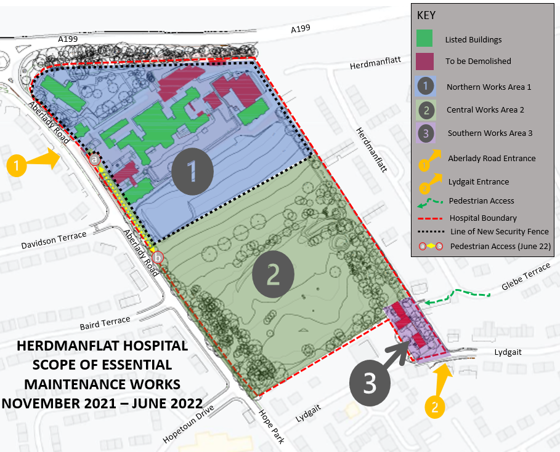
Please note - line of new security fence shown as approximate only
AREA 2 – Essential landscape and tree maintenance works as per recommendations of Independent Arboriculturist and Ecologist. Public Pedestrian Access will be maintained between November 2021 and June 2022 however access may be restricted for short periods of time whilst maintenance is carried out and to allow safe demolition within AREA 3, Hopetoun Mews.
AREA 1 – Asbestos removal works, soft strip of combustible materials, selective demolition of non-listed buildings and erection of security fencing.
Area 1 will remain fenced off until further notice. A pedestrian access strip will be provided from point ‘a’ to point ‘b’ from June 2022. Fence positions shown on plan above are approximate only.
Pedestrian access to and from the Aberlady Road entrances will be suspended between November 2021 and June 2022. The Aberlady Road gates will provide access for construction traffic, although we anticipate that there will be very few movements by large vehicles apart from at the start and end of the works period.
AREA 3 – Demolition of housing at Hopetoun Mews. Pedestrian access from Lydgait will be restricted for a short period of time to ensure public safety. When demolitions in AREA 3 have been completed, pedestrian access will be restored.
Limited vehicular access for construction traffic and construction staff will be maintained throughout. Overall traffic use anticipated to be minimal

