East Lothian Council
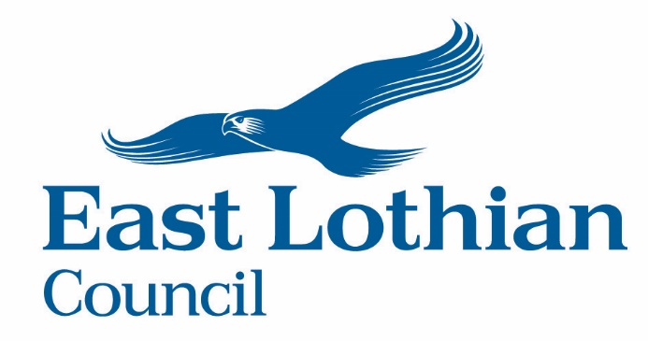
Privacy Notice

Section 1: Our contact details
Your personal information is being collected on behalf of East Lothian Council by:  City of Edinburgh Council  Insurance Services  Level 2.6 Waverley Court  4 East Market Street  Edinburgh  EH8 8BG  Email:Insurance@eastlothiancouncil.gov.uk | Data Controller:  East Lothian Council  John Muir House  Haddington  EH41 3HA | Data Protection Officer:  East Lothian Council  John Muir House  Haddington  EH41 3HA  Telephone: 01620 827827  Email:dpo@eastlothian.gov.uk
Section 2: Why we need your personal information
Should you wish to submit a claim against East Lothian Council, we will need to gather and use your personal data to progress your claim, as part of the legal process to determine whether the Council is liable for loss, damage and / or injury.
East Lothian Council is legally required to protect the public funds it administers. For this reason, your information may also be used to prevent and detect fraud, and we may share your information with other organisations responsible for auditing and administering public funds. For more information, please visit: https://www.eastlothian.gov.uk/info/210598/access_to_information/12340/privacy_and_cookies/1

Section 3: Legal Information
In order for us to collect and use your information, we have to have a ‘legal basis’ for doing so. The legal basis for processing your personal information is:
We need to process your personal information for the purposes of the legitimate interests pursued by us or a third party.
The kinds of personal information we are collecting may include but is not limited to:

- Name
- Previous name
- Address
- Date of birth
- National insurance number
- Information about the nature of the claim
- Information about other people, such as witnesses
- Medical/health information
- Other sensitive information relating to the claim
The types of information listed in points h and i above are known as ‘special category’ personal information. We need an additional ‘legal basis’ in order to process these kinds of information.
The legal basis for processing your special category information is that we need to process your information to establish, exercise or defend legal claims.

Section 4: Sharing and transfer
We will be sharing your personal information with the following:

- Our insurers and their representatives
- Our brokers
- Our claims handling contractor
- Other services within East Lothian Council
- The City of Edinburgh Council who administer our insurance service

The Council may also provide personal information to third parties, but only where it is necessary, to progress your claim against the Council and where permitted under data protection legislation.

We will only share your information with suppliers who have sufficient measures and procedures in place to protect your information and can meet their legal obligations under data protection legislation. These requirements will be set out in contracts or information sharing agreements. We will not share your information for marketing purposes.

Your information may be stored and processed on servers based out with the European Economic Area. Any transfer of personal information overseas will be in full compliance with data protection legislation.

Section 5: How long will we keep your personal information?
We keep your personal data in line with our data retention policy, called a Retention Schedule. For a downloadable copy of the Council’s Retention Schedule, please visit our website at www.eastlothian.gov.uk and search for ‘Retention Schedule’.

Section 6: Your rights
- You have the right to be informed about how your information will be used.
- You have the right to access your personal information. Normally this is done by placing a ‘Subject Access Request’ with the Council. For more information on placing Subject Access Requests, please visit https://www.eastlothian.gov.uk/info/210598/access_to_information/12300/access_to_information/1
- You have the right to ask us to correct inaccurate or incomplete information.
- In certain circumstances, you have the right to have your personal information erased.
- In certain circumstances, you have the right to ask us to limit the ways we use or share your information.
- In certain circumstances, you have the right to ask us to move, copy or transfer your information to another organisation in an electronic format.
- In certain circumstances, you have the right to object to the ways we process your information.
- In circumstances where your data is processed automatically, without human intervention, you have the right to certain protections.
You can find more information about data protection and your rights on the Information Commissioner’s Office (ICO) website at https://www.ico.org.uk.

Section 7: Complaints
We take your privacy seriously, and would like to know about your concerns so that we can address them as soon as possible. If you wish to make a complaint, we recommend that you contact the Council’s Data Protection Officer using the contact details at the start of this Privacy Notice.
If we are unable to resolve the issue to your satisfaction, you have the right to complain to the Information Commissioner’s Office (ICO). You can find further information about raising a concern with the ICO on their website: https://ico.org.uk/concerns/.
You can contact the ICO by post at:
Information Commissioner’s Office
Wycliffe House
Water Lane
Wilmslow
Cheshire SK9 5AF

Telephone: 0303 123 1113 / 01625 545 745

Section 8: Information about other people
If you have provided anyone else’s personal information, please make sure that you have told them that you have given their information to East Lothian Council. We will only use this information where it is necessary, to progress your claim against the Council and where permitted under data protection legislation.

