HOW TO REPORT ROAD RELATED DEFECTS

The preferred method for reporting road related defects within East Lothian Council is to use the reporting system on the Council’s website. The link to this is:
https://www.eastlothian.gov.uk/info/21056/roads_and_transport
You can also use this system to obtain an update on a reported defect, however, if detailed feedback is required, please ensure that you add your contact information in the relevant boxes and request feedback within the additional information box.
By using this system it ensures that all defects are recorded, giving a more accurate picture when assessing the condition of the road network for future planned works.
The following is not an exhaustive list, but, gives you an indication of the road related issues that can be reported:
- Issues with roads ( potholes)
- Issues with footpaths
- Street lighting faults
- Traffic signals faults ( traffic lights, pedestrian crossing)
- Road signs
- Drainage
- Bus shelters
- Grit bins
- Road markings
- Road verge grass cutting
Once you have clicked on the above link, this will take you to a landing page were you will have various options to report road related issues as shown below.
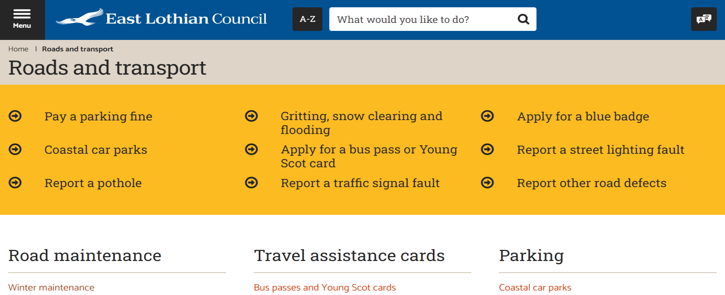

If you are unable to report using the above option and it is not an emergency, you can also make contact via the following e-mail: roadservices@eastlothian.gov.uk with your road related issue. Your e-mail will then be directed to the relevant Officer within the service.
If you have no access to a computer or smart device then the alternative option is to call East Lothian Council directly on 01875 824305 during working hours.
Should the issue cause a serious threat to life, property or safety, please telephone us directly on 01875 824305 during working hours or 01875 612818 out with working hours.

