MONDAY

MONDAY
10.00 – 12.00 PATCHWORK EH32
12.00 – 1.30 CASUAL BOOKINGS
1.45 – 3.45 LADIES BADMINTON
4.00 – 6.00 CASUAL BOOKINGS
6.30 – 8.00 P7 YOUTH CLUB

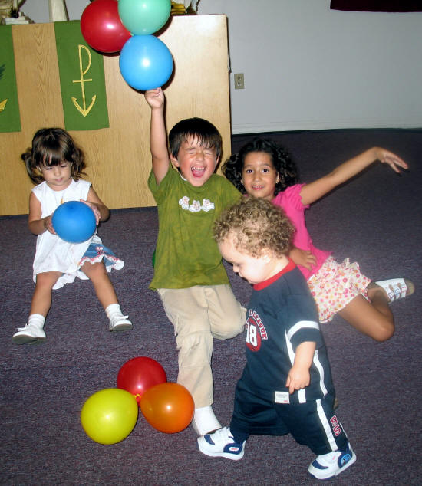

TUESDAY

10.00 – 11.30 WALKING GROUP
10.00 – 12.00 PICKLEBALL
1.30 – 3.30 TEA DANCE
4.00 – 5.00 TIGER TOTS
5.00 – 6.00 TAE KWON DO

COUNCILLOR SURGERIES SEE NOTICE BOARD FOR DETAILS

WEDNESDAY

10.00 – 12.00 PATCHWORK EH32
1.00 – 3.00 CARPET BOWLING
6.00 – 7.30 P6 YOUTH CLUB

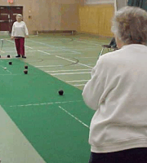

CAFETERIA OPEN 10AM – 3PM SERVING HOT AND COLD SNACKS AND DRINKS
DAILY SPECIALS AVAILABLE

THURSDAY

10.00 – 11.00 OVER 60’S EXERCISE
1.30 – 3.30 QUILTERS
1.30 – 3.30 UPWARD MOBILITY
3.45 – 5.15 YOUTH THEATRE
6.00 – 8.00 SENIOR YOUTH CLUB

FRIDAY

10.00 – 11.00 OVER 60’S EXERCISE CLASS
11.30 – 12.30 OVER 60’S EXERCISE CLASS
1 .00 – 3.00 FRIDAY PLAY SESSIONS



SATURDAY

11.00am – 2.00pm BIRTHDAY PARTIES
2.30pm – 5.30pm BIRTHDAY PARTIES

10am– Midnight PRIVATE FUNCTIONS

NB. CENTRE PROGRAMME CHANGES FROM TIME TO TIME THROUGHOUT THE YEAR.

