Let’s Do Net Zero Community Buildings Fund
Information for partners and stakeholders

Achieving net zero means we all need to take action.
The Scottish Government’s Community and Renewable Energy Scheme (CARES) is here to support communities to engage with, participate in and benefit from the energy transition to net zero.
The new Let’s Do Net Zero Community Buildings Fund from CARES will help community organisations reduce their building energy costs and greenhouse gas emissions. The fund is now open and is planned to run until the end of March 2025, subject to funding availability.
Funding is available for many types of self-managed community buildings, including:
- village halls
- community centres
- community hubs
- sports facilities
- faith buildings.
CARES has already supported many community organisations throughout Scotland to successfully install renewable technologies in their community buildings. You can read about these projects on our website, including:
- Cairnlea Parish Church installed two air source heat pumps and now has a cosy hall to restart its community activities
- Aboyne and Mid-Deeside Community Shed installed four air source heat pumps to provide space heating at its community shed
- Loch Ness Hub installed solar panels and an air source heat pump to decarbonise the building’s heat and energy supply.

Who can apply?
Applicants must be constituted non-profit distributing community organisations, including organisations with charitable status, that are established and operating across a geographically defined community, or faith groups.
Some common community organisation structures include:
- Scottish Charitable Incorporated Organisations (SCIO)
- Private Companies Limited by Guarantee (CLG)
- Community Benefit Societies (BenCom)
- Community Interest Companies (CIC).

Orgnaisations that are constituted but unincorporated may also apply but must provide additional information.

How much is available?
Grant funding is available for up to 80% of eligible costs, up to a maximum of £80,000. Please read the funding guidance on our website for full information.

What’s the application process?
Full details of how to apply, including an application form, are on the Local Energy Scotland website.
Applicants must read the full funding guidance to find out if their organisation, building, and improvements are eligible.

How can I help promote the fund?
We would be grateful if you could help us reach communities across Scotland by sharing information about the funding.

Social media
We will be sharing promotional material and updates on our Twitter, LinkedIn and Facebook pages.
We would be grateful if you could like and share these to help us spread the word about the funding available. Alternatively, you can use these suggested posts and images on your own social media channels.
Twitter
Funding from @scotgov’s Community and Renewable Energy Scheme (CARES) is available to help communities install low carbon and renewable technologies, such as heat pumps, in community buildings.
https://bit.ly/LDNZCBfunding
#LetsDoNetZero
Facebook / LinkedIn:
Do you want to cut your community building’s energy costs and carbon emissions?
The Let’s Do Net Zero Community Buildings Fund from the Scottish Government’s Community and Renewable Energy Scheme (CARES) is here to help.
Funding is available to help communities install low carbon and renewable technologies, such as heat pumps, in community buildings. Funding is available for many types of community buildings, including:
- village halls
- community centres
- community hubs
- sports facilities
- faith buildings.
Find out more at https://bit.ly/LDNZCBfunding

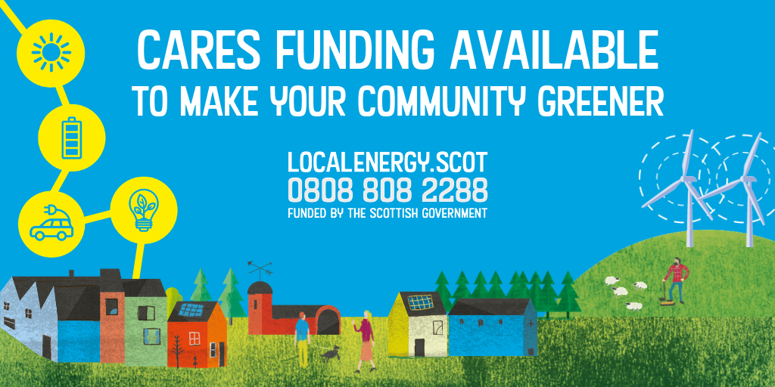
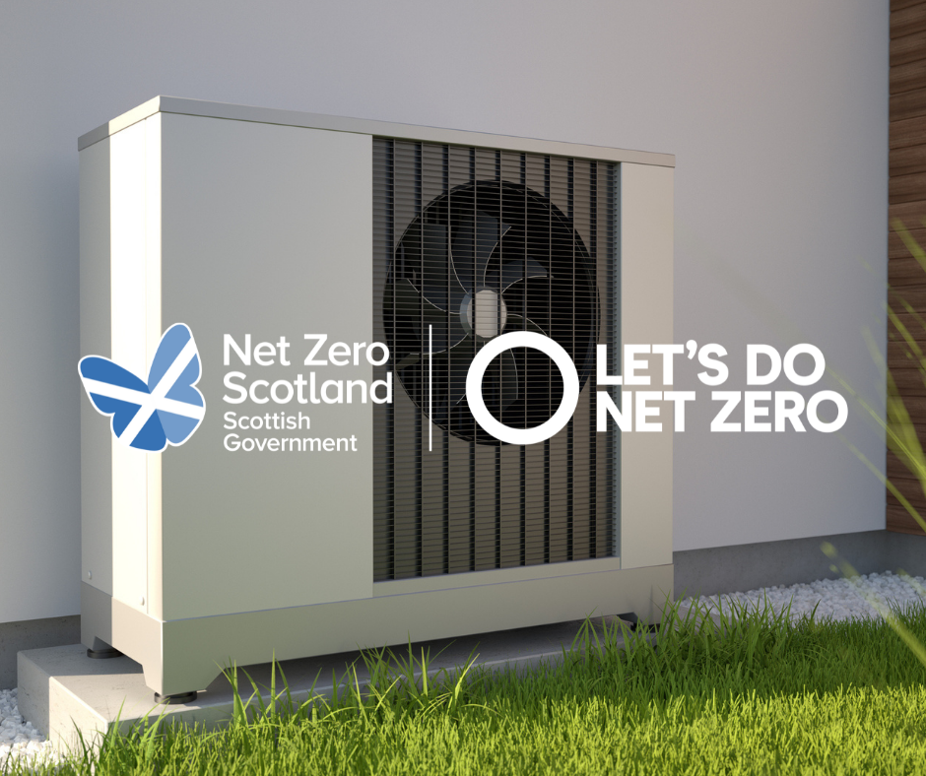

Email/Newsletters
Please use the suggested text below to forward on to relevant contacts, or for including in any relevant newsletters.

Funding available to decarbonise community buildings
New funding is now available from the Scottish Government’s Community and Renewable Energy Scheme (CARES). The fund aims to support community organisations to reduce their building energy costs and carbon emissions.
The Let’s Do Net Zero Community Buildings Fund is open now and is planned to run until the end of March 2025, subject to funding availability.
Funding is available for many types of community building, including:
- community cafes
- community hubs
- faith buildings
- public halls
- community halls and centres.
Grant funding is available for up to 80% of eligible costs up to a maximum of £80,000.
Find out more.

About Local Energy Scotland and CARES
Local Energy Scotland administers and manages the Scottish Government’s Community and Renewable Energy Scheme (CARES).
We are a consortium made up of: Energy Saving Trust, Changeworks, The Energy Agency, and Scarf, with support for delivery from Ricardo Energy & Environment and QMPF.
We help communities with:
- free advice and support to develop renewable energy schemes, or to secure and manage income from renewables
- advice on funding streams
- support to access CARES funding
- support to access the Energy Investment Fund (post-consent loans).
CARES was established by the Scottish Government to encourage local and community ownership of renewable energy across Scotland and to help maximise the benefits to communities of renewable energy systems – whether commercial or community-owned. Its goal is that communities across Scotland are engaging, participating and benefiting in the energy transition to net zero.
CARES aims to accelerate progress towards the Scottish Government’s target of 2GW of renewable energy to be locally or community owned by 2030, and to assist with delivering the Scottish Government's Energy Strategy through the provision of loan finance, grant funding and specialist advice.

