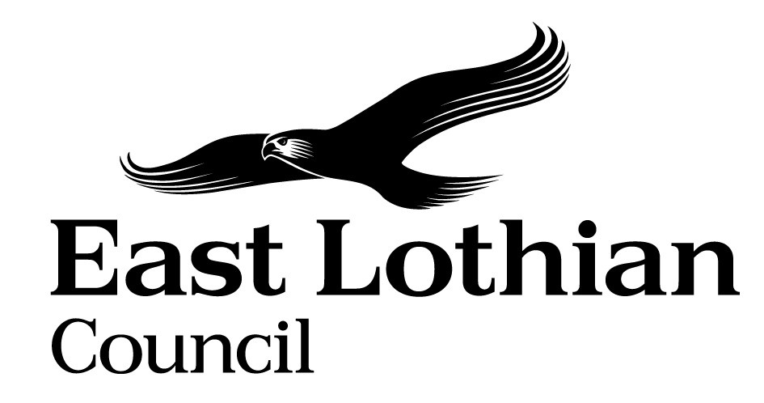

Supporting Good Decisions
Promoting Equality & Human Rights, Reducing Inequality and Protecting the Environment

Integrated Impact Assessment Form

Integrated Impact Assessment Form
Promoting Equality, Human Rights and Sustainability

Title of Policy/ Proposal | Annual Assurance Statement 2022 Submission
Timescale for Implementation | 31st October 2022
IIA Completion Date | 18/08/22
Completed by | Gillian Reid
Lead officer | Stephanie Irvine

Section 1: Screening

1.1 Briefly describe the policy/proposal/activity you are assessing.
Set out a clear understanding of the purpose of the policy/ proposal/ activity being developed or reviewed (e.g. objectives, aims) including the context within which it will operate.
In 2019 the Scottish Housing Regulator (SHR) revised its regulatory framework and now places a requirement on all social landlords to submit an Annual Assurance Statement to the SHR by the end of October each year. This statement must either confirm that the landlord is complying with all regulatory requirements and standards or highlight any areas of non-compliance and advise how these will be addressed.
The Annual Assurance Statement ensures that the council is meeting all its legal obligations associated with housing and homelessness services, equality and human rights and tenant and resident safety.

  - What will change as a result of this policy?
Landlord evidencing that they have carried out their assessment and have met all of the requirements and standards as directed by SHR.

  - Deciding if a full Impact Assessment is needed.

Please answer the following questions:

 | Yes | No
- The policy/ proposal has consequences for or affects people e.g. how they can access a service? |  | X
- The policy/proposal has potential to make a significant impact on equality? | X
- The policy/proposal is likely to have a significant environmental impact? |  | X
- The policy/ proposal has implications for the storage/ collection of personal data? |  | X

- If you have answered yes to questions 1 and 2 above, please proceed to complete the Integrated Impact Assessment. If you have answered No then an IIA does not need to be completed. Please keep a copy of the screening paperwork.

- If you have identified that your project will have a significant environmental impact, please proceed to complete the Integrated Impact Assessment. You will also need to consider whether you need to complete a Strategic Environmental Assessment. Please contact

- If you have answered yes to question 4, please seek further advice from the Data Protection Officer.

__________________________________________________________________

Section 2: Integrated Impact Assessment

  - Have those who are affected by the policy had the opportunity to comment on new proposals? N/A
What information/data have you used to inform the development of the policy to date? The council must ensure and evidence that they are meeting all of the requirements specified by the SHR. All managers must also complete a quarterly check of their individual service provision to ensure that they are regularly checking that they are complying with the SHR guidance.
All of the information is gathered which is required is examined by Internal Audit on an annual basis and is checked against the guidance. Committee (Audit & Governance) approval is then sought before the Annual Assurance Statement is signed off.

  - What does the evidence/ research suggest about the policy’s actual or likely impact on equality groups and those vulnerable/ or experiencing socio-economic disadvantage?
Evidence | Comment
Which groups are in in particular need of this service? | The Annual assurance statement ensures that the council is meeting all its legal obligations associated with housing and homelessness services, equality and human rights and tenant and resident safety.  The AAS ensures that all obligations are met which affects all tenants. Those from protected and vulnerable groups will also benefit from the assurance.  THE AAS ensures that the council reports on any safety concerns whilst delivering a housing and homelessness service. This again benefits all council tenants.  ELTRP work with the council throughout the reporting year on project groups such as HRA, Landlord Report, TP Strategy and are able to have input into any policy changes on behalf of our tenants. Council tenants’ views are sought by survey for any policy changes throughout a reporting year such as the Rent Consultation.
What level of service uptake/ access is there from protected and vulnerable groups?
Can you identify positive outcomes for service users
What is the service user experience of those from protected or vulnerable groups?
What opportunity have those from protected groups had to co-produce or comment on the service/ plans?

  - How does the policy meet the different needs of groups in the community?

Equality Groups  - Older people, people in the middle years  - Children and young people children  - Women, men and transgender people (includes issues relating to pregnancy and maternity)  - Disabled people (includes physical disability, learning disability, sensory impairment, long-term medical conditions, mental health problems)  - Minority ethnic people (includes Gypsy/Travellers, migrant workers)  - Refugees and asylum seekers  - People with different religions or beliefs (includes people with no religion or belief)  - Lesbian, gay, bisexual and heterosexual people  - People who are unmarried, married or in a civil partnership | The Annual assurance statement ensures that the council is meeting all its legal obligations associated with housing and homelessness services, equality and human rights and tenant and resident safety this benefits all of the demographic who are council tenants.  Part of the Annual Assurance statement is ensuring that equalities and human rights are promoted when carrying out the housing service. New guidance on Equalities and Protected Characteristics has been issued for landlords by SHR in August (draft) and finalised in March 2022 and a group has been set up representing the housing and homelessness service to look at how this guidance can be put into practice.  The Council has produced a new Equalities Plan for 2021-25 which sets out our commitment to eliminate unlawful discrimination, promote equality of opportunity, foster good relations between different groups in our society, and aiming to ensure that no one is denied opportunities because of who they are. These principles underpin all of the work of the Council.
Those vulnerable to falling into poverty  - Unemployed  - People on benefits  - Lone Parents  - Care experienced children and young people  - Carers (including young carers)  - Homeless people  - Those involved in the community justice system  - People with low literacy/numeracy  - Families with 3 or more children  - Those with a child/ children under 1 | As already stated the AAS will benefit all council tenants by being assured that the council is meeting all of its obligations.
Geographical communities  - Rural/ semi rural communities  - Urban Communities  - Coastal communities  - Those living in the most deprived communities (bottom 20% SIMD areas) | As already stated the AAS will benefit all council tenants by being assured that the council is meeting all of its obligations.
Communication Needs:  - Gaelic Language Speakers  - BSL users  - English as a Second Language  - Other e.g. DeafBlind, Plain English, Large Print | As already stated the AAS will benefit all council tenants by being assured that the council is meeting all of its obligations.  The new equalities guidance will allow us to gather more up to date information on any specific requirements which our tenants and applicants have and be able to tailor correspondence and our interactions with them to meet their needs.

  - Are there any other factors which will affect the way this policy impacts on the community or staff groups?

  - Is any part of this policy/ service to be carried out wholly or partly by contractors?
If yes, how have you included equality and human rights considerations into the contract?
N/A
  - Have you considered how you will communicate information about this policy or policy change to those affected e.g. to those with hearing loss, speech impairment or English as a second language?
N/A

  - Please consider how your policy will impact on each of the following?
Equality and Human rights
- Promotes / advances equality of opportunity e.g. improves access to and quality of services
- Promotes good relations within and between people with protected characteristics and tackles harassment
- Promotes participation, is inclusive and gives people control over decisions which affect them
- Preserves dignity and self-respect of individuals (does not lead to degrading treatment or stigma)
- Builds support networks, resilience, community capacity
Comments:
Using the new guidance produced by the SHR allows us to gather more information regarding the protected characteristics of our tenants and applicants with the aim of providing a better tailored service to meet their requirements.

Reduces Poverty
- Maximises income and/or reduces income inequality
- Helps young people into positive destinations
- Aids those returning to and those progressing within the labour market
- Improves employability skills, including literacy and numeracy
- Reduces the costs of taking part in activities and opportunities
- Reduces the cost of living

Comments :

Protecting the Environment and Improving Sustainability:
- Reduces the need to travel or increases access to sustainable forms of transport
- Minimises waste / encourages resource efficiency / contributes to the circular economy
- Ensures goods / services are from ethical, responsible and sustainable sources
- Improves energy efficiency / uses low carbon energy sources
- Protects and/or enhances natural environments / habitats / biodiversity
- Promotes the transition to a low carbon economy
- Prepares and/or adapts communities for climate change impacts

Comments:

Section 3.Action Plan

What, if any changes will be made to the proposal/ policy as a result of the assessment?
Changes to be made | Expected outcome of the change | Resources Required | Timeline | Responsible person
Project Group looking at gathering of protected characteristics on applications, Complaints, surveys and other interactions with tenants | Compliance with SHR guidance on equalities and gathering of protected characteristics | Project Group time, design of new application form (small cost) | By end of 2022 | Stephanie Irvine

For consideration of the Head of Service

Can you identify any cumulative impacts on equality groups or vulnerable people arising from this policy, when considered alongside other changes across other services?
Gathering protected characteristics in line with SHR Guidance allows us to gather more information from our tenants and applicants with the aim of providing a better tailored service to meet their requirements. This will include for example disability requirements, language etc. which will allow the council to tailor a targeted approach when trying to meet applicants and tenants specific needs. It will also allow us to report more accurately to the Scottish Government on the demographic of our tenants when required.


Sign off by Head of Service

Name Wendy McGuire Date 8th September 2022

