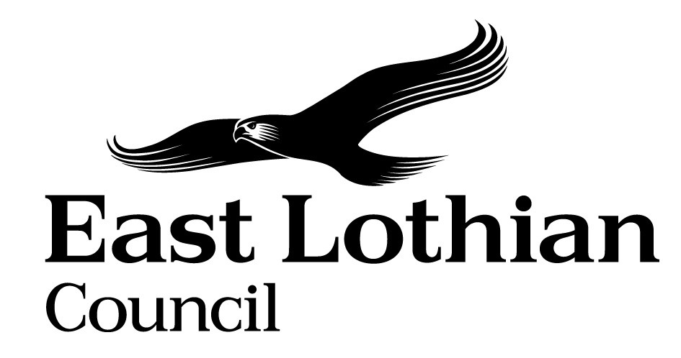

Supporting Good Decisions
Promoting Equality & Human Rights, Reducing Inequality and Protecting the Environment

Integrated Impact Assessment Form

Integrated Impact Assessment Form
Promoting Equality, Human Rights and Sustainability

Title of Policy/ Proposal | Whistleblowing Policy
Timescale for Implementation | Complete update by September 2022 however policy remains ongoing
IIA Completion Date | 16th December 2021
Completed by | Duncan Stainbank
Lead officer | Duncan Stainbank

Section 1: Screening

1.1 Briefly describe the policy/proposal/activity you are assessing.
Whistleblowing policy provides guidance and assurance to all workers and ex workers of East Lothian Council that they can raise concerns in a protected, confidential and appropriate manner in accordance with legislation.

  - What will change as a result of this policy?
Minimal changes as a result of the Policy refresh that involve the clarity that all fraud Bribery and Corruption allegations should be reported into Internal Audit and updates to the other elements of the Policy. In addition contact details have updated however the overall operation of the Policy has not been updated.

  - Deciding if a full Impact Assessment is needed.

Please answer the following questions:

 | Yes | No
- The policy/ proposal has consequences for or affects people e.g. how they can access a service? | Yes
- The policy/proposal has potential to make a significant impact on equality? |  | No
- The policy/proposal is likely to have a significant environmental impact? |  | No
- The policy/ proposal has implications for the storage/ collection of personal data? | Yes

- If you have answered yes to questions 1 and 2 above, please proceed to complete the Integrated Impact Assessment. If you have answered No then an IIA does not need to be completed. Please keep a copy of the screening paperwork.

- If you have identified that your project will have a significant environmental impact, please proceed to complete the Integrated Impact Assessment. You will also need to consider whether you need to complete a Strategic Environmental Assessment. Please contact

- If you have answered yes to question 4, please seek further advice from the Data Protection Officer.

__________________________________________________________________

Section 2: Integrated Impact Assessment

  - Have those who are affected by the policy had the opportunity to comment on new proposals? This is going to be completed through sending the Policy for senior management and Trade Union consultation.

  - What information/data have you used to inform the development of the policy to date? Review of whistleblowing advice on the GOV.uk site and legislative review although no significant changes since the last update.

  - What does the evidence/ research suggest about the policy’s actual or likely impact on equality groups and those vulnerable/ or experiencing socio-economic disadvantage?
Evidence | Comment
Which groups are in in particular need of this service? | All workers across the Council have access to this service and impossible to say who may be in need until they come forward.  The protected characteristics of whistle-blowers are not recorded to protect anonymity and therefore this information is not available. However the policy and processes are available to all workers within the Council.  Yes service users get there concerns investigated independently whilst under legislative protection.  As this is not something that we ask or hold no experience record is held.  This is handled through the Union consultation and would expect input from the Unions to consider this from a members perspective.
What level of service uptake/ access is there from protected and vulnerable groups?
Can you identify positive outcomes for service users

What is the service user experience of those from protected or vulnerable groups?
What opportunity have those from protected groups had to co-produce or comment on the service/ plans?

  - How does the policy meet the different needs of groups in the community?

Equality Groups  - Older people, people in the middle years  - Children and young people children  - Women, men and transgender people (includes issues relating to pregnancy and maternity)  - Disabled people (includes physical disability, learning disability, sensory impairment, long-term medical conditions, mental health problems)  - Minority ethnic people (includes Gypsy/Travellers, migrant workers)  - Refugees and asylum seekers  - People with different religions or beliefs (includes people with no religion or belief)  - Lesbian, gay, bisexual and heterosexual people  - People who are unmarried, married or in a civil partnership | Where they form part of the worker group within East Lothian Council they will receive the same investigation service with several communication methods and points to meet these needs. Amendments will be made to communication methods and collection of evidence to meet the needs of individuals as part of reporting and investigation processes.
Those vulnerable to falling into poverty  - Unemployed  - People on benefits  - Lone Parents  - Care experienced children and young people  - Carers (including young carers)  - Homeless people  - Those involved in the community justice system  - People with low literacy/numeracy  - Families with 3 or more children  - Those with a child/ children under 1 | Where they form part of the worker group within East Lothian Council they will receive the same investigation service with several communication methods and points to meet these needs. Amendments will be made to communication methods and collection of evidence to meet the needs of individuals as part of reporting and investigation processes.
Geographical communities  - Rural/ semi rural communities  - Urban Communities  - Coastal communities  - Those living in the most deprived communities (bottom 20% SIMD areas) | Where they form part of the worker group within East Lothian Council they will receive the same investigation service with several communication methods and points to meet these needs. Amendments will be made to communication methods and collection of evidence to meet the needs of individuals as part of reporting and investigation processes.
Communication Needs:  - Gaelic Language Speakers  - BSL users  - English as a Second Language  - Other e.g. DeafBlind, Plain English, Large Print | When required translation services are available to the council through the customer feedback team to meet these needs.

  - Are there any other factors which will affect the way this policy impacts on the community or staff groups?
No

  - Is any part of this policy/ service to be carried out wholly or partly by contractors?
If yes, how have you included equality and human rights considerations into the contract?

  - Have you considered how you will communicate information about this policy or policy change to those affected e.g. to those with hearing loss, speech impairment or English as a second language?
Communication will be completed through the line management process and communication in written format with translation available if required.

  - Please consider how your policy will impact on each of the following?
Equality and Human rights
- Promotes / advances equality of opportunity e.g. improves access to and quality of services
- Promotes good relations within and between people with protected characteristics and tackles harassment
- Promotes participation, is inclusive and gives people control over decisions which affect them
- Preserves dignity and self-respect of individuals (does not lead to degrading treatment or stigma)
- Builds support networks, resilience, community capacity
Comments: The Policy includes multiple points of contact both in local service areas and within the unions and multiple ways of registering a concern to promote participation and inclusion and support the networks available.

Reduces Poverty
- Maximises income and/or reduces income inequality
- Helps young people into positive destinations
- Aids those returning to and those progressing within the labour market
- Improves employability skills, including literacy and numeracy
- Reduces the costs of taking part in activities and opportunities
- Reduces the cost of living

Comments : There are no costs associated with raising a concern and any of the costs of investigation would be covered by East Lothian Council.

Protecting the Environment and Improving Sustainability:
- Reduces the need to travel or increases access to sustainable forms of transport
- Minimises waste / encourages resource efficiency / contributes to the circular economy
- Ensures goods / services are from ethical, responsible and sustainable sources
- Improves energy efficiency / uses low carbon energy sources
- Protects and/or enhances natural environments / habitats / biodiversity
- Promotes the transition to a low carbon economy
- Prepares and/or adapts communities for climate change impacts

Comments: No environmental impact from the Whistleblowing policy but allows a route to make concerns heard in relation to breaches of any environmental legislation and therefore continues to enhance the Governance and control framework for protecting the Environment and Improving Sustainability.

Section 3.Action Plan

What, if any changes will be made to the proposal/ policy as a result of the assessment?
Changes to be made | Expected outcome of the change | Resources Required | Timeline | Responsible person
None

For consideration of the Head of Service

Can you identify any cumulative impacts on equality groups or vulnerable people arising from this policy, when considered alongside other changes across other services?

No cumulative impacts have been identified.

Sign off by Head of Service

Name: Duncan Stainbank
Date: 16/12/2021

