Planning for an ageing population feedback report April – September 2022

Table of Contents
Executive Summary 2
Key Findings 3
Background 5
Community Hospitals and Care Homes Provision Change Board 5
Communications and Engagement Strategy 6
Emerging Themes 11
Living independently at home 11
Intermediate care 12
Bed provision 13
Care at home 13
Fear of what will happen in older age 14
Information about services, activities and support 16
Support Networks 17
Support for Carers 18
Earlier intervention 19
Community-based support 21
Accessibility of services 22
Transport 22
Housing 22
Recruitment and retention 23
Thank you 24

Executive Summary
With the understanding that East Lothian has a significantly growing older population, in the coming years there will be an increase in demand to provide additional care and support.
As well as addressing the hospital and care home bed provision throughout East Lothian, there is a need to take account of policy direction at a national and local level, which is to shift the balance of care from institutional care to care in the community and to enable people to live longer at home or in a homely setting.
Over the summer of 2022, the Communications and Engagement working group of the Community Hospitals and Care Homes Change Board have engaged in a number of activities asking for public opinion on what they are looking for in later life, from both a community and care perspective, under the campaign title of “Planning for an Ageing Population”.
This report provides a summary of the activities undertaken to engage with the stakeholder groups, and the subsequent emerging feedback themes gathered from the consultation process as outlined in the graphic below.
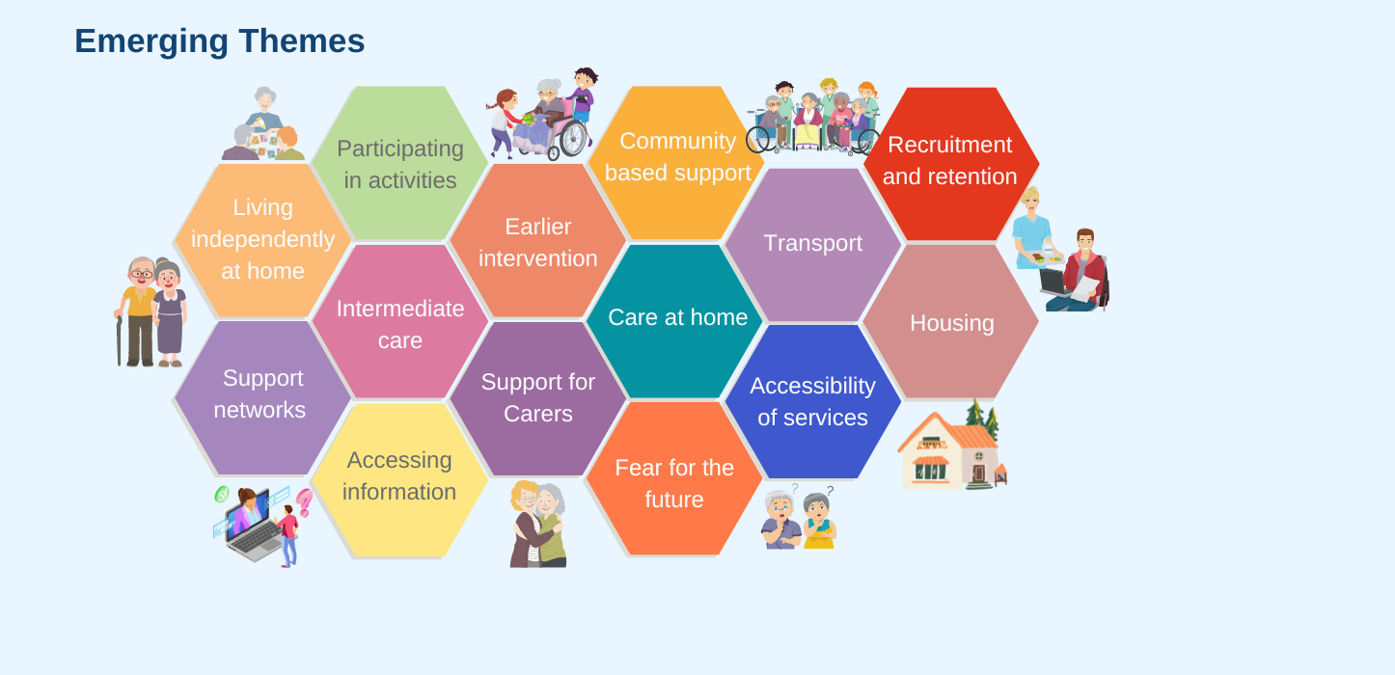

Key Findings
- Living Independently At Home
As far as possible, respondents indicated they want to be able to stay in their own home for as long as possible, with additional support when required.

- Intermediate Care
There was considerable support for the provision of Intermediate Care services across the community, and those who had received it, benefited from the service they received. The majority believed that Intermediate Care services assisted to provide independence and allowed recipients to maintain relationships with friends and family.

- Bed Provision
Other than during the introductory presentation at the engagement session about the analysis completed on the current and future provision of beds, there was a notable lack of reference to bed provision in the follow up discussions and the survey feedback. Discussion topics were much more focused on the ability and opportunity to live at home and leading as active a life as possible.

- Care at Home
While there was considerable support for and appreciation of the provision of Care at Home services, there was an overwhelming concern that the Care at Home service is only meeting the most basic of needs to ensure people were not at risk. The level of care provided can be minimal to meet the need due to time restrictions placed upon staff, and there aren’t enough carers in order to meet current demand. Some people felt the visits were rushed, and as such were not meeting their full needs, despite the visits by care staff some people still felt isolated, lonely and at times not safe.

- Fear for the future
In this area, there were three key concerns highlighted:
- Social isolation: many people highlighted isolation and loneliness as a key contributor to physical and mental decline.
- Access to care: there was a concern about the availability of health and social care services, and having to be put on a waiting list for care packages to become available when they were most in need.
- The cost of care and personal finances: the impact this could have on receiving the appropriate level of care, waiting times, and the wider impact that it could have on family members or the need to sell their property to cover care costs.

- Support Networks
The community provision of support networks is of great significance, and is a highly valued service for all that access and use them. Day centres in particular offer companionship, activities, mental and physical stimulation and have been identified as greatly enhancing the personal wellbeing of attendees. There were requests to expand this provision further, and make it more accessible in the future to include weekend and evening support as well as ensuring people could access the service earlier.

- Support for Carers
There was a clear request for more support to be available / accessible to unpaid carers. Unpaid carers are currently experiencing significant levels of stress, either waiting for additional support or assistance, lack of respite, or knowing who or where they can refer to, to gain access to support and advice.

- Earlier Intervention
The use of community based early intervention methods, such as personal interest groups, recreational activities and social gatherings were highlighted as potential activities that could enhance the physical and mental wellbeing of older people, reducing issues related to isolation and loneliness.

- Community Based Services
In order for earlier intervention methods to be successful, there is a greater need for there to be:
  - more information available on what is on offer, and how to access activities
  - consideration on the location that activities are offered in, and how accessible these are, in terms of geographical location, so they are not just offered in the towns but also reach those living in rural communities
  - thought given to the cost of attending activities to promote inclusivity
  - appropriate transport arrangements in place to allow individuals to get to and from activities
  - more support for volunteers and the key role they play in organising, managing and planning activities and service

- Transport and Housing
Community infrastructure including transportation links and appropriate housing for older people was raised as a growing concern. It was felt considerable thought will need to be given as more community, council and local support services are required to cater for an increasing ageing demographic of residents.

- Recruitment and Retention
Finally, and one of the most important elements underpinning all care services, is the absolute requirement of sufficient staffing levels to deliver, maintain, expand and cater to the growing needs of the ageing population in East Lothian. This is a key challenge for all Health and Social Care Partnerships in Scotland, including East Lothian and we recognise the impact that can have on our ability to provide adequate staffing capacity.

Background
Community Hospitals and Care Homes Provision Change Board.
The Community Hospitals and Care Homes Change Board was established in 2021 with the aims and objectives of:
- Deliver more care closer to home – actively tackle the rise in unplanned or avoidable hospital admissions and significantly reduce delayed discharges from hospitals to home or a homely setting
- Address the variation in the use and delivery of health and social care services across the county and tackling inequality
- Develop a strong focus on prevention and low level support
- Ensure best value for the public purse through more effective partnership working
East Lothian Health and Social Care Partnership (ELHSCP) recognises and endorses the need to engage with local communities when planning, redesigning, or changing the way it delivers care or the services it provides.
The timeline for engagement for the Community Hospital & Care Home Provision Change Board was outlined as follows:
Date | Proposed Work stream and Engagement Activity
Summer 2021 | Planning data collection and review period begins
October 2021 | Issue update and briefing to East Lothian Communities
Autumn 2021 | Engagement with Staff, Health and Wellbeing Associations and ongoing consultation
Winter 2021/22 | Initial data findings reported to Change Board
Spring 2022 | Community consultation process begins
Late Summer 2022 | Update report on consultation presented to Change Board
Autumn 2022 | Final report and proposed recommendations presented to Change Board
Winter 2022/23 | Final report and proposed recommendations presented to Change Board and IJB.

Communications and Engagement Strategy
A key part of the communications and engagement strategy is to provide a clear vision of how ELHSCP sees older people’s services in East Lothian being provided in the future, and how these services can be resourced and delivered alongside existing services for other age groups.
The aim of the engagement and consultations are to:
- keep the communities within East Lothian informed of progress on matters surrounding the shaping and scope of future Older People’s Social Care service; and
- to ensure that all citizens and stakeholders are provided an opportunity to express their views and opinions with regard to the development of an East Lothian wide Older People’s Strategy
The approach taken to engage with local communities and wider stakeholders should be easily understood, should allow all parties a voice, and be easily monitored - with inputs and outputs captured so success can be easily measured. The Scottish Government’s Seven National Standards have been chosen as they provide a very easily understood framework, which can help achieve these aims.
The Seven National Standards
- Inclusion: importance of identify all relevant community stakeholders and ensure that specific measures are taken to engage with them
- Support: as part of the stakeholder mapping exercise different groups should be assessed for their needs
- Planning: There is a clear purpose for the engagement, which is based on a shared understanding of community needs and ambitions.
- Working together: We will work effectively together to achieve the aims of the engagement.
- Methods: We must use methods of engagement that are fit for purpose
- Communication: We will communicate clearly and regularly with the people, organisations and communities affected by the engagement
- Impact: We will assess the impact of the engagement and use what we have learned to improve our future community engagement

Stakeholder Mapping and Communications Plan
At the outset of the Community Hospitals and Care Homes Provision Change Board, a number of groups and individuals were identified as part of a stakeholder mapping exercise.
In line with this, four key target audiences groups were identified for the Communications Plan.
Consideration was taken to identify their attributes, interest levels, appropriate communication methods, and the creation of specific media designs to deliver the key messages to each audience.
 | Audience 1 | Audience 2 | Audience 3 | Audience 4
Attributes | Aged 40-60. Little or limited experience of care services. Currently working / have own family. | Aged 60-75. Might have some experience of care. Approaching or recently retired. Still active in life. | People with experience of care (either personally or from family member)  Mixed age groups. | Stakeholder groups  Care providers / third sector / GPs  Community Councils  Employee groups
Interest | Looking to the future – retirement years, or having to care for family members – what do they want? | Looking to the next 10-15 years. What services might they require, how would they find / access them? | Satisfaction levels, experiences to date. What improvements can be made? | Invested interest, looking at direction, strategy, how actions will support the community.
Key Messages | Picture yourself in your retirement – how can care services now help you achieve this vision.  Might not need us now, but when you do, what do you want? | Looking at retirement and beyond …  What do you want to enjoy? What care services might you require? What might they look like? | Share your care experiences - we’re planning for the future.  What can we do to improve care services in the future? | Share your care experiences - we’re planning for the future.  What can we do to improve care services in the future and in doing so benefit the community as a whole?
Comms Medium | - Social Media Networks & Influencers  - Animation / Video  - Links to survey  - Public venues – Council Offices / Libraries / Gyms / Community Centres | - Social Media Networks & Influencers  - Animation / Video  - Links to survey  - Press Release / Courier Feature  - Local Radio Stations  - Public venues | - Limited Social Media  - Workshops / Events  - Focus Groups  - Direct contact – in person  - Day Centres / Care Homes  - Existing users of services  - Handing out surveys  - Newsletters | - Workshops / Events  - Focus Groups  - Direct contact – in person  - Handing out surveys  - Newsletters  - Organised meetings  - Training sessions
Media | - Social Media Video  - Social Media Tiles  - Pull Up Banners, to be rotated around ELC Public Places  - Email newsletter | - Social Media Video  - Social Media Tiles  - Pull Up Banners, to be rotated around ELC Public Places  - Email newsletter | - Events / Focus Groups  - Invitations  - E-newsletters  - Printed Surveys  - Workshop Presentation | - Events / Focus Groups  - Invitations  - E-newsletters  - Printed Surveys  - Workshop Presentation
Below are examples of the visuals used to promote the engagement campaign:

- Social Media Tiles:
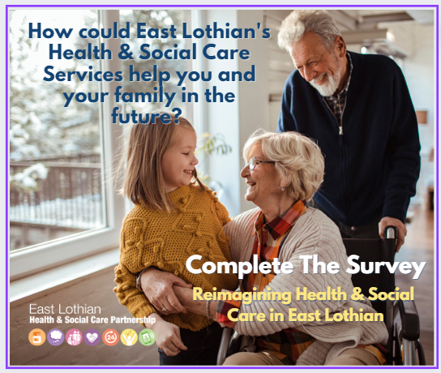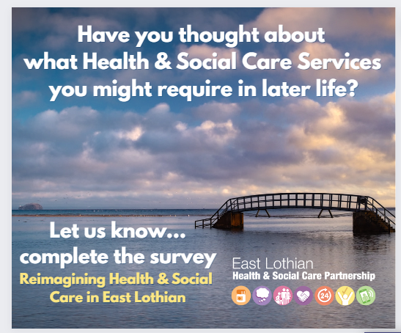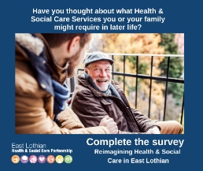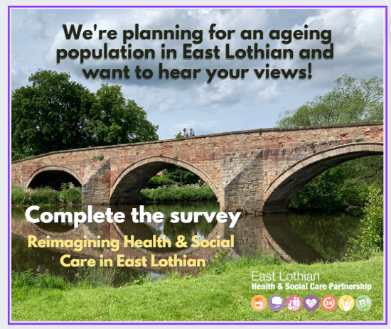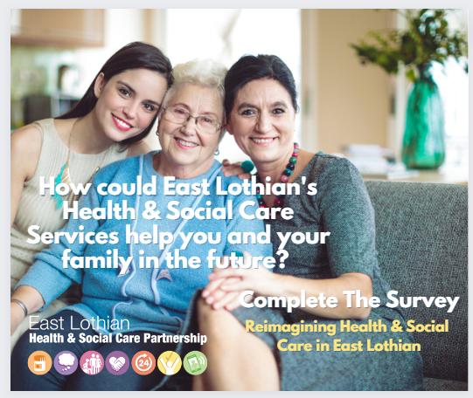
- Promotional Videos:
  - Audience 1 Aged 35-55: https://youtu.be/eZgVr1wB-v4
  - Audience 2 55-75: https://youtu.be/u_JsAGk0P5A

Communications Timeline:
 | Activity | Reach
JULY | Social Media Campaign - Promoting Survey Link | 7,432
 | Social Media Paid Advertising Campaign – Video Promotion | 3,298
AUGUST | Social Media Campaign – Promoting Survey Link | 1,241
 | Social Media Paid Advertising Campaign – Post | 4331
 | Social Media – Event Promotion | 14,337
Pull-Up Banner Locations:
- Musselburgh Primary Care Centre
- Brunton Hall, Musselburgh
- Fraser Centre, Tranent
- Loch Centre, Tranent,
- Port Seton Community Centre
- John Muir House Reception, Haddington
SEPTEMBER | Social Media Campaign – Promoting Survey Link | 1,452
Pull-Up Banner Locations:
- Dunbar Leisure Pool
- Bleachingfield Centre, Dunbar
- North Berwick Sports Centre
- Aubigny Sports Centre, Haddington
- East Lothian Community Hospital
- John Muir House Reception, Haddington
TOTAL |  | 25,402

Online Survey Questionnaire
The primary engagement tool used to engage with audience groups was the creation of a
“Re-imagining Health and Social Care in East Lothian” questionnaire, which was available to complete online and in paper format.
The communications campaign focussed on driving visits to the online portal to complete the survey.
The questionnaire included a series of 28 questions that covered:
- People’s preparation for ageing
- Interests and activities people would like to participate in as older people
- Views on intermediate care and other support for older people
- Views on palliative care
The survey returned a total of 475 results. However, after extensive analysis of the data entries, 293 were identified as having been generated by automated spam bots (computer generated responses). In order to ensure the integrity of the data and genuine responses, these were removed and analysis was carried out on the remaining 182 entries.

Survey Respondents Profile
Age: The largest group of correspondents (37%) were people aged 56-65, followed by 21% aged 46-55, 13% aged 36-45 and 12% aged 66-75. The smallest response by age group was people aged 75+ at 5%.
Gender: 83% of respondents were female and 13% male.
Location: Respondents were geographically based across the county, 19% of respondents were from North Berwick, 18% from Haddington, 17% from Dunbar, 15% from Tranent, 13% from Musselburgh, 8% from Prestonpans, 5% from Port Seton and 4% from rural areas
Retirement: 63% of people did not answer this question, 14% were already retired and 13% would be retiring in the next 5-10 years. This question was included in the questionnaire in specifically focus the minds of the respondents what they would want from their retirement – the next set of questions - and to put into perspective how far away that would be.
Public Engagement Events
In order to directly reach out to the community and gather more qualitative feedback directly, a range of public and target audience specific engagement events were organised both online and in person across the county. We were aware of the importance of having a range of engagement opportunities, specifically for face-to-face meetings. These sessions were particularly welcomed by those who attended. It also enabled a positive and product free-flow of discussion about the questions posed and issues discussed.
These sessions were structured and organised to provide a background to the engagement session, and introduction to the Hospital and Care Home provision project and our investigative findings to date.
Engagement Events Timeline
 | Date/time | Audience | Meeting method
JULY | 7th July 2022  1:30pm – 2:30pm | Day centre service-users, staff, relatives/carers | North Berwick Day Centre
 | 19th July 2022 11:30am – 12.30pm | Day centre service-users, staff, relatives/carers | Harlawhill Day Centre, Prestonpans
 | 20th July 2022  11:00am – 12:00pm | Day centre service-users, staff, relatives/carers | Dunbar Day Centre
 | 21st July 2022 11:30am – 12:30pm | Day centre service-users, staff, relatives/carers | John Bellany Day Centre,  Port Seton
 | 27th July 2022  1.30pm – 2.30pm | Day centre service-users, staff, relatives/carers | North Berwick Day Centre
AUGUST | 4th August 2022  11:00am – 1:00pm | Rural Communities | Online - Teams
 | 4th August 2022  2pm - 3pm | Day centre service-users, staff, relatives/carers | Primrose Day Centre,  Crookston Care Home, Tranent
 | 11th August 2022 11:00am – 1:00pm | Eastern Communities | Online - Teams
 | 18th August 2022 11:00am – 1:00pm | Western Communities | Online - Teams
 | 25th August 2022  11:00am – 1:00pm | Carers | Online - Teams
 | 29th August 2022 11:00am – 1:00pm | Providers/Third Sector | Online - Teams
SEPTEMBER | 6th Sept 2022  12:30pm - 2:00pm | North Berwick Community | North Berwick Community Centre
 | 12th Sept 2022  10:00am – 11:30am | Dunbar Community | Bleachingfield Community Centre
 | 12 Sep 2022  1:30pm - 3:30pm | Musselburgh Community | Brunton Hall

Engagement Session Questions
Day Centre Service-uses and staff
- How would you like to spend later life?
- What helps to keep you active and engaged with your community?
- Any other issues you would like to comment on?
Carers
- What are your experiences of caring for an older family member?
- What works well?
- What doesn’t?
- What could be better?
Online Teams Engagement Sessions
Communities/carers sessions
- What activities would you like to see in your community as you grow older?
- Your/your family’s experience with East Lothian’s existing care services
- Your ideas on how community care services (that reduce hospital admissions or help shorten
Providers
- What are your thoughts on what you have heard- in your experience of delivering care in East Lothian where do you feel investment is required?
- Workforce feels like the biggest challenge to service delivery in HSC just now – would you agree and do you have thoughts on solutions?
Secondary Research Sources
In addition to the primary research and data collected from the questionnaire and the engagement sessions, information was also gathered from the feedback and responses obtained from the IJB Strategic Plan Health, Housing and Place Engagement (April – July 2022) (1,060 participants).

Emerging Themes

Living independently at home
Almost all respondents said that they would prefer to live independently at home, with some form of support, as necessary. Care homes were seen as being a last resort when care needs were so high that staying at home was no longer an option.
One older person living independently at home said that she would like to go into a care home now because she was lonely at home and one carer said she would like to go into a care home to prevent her family having to experience being unpaid carers for her. These are two real-life examples of the support and provision needed to support people to live at home independently but with the need to provide wrap-around care and support allowing them to have a good quality of life.
Services like Community Alarm and the ECS (emergency care service) which helps with falls out of hours were very much appreciated and seen to be important to staying independent and providing the wider family with reassurance.
It was noted that some older people were taking measures to keep fit and active, had moved to housing better suited to older people and were adapting their homes in preparation for older age.
However, it was also noted that moving to suitable housing and carrying out adaptations were not an option for many older people, especially those living on a lower income.

Intermediate care
People in the engagement sessions were also very supportive of intermediate care to facilitate faster hospital discharge, prevent hospital admission and support them to live at home for as long as possible. This was also emphasised within the survey, with 76% of respondents agreeing that Intermediate Care helps to allow a person to maintain or regain independent living.
From the survey 37% of respondents had family who had used intermediate care, 9% friends and 3% had used it themselves.
- The main services used by people themselves were MSK (11%), Pain Management (7%) and Community Occupational Therapy and Physio (3%)
- The top services used by family members were Care at Home (37%), Community Occupational Therapy and Physio (29%) and the Emergency Care Service (21%)
- The top services used by friends were Care at Home (9%), Hospital to Home (5%) and Community Occupational Therapy and Physio (3%)
The key themes arising in response to how Intermediate Care Services could be improved, included:
- the need for better communication between patients, carers and staff; staff in different teams and hospitals (for example, RIE and East Lothian services), and more public information about services and pathways
- addressing long waiting times for assessment, services and hospital discharge
- resolving issues with staff shortages
- awareness of pressures on funding for services
- addressing issues with the timing and length of home visits
- identifying the difference in quality between care delivered by ELHSCP and private providers – experience of ELHSCP services was much more positive than private providers
- issues around the pressures on carers
- particular issues for people living with or caring for people with dementia
- impact of social isolation
- issues with access to services for people in rural areas
- the value of being cared for at home.
- issues around access to GPs and GPs’ knowledge of services
- three replies relating to the Edington
- three others advocating the use of convalescent homes

Bed provision
Those at the engagement sessions had been given a presentation that demonstrated that the Partnership’s research revealed that the question wasn’t around the need for more beds but more about intermediate care and the need for earlier intervention and preventative services. Almost everyone in the engagement sessions was in agreement with this assessment.
In general, other than during the presentation, the topic of bed provision, access to beds, or the need for more / less beds was barely referenced during the engagement sessions.
Further responses from the questionnaires also indicated that people were not concerned about the number of care home beds in the community. Again, this can be surmised by the lack of references within the free text comments about bed provision.
There was however, much more emphasis and concern raised about having the ability and opportunity to allow individuals to stay in their own home for as long as possible, living active and healthy lives in the community.
Furthermore, requests to have care support, were generally at the point that it was becoming absolutely necessary to support the individual at home. Discussion in the groups highlighted that there was a need to intervene earlier in a person’s journey rather than at points of crisis or pressure. This came up, for example, in discussions on accessing day centre provision and the benefits to the person receiving the service and their carer.

Care at home
Feedback from day-centre care-at-home service-users
Many of the day centre users received care at home. They valued it highly as a means of remaining independent and as a source of social interaction.
However, they raised the following issues:
- long waiting lists for accessing care packages
- a chronic lack of carers
- they would like more help from paid carers to manage at home (for example, with household tasks)
- paid carers not being given enough time to do the job
- 15 minute visits not being long enough; some wished that they could go back to the time of home helps
- the need for more flexibility with care visits
- even with four visits a day, people weren’t getting the social interaction they need
- the minimum wage stops people from living in certain areas of East Lothian, as does the lack of affordable housing
Feedback from day-centre staff
Day centre staff, many of whom had previously worked in the care sector, reported a number of issues with care at home, including:
- care providers are short-staffed
- office staff in care companies didn’t really care as long as shifts are covered, irrespective of the travel time involved for carers
- there were pressures on visits where care giving and record-keeping has to be done within the 15 minute visit
- 15 minute visits were originally intended for medication prompt visits only, not for personal care - it is difficult to shower and dress someone in 15 minutes and carers were rushed
- care at home shifts are long
- often no allowances are made for travel time between clients
- Travel time and pay was felt not to be sufficient, especially with the increase in fuel costs and this is further exacerbated when people are working part-time hours as opposed to full time.
- good carers are not rewarded and there should be a shift away from negative stories about carers and a new focus on good news stories about them.
- paid carers are still not paid enough (carers are in charge of administering medication but are paid less that shelf-stackers at supermarkets)
- feeling that they were failing their clients (they could do ‘ping dinners’ with the Wiltshire Farm Foods meals in the allotted 15 minutes, but they couldn’t stay long enough to see that the food was eaten)
Whilst receiving care at home is highly valued and in general very high quality service, keeping people at home longer and more independent, some concerns were raised about the quality and consistency of the care provided, and it is not possible for the service to meet all the needs of the individual. The level of care provided to individuals is limited and there aren’t enough carers in order to meet current demand.

Fear of what will happen in older age
Social isolation
In most sessions, people saw social isolation as a key contributor to physical and mental decline.
Social isolation was raised as an issue by many older people themselves and also by representatives in the community sessions. This was particularly the case where a partner had died or had developed dementia.
Individuals and family members of those receiving care at home also shared this concern. While attending to their basic personal and health needs, it was not always meeting their overall wellbeing needs, and did not alleviate issues around isolation or loneliness often experienced by people living on their own.
There are many challenges we are highlighting in this report but it feels social isolation is a high-level and important issue.
Cost of care
The cost of care was highlighted as a concern within the questionnaire responses, 48% of people were very concerned and 34% were fairly concerned. When asked to explain the nature of their fears:
- 32% said that not having a plan about meeting the cost was their main concern
- 27% gave their second main concern as being worried about being a burden to their family
- 28% gave their third main concern social care being more expensive when they retired
Under other reasons, people listed concerns with looking after a relative with mobility problems or additional needs when they were older and frailer, issues with care at home, the impact of poor public transport when no longer able to drive and the impact of costs on personal wealth impacting on legacies to family.
Some of the specific concerns expressed about the cost of care were:
- You don't know how long you will need it for, or even if you will, so it's hard to plan for.
- I worry that I'd have to sell my home if I needed care
- The cost of care is very expensive and will only go up!
- Concerns are due to having worked hard all my life and having nothing to leave to children/grandchildren and family
The cost of care is clearly a concern for many people, both now and into the future. However, the cost of care is not simply a financial concern (important though it is) it is about an anxiety that is difficult to measure and understand. If or when this may impact upon an individual who requires care and their family, or a carer whom may be impacted by any financial assessment or decisions.
When looking at the provision of care in the future, careful consideration needs to made about how this funded, and the costs that are passed on to end users, especially in tackling inequalities in areas of deprivation.
Access to Care
From the engagement sessions, the following further concerns were directly highlighted:
- Fewer staff affects the ability to stay in one’s own home and/or available care home places
- There were also calls for more numerous and better funded care home places.
- Many participants raised the issue of care home places, whether there would be sufficient number for the growing population and whether sufficient staff could be recruited for both care homes and care at home
- Concerns were raised over the growing use of agency workers in care homes and for at home care. This leads to a breakdown in continuity of care plus, people do not always know who is coming into their own home
- Some people found it hard to think about the future because it scared them so much and were very worried about the cost of private care

This concern was also echoed in the online survey for the IJB Strategic Plan. People were very aware of shortage of care at home packages and problems with recruitment and retention.

Information about services, activities and support
Hospital diagnosis/discharge
There was concern that people were being diagnosed with a life-limiting illness or disease and being discharged from hospital without any information being offered to them or their carers. Also what this would mean for them, what would happen next, and where to get information, advice and support about the situation they were now in.
Single point of contact and pathways
People were very supportive of having a Single Point of Contact or a key worker who would be the go-to person for the patient and their carers in this situation. They would be able to outline the pathway for treatment and support, provide information, updates about care and links to support and information, and be the person to phone when the patient or carer had queries.
Information about events and activities
People felt that there were activities and events going on in communities but many people did not know about them.
Centralised source of information
It was generally felt that a centralised information system that was regularly updated about community events and activities across East Lothian would be really useful. However, it was not clear who would provide this, how it would be maintained or where it would be hosted. It was felt that it may need dedicated support.
Training for all health and social care staff in information giving
It was felt that all HSCP staff should routinely provide information to patients, service-users and carers about advice and support, but that this would require centralised information that they could draw upon and some training in advice-giving.
Libraries
In one session, a representative from East Lothian Council’s Library Service spoke about how increasingly frequently they were being asked for advice and information about services and support and how this role was something they would like to develop.
Communications
Participants also discussed the need for communications strategy and the need to have honest conversations with the public about the pressures on health and social care and the need for all of us to think about our life in older age much earlier. This was seen as something that would contribute to early intervention by encouraging people to engage with activities that would promote health and wellbeing and be more prepared for ageing. This would be supported by regular messaging about services, support and access to them.

Information about services: In Summary
Emphasis needs to be placed on gathering and providing appropriate information for target audiences about the different options, services, delivery, implications and costs of community activities and care services.
More should be done to help signpost patients and family members to where they can find additional advice and support. This could also include engaging wider public networks and service providers to support signposting and gain access to information available.

Support Networks
Meeting Centres
Many people were impressed by the Meeting Centre model being pioneered in Musselburgh as a way of tackling social isolation for people living with dementia and their carers and would like to see this approach extended more widely to other communities.
Day Centres
Day centres were seen as being very important across all sessions. They had been a key source of support to older and more vulnerable people during the pandemic, which had necessarily forced day centres to develop new models of support for people at home.
This outreach element had been continued and had grown into a new delivery model post-Covid. Outreach was used in various ways by day centres, ranging from assessing people for day centre attendance, encouraging people to join a day centre, and delivering support at home to alleviate isolation. The promotion of the new delivery model for outreach and day services has been welcomed and there is interest to explore the further potential and development of this model.
People receiving day centre support
People receiving day centre support were very appreciative of that support. They emphasised companionship, good food, activities, outings and support and advice. For carers, the day centre provided a predictable source of a few hours of respite each week, which allowed them personal time, to do housework and household admin, go shopping or do some exercise.
Waiting lists for Day Centres
In some areas, waiting lists were not particularly pressured; in fact, some had to battle stigma and families not being willing to have their relative attend. In other areas, there were waiting lists, most areas were looking to expand what day centres could offer and when.
Referrals for Day Centres
Someday centre staff felt that social workers and GPs were referring people to them without having carried out an assessment as to whether this was a suitable service for the person they were referring. In some cases, it was felt that this was a box-ticking exercise without follow-up to see if the person was taking up the service. In other cases, it was felt that GPs were referring people who might have dementia without having provided a formal diagnosis.
Evening and weekend opening of Day Centres
Some of the day centres and people in some of the engagement sessions felt that day centres should be open in the evening and at weekends to provide more opportunities for socialisation for older people and additional support/respite for carers.
Intergenerational work
Most day centres had taken part in intergenerational work pre-Covid but this had largely fallen away and had not restarted. Activities included visits by nursery children, which some service-users enjoyed but others did not, and social commitment/work experience placements by students in the senior phase at local secondary schools. Some saw these placements as an opportunity for encouraging young people to take up careers in social care
Support networks: In Summary
Support networks, and the opportunity for older people to engage with other people and their local communities has an incredibly positive impact on their mental and physical wellbeing. Maintaining, and where possible enhancing, this provision within the community would be a very welcomed and proactive measure in planning for an ageing population.

Support for Carers
Pressures on unpaid carers
Many unpaid carers were experiencing high levels of stress for a variety of reasons including
- having to wait for a long time to get care-at-home support;
- failing to identify themselves as a carer, and not knowing to ask for support,
- not knowing where to ask for support,
- loneliness (particularly for carers of a partner with dementia),
- lack of respite and lack of support from their wider family
Issues for neighbours acting as unpaid carers in rural areas
There are a number of people, who are older neighbours in some of the communities, providing support. Many of the neighbours themselves were ageing and somebody who was 86 with dementia and deteriorating, was being looked after by someone who was 84 and already had their own problems. People were willing to help but they needed support and breaks from caring as well.

Earlier intervention
Using community based activities and support to prolong health and wellbeing
In all sessions people wanted early intervention and prevention, but felt that problems with funding, knowledge about services, access and transport, coupled with concerns about the rising cost of living and affordability of social activities, presented serious problems.
Within the survey, when asked, to what extent do you agree that participation in social and physical activities is beneficial to an individual’s health and wellbeing especially in older age? The overwhelming majority strongly agreed (86%) or agreed 11%.
From a prompted list of activities;
- 80% wanted to have social gatherings with families and friends
- 77% wanted to explore the local area and visit places of interest
- 77% wanted to go for coffee or visit restaurants, shops and pubs
- 76% wanted to pursue personal interest groups
- 70% were interested in personal fitness activities
- 64% were interested in community recreation activities
- 51% were interested in learning new skills or other educational activities.
- The least popular options were watching sport (36%) and taking part in recreational sports (21%)
However, as highlighted earlier in the report there is a need for greater publicity and awareness of the services and activities that are available, and providing information about how people can access them.

Participating in Activities
Key to a better old age
Activities were seen as being key to remaining active, engaged and healthy in older life in the physical and online engagement sessions and in the online questionnaire. The kind of activity was dependent on levels of mobility and mental health. For respondents with mobility problems or living with dementia, day centres were very important. The reasons given for enjoying day centres included company, good food and eating in company, activities, outings and being able to get advice and support from staff. Staff also noted the positive impact that attending a day centre had on mobility, and most held regular chair-based exercise sessions.
Friends and family
People with greater mobility and strong friendship groups or family relationships enjoyed meeting friends for lunch and using their bus pass to go into town to shop or meet friends and family.
Physical activity
A few people were still keen walkers, some still went swimming or utilised local gym facilities.
Cost of activities
In a number of sessions, the cost of non-day-centre leisure activities like swimming and exercise classes was mentioned as a potential barrier, and there were worries that this impact would increase as the cost of living crisis took hold.
This was also a worry for day centres, who had either already had to raise their daily fee or were considering doing so. Several were struggling with the costs of fuelling and maintaining their day centre buses.
Variation in support networks across the county
The amount of daily social interaction varied. In some areas of the county, people had families who lived close by and wanted to be involved in supporting older relatives. Families would drop round to see them regularly and help with shopping and cleaning; many were unpaid carers. In these very settled communities, some people had relationships that dated from being at school together; many knew their neighbours and neighbours looked out for them.
In other areas, specifically those which had experienced population increases of people in the older years, indicated they had limited or no family nearby and hadn’t had the opportunity to build relationships with neighbours. This separation from the community became more pronounced when a partner died. Organisations like Community Connections in North Berwick sought to alleviate this through initiatives like the Scone Café.
In looking to develop future services and provision it is important to note the variable needs for different areas and communities across East Lothian. We will not be looking to develop only one model.

Community-based support
Design
Many people felt that communities should play an active role in developing this sort of provision to use local knowledge and skills to ensure solutions that meet local needs and wishes. It was felt that there were existing resources in some communities that could provide this sort of support but in some areas there might be the need to develop new ones.
Resources
There was concern about short-term funding – this could lead to services springing up and disappearing in a relatively short time, just as people were beginning to get to know about them/rely on them. Longer-term funding was seen to be of key importance. One person suggested that corporate funding grants might be a source of funding for this sort of work.
Self-Directed Support
It was also suggested that Self-Directed Support should be more widely promoted and used more creatively to help people access community-based support from personal budgets. However, it is noted the challenge is people may have a personal budget but there is a lack of a service or activity to purchase.
Venues
People in rural communities felt that there were opportunities to use village halls and churches to host activities like dementia cafes and other activities. However there were worries about the layout of building not being conducive to activity (for example, churches with pews) and also that the upkeep, general heating and lighting of village halls was proving too expensive for the council and community groups to support some areas.
Community Hubs
Community Hubs were welcomed as a way forward by quite a few participants as a focus for community activities, one-stop-advice shops, benefits surgeries and intergenerational work. Cafes were mentioned as a key component of community hubs, giving people somewhere to go to socialise, eat and keep warm. It was felt that these should be community-led ventures rather than something imposed on the community. Each community is different, had different needs and required supports tailored to its needs.
Volunteers
Volunteers should play a key role in community-based support but it was acknowledged that there was a degree of volunteer fatigue post Covid-19 and this may be problematic.
Resilience in rural communities
It was felt that rural communities had to be more resilient. They were able to access fewer services, had issues with public transport and quite a few rural workers worked seasonally or did several jobs. It was suggested that this might be fertile ground for recruiting people who didn’t want to have a full-time career in care but would be interested in picking up a limited number of care shifts for people in their area as part of their working week.

Accessibility of services
The issues that prevented people from accessing services included:
- Lack of information about services
- Little knowledge of (and possibly appetite for) self-referral services
- Over reliance on GPs as the gateway to services – GPs themselves not being fully aware of what is available
- Staff involved in care not being aware of or not signposting to support services
- No longer being able to drive and being reliant on family/neighbours or public transport
- Location of services, for example, in Edinburgh or Haddington – poor public transport links
- In rural, urban peripheral areas and new housing estates, poor or no public transport
- Inability to afford private transport (for example, taxis)
- Limited availability of and strict criteria for patient transport services
- Strict criteria for RVS volunteer car services
- Lack of assistance to use public transport and taxis (for example, a supporter to help someone into and out of transport)
- Online services were less accessible to people on low incomes because of inability to afford sufficient data or broadband, or smart phones, tablets or personal computers – this may be exacerbated by the cost of living crisis
- Online services could be less accessible in some areas because of poor broadband/4G coverage
- Some people did not like to use/could not use digital technology

Transport
Transport was also raised in almost every session. Lack of transport impacted on people’s ability to access services and could lead to functional decline because people couldn’t easily access activities and groups. This impact was being compounded by the cost of living crisis and its impact on taxi fares and fuel for day centre buses. People may also need support to use transport (e.g., getting on and getting off, and accessing the venue they are travelling to).

Housing
Issues with housing for later life
Housing was regarded as being very important to health and wellbeing in later life. There were concerns around:
- The lack of bungalows
- The impact of new developments, with their emphasis on larger homes
- Older people being isolated in new developments due to lack of public transport and local centres for those in the new estates to meet up
- Lack of affordable housing for key workers (for example, care at home)
- Older people being unwilling to move away from larger properties because they had lived in their home in a specific community for a long period of time and were not keen to ‘start over’ somewhere new
- The need for more extra care housing
- The impact on communities of people moving somewhere new to retire and leaving support networks of friends and families behind, leading to isolation in their new home, particularly, for couples when one partner dies
Care and Repair
Care and repair was commended by service-users as a service that enabled them to stay in their own homes for longer, both through adaptations and minor running repairs. It also had a role in supporting people’s independence after hospital discharge. However, Care and Repair’s staff compliment had reduced at a time when demand for its services were growing.

Recruitment and retention
Recruitment and retention was identified a serious concern in all forums. There were a number of major issues in recruiting and retaining staff, many of which have been cited in the section on Care at Home above. Additionally, people raised these issues:
- recruitment and retention is harder now than it has ever been
- the need to resolve the issues around low pay – if not resolved, it will lead to fewer staff and much greater levels of delayed discharge from hospital

People said that without appropriate staffing levels in place, the situation becomes even more challenging.
It was suggested that this should be included within East Lothian’s strategies and look at how we grow our own staff across the county, making best use of nearby Educational Institutions in and around East Lothian, to encourage opportunities and pathways into care services.

Thank you
East Lothian Health and Social Care Partnership are incredibly grateful to everyone who took the time to complete the survey, attend engagement sessions and share their experiences, views and thoughts on health and social care as we plan for an ageing population in East Lothian.
We would especially like to thank the individuals and representatives from the Day Centres, community groups, local organisations, Carers of East Lothian, East Lothian Councillors and Community Council representatives who attended the in person sessions.
We have read and reviewed all the responses to the survey as well as the opinions shared in the open discussions. The information provided will help us to develop and direct resources to services that can best support people who need Health and Social Care Services.
Going forward, we will continue to update our key stakeholders on the progress and further actions of the Community Hospital and Care Homes Change Board.

https://www.eastlothian.gov.uk/downloads/file/23533/east_lothian_profile_summary
https://www.eastlothian.gov.uk/downloads/file/31754/east_lothian_community_hospitals_and_care_homes_project_communications_and_engagement_strategy
https://www.scdc.org.uk/what/national-standards

