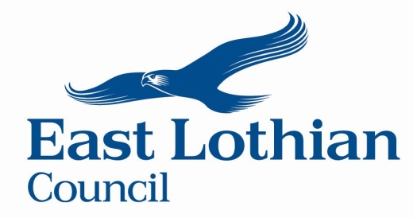

East Lothian Council
One Council Partnership Fund
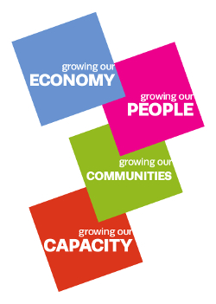
End of Project Report 2023/24

When you have completed this end of project form, please return it to the email address below. If you have any questions before you submit the form you can also email us at the same email address.

partnershipfunding@eastlothian.gov.uk

FOR OFFICIAL USE ONLY
Name of Organisation |  | Date received

Part 1 – About Your Organisation
Organisation Details:

Name of organisation:
Main contact name:
Telephone number:
Email:
Project name:

Part 2 – About Your Project
Project Details:

Expected start date | Actual start date
Expected finish date | Actual finish date
Reasons for difference in date:

Referring to the Council Plan and East Lothian Partnership’s Local Outcomes, which of the following outcomes did your project meet? Please select at least one outcome that your project contributed towards. Please use an ‘X’ to mark your choice
Growing our Economy:
Reduce unemployment | ☐
Improve the employability of East Lothian’s workforce | ☐
Growing our People:
Reduce the attainment gap and raise the achievement of our children and young people | ☐
Improve the life chances of the most vulnerable people in our society | ☐
Growing our Communities:
Extend community engagement and decision making | ☐
Increase community and individual resilience | ☐
Growing our Capacity:
Deliver transformational change | ☐
Harness the opportunity technology offers in the provision of services | ☐

Local Outcomes Improvement Plan (LOIP) (Please select at least one outcome that your project contributed towards)
Theme 1 Prosperous:
Outcome 1.1 East Lothian people are working, are free from in-work poverty and are able to develop and improve their work skills. | ☐
Outcome 1.2 Local businesses are thriving and the business base is expanding. | ☐
Outcome 1.3 People and businesses in East Lothian have better access to digital infrastructure and the digital skills they need. | ☐
Theme 2 - Community Minded:
Outcome 2.1 East Lothian has strong resilient communities where people respect and support each other. | ☐
Outcome 2.2 East Lothian people can live affordably and contribute to a thriving community life in a high-quality environment. | ☐
Theme 3 – Fair:
Outcome 3.1 We tackle the causes and effects of poverty in East Lothian and we reduce the gap between the richest and the poorest people. | ☐
Outcome 3.2 People in East Lothian are enjoying healthier lives. | ☐

Approximately how many people benefitted from your project?

Who were the main beneficiaries?
People on low income | ☐
Unemployed people | ☐
People with poor health | ☐
Children | ☐
Young people | ☐
Disabled people | ☐
Ethnic minorities | ☐
Older people | ☐
Women | ☐
Men | ☐
LGBT people | ☐
Part 3 – Finance

Give a brief summary of your project and details of how your organisation spent the money:-

How did you evaluate your project and what difference did your project make?

Explain how your project has changed or benefitted people, a community or a place include everything from your original budget as submitted with your application

Please tell us how you showed a commitment to equal opportunities as part of your project.

Approved grant: | £
Actual spend: | £

Breakdown of costs of your organisation’s project
List all the individual items or activities that made your project and were approved in your application. Include everything you needed for the project, e.g. equipment, staff costs, building work, promotional material, etc.

Item or activity | Cost in application (£) | Actual spent on item (£)
TOTAL:

Breakdown of project income

Source (e.g. name of funder, sponsorship, ticket sales, etc.) | Estimated (£) | Actual (£)
East Lothian Council Grant
TOTAL:

Please explain if there are any major differences in spend or income
If there is a big difference in spend and/or income or sources please provide a brief explanation for that difference.

Copies of invoices and receipts attached | Yes ☐ | No ☐

Any Other Comments:

Part 4 – Declaration
I declare that the information contained in this End of Project form is correct to the best of my knowledge, that I have read the Guidance Notes and that I understand and accept the terms and conditions noted within them.

Would the person named as main contact for this End of Project Report please sign below:  in blue ink  Signature: |  | Print: | Date:
To be completed by the Chairperson or equivalent of your group or organisation (if different from above)  in blue ink  Signature: |  | Print: | Date:
Attachments checklist. |  |  | Please Indicate (x)
1 | Signed End of Project Report (this form) |  | ☐
2 | Evaluation report evidencing impact |  | ☐
3 | Publicity Material |  | ☐
4 | Photographs |  | ☐
5 | Video /TV footage (provide a link if available) |  | ☐
6 | Other e.g. copies of invoices/receipts (please specify) |  | ☐

