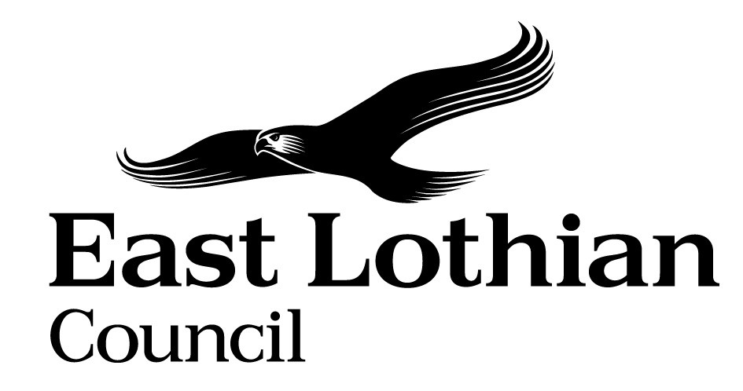

Supporting Good Decisions
Promoting Equality & Human Rights, Reducing Inequality and Protecting the Environment

Integrated Impact Assessment Form

Integrated Impact Assessment Form
Promoting Equality, Human Rights and Sustainability

Title of Policy/ Proposal | Trust Funds Review: Stewardship and Administration Changes
Timescale for Implementation | During 2023/24 possibly into 2024/25
IIA Completion Date | 02 June 2023
Completed by | Gareth Davies
Lead officer | Gareth Davies

Section 1: Screening

1.1 Briefly describe the policy/proposal/activity you are assessing.
Set out a clear understanding of the purpose of the policy/ proposal/ activity being developed or reviewed (e.g. objectives, aims) including the context within which it will operate.

Proposal to amend stewardship and administration arrangements for Trust Funds currently within the responsibility of East Lothian Council. Objective is to ensure that Trust Funds appropriately achieve their objectives.

  - What will change as a result of this policy?
The stewardship and administration of Trust Funds under ELC responsibility. Options are:
- Changes to East Lothian Council stewardship and administration arrangements for the Trust Funds
Or
- Transfer of stewardship and administration arrangements to a third party, potentially with Councillor involvement maintained in the grant award process

  - Deciding if a full Impact Assessment is needed.

Please answer the following questions:

 | Yes | No
- The policy/ proposal has consequences for or affects people e.g. how they can access a service? | Yes
- The policy/proposal has potential to make a significant impact on equality? | Yes
- The policy/proposal is likely to have a significant environmental impact? |  | No
- The policy/ proposal has implications for the storage/ collection of personal data? | Yes

- If you have answered yes to questions 1 and 2 above, please proceed to complete the Integrated Impact Assessment. If you have answered No then an IIA does not need to be completed. Please keep a copy of the screening paperwork.

- If you have identified that your project will have a significant environmental impact, please proceed to complete the Integrated Impact Assessment. You will also need to consider whether you need to complete a Strategic Environmental Assessment. Please contact

- If you have answered yes to question 4, please seek further advice from the Data Protection Officer.

__________________________________________________________________

Section 2: Integrated Impact Assessment

  - Have those who are affected by the policy had the opportunity to comment on new proposals?

No – consultation with wider stakeholders is expected to follow after initial feedback from Council on the options identified.

  - What information/data have you used to inform the development of the policy to date?

Review of Trust Funds purposes and existing stewardship and administration procedures.

  - What does the evidence/ research suggest about the policy’s actual or likely impact on equality groups and those vulnerable/ or experiencing socio-economic disadvantage?
Evidence | Comment
Which groups are in in particular need of this service? | Most likely to affect the following:  - Those in poverty or need and/or elderly  At present there is low level uptake of funding/grant opportunities and this should be improved.  The proposals are intended to improve ability for those in need or otherwise qualifying to obtain grant / funding support from existing Trust Funds.  No consultation engagement undertaken as yet. This will be subject to Councillor feedback.
What level of service uptake/ access is there from protected and vulnerable groups?
Can you identify positive outcomes for service users
What is the service user experience of those from protected or vulnerable groups?
What opportunity have those from protected groups had to co-produce or comment on the service/ plans?

  - How does the policy meet the different needs of groups in the community?

Equality Groups  - Older people, people in the middle years  - Children and young people children  - Women, men and transgender people (includes issues relating to pregnancy and maternity)  - Disabled people (includes physical disability, learning disability, sensory impairment, long-term medical conditions, mental health problems)  - Minority ethnic people (includes Gypsy/Travellers, migrant workers)  - Refugees and asylum seekers  - People with different religions or beliefs (includes people with no religion or belief)  - Lesbian, gay, bisexual and heterosexual people  - People who are unmarried, married or in a civil partnership | Older people – improves access to grant funding where relevant.  No specific transgender implications identified.  Improves access to grant funding where poverty / need arises.  Fund deeds tend to be focused on locale specific beneficiaries, with area of residence a consideration.  Most trust funds do not specify any religious criteria, so no exclusion anticipated.  No specific LGBH implications identified.  Most trust funds do not specify any married status criteria, so no exclusion anticipated.
Those vulnerable to falling into poverty  - Unemployed  - People on benefits  - Lone Parents  - Care experienced children and young people  - Carers (including young carers)  - Homeless people  - Those involved in the community justice system  - People with low literacy/numeracy  - Families with 3 or more children  - Those with a child/ children under 1 | All of these groups may potentially benefit from improving the effectiveness and availability of Trust Fund grant funding.
Geographical communities  - Rural/ semi rural communities  - Urban Communities  - Coastal communities  - Those living in the most deprived communities (bottom 20% SIMD areas) | The Trust Funds are generally specified for a geographical area. Changes may allow for amalgamation of some Trust Funds into a wider, more available, pool of funds for each local area (eg Musselburgh). The trust funds would be available to all qualifying people / purposes within the geographic area concerned. Most trust funds are specifically relevant for those in poverty or need.
Communication Needs:  - Gaelic Language Speakers  - BSL users  - English as a Second Language  - Other e.g. DeafBlind, Plain English, Large Print | Improving access to the Trust Funds includes better publicity and outreach of fund availability to qualifying beneficiaries. This may include those with English as a second language, or those with particular needs (eg blind, deaf etc).

  - Are there any other factors which will affect the way this policy impacts on the community or staff groups?

No other aspects identified.

  - Is any part of this policy/ service to be carried out wholly or partly by contractors?
If yes, how have you included equality and human rights considerations into the contract?

No – potential transfer of stewardship would not be a purchasing relationship. The third party would become responsible for the funds.

  - Have you considered how you will communicate information about this policy or policy change to those affected e.g. to those with hearing loss, speech impairment or English as a second language?

Communication and outreach options for publicising availability of grants are to be determined.

  - Please consider how your policy will impact on each of the following?
Equality and Human rights
- Promotes / advances equality of opportunity e.g. improves access to and quality of services
- Promotes good relations within and between people with protected characteristics and tackles harassment
- Promotes participation, is inclusive and gives people control over decisions which affect them
- Preserves dignity and self-respect of individuals (does not lead to degrading treatment or stigma)
- Builds support networks, resilience, community capacity
Comments:
- Improves access to available funding for qualifying beneficiaries / purposes
- Some targeting to those with greatest need eg in poverty
Care will be required to avoid application for grants being seen as stigmatising
Reduces Poverty
- Maximises income and/or reduces income inequality
- Helps young people into positive destinations
- Aids those returning to and those progressing within the labour market
- Improves employability skills, including literacy and numeracy
- Reduces the costs of taking part in activities and opportunities
- Reduces the cost of living

Comments :

- Improves access to available funding for qualifying beneficiaries / purposes
- Some targeting to those with greatest need eg in poverty

Protecting the Environment and Improving Sustainability:
- Reduces the need to travel or increases access to sustainable forms of transport
- Minimises waste / encourages resource efficiency / contributes to the circular economy
- Ensures goods / services are from ethical, responsible and sustainable sources
- Improves energy efficiency / uses low carbon energy sources
- Protects and/or enhances natural environments / habitats / biodiversity
- Promotes the transition to a low carbon economy
- Prepares and/or adapts communities for climate change impacts

Comments:

- No specific environmental or sustainability issues identified

Section 3.Action Plan

What, if any changes will be made to the proposal/ policy as a result of the assessment?
Changes to be made | Expected outcome of the change | Resources Required | Timeline | Responsible person
Stewardship and Administration of Trust Funds | Improvement in effectiveness of funds to achieve purposes; more grants awards/ projects funded; | ELC: Staff time, procedure development; grant application and evaluation process.  Legal services advice.  Possible transfer to third party: ELC staff time; legal services review; | 2023/24 into 2024/25

For consideration of the Head of Service

Can you identify any cumulative impacts on equality groups or vulnerable people arising from this policy, when considered alongside other changes across other services?

Improved access to grant funding for qualifying beneficiaries.

Sign off by Head of Service

Name Ellie Dunnet
Date 6 June 2023

