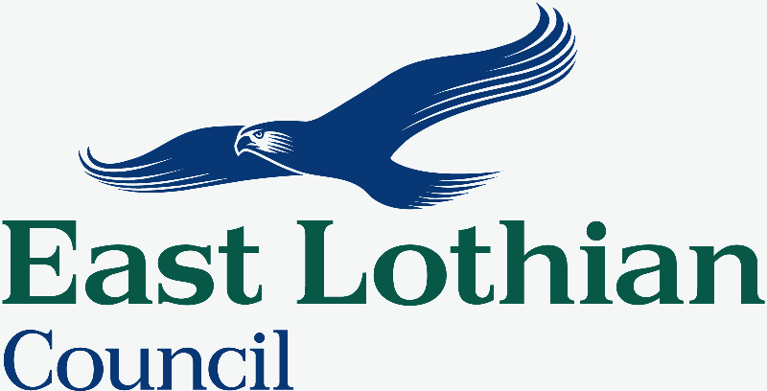

Members’ Library Service Request Form

Date of Document | 25/08/23
Originator | Ellie Dunnet
Originator’s Ref (if any) | n/a
Document Title | Impact Assessment - Scottish Welfare Fund

Please indicate if access to the document is to be “unrestricted” or “restricted”, with regard to the terms of the Local Government (Access to Information) Act 1985.

Unrestricted |  | Restricted

If the document is “restricted”, please state on what grounds (click on grey area for drop-down menu):

Additional information:

Authorised By | Ellie Dunnet
Designation | Head of Finance
Date | 29/08/23

For Office Use Only:
Library Reference
Date Received
Bulletin

