We want to hear your
ideas and solutions.
Planning Older People’s Services Engagement Pack

About this pack
This pack includes:
- Presentation Video
A link to a video that you share can with your groups at the beginning of the session. The video gives you more information about the project, the challenges we face and some of the issues that we want to solve with you.
Access the presentation via YouTube:
Planning Older Peoples Services Community Presentation with Voiceover - YouTube

- Facilitators’ Notes
A guide on how to deliver the engagement session

- A Community Briefing Document
Please share this document with attendees before they attend the workshop session so they have an information about the background and wider context to this engagement session.

- A Recording Sheet
Please use this to write up the key themes, ideas and solutions from your group.

Facilitators’ notes

General introduction to the workshop
- Appoint a note-taker to record people’s ideas on the recording sheet provided.
- Ask everyone to say who they are and why they are here today.
- If you are working with a group who don’t know each other very well, you may want to do an ice-breaker – you can find more about ice-breakers here.
- Ask people to be sure that they are willing for the feedback they give to be shared with ELHSCP for the purposes of the Planning Older People’s Services Project
- Tell people how long the session will take, if there will be comfort/refreshment breaks and the timings for the session.
Watch video with group - Planning Older Peoples Services Community Presentation with Voiceover - YouTube

Trauma-informed
If you are working with people who are vulnerable and who may want to share information that distresses them, please think about how you can support them at the sessions and what support you may want to put them in touch with afterwards. If you need help with this, email jogden-smith@eastlothian.gov.uk

Workshop questions

How many questions do you have to cover?
That is entirely up to you. You may want to focus on one question that is of particular interest to your group, several questions or all of them. You may like to do one session or a series of sessions looking at particular questions.

Suggested introduction to the session

What you need to know: the background context
It would probably be good to give people a quick recap on what was discussed in the slides and Community Briefing Document by going through the points below, before you start on the questions.
When planning how East Lothian older people’s services will be delivered, there are a range of factors that need to be taken into consideration, for example:
- Population growth
East Lothian has one of the fastest growing local authority populations, especially people aged 65 and over.
- Deprivation
Deprivation measures the level of poverty in geographical areas. East Lothian has 6 wards, which is split into 132 data zones. Eight zones in East Lothian are in the 20% most deprived areas of Scotland. In more deprived areas, life expectancy is lower, and individuals are more likely to experience more challenging health, social and economic conditions.

- Staffing
The health and social care sector is experiencing a staffing crisis. Some key positions within the care sector are low paid, challenging roles, which directly compete with hospitality, retail, education and cleaning sectors. Additionally, the majority of care staff are over the age of 45 years. For every 100 people working in this sector in 2023, 49% will no longer be working by 2043.

- Finances
East Lothian’s Integration Joint Board receives funds from both NHS Lothian and East Lothian Council to deliver health and social care services. The Scottish Government has already outlined significant financial challenges ahead. East Lothian has already had a funding reduction for 2023-24, which is only likely to continue.

Any option that is put forward to deliver future services for older people must be carefully costed and analysed to ensure affordability and best value.

- Wider factors outwith ELHSCP control
We also have to consider the potential impact of the proposed National Care Service, the lack of available and suitable building spaces from which to deliver community services, and access issues including transport to help people get to and from activities.

Thinking about the bigger picture
This is a big conversation that will have a lasting impact on the shape of older people's services for many years to come. If it doesn't affect you directly now, it almost certainly will in the future.
It is unlikely that services for older people will be able to continue operating as they do at present. It is important that East Lothian Health and Social Care Partnership works with communities across East Lothian to look at how we can all help people to remain as healthy and independent as possible for as long as possible.
There are no easy answers, but these are important questions about how we make the best use of very limited resources to the greatest benefit for older people and their carers across East Lothian.
So, that being said, it's over to you...

Question 1: Intermediate Care
Intermediate care services provide support to people either to prevent a hospital stay or to return home from hospital more quickly. This includes things like hospital at home, Physiotherapy, Occupational Therapy, Technology Enabled Care, pain management, and mental health support, all of which helps people retain or regain independence.
What kind of intermediate care should be the focus for your area?
Suggestion – your group may want to focus on the role that communities, community groups and organisations could play in helping people to retain or regain their independence.

Question 2: End of Life Care / Palliative Care
2a: End-of-life care
We know from our engagement last year and from national data that most people would prefer to die at home. However, the number of people being supported to die at home in East Lothian is lower than the Scottish average.
Do you have any ideas as to how we can further support end-of-life care in East Lothian?
Suggestion – your group may want to think about:
- How we could realign ELHSCP resources to support more people to die at home
- How we could realign ELHSCP resources to help more people to die in a homely setting – for example, end-of-life care beds in care homes
- Any ways in which local community groups and organisations could support people in their wish to die at home – for example, support to relatives.

2b: Palliative and end-of-life care
Palliative care is care given to improve the quality of life of patients who have a serious or life-threatening disease, such as cancer. Palliative care is an approach to care that addresses the person as a whole, not just their disease.
Do you have any ideas as to how we can further support palliative care in East Lothian?
Suggestion – as palliative care looks at supporting people with a serious or life-threatening condition, what can communities do to support both the person and the carers/family of that person?

Question 3: Hospital bed provision
There are three hospitals in East Lothian – East Lothian Community Hospital and two older and smaller satellite hospitals, Belhaven in Dunbar, and the Edington in North Berwick.

East Lothian Community Hospital in Haddington was opened in 2019 and was specifically designed to support older people. It offers reablement services, palliative care, dementia care and a wide range of additional services.

Hospital beds within East Lothian Community Hospital are well managed and there are enough beds available to meet current and future foreseeable demand.

We need to ensure our hospital services are available to everyone in East Lothian. When considering their future use, we need to think about what benefits they offer to people in East Lothian as a whole, and how we ensure the hospital bed provision is sustainable financially and in line with modern health care standards.
What are your thoughts?
Suggestion – your group may want to think about:
- How we offer equitable access to hospital care in East Lothian to people from all parts of East Lothian, including rural and other areas not well served by public transport.
- Are the satellite hospitals sustainable, given their age and the cost of maintaining them in line with national standards for infection control, privacy and dignity? If you answer ‘yes’, how would they be funded without disadvantaging patients elsewhere in East Lothian?
- Are there other ways of providing the care once provided by the satellite hospitals?
- What would make East Lothian Community Hospital more accessible to patients from all areas of East Lothian?

Question 4: Care at home
Care at home supports people with medication and personal care with short visits between one and four times a day.

There is a shortage of care at home services which is more acute in some areas of East Lothian than others.

Care at home services have difficulty in recruiting people due to low pay and challenging work conditions.

Suggestion – questions you may like to ask are:
- What is your personal or professional experience of care at home services?
- What works well and what doesn’t work well?
- Is there a role for communities and community groups and organisations to play in providing the social aspect of care at home, which is often the thing that people value most about it?
- How can we work together to tackle social isolation while helping people to remain living independently at home?
- How do we tackle the recruitment and retention crisis for paid carers?
- How can ELHSCP and communities work together to lessen the impact of caring on unpaid carers, besides care at home?

Question 5: Care Homes
There are currently sufficient care home places in East Lothian, but consideration must be given to future care home provision. Care homes are not equally distributed across East Lothian and the majority of beds are within private care homes, which are located in the more affluent areas of East Lothian.

There is no budget to build new care homes and limited budget to fund repairs to ELHSCP managed homes.
How can we ensure that East Lothian’s care homes are sustainable, fit for purpose and located in the right areas to meet the needs of local residents?
Suggestion – the group may like to think about:
- What the issues are for people and their relatives and carers in areas like Port Seton, Cockenzie and Prestonpans where there is no care home provision?
- What can we do to improve things for people in these areas?

Question 6: Minor Injuries Unit
Minor Injuries Units (MIUs) offer adults and children over 12 months old, advice and treatment for a variety of injuries including strains, sprains, wounds and minor burns, minor bumps to head and face, simple eye injuries and insect bites and stings.
Patients presenting with minor injuries and ailments are currently seen within some GP practices, by visiting a local pharmacy or by calling NHS24 on 111 for an appointment to be seen at the MIUs at the Royal Infirmary, Western General Hospital or Royal Hospital for Sick Children and Young People.
There have been previous suggestions from the public that East Lothian should have its own dedicated Minor Injuries Unit, based at a centralised location. This would be in addition to the minor injuries services in place currently.
Do you think that provision of a Minor Injuries Unit should be a priority within East Lothian?
Suggestion – you may like to think about the following:
- Given the provision we have already, do we need a Minor Injuries Unit?
- If we do need a Minor Injuries Unit, where should it be sited so that it can serve the highest number of patients in East Lothian? You may want to consider public transport links as part of this.

Question 7: Priorities
What do you think should be the priorities for services for older people in East Lothian?
Suggestion – you may like to think about how you would prioritise the following services for older people:
- Care at Home Provision
- Care Home Provision
- Community Based Services
- Hospital Bed Provision
- Intermediate Care
- Minor Injuries Unit
- Palliative Care
Please add in any other priorities that you have for older people’s services.

End of session
- Let people know that the recording sheet reflecting what people have said at the workshop will be sent on to East Lothian Health and Social Care Partnership so that it can be included in the list of ideas that will inform the start of the Options Appraisal process.
- If people have more ideas that they would like to share outwith the meeting, please ask them to email them to us at engagement-hscp@eastlothian.gov.uk
- They can also take part in our online survey at https://eastlothianconsultations.co.uk/communications/services-for-older-people
- We will be sending out regular updates on emerging themes and progress and we would be happy to share them with anyone who would like them. Again, please ask them to email us at engagement-hscp@eastlothian.gov.uk
- Finally, please say a big thank you from us for everyone giving up their time and sharing their ideas.

Thank you

Planning older people’s services in East Lothian
A case for change
Our population is changing. People are living longer, and our previous research has informed us that many older people want to stay in their own homes for as long as possible. We need to continue developing services that do this. We want to support people to live in their own homes, within their local communities for as long as possible.

East Lothian Health and Social Partnership (ELHSCP) is responsible for delivering effective older people’s services.
ELHSCP can’t do this alone. We need to draw on the support of all our citizens and communities. We need your experience of health and social care to inform how high-quality and sustainable services are developed. We want to work together to help support older people to live independent lives for as long as possible.

Why get involved?
We want you to be part of the conversation. We want you to help co-design the future provision of health and care services. These are services you may want to use yourself, for other family members and or friends who are getting older.

ELHSCP aims to provide the best health, best care, and best value for the people of East Lothian. Be part of the conversation and decisions that makes this happen.

As a collective entity, we need to discuss, consider and propose
options regarding how East Lothian can and will deliver older
peoples’ services in the future.

What will shape future services?
Population
Over the next 10 years, population growth will rise in East Lothian, especially in the over 65 year age group. See Graph 1 below.
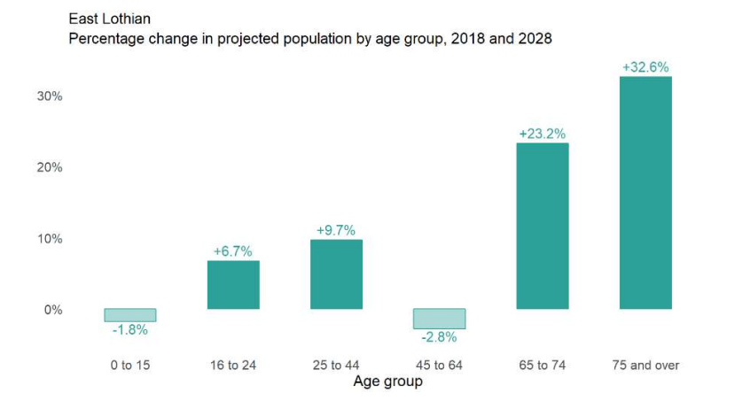

Graph 1.

This means that we have to increase our focus on:
- preventing ill health
- managing long-term illnesses
- identifying new ways of working to meet the needs of the growing population of older people

With an increasing ageing population we need to identify plans now
and put in place the necessary preparations to meet future needs

Deprivation

The Scottish Index of Multiple Deprivation (SIMD) is used to assess how deprived an area is. It divides Scotland into 6,976 small areas, called 'data zones' and measures the level of poverty in each of these areas.

It does this by looking at factors that contribute to deprivation, for example:
- income  - levels of crime  - employment | - access to services  - housing  - education | - health

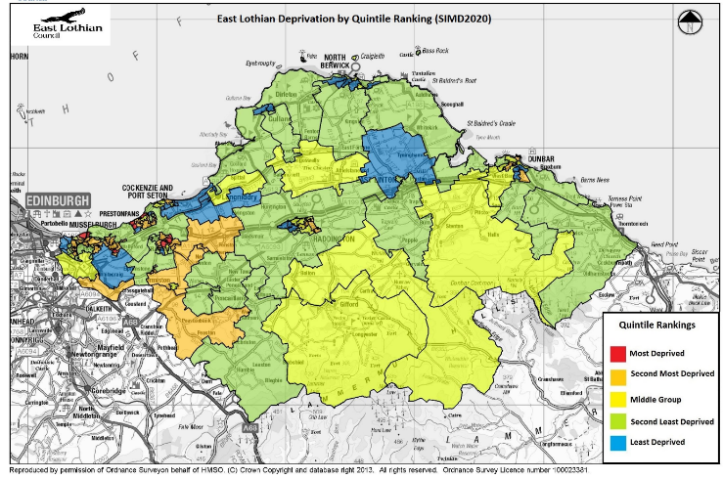
Eight data zones in East Lothian register as being in the 20% of most deprived areas in Scotland. Map 1: Deprivation in East Lothian.
Map 1: Deprivation in East Lothian

Deprivation leads to health inequalities, for example:
- lower life expectancy
- higher rates of disease
- more long-term illness

We have to take deprivation into account when we are planning for the future.

Staffing
Health and social care is dealing with a staffing crisis at a national and local level. East Lothian is no exception.
Our workforce is ageing. In 2020, 80% of social care staff were female and 44% over the age of 45 years.
Many people working in the care sector receive low pay but carry out challenging roles. The majority of positions within the care sector are low paid, challenging roles, which directly compete with hospitality, retail, education and cleaning sectors
By 2043, for every 100 people of working age, 49 of them will no longer be working.
This means a much tighter labour market. At the same time, it will increase demand for public services like social care.
To be able to continue delivering services, we will have to,
- identify effective means of recruiting enough staff
- identify effective ways of retaining them

This needs a national approach as well as a local one.

Finances
Finance is another key issue. NHS Lothian and East Lothian Council fund us to deliver health and social care services. Their funds come from Scottish Government. Scottish Government has said that there are significant financial challenges ahead.

We are already seeing the impact of this. Funding has reduced for 2023-24 and it will continue to reduce over the next few years.
Any option that we put forward for services for older people must, be fully costed and analysed to ensure affordability and best value.
We need to do more with less funds.

Other issues
There are other things that need to be considered, for example:
- The impact of the proposed National Care Service
- The number of spaces available for community-based services to take place
- If we will be able to access to those spaces
- How to get people to and from community spaces using public transport.

These are wider issues that ELHSCP does not have control over,
which may affect the way in which we can deliver services

What do we know already?
In 2022, we engaged extensively with East Lothian communities. We asked them to tell us what they wanted from health and social care services in later life.
Here are the key things people told us:

- People would prefer to stay independently, in their own homes for as long as possible.
- If people needed care, they would prefer to have it at home, or in a homely setting and not go into hospital.
- They wanted more ‘Intermediate Care Services’ these services are based in the community and help people stay out of hospital or get people home from hospital with minimal delay.

In addition to asking public opinion, research was undertaken into the current provision, and future demand for care home beds and hospital beds. The results of this research identified:

- The hospital bed provision within East Lothian Community Hospital is well managed and there are enough beds available to meet current and any future demand.
- There is still a need for care home provision within East Lothian. It is likely there will be a need to replace 70 care home beds, and provide up to 30 new care home beds to meet demand.

We need to think about:
- the best locations for care homes to best meet the need for all communities in East Lothian
- whether East Lothian Council or the private sector is able to provide Care Homes

What are the challenges facing health and social care services?

Intermediate Care Services
There is an increasing demand for Intermediate Care Services. Intermediate Care services, like reablement and hospital at home, prevent unplanned hospital admissions. It also frees up hospital beds needed by others by helping people to return home quicker.

How can we ensure Intermediate Care is a priority for future care provision?

Palliative Care
Palliative care is about supporting people to die at home, or in a homely setting, if that is their wish. Fewer people die at home in East Lothian than the Scottish average. Feedback shows that most people in East Lothian would like to die at home or in a homely setting.

What improvements do we need to make to offer more palliative care closer to home in East Lothian?

Hospital Beds in East Lothian
We know that East Lothian Community Hospital has enough beds to meet future need. There are also two smaller ‘satellite’ hospital bed sites - the Edington Hospital and Belhaven Hospital.

How sustainable are these ‘satellite’ hospital beds? To answer this, we need to think about staffing resource, facilities and running costs. Are there alternatives that could support the community better than the hospital beds?

Care at Home
There is a shortage of care at home services, which is more severe in some areas of East Lothian than others. Recruiting staff into these roles is extremely difficult.

How can we support people to stay independent in their own homes? To answer this, we need to think about how we address staffing and resource shortages.

Care Homes
We have enough care home places but some places in East Lothian have more care home beds than others. The majority of beds are in private care homes. ELHSCP has no budget to build new care homes. There is only a limited budget to fund repairs which are much needed in The Abbey and Blossom House in Dunbar. Eskgreen Care Home in Musselburgh had to close in December 2022. This was due to:
- the building falling into disrepair
- the structure of the building not meeting the required quality standards

How can we support and develop the care home system to meet the future needs of East Lothian’s population?

Minor Injuries Unit
Many people have asked for a Minor Injuries Unit (MIU). An MIU treats injuries that are not critical or life-threatening in East Lothian.

Do we need a Minor Injuries Unit in East Lothian?
If so, will this prevent hospital admissions or overnight care in the Royal Infirmary?
Is there enough demand to have MIU in East Lothian?
Could this resource be better used on other priorities?

Discussing, considering and proposing options
We need to come up with options that are:
- realistic
- achievable within a timescale not exceeding 10 years

The most useful options are those that will help to co-design:
- Services offered to people within their own home or local area
- Services delivered within dedicated care home facilities
- Services provided in East Lothian hospitals, where someone needs to be admitted for treatment
- Services that focus on early intervention and prevention

How will options for these challenges be discussed and decided upon?
We want people to reflect on all the information presented above. We will talk to you and work with you to identify solutions to the challenges identified above.
This will work will have several stages:
- Stage 1. Gather interest from key stakeholder groups including community councils, area partnerships, third sector, independent sector and general public to contribute ideas and options as part of this engagement project.

- Stage 2. Collate ideas and suggestions from stakeholder groups, online survey, engagement events, and workshops to create a ‘long list of ideas, options and suggestions’
- Stage 3: Assess every suggestion against ‘hurdle criteria’. Hurdle criteria are conditions that need to be met for an option to progress to create a shortlist of options.

- Stage 4. We will investigate, model and test the shortlist of options. This will include looking at costs, timescales and demand.

- Stage 5. The Project Team and Stakeholder Group will then work on a shortlist. They will assess each option for desirability, viability and feasibility. They will be using an assessment framework to help them assess each option in a fair and consistent way. The options will be scored and weighted, to develop a refined options list.

- Stage 6. A 12 week public consultation will take place on the proposed finalised options.

- Stage 7. A final report will be go before the East Lothian Integration Joint Board (IJB). They will discuss all the findings of the engagement and consultation process. They will then make a decision and direct ELHSCP on which options to take forward.

Timeline
The engagement for this project begins in August 2023. We aim to present the final report to the IJB in September/October 2024.

These timescales are current indicative and may be subject to change.

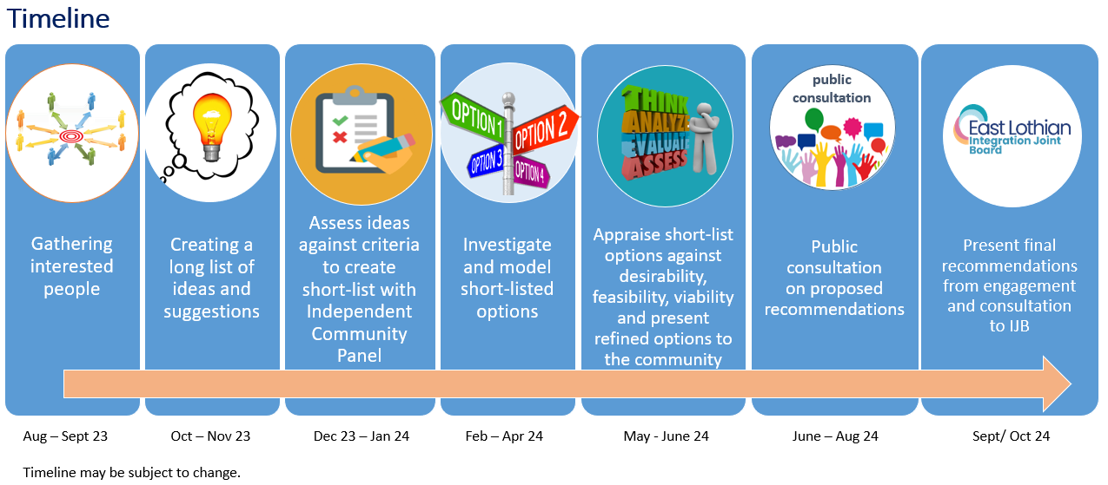

Further information resources

Email: engagement-hscp@eastlothian.gov.uk

Webpage: www.eastlothian.gov.uk/elhscp/pops
On the webpage you can find:
- Engagement and Consultation Strategy
- Options Development Strategy
- Engagement Timetable
- Findings to date

Recording Sheets
Name of Group engaging:
Date of Engagement:
Participant’s name | Contact details (if they would like further contact) | Interest in engaging further – Yes/No
Intermediate care
Record your feedback here

Palliative and end-of-life care

Record your feedback here

Hospital bed provision
Record your feedback here

Care at home
Record your feedback here

Care homes
Record your feedback here

Minor Injuries Unit
Record your feedback here

What do you think should be the priorities for services for older people in
East Lothian?
Record your feedback here

Record your feedback here

Consent to share anonymised feedback
ELHSCP will not publish any information in their feedback reports that makes any person identifiable from what they have said. Please confirm that the group are happy to share the feedback on this recording sheet with ELHSCP by ticking the box.

Returning your Recording Sheet
You can type into the recording sheet or fill it in by hand – whatever suits you best. If you are typing into the recording sheet, the boxes should expand to accommodate your text.
If you are doing this by hand and you don’t have enough space, please continue on another piece of paper and remember to include a heading about the particular theme and question your feedback relates to.
When recording sheets are ready to return to us you can:
- Email the filled in Word document to engagement-hscp@eastlothian.gov.uk
- Scan your recording sheets and email them to engagement-hscp@eastlothian.gov.uk
- Post them to:
ELHSCP
Room 217
John Muir House
Brewery Park
Haddington
EH41 3HA
- Drop them off to any local council office in an envelope marked with the address above and ask Customer Services to return it to us for you via internal mail.

Please return all recording sheets by 31 December 2023

Thank you very much indeed.

