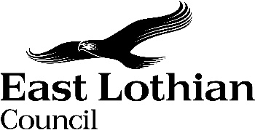

East Lothian Council

Notice of Polling Districts and Places Review

Notice is hereby given that in accordance with Section 18C of the Representation of the People Act 1983 East Lothian Council is to carry out a review of its polling districts and polling places.

The Returning Officer for the East Lothian constituency will comment on the proposals. Those representations will be published on the Council’s website, www.eastlothian.gov.uk, and will be available for inspection at John Muir House, Brewery Park, Haddington, EH41 3HA and Brunton Hall, Musselburgh, EH21 6AA in accordance with the timetable set out below.

Publish Notice of Review Monday 6 November 2023

Proposals Published Monday 4 December 2023

Commencement of Public Consultation Monday 4 December 2023

End of Public Consultation Monday 29 January 2024

Final Proposals Considered by Monday 8 April 2024

Approval Sought at East Lothian Council Meeting Tuesday 23 April 2024

East Lothian Council would welcome the views of electors within East Lothian, particularly disabled residents, on the authority’s proposals, the Returning Officer’s representation, or any other matters. Any views should, if possible, give alternative places that may be used as a polling place. Comments should be sent to:

Elections Office
East Lothian Council
John Muir House
Haddington
EH41 3HA

Or email elections@eastlothian.gov.uk

All responses should be submitted on or before 29 January 2024.

