EAST LOTHIAN COUNCIL HOUSING OPTIONS TEAM
HOUSING SUPPORT SERVICE

Health (Tobacco, Nicotine etc., and Care) (Scotland) Act 2016 and Duty of Candour Procedure (Scotland) Regulations 2018
The organisational duty of candour provisions became a legal obligation on 1 April 2018. In accordance with this, organisations providing health, care and social work services in Scotland are required by law to set out a procedure for the duty of candour. Organisations are expected to follow this, in a situation where there has been an unintended or unexpected incident that results in death or harm (or additional treatment is required to prevent injury that would result in death or harm). An annual report on the duty of candour is required from 2018/19 onwards, each year as soon as is practicable, following the end of the financial year.

The focus of the duty of candour legislation is to ensure that organisations tell those affected that an unintended or unexpected incident has occurred; apologise; involve them in meetings about the incident; review what happened with a view to identifying areas for improvement; and learn (taking account of the views of relevant persons).

The overall purpose of the duty of candour is to ensure that organisations are open, honest and supportive when there is an unexpected or unintended incident / consequence resulting in death or harm, as defined in the Act. The duty of candour procedure must be activated as soon as reasonably practicable after becoming aware that, in the reasonable opinion of a registered health professional, there has been an unexpected or unintended incident resulting in death or harm in a health, care or social work setting.

Overview
The person (or their next of kin) (“relevant person”) are identified and contacted. The relevant person is notified about the incident and what actions are going to be taken. A meeting is arranged and the relevant person is given an opportunity to ask questions. The relevant person receives an apology from the organisation, and is advised what happened in the context of what should or should not have happened. (The Act makes it clear this is not an admission of liability).

The organisation then carries out a review and feeds back to the person in respect of what has been learned and what actions and/or training has or will take place to ensure as far as possible that it does not happen again.

Procedure start date
The procedure start date is the date that the organisation receives confirmation from a registered health and or social care professional that an unintended or unexpected incident appears to have resulted in an outcome that relates directly to the incident (rather than to the natural course of the relevant person’s illness or underlying condition).

Notification
The relevant person should be notified as soon as reasonably practicable but it is considered good practice to notify the relevant person within 10 working days of the procedure start date.

Staff Training
Duty of Candour training is a mandatory requirement. The Duty of Candour e-learning module has been installed on the Council’s LearnPro platform. This module is approved by the Scottish Government; Healthcare Improvement Scotland; NES; SSSC and the Care Inspectorate. It can also be accessed through the Knowledge Network, NES, SSSC and Social Services Knowledge Scotland.

Completion of this module is an essential learning requirement for staff.

Annual Report
Starting from April 2019 services must, by law, produce a short annual report showing the learning from their duty of candour incidents that year, publish it, and notify the Care Inspectorate that it has been published.

To help you decide whether or not duty of candour must be activated:

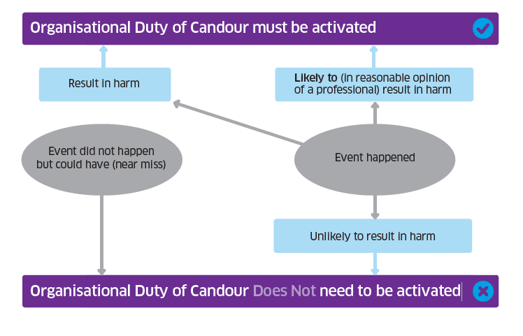

Duty of Candour Process Checklist – Housing Options Team

Step 1  Identify and contact the Relevant Person | - Do you know who the relevant person is in respect of the incident (i.e. the person who will receive the apology)?  - Is their preferred method of communication already known? If not, this needs to be determined and noted.  - Has it been possible to make contact with them? If not, a note should be made of the attempts that have been made to make contact.
Step 2  Notify the relevant person | - Provide the relevant person with an account of the incident and what actions are going to be taken. (Note that if it is more than a month since the incident you need to explain why.)
Step 3  Arrange a meeting | - Arrange a meeting and provide the person with the opportunity to ask questions in advance of the meeting.  - At the meeting, (or through communication if a meeting is not desired):  - Apologise, if this has not already happened  - Tell the person what happened  - Tell them what further steps are being taken  - Give the relevant person the opportunity to ask further questions and express their views  - Tell them about any other processes that might be on-going  - Provide them with a note of the meeting and details on how to contact a person within the organisation.
Step 4  Carry out a review | - Start a review – remember to seek the views of the relevant person  - Prepare a report – to include the manner in which it has been carried out  - Ensure that the report focus is on improving quality and sharing learning  - Report to include the actions taken in respect of the duty of candour procedure  - Offer to send the relevant person a copy of the review report – remember to let them know of any further actions subsequently  - Make sure that a written apology is offered.
Throughout -  Support and assistance for relevant person and staff | - Consider and give relevant person support or make assistance available to them  - Staff to receive training and guidance on all requirements of the procedure  - Employees to be provided with details of services or support relating to their needs arising from the incident.
Records | - Organisations must keep a written record for each incident to which the duty of candour procedure is applied, including a copy of every document or piece of correspondence relating the application of the duty of candour procedure to the incident. The written record should be retained and held on the Housing Options Team Duty of Candour Database.
Annually | Every year, the Housing Options Team Leader will:  - Prepare a Duty of Candour annual report.  - Inform the Care Inspectorate that an annual report has been completed.  - Publish the report on the Council’s website.

Detailed guidance on following the Duty of Candour process can be found on the Scottish Government website and by clicking on this link: http://www.gov.scot/Topics/Health/Policy/Duty-of-Candour

Further sources of support:

Regulations and detailed guidance about the duty of candour process has been issued by the Scottish Government: http://www.gov.scot/Topics/Health/Policy/Duty-of-Candour

Email: dutyofcandour@gov.scot

Scottish Government FAQs: http://www.gov.scot/Topics/Health/Policy/Duty-of-Candour/FAQ

Scottish Government Learning Module: http://www.knowledge.scot.nhs.uk/scormplayer.aspx?pkgurl=%2fecomscormplayer%2fdutyofcandour%2f

ELC LearnPro: The Duty of Candour e-learning module has been installed on the Council’s LearnPro platform. This is the module approved by the Scottish Government, Healthcare Improvement Scotland, NES, SSSC and the Care Inspectorate. It can also be accessed through the Knowledge Network, NES, SSSC and Social Services Knowledge Scotland.

Completion of this module is an essential learning requirement for staff.

