Who receives a financial assessment form?

If you receive a package of non-personnel care, you might have a chargeable service. The service can be something you receive at home or when you are out.

What is a financial assessment?

The financial assessment calculates how much a person contributes towards the service they receive. The amount a person contributes for a service is based on their income and savings.

I’ve completed a financial assessment before.

People’s financial circumstances can change. Completing reassessments allows us to ensure that contributions towards services are accurate.

When will my new contribution start?

The new contribution will start on 01/04/2026. We are completing financial assessments early to ensure all contributions are amended by 01/04/2026.

My income increased in April 2026 due to an increase in benefits, should I inform you of this change?

The contributions paid during 2026/27 will be based on income and savings 2025/26. You do not need to inform us of the April 2026 uplift in benefit entitlement.

When should I contact the team?

If your income increases by more than £50 per week, or if your savings are approaching £16,000 please contact the Financial Assessment team on 01620 827 901 or awfinancialassess@eastlothian.gov.uk

Will my contribution increase/decrease a lot?

Reassessments completed in 2024/2025 resulted in some people having a noticeable increase in contribution. This was due to financial assessments not being completed for over 4 years and people’s income increasing during this time. Financial assessments are now completed ever year, resulting in a less significant change due to people’s income and savings being similar to previous assessment.

Financial Assessments are completed using East Lothian Councils Charging policy and COSLA charging guidance.

Capital thresholds for 2025/2026

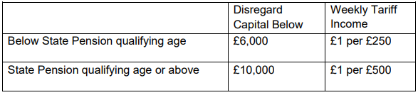

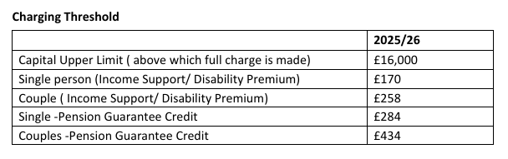

Taper rate:

- Taper 1: 70% of first £50 of available income

- Taper 2: 90% of remaining available income.

Full details of the Charging Policy can be found on East Lothian council’s webpage

