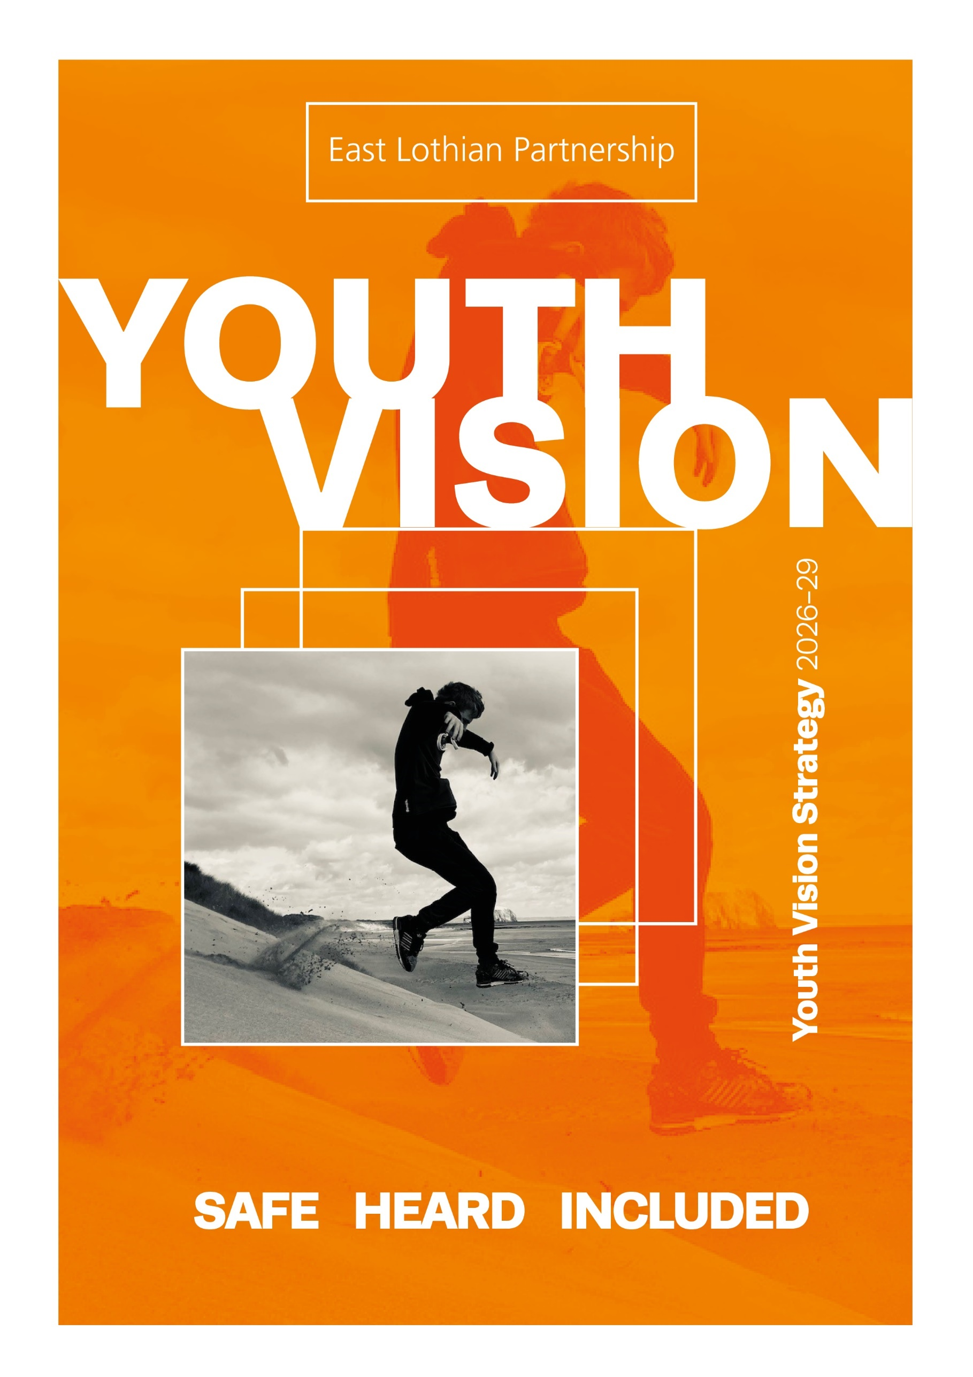

Welcome to our Youth Vision 2026-29

Youth Work is amazing! It brings so many kinds of people together and helps children and young people make friends, try new things and feel more involved in our community. There is lots of brilliant youth work happening across East Lothian. We want to celebrate this and continue to grow our support for young people through youth work

Young People’s Advisory Group
The East Lothian Youth Vision is a three year strategy for Youth Work - from 2026 to 2029.
Our vision is for Youth Work to help ensure
young people in East Lothian are safe, heard
and included.

The strategy was developed by young people, Youth Work organisations, East Lothian Partnership, and East Lothian Council.
It explains how we aim to deliver positive impacts for young people using our resources effectively.

Each year, we’ll create an impact report, to celebrate youth work and to measure progress
by sharing stories, achievements and challenges.

.

Cover photo © Dylan MacFadden

Contents

Introduction to Youth Work 3

What guides our Youth Work? 4

Plan on a Page 5

Goal 1: Safe 6-7

Goal 2: Heard 8-9

Goal 3: Included 10-11

Governance 12

Next Steps 13

Strategy development 14

Young People’s Photo Gallery 15-16

Acknowledgements 17

Links to related strategies 18

References 19

Accessible formats & contact us 20


@ Leo Hackett and Dylan MacFadden

Introduction to Youth Work
Youth Work improves the life chances of children and young people
In East Lothian, services and organisations working with communities are committed to improving the life chances of all children and young people, while reducing existing inequalities. Youth work plays a key role in achieving these priorities. By building trusted relationships between young people and supportive adults, youth work creates safe spaces where young people feel heard, included, and able to access help. It supports both educational and personal development, helping to improve engagement, and achievement. By encouraging positive peer and community connections, youth work helps young people build resilience, confidence, and a strong sense of belonging—reducing the risk of long-term challenges such as poor mental health, involvement in crime, or unemployment.

What is Youth Work?
Youth Work is an informal education practice that supports young people’s social,
emotional and educational development. It can be adapted across a variety of settings,
and typically engages with young people within their local community. YouthLink Scotland

There are 3 essential and definitive features of Youth Work practice, highlighted by YouthLink Scotland’s
The Nature and Purpose of Youth Work.
- Young people choose to participate
- Youth work builds from where young people are
- The young person and the youth worker are partners in a learning process.
YouthLink Scotland created the National Youth Work Outcomes and Skills framework. Young people are at the core of youth work delivery with the Youth Work Outcomes and Skills Framework detailing the seven overarching outcomes of youth work. These set out how youth work can contribute to improving life chances of children and young people. We use this in East Lothian to guide our youth work practice.
Evidenced Impact of Youth Work
Youth work delivers wide-reaching benefits — not just for young people, but for communities and the economy. Research commissioned by YouthLink Scotland shows that every £1 invested generates at least £7 in value, highlighting its strong return and lasting impact.
Amongst the growing body of research two Scottish studies (2018 & 2020) highlight the powerful role of Youth Work. Both reports found that youth work provides a safe, supportive environment where young people:
- Build confidence and life skills
- Form trusted relationships with youth workers
- Feel valued, respected, and listened to
- Make positive choices and handle challenges
- Develop new skills and friendships

These findings show a consistent and compelling picture of Youth Work as a vital space for personal growth, learning and emotional support.

What Guides Our Youth Work?

The Youth Vision is underpinned by and supports several key policies and approaches,
in particular the United Nations Convention on the Rights of the Child (UNCRC),
The Promise, a trauma-informed approach and the Lundy Model of Participation.

United Nations Convention on the Rights of the Child

The incorporation of the UNCRC into Scottish law is helping children and young people see their rights recognised in meaningful ways. In East Lothian, youth work plays a vital role in making these rights a reality. By fostering inclusive environments where young people are heard, respected and actively involved in decisions that affect them, youth work bring the principles of the UNCRC to life.

Trauma Informed and Responsive Practice
Safety, trust, collaboration, choice and empowerment are the principles that underpin trauma inform and responsive practice. Youth work providers are committed to embedding this approach, it’s about understanding and responding to young people’s needs by building relationships, creating safe spaces where people can connect, providing choices and working collaboratively to build on young people’s strengths. A trauma informed approach will make sure our youth work services are open and accessible to all.

The Promise
The Promise is Scotland’s commitment to children, young people and their families that every child grows up loved, safe and respected. Youth work plays a vital role in fulfilling this vision by building trusted relationships, offering safe spaces, and empowering young people to develop their voice, confidence, and potential. Together, The Promise and youth work create a foundation for lasting change—where young people are not only heard but are central to shaping the services and communities that affect their lives.

The Lundy Model of Participation
The Lundy Model of Participation, developed by Professor Laura Lundy, helps adults support children and young people to express their views and have those views taken seriously. It focuses on four key elements:
- Space: Children and young people must be given safe, inclusive opportunities to form and express their right to participation. We use this model in East Lothian to help improve how we listen to and act upon what children and young people tell us.
- Voice: Children and young people must be supported to express their views freely and in their own way.
- Audience: Adults must actively listen to what children and young people say.
- Influence: Children’s and young people’s views must be acted upon, with clear feedback showing how their input made a difference.

Tackling Child Poverty
Youth work is crucial to tackling child poverty in Scotland. It builds health and wellbeing, improves engagement with learning and reduces risk taking behaviour, helping lift young people out of poverty. In East Lothian we provide youth work opportunities that are free or low-cost, and often include access to healthy food. These spaces are safe, welcoming, and built around trusted relationships with adults. Youth work creates opportunities for young people to thrive. Through these trusted relationships with children, young people, and their families, youth workers also help sign post to other services offering support in the community.

East Lothian Youth Vision 2026-29
Plan on a Page - Our East Lothian Youth Work Strategy.

Our Vision for Youth Work

Young people in East Lothian are safe, heard and included.

Goals Outputs [The Youth Vision will include these Actions]
Safe
Children and young people feel safer in their communities

- Provide welcoming spaces for children and young people to connect, express themselves, and have fun.
- Youth workers will continue to build relationships, offering guidance and information to help children and young people make safe, informed decisions.

Heard
Children and young people’s ideas and experiences will be heard, listened to and acted upon
- Create and strengthen inclusive opportunities for young people to express their views.
- Build the capacity of adults and decision-makers to actively listen and respond meaningfully to young people’s views

- Celebrate and recognise the achievements and contributions of young people in the community
- Children and Young people and youth workers
co-design inclusive activities to reflect needs and interests.

Included
Children and young people feel included in their communities

Measuring Impact – Examples of how evidence is gathered
- Youth work surveys and Case studies

- Feedback from young people, youth workers, and stakeholders
- Data on youth work attendance, participation, and session delivery
- Number of peer leadership and volunteering opportunities
- Number of youth awards and certificates achieved
- Wider community impact – school surveys, police reports etc.

Young people involved in developing the Youth Vision shared how youth work supports them to feel safe, heard, and included. Definitions are in line with GIRFEC wellbeing indicators.

Goal 1 - SAFE

Children and young people feel safer in their communities

Children and young people told us:
Adults need to take young people’s safety seriously. We need the police, education, parents, politicians to help improve safety for young people.

Youth Work takes us away from different environments where we might not be safe and offers a space for us to go where there are adults we trust.

Since it is getting dark in the evenings my mum lets me stay out later because I am in youth club.

In a youth centre you can find out your own mind, explore who you are. Passions you have, you can follow without feeling judged. Youth workers listen to what you like and help you explore this.

Definition of Safe – Youth work creates environments where young people feel secure, nurtured and listened to.

How we know Youth Work makes a difference:
Feeling Safer and Reconnecting with School – Specialist Youth Work through North Berwick Youth Project
North Berwick Youth Project’s wellbeing walks continue to make a big impact. This year, youth workers
supported 51 young people during the school day, helping them improve their mental health and wellbeing.
One young person shared how weekly walks with their youth worker became a turning point:
“School wasn’t working for me and I felt low and isolated. Meeting my youth worker every
Tuesday gave me someone to talk to and helped me feel less alone. She helped me build confidence, make friends, and feel more like myself again. Without her, I’d probably still be stuck at home.”
This support helped her feel safer, more connected, and ready to re-engage with school life.
A Guidance Teacher at North Berwick High School, added:
“Their simple referral system and weekly check-ins with a thoughtful youth worker do so much good.
Our young people are so positive about the support. Thanks NBYP!”
Building Trust and Safety Through Outreach Youth Work in Haddington

In response to concerns about young people’s safety, Haddington youth workers undertake outreach youth work at the weekends, engaging with young people on the streets and in the park. The regular presence of the outreach youth workers helps build trust with young people in public spaces, especially those who don’t attend youth clubs. They offer a wide range of advice including staying safe and looking out for friends.

These interactions can also lead to more in-depth conversations about mental health, self-harm and suicide, with youth workers guiding young people to specialist support. Now reaching up to 150 young people in one evening, the outreach team plays a key role in ensuring young people are seen, heard and supported.

Our plan to achieve Goal 1

Goal 1 – SAFE Outcome:
Children and young people report feeling safer in their communities through youth work experiences and relationships with trusted adults

Context: This outcome contributes to the following national and local priorities:
National Youth Work Outcomes and Skills Framework:
Outcome 1. Young people build their health and wellbeing
Outcome 2. Young people develop and manage relationships effectively
Outcome 4. Young people participate safely and effectively in groups and teams
Outcome 5. Young people consider risk, make reasoned decisions and take control
Young people will gain skills in how to look after themselves, learn to make decisions, communicate, solve problems and build positive relationships.

National Community Learning and Development (CLD) Outcomes:
1: CLD participants have increased skills and knowledge
2: CLD participants have improved mental health and wellbeing
Local Priorities:
Youth work in East Lothian will continue to provide low or no-cost opportunities for children and young people in their communities, supporting families impacted by poverty (East Lothian Poverty Plan). To build welcoming and safe spaces where everyone is respected (East Lothian Plan), we will offer inclusive, community-based wellbeing activities in safe spaces, led by trusted adults (Children and Young People’s Services Plan). Working in partnership with families and other services, we are committed to ensuring that care-experienced young people and young carers have equal opportunities to take part, be active, and thrive through youth work (Corporate Parenting Plan).

Outputs | Measuring Impact
- Sustain a youth work offer to ensure children and young people have access to trusted, caring adults.  - Provide welcoming spaces for children and young people to connect, express themselves, and have fun.  - Youth workers will continue to build relationships, offering guidance, support, and information to help children and young people make safe, informed decisions.  - Create and promote opportunities for children and young people to influence decisions that affect their safety.  - Young people and partners work together to celebrate achievements of children and young people and challenge negative stereotypes.  - Workforce development on Trauma Responsive  Practice. | - The number of safe, inclusive spaces for Youth Work created or maintained.  - SEE Survey results show increase in how safe young people feel in their communities.  - Reductions in anti-social behaviour.  - Youth work surveys capturing young people’s feelings of safety.  - Feedback from young people, youth workers and stakeholders around National Youth Work Outcomes identified for this goal.  - Case studies show how youth work helps young people take part in decisions about their safety.  - Feedback and case studies on youth celebrations.  - Workforce development data

Goal 2 - HEARD
Children and young people’s ideas and experiences will be heard,
listened to and acted upon

What children and young people told us:

I think being heard is a key aspect of youth work. I feel heard when I can give my opinion, and someone really listens.

I’d be up for trying to speak to politicians. Speaking directly to them would be a way to make a change.

Young people’s views need to be listened to. We have ideas for the things that need to be improved or changed.
Groups of young people could come together and talk about how we could make things better.

Definition of Heard – Young people are encouraged to share their views, and those views are respected and taken seriously.

How we know Youth Work makes a difference:
Young Carers heard and valued
Since April 2023, the Young Carers Advisory Group in East Lothian has empowered 11–16-year-olds to shape the support they receive. Meeting each school term, members have: Designed the service logo, co-created holiday programmes, produced website videos, consulted peers on key issues, advocated for a Carer ID card, engaged with professionals and decision-makers, represented the service at events like the Scottish Young Carers Festival. One member now chairs the group, and several have become Young Carer Ambassadors, leading assemblies and running school lunch clubs.
“Being part of this group has boosted my confidence. I’ve taken on leadership roles and helped
make things better for other young carers, their families, and schools.” — Group Member

Recharge Youth Reps
We’re the Recharge Youth Reps—12 to 14-year-olds who meet weekly at Recharge Youth Centre in Tranent. We help shape what happens at Recharge and come up with ideas to improve our community.
We’ve volunteered at Fa’side Community Kitchen, run fundraising events, and made an animation about children’s rights and life in East Lothian. We’ve even spoken to councillors about things that matter to us—like parks, lighting, school, and places to hang out.
Being part of the group has helped us learn more about our community and the issues that affect it. Most of us feel more confident now and are better at speaking up for what we believe in.

Recharge also runs youth forums for ages 15–18 and is looking to establish an S1 – S2 group soon. The youth forums will work together, offering peer support to help each other on their participation journey.

Our plan to achieve Goal 2

Goal 2 - HEARD Outcomes:
Children and young people in East Lothian report their views are heard, listened to and acted upon.
Opportunities for children and young people’s ideas to shape decision-making will be strengthened.
The Lundy Model helps shape outcomes and outputs for this goal.

Context: These outcomes contribute to the following national and local priorities:
National Youth Work Outcomes and Skills Framework:
Outcome 6. Young people grow as active citizens, expressing their voice and enabling change
Outcome 7. Young people broaden their perspectives through new experiences and thinking
Young people will gain skills in organising and planning, leadership and communication, teamwork and creating change.

National Community Learning and Development (CLD) Outcomes:
1: CLD participants have increased skills and knowledge
2: Community groups have strengthened their capacity to address their own priorities and make decisions about their own communities.
Local Priorities: To work toward the vision of an East Lothian free from poverty the youth work sector will continue to work in partnership towards a shared vision of equality and equity. Continuing to adapt to the needs of children and young people, through listening to and acting upon the voice of lived experience from children and young people (East Lothian Poverty Plan). By upholding good practice participation, the youth vision will support young people to be strong, resilient and respected and able to share their views and take part in opportunities to shape decision making (Community Engagement and Participation Strategy). Youth Vision supports the priorities of the Children and Young People’s Services Plan and the Corporate Parenting Plan by committing to Children’s Rights and using good practice participation to empower children and young people to address issues, design solutions and shape services.
Outputs | Measuring Impact
- Continue to provide safe environments with supportive people to help children and young people developing confidence as active citizens (Space).  - Create and strengthen inclusive opportunities for young people to express their views (Voice).  - Build the capacity of adults and decision-makers to actively listen and respond meaningfully to young people’s views (Audience).  - Establish clear feedback loops to show how young people’s input has influenced decisions and share examples of impact to build trust and transparency (Influence).  - Promote and share good practice in participation with decision makers, partners and communities. | - The number of safe, inclusive spaces for Youth Work created or maintained.  - Youth work surveys capturing young people’s feelings on being heard, and able to influence change.  - SEE Survey results show increase in number  of young people involved in decision-making  in communities.  - Numbers of youth participation opportunities.  - Feedback from young people/youth workers/ stakeholders around National Youth Work Outcomes identified for this goal.  - Case studies highlight decisions influenced  by children and young people.  - The number of professionals and decision-makers trained in youth engagement.

Goal 3 - INCLUDED
Children and young people feel included in their communities

What children and young people told us:

To feel included we need options for us, as young people, this could be more mental health support or help to find work or more free places to go. We want the same opportunities as other people get.

In youth club I feel I can be myself. It feels like stigmas are abolished here - where all people can feel included - LGBTQ, transgender people, ethnic minorities.

Through youth work I now feel kinder.
We have planned fundraisers and the skills
I have built here have benefited the community. I have used them in other groups through teaching and mentoring younger people.

Volunteering at youth club helps me feel included.

Definition of Included – Young people have help to overcome inequalities and are valued members of their communities.

How we know youth work makes a difference:
Growing and Changing use their voices and experiences to create change
Growing and Changing is a group of five young people from Prestonpans who’ve faced challenges like poverty, bereavement, and additional support needs. Their experience of hardship led to further inequalities in the local community and in school and made them feel different from their peers.
Over the past year, they’ve built a strong peer support group and established that they want to use
their voices and experiences to create change for the better for other young people experiencing hardship.
They’ve launched a campaign called What Makes a Supportive Person. They’ve gathered views from over
250 children and young people across East Lothian to influence how adults work with young people.
They’ve hosted events, met with NHS professionals, councillors, and other decision-makers, and are already working on impact; hoping to influence East Lothian Council job descriptions based on their campaign findings and incorporation of their findings into training and support for youth workers.
Growing and Changing also have plans to make a film and are working towards their Saltire Awards, Dynamic Youth Awards and Participative Democracy Certificates.
Amber’s Peer Mentoring Story – Bridges Project
Bridges Project’s Listening Peers programme supports young people aged 13–25 through peer mentoring. Trained Mentors, young people with lived experience themselves, offer one-to-one support and help others feel heard, included and empowered. Amber was referred at 14, facing bullying, poor mental health and a difficult home life. Receiving mentoring support was life-changing for Amber:
“I felt that my Mentor just got me. She completely understood me, more than anyone had done in the past. She also talked about her own experiences, which made me trust her more. If I didn’t have Bridges Project, I genuinely don’t think I would have been here.”
Amber has now become one of Listening Peers’ most prolific Mentors herself, giving back by supporting other young people to thrive.

Our plan to achieve Goal 3

Goal 3 Outcome:

Children and young people feel a stronger sense of inclusion and wellbeing through inclusive youth work opportunities and access to helpful information in their communities.

Context: This outcome contributes to the following national and local priorities:
National Youth Work Outcomes and Skills Framework:
Outcome 1. Young people build their health and wellbeing
Outcome 3. Young people create and apply their learning and describe their skills and achievements
Outcome 7. Young people broaden their perspectives through new experiences and thinking
Young people will gain skills in leadership and communication, teamwork, creating change
and organising and planning.

National Community Learning and Development (CLD) Outcomes:
1: CLD participants have increased skills and knowledge
2: CLD participants have improved mental health and wellbeing

Local Priorities: Youth Vision contributes to children and young people’s stronger sense of inclusion in their communities and increased wellbeing. They will be confident in their skills to make connections with their community (East Lothian Plan). The Youth Vision supports the work of the Raising Attainment Strategy in closing the poverty related attainment gap; by providing informal education opportunities to young people to building their learning, skills and confidence and opportunity to volunteer and gain accreditation and awards within and out with formal education settings. Youth work, through person centred practice, safeguarding and child protection procedures works within the GIRFEC framework in East Lothian, contributing to children feeling happier, healthier, included, and heard (Children and Young People’s Services Plan).

Outputs | Measuring Impact
Children and Young people and youth workers co-design inclusive activities to reflect needs and interests.  We will support young people to manage their wellbeing through youth work.  Provide access to and share information about local supports and opportunities for children and young people.  Create opportunities for young people to support their peers.  Offer youth work opportunities that enable volunteering and achievement.  Celebrate and recognise the achievements and contributions of young people in the community. | - Data gathered on youth work attendance, participants, sessions.  - Youth work surveys capturing young people’s feelings on inclusivity of youth work offer.  - Youth work surveys capturing young people’s feelings on managing their wellbeing through youth work opportunities and information shared.  - SEE Survey results show increase in number  of young people able to get mental health information in East Lothian.  - Feedback from young people/youth workers/ stakeholders around National Youth Work Outcomes identified for this goal.  - Number of peer leadership, volunteering opportunities and awards offered and competed.  - Case studies on achievements and celebration work with young people.

Governance of the Youth Vision

Governance of the strategy will be overseen by East Lothian Community Learning and Development Partnership, reporting to the East Lothian Partnership.

East Lothian Partnership
East Lothian Council
East Lothian Community Learning & Development Partnership
East Lothian
Children’s Strategic Partnership
Youth Vision Oversight Group (monitoring progress and updating actions)
Members of these groups make up the Youth Vision Oversight Group:
Children & Youth Networks linked to the 6 Area Partnerships
Members of the Youth Vision Short-Life Working Group
Young People’s
Action Group
The Youth Vision Oversight Group will publish an annual impact report highlighting achievements and challenges. This will be shared with children and young people, their families and key partners.

Next Steps

Continue to Support High-Quality Youth Work in East Lothian

In East Lothian, our youth work is guided by the National Occupational Standards for Youth Work and the CLD Competences and Code of Ethics set by the CLD Standards Council. These frameworks help us stay grounded in good practice and strong values. We work closely across teams, organisations, and local areas—sharing ideas, learning, and what works well. This joined-up approach helps us plan strategically and to react, when possible, to emerging issues. Young people get consistent, high-quality support wherever they are.

Sharing the Purpose and Impact of Youth Work

The Youth vision will be used as a springboard to strengthen communication about the purpose and impact of Youth Work. We will share this document, our plan on a page and a creative version of the Youth Vision with children, young people, parents and partners. Through our three key goals, safe, heard and included we will continue to celebrate and recognise the achievements and contributions of young people in the community.

Working Together for Improvement

The Youth Vision can only be achieved by working together. Establishing a strong working group of young people and key partners will help us stay focused by creating and reviewing a shared action plan each year. By doing this, we can track progress and make sure we’re delivering on our goals. Each year, we’ll produce a Youth Vision report with key data and real-life examples to show how we’re meeting our goals. This work will be led by a subgroup of the CLD Partnership and shared with the wider strategic partnerships to keep everyone informed and involved.


@ @ Oliver Rhodes

How we developed our Youth Vision Strategy

The Youth Work Strategy was co-developed by young people, youth organisations,
East Lothian Council, and key partners. A Young People’s Advisory Group (YPAG)
worked with professionals from 2021–2022 to consult peers and draft a Youth Vision,
which was refined and approved in 2025.

Youth Voice Highlights

Initial Work:
- 6 young people made up the YPAG - The Young People’s Advisory Group; young people aged between 12 and 24 played a major role in the development of this strategy.
- 85 young people in 2022 took part in an online survey about their communities.

2025 Engagement:
- 99 children and young people voted and commented on the Youth Vision’s goals,
based on YPAG priorities and GIRFEC wellbeing indicators.
- 117 secondary pupils participated in Scottish Youth Parliament sessions and a related consultation on community needs.
- 2,819 pupils took part in 2024/2025 Student Evaluation of Experience (SEE) Survey;
1059 in P6, 963 in S2 and 797 in S4. Their feedback on community-based wellbeing indicators shaped the Vision.
- 74 young people participated in the Autumn 2025 public consultation, leading to final revisions.
Partner Involvement
- 29 partners attended an event in February 2025 to help refresh the Youth Vision.
- 17 professionals joined a Short Life Working Group to co-produce the final strategy.
- 42 adults (youth workers, parents and carers, partners) participated in the Autumn 2025 public consultation.

Supporting Data Sources

- East Lothian by Numbers, 2022
- East Lothian Poverty Profile, 2025
- NHS Lothian Public Health Survey, 2023
- Young Scot BIG Survey Report, April 2024
- East Lothian Local Outcome Improvement Plan Consultation, 2025.
- East Lothian Education, Student Evaluation
of Experience (SEE) Survey 2024/2025


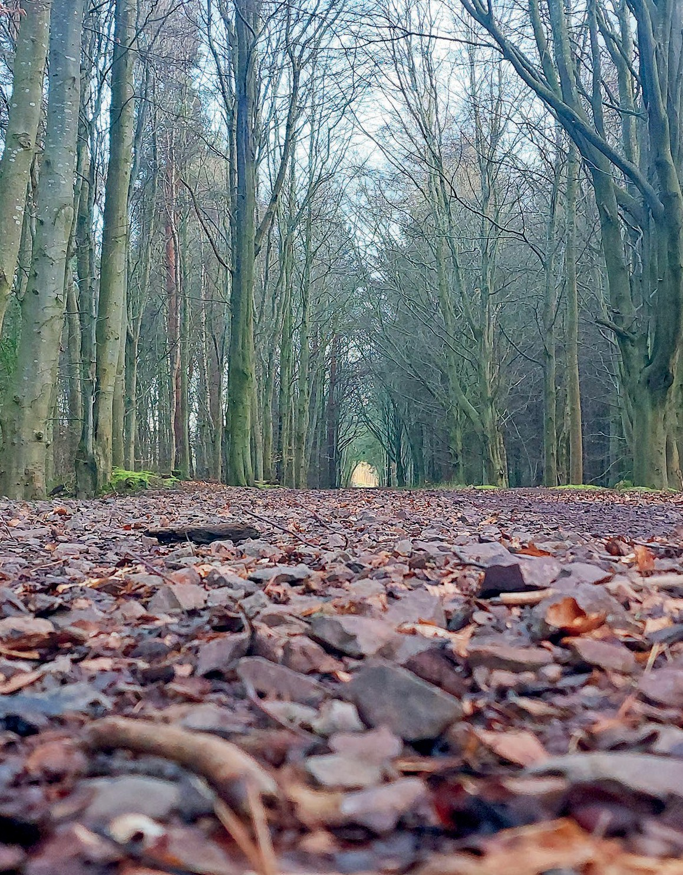
© Ayesha Norton © Leo Hackett

YOUTH VISION PHOTOGRAPHY GALLERY
WINNERS: Leo Hackett | Dylan MacFadden SECOND: Oliver Rhodes
THIRD: Arwen Hopkins | Ayesha Norton COMMENDED: Mariana Leyden




@ Ayesha Norton
@ Oliver Rhodes
@ Mariana Leyden


© Oliver Rhodes
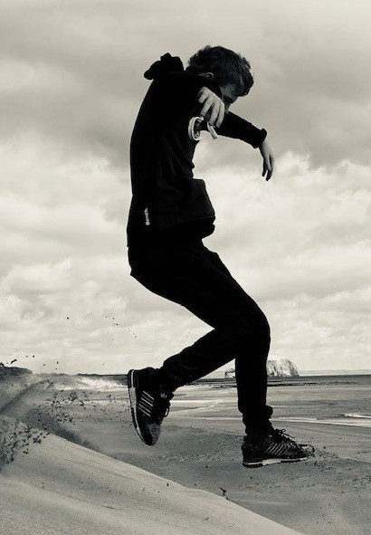

© Dylan MacFadden © Arwen Hopkin

Acknowledgements

We’d like to thank all the young people, and the following organisations and teams involved in the development of the Youth Vision, including those who took part in the public consultation. Their contributed time, insight, and expertise have helped shape a document that reflects the needs and aspirations of young people.

East Lothian Council Services involved:

Connected Communities, Education & Children’s Services, Housing, Library Service, Young Carers Service, Arts Service, Sports Development/Active Schools, Safer Communities Team

Recharge Youth Centre: https://rechargetranent.org.uk/
Circle https://circle.scot/
Bridges Project https://bridgesproject.org.uk/
North Berwick Youth Project https://www.northberwickyouthproject.org.uk/
Can-Do https://www.can-do.scot/
Choose Play https://elpa.org.uk/chooseplay-training/
Who Cares Scotland? https://www.whocaresscotland.org
Volunteer Centre East Lothian https://www.volunteereastlothian.org.uk/
NHS Lothian Public Health https://services.nhslothian.scot/publichealth/
Police Scotland https://www.scotland.police.uk/

Links to related strategies

Local Context: Youth Work contributes to East Lothian’s Strategic Outcomes

East Lothian Children and Young People Services Plan: https://www.eastlothian.gov.uk/downloads/file/31411/children_and_young_people_services_plan_2023-2026

East Lothian CLD Partnership Plan: https://www.eastlothian.gov.uk/downloads/file/34610/community_learning_and_development_partnership_plan_2024-27

The East Lothian Plan 2017-27 (Local Outcomes Improvement Plan):
https://www.eastlothian.gov.uk/downloads/file/22812/the_east_lothian_plan_2017-27

The East Lothian Plan 2026-2036 (Local Outcomes Improvement Plan) in development at time of Youth Vision Publication.
https://www.eastlothian.gov.uk/info/210592/community_planning/12445/east_lothian_partnership/5

East Lothian Partnership, Poverty Plan Priorities for Tackling Poverty 2024-2028:
https://www.eastlothian.gov.uk/info/210705/elp_poverty_plan

East Lothian Partnership, Corporate Parenting Plan 2024-27
https://www.eastlothian.gov.uk/downloads/file/31781/east_lothian_corporate_parenting_plan_2020-2023

Area Partnership Plans
https://www.eastlothian.gov.uk/info/210567/your_community/12397/area_partnerships_in_east_lothian

Raising Attainment Strategy https://www.eastlothian.gov.uk/news/article/14312/decrease_in_poverty-related_attainment_gap

References Youth Link Scotland, National Youth Work Outcomes & Skills Framework https://www.youthlink.scot/education-skills/youth-work-outcomes-skills
Youth Link Scotland, Scottish Parliament Election 2021 The Report Resilient, Resourceful, Reimagined and Recognised A manifesto to support Scotland’s youth workers and young people https://www.youthlink.scot/wp-content/uploads/Manifesto-Report_FINAL.pdf
The Impact of Community-based Universal Youth Work in Scotland, Youth Link Scotland, 2018 https://www.youthlink.scot/wp-content/uploads/Impact-of-Universal-Youth-Work-in-Scotland.pdf and The Impact of Universal Youth Work, Edinburgh 2020, Youth Link Scotland https://www.youthlink.scot/wp-content/uploads/Impact-of-Universal-Youth-Work-in-Edinburgh.pdf
National Trauma Transformation Programme https://www.traumatransformation.scot/
Laura Lundy, the Lundy Model of Participation https://participationpeople.com/wp-content/uploads/2020/11/Compressed-PP-_-Lundy-Model-Explained-2.pdf
A Right A Space A Future, Scotland’s Youth Work Sector Manifesto 2026, YouthLink Scotland https://www.youthlink.scot/wp-content/uploads/Youth-Work-Manifesto-2026.pdf
Getting it right for every child (GIRFEC) https://www.gov.scot/policies/girfec/wellbeing-indicators-shanarri/
CLD Standards Council Scotland https://cldstandardscouncil.org.uk/resources/standards-and-benchmarks/national-occupational-standards/youth-work-nos/ Versions of this information can be provided in Braille, large print, audiotape, or your own language. For assistance please call: 01620 827 827 British Sign Language (BSL) users can contact us via www.contactscotland-bsl.org Contact us Connected Communities East Lothian Council John Muir House Haddington EH41 3HA connect-el@eastlothian.gov.uk

