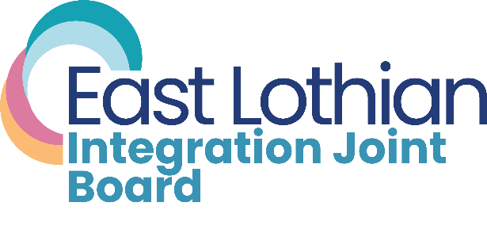

Service User Representative Vacancy
East Lothian Integration Joint Board
An opportunity has arisen for a service user representative to join East Lothian Integration Joint Board, for a three-year term, with the possibility of a further three-year extension.
This non-voting position will continue the work of the previous user representative in providing a user perspective in the meetings of the East Lothian Integration Joint Board.
This position acts on behalf of those people who use the health and social care services delivered by East Lothian Health and Social Care Partnership across the county.
An interest or background in public involvement, lived experience and co-production in health and social care would be an advantage. It is a requirement of the position that applicants live in the East Lothian council area.
Expenses are available for travel.

What is East Lothian Integration Joint Board?
The East Lothian Integration Joint Board (commonly called the IJB) works to integrate health and social care. Its membership includes East Lothian Council elected members, NHS Lothian Board non-executive directors, representatives of the third sector, health and social care professionals and others.
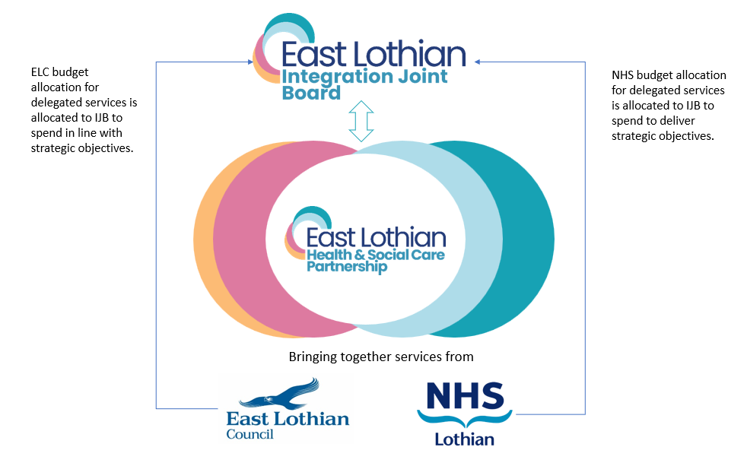
The IJB meets 10 times a year, with a schedule of formal business meetings (currently held on Microsoft Teams and with recordings available online) and development sessions. The IJB follows the East Lothian Council summer recess in July. Some meetings may be held in person.
The IJB is responsible for the development of a Strategic Plan to set out priorities for delivery of health and social care services across the East Lothian area.
The most recent Strategic Plan, for the period 2022-2025 is available at: www.eastlothian.gov.uk/downloads/file/33015/east_lothian_ijb_strategic_plan_2022_-_25.
The follow-on 2025-30 plan is currently being finalised.
The current Strategic Plan has seven objectives, which aim to:
- Develop services that are sustainable and proportionate to need
- Deliver new models of community provision, working collaboratively with communities
- Focus on prevention and early intervention
- Enable people to have more choice and control and provide care closer to home
- Further develop/embed integrated approaches and services
- Keep people safe from harm
- Address health inequalities.

Message from the Chief Officer
Fiona Wilson, Chief Officer, East Lothian Integration Joint Board says of the position:
“I very much welcome the involvement of service users, carers and family in the development of health and social care services for East Lothian’s varied communities. The service user representative position on the IJB is key to ensuring that the voice of service users is heard at the IJB and influences all that we do.”

Recruitment Process
Appointment to the position is via application form and online interview. The interview panel will consist of the IJB Chair and the IJB Chief Officer.
The closing date for applications is close of business on Friday 20th February.
Interviews will be held on Microsoft Teams on Thursday 12th March.
All applications should be sent by email to: suzanne.okane@nhslothian.scot.nhs.uk
or by post to: Fiona Wilson, Chief Officer East Lothian IJB, John Muir House, Brewery Park, Haddington EH41 3HA
If you require any more information, please telephone: 07813 784383
Application
East Lothian Integration Joint Board (IJB) Service User Representative

Name:
Address and Postcode:
Phone No:
Email:

Please say why you are interested in the Service User Representative Role.
Please say what experience you have as a Service User.
Please describe the skills and qualities you would bring to the role.
Please provide an example of when you have used your knowledge and lived experience as a Service User to engage with a statutory body on any issue.
Please provide any other information you feel is relevant to your application.

Please provide contact details of two referees to support your application.
Referee 1
Name
Contact Address
Phone Number
Email
Relationship to you

Referee 2
Name
Contact Address
Phone Number
Email
Relationship to you

I confirm that the information I have provided is accurate and completed
to the best of my ability.

Signature Date
________________________________________ __________________

Please return the completed form by close of business on Friday 20th February by email to:
suzanne.okane@nhslothian.scot.nhs.uk
or by post to:
Fiona Wilson,
Chief Officer East Lothian IJB,
John Muir House,
Brewery Park,
Haddington EH41 3HA

