Draft MINUTES
Meeting of the H&L AP,
Wednesday 9th Sept. , 7-9pm
The Town House, Haddington

Meeting Chaired by: Douglas Proudfoot, (Interim Chr) Head of Development, ELC (DP)

Members present
Gordon Crawford, Yester Parent Council (GCr)
Craig McLachlan, Gifford Community Council (CM)
Douglas Reynolds, Bolton Steadings TRA (DR)
Tom Trotter, Elected Member, ELC (TT)
Paul Darling, Haddington Community Council (PD)
John McMillan, Elected Member, ELC (JM)
Phillip White, Garvald and Morham Community Council (PW)
Frances Wright, Haddington Community Development Trust (FW)
Loreen Pardoe, Support from the Start

Substitute Members present
Paul Sales, Bolton Steadings TRA (PSa)
Ron Pearman, Haddington Community Sports Hub (RP)
Alastair Beck, Humbie E&W Saltoun and Bolton Community Council (AB)
Penny Short, Garvald and Morham Community Council (PS)
Nick Morgan, Gifford Community Council (NM)
Jane Hobbs,, Haddington Infants Parent Council (ET)
Karen Stevenson, Haddington Community Development Trust (FW)

Others in attendance
Stuart Gibb, Area Manager, ELC (SG)
Doug Haig, East Lothian Council (DH)
Kaela Scott, Local Community Planning Officer, ELC (KS)
Mandy Smith, Community Wardens (MS)

Apologies received
Brian Baillie, Haddington East TRA (BB)
Alan Dunton, Haddington East TRA (AD)
Rosemary Greenhill, Humbie E&W Saltoun and Bolton Community Council (RG)
Elaine Toweler, Haddington Infants Parent Council (ET)
Gill Colston, East Lothian Health Network (GC)

Agenda Item | Key discussion points | Action
- Welcome | DP welcomed all attendees to this meeting of the Area Partnership and confirmed that the meeting was quorate.
- Approval of Minutes | Minutes from the 24th June were approved without amendment.
- Matters Arising | DR raised a number of concerns following the last meeting:  - he questioned the governance of the Partnership, particularly how decisions had been made at the last meeting.  - he queried how budgets were being monitored and reported on.  - he felt the Partnership had not been given sufficient information about the proposals (particularly the on-going revenue implications of the Athelstaneford skatepark and the conditions of the Viridor grant)  - he suggested that the Partnership was making decisions on an ad hoc, first come basis  - he questioned the priority setting process that the Partnership had undertaken to underpin the plan – noting that he felt a key priority that had been overlooked was care for the elderly in the area, particularly over the winter and in more isolated areas.  DP (chair) responded to say that, while the allocation of budgets in this, our first year, may be more responsive than they will be in future years with our Area Plan fully developed – that all decisions regarding the allocation of funds had been made within the procedures established in the Area Partnership Standing Orders and were in line with goals identified and prioritised in our draft Area Plan.  - CM expressed the view that the budgets were there to be spent and when they were able to be used to help clearly valuable local projects, and particularly to lever in wider funding for the area these opportunities should not be wasted.  - Members confirmed their support of the key priorities in the draft Area Plan and expressed their general agreement with CM’s position.  SG explained that it was part of his role to monitor the budgets devolved to the Area Partnership, and that there were clear procedures in place to ensure that any money granted to an external organisation was used for its intended purpose and its impact reported back to the Area Partnership.  He further noted that he would be providing a budget update as part of his Area Manager’s report.  KS clarified that the Athelstaneford skate park proposal had been raised at short-notice by a member of the Partnership (EA) as unexpected circumstances had imposed a deadline on the decision to ensure that the Viridor funds granted could be retained. A brief background paper had been distributed at the meeting and EA explained the situation to members requesting help with the Athelstaneford Parent Council project (which was already included in the draft Area Plan)  - KS confirmed that as this was a Athelstaneford Parent Council project it was their responsibility to ensure on-going maintenance / adoption by ELC (which they have done) and also to meet any conditions of the Viridor grant. H&L AP are simply providing the last outstanding amount of money required to deliver the project..  East Lothian on the Move  NM updated the meeting about the East Lothian on the Move public consultation event earlier in the week which was looking at smarter travel choices in the area.  - He noted that while attendance had been poorer than hope that some interesting ideas and projects were coming out of it which will help identify some key, practical actions for inclusion in the Area Plan and Local Transport Strategy.  - He reminded members that this was just the first stage of the project and encouraged them to engage with the project as it moves forward.
- Election on a Chair (and Vice Chair) | DP noted that we had received 1 nomination for the role in advance of the meeting from Craig McLachlan and asked if there were any further nominations from the meeting.  There were no further nominations.  CM addressed the meeting to state that he would be very happy to take on the role of the chair and noted how pleased he was to see the Partnership moving on and beginning to deliver for this community.  DP called for a vote of members in support of CM as chairperson. The vote was carried with 1 abstention.  Decision: CM has been duly elected as Chair of the Haddington and Lammermuir Area Partnership  DP asked if there were any nominations for vice –chair. There were none forthcoming so DP and CM asked all member to consider themselves for this role before the Annual Public Meeting and get in touch if they wanted additional information.
- Area Manager’s Report  - Moving forward with the priorities and actions identified in the draft Area Plan | Town Centre Working Group and Signage Walkabout  Following the last meeting JM co-ordinated a town centre walk-about to look at signage – with some very useful projects identified.  This will feed into the work of the Town centre sub-group – which has also had a 1st meeting, bringing together ELC officers, HCDT, HADAS, HCC, HBA and AP representatives to co-ordinate taking forward the key goals of the Haddington Vision.  Work with Community Broadband Scotland to deliver rural Broadband  SG admitted that progress on this has not been as fast as we had hoped and felt that mixed messages from CBS were the main reason for this delay. He reported however that there was a meeting scheduled for the 29th Sept with senior staff from CBS to re-look at how things could be advanced in East Lothian and he was hopeful that this would result in a more concrete project and timetable.  Shared use of the Garvald school bus  SG reported that he had met with Ian Dalgleish from ELC Transport regarding this and been informed that since this service was operated by AC Taxis there was no capacity to take fares and this would make it impossible.  - Members commented that the Garvald bus was not an AC Taxi minibus and therefore this logic did not seem to apply  - AB commented that the need to improve public transport to the rural area was prioritised over a year ago and should have been included in the last supported bus contracts but as of yet there were no real improvements of the ground. He stressed the need for there to be more creative thought put into how these needs could be met and encouraged SG to push harder.  - DR suggested the need for an community taxi service  - KS noted that some of these things were being looked at as part of the On the Move project.  SG agreed to revisit these matters with relevant ELC staff.  Haddington Skatepark  SG reported that a bid for £50,000 had been made to Viridor which, if successful would combine with the money already raised and £22000 secured from the Local Housing Partnership to enable delivery of the project. He also spoke about the on-going engagement that had been underway with local residents, the HE TRA, the football club and transportation colleagues to ensure safe access and parking were built into the proposals.  - DR raised concerns about ongoing maintenance of the facility and questioned whether this would have revenue implications for the Partnership.  - PD confirmed that the equipment supplied has a 30 year guarantee and that the skatepark will be adopted by ELC as part of their regular upkeep of the park.  - DH and PD also confirmed that the skatepark working group are continuing to fundraise locally for the project – funding that can be used to support the launch if not required for the build  - SG also reported that there are opportunities for road calming and parking improvements (up to 22 spaces) to be integrated into work in the area, and that this was something he was following up and would update the Partnership in due course.  DP drew the membership’s attention to the proposal circulated in advance of the meeting (Appendix1), to allocate funding to the Skatepark project as a 3rd party contribution to release Viridor funding if the grant is successful, and asked for the Partnership’s support.  - Allocating this funding was agreed by majority  Decision: the H&L AP will provide funds up to £5091 to meet the 3rd party contribution required to release the Viridor funds if the application is successful.  Tour of Britain  SG reported that his event had taken place that day and seems to have been very successful and well supported.  Youth Priorities Sub-group  This group has not yet met although a range of related discussions have continued.  - LP reported that the bid made jointly by support from the Start and the Sports Hub to undertake a feasibility study related to increasing flexible use of the Neilson Park Pavilion had been unsuccessful. The group was now considering other options to take this work forward.  - SG reported he has had difficulties making progress with Enjoy to extend some of their youth activities and has yet to be able to organise a meeting.  - SG reported that conversations were continuing to between staff and Knox to re-initiate the homework club at the Nungate – the biggest issue at present however is sustaining ongoing access to the facility.  SG referred to the 2nd funding proposal distributed in advance (appendix 2) – to fund a RUTS programme for targeted young people from Knox during the October break – linking it to the opportunities being looked at by the youth sub-group.  Mandy Smith spoke to this proposal and clarified why this was a discounted offer and she felt an opportunity that should not be missed.  - TT, CM and DR spoke in support of the proposal  DP called for a vote and the proposal was agreed by majority.  Decision: the H&L AP will provide £400 to support this.  Road Safety Sub-group  SG re-issued the call for member groups to identify local issues / short term priorities for consideration by this group. Potential projects should be sent to H&L-AP@eastlothian.gov.uk  CM stressed the importance of members becoming involved in the sub-groups as this is where the real work needs to be done. He encouraged members to consider where they could assist and contact SG to volunteer.  Budget update  SG provided a verbal update regarding the budget and agreed to send a more formal statement to members following this meeting.  Our General budget for this current financial year is £50,000.  To date the Partnership has committed £2,297 as contribution to Athelstaneford skate park (Agreed 24th June 2015)  With the allocations made today this leaves £42,212 still to be allocated.  To date the only allocation from the £50,000 Roads Capital Budget is the £5,000 for a reactive speed sign and 2nd NAL socket for East Saltoun (Agreed 24th June 2015). | SG: to continue to develop this group and work with them to develop recommended actions for the Area Plan  SG: to pursue  SG: to notify members if the Viridor application is successful  Members: identify specific issues / projects to establish a long list of possible actions for the sub-group to work from.  Members: Contact SG if interested in one of the Sub-Groups.
- Planning for the Annual Public Meeting | KS reminded members that there was a requirement for the Area Partnership to host an Annual Public Meeting as an opportunity to display and consult on the Area Plan with the wider community of the ward.  It was felt the provisional date identified (7th October) was too soon to organise this and a new date 21st October was agreed. | KS SG and CM : to meet and set a framework for the event and involve other members as needed.
- AOCB | Local Government Boundary Commission - Consultation (22nd Oct.)  KS referred to the information regarding the proposed changes to the ward boundaries that had been distributed in advance of the meeting and asked whether the Partnership wanted to make a response.  - DR questioned whether disruption to the Partnership working was really a reason to oppose the new boundaries  - PS, CM, TT, GC all spoke about the impact the change would have not only on local planning in relation to breaking up natural communities, dividing school clusters and the practical implications of re-aligning Partnerships, priorities and workloads.  DP asked the members to vote on whether we should make a response opposing the changes on behalf of the Partnership  - The vote was carried by majority | Members: to contact KS with comments for inclusion in a draft response  KS: to draft a response and circulate for comment in advance of submission
- Date of Next Meetings | Annual Public Meeting - Wednesday 21st October, Knox Academy  - 7pm for members  - 7:30pm for public attendees  - This will be the first APM of H&LAP where a community chairperson will be appointed and the draft Area Plan will be presented to the wider public for consultation  Wednesday 18th November, 7-9pm, venue tbc | Please send any apologies to: h&l-ap@eastlothian.gov.uk

Proposal to allocate funds to the Haddington Skate Park Project
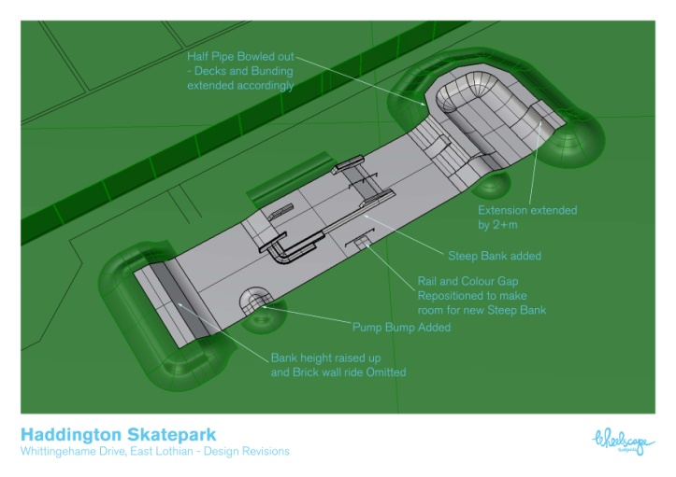

Background
In a survey carried out in 2011 by Urban animation on behalf of (what subsequently became) Haddington Community Development Trust a Skate park was identified by the Young People in the Area as a primary requirement. Haddington Community Council (HCC) then became involved in this project when a Young Person wrote to them asking for their support. In May 2015 the Haddington and Lammermuir Area Partnership agreed to support the development of the Skate park project under auspices of the Area Partnership as this was identified as a Goal to be delivered under the draft Area.
Land for the project has currently been identified in front of the football pitches on Whittingehame Drive, Haddington and ELC Amenity Services are fully supporting the project and have agreed to 'adopt' the skate park on completion for maintenance etc.
Over the summer period a number of workshops have been held with some Young People culminating in ELC Amenity Services carrying out a tender / procurement exercise. The winning bid came from Wheelscape (http://www.wheelscape.co.uk/) a Company who specialise in bespoke Skate park design and construction and the project was identified as having a total budget cost of £107,750 (see over for details). To date all but £50K has been raised from a number of sources in funding for this project and a subsequent bid for this amount was made to Viridor Credits at the start of August 2015. A decision on this is expected imminently.
When Viridor Credits awards funding it awards a gross amount to the applicant (in this case HCC) and for this amount to be released a payment of 10% of the award (i.e. £5K) is required from a Contributing Third Party (that is neither the applicant Organisation i.e. HCC nor Viridor Credits) to Viridor Waste Management.
Current Project Budget
Total Project Value | £107,750 | Notes
ELC Contribution | £20,000 | Land, clearance, landscaping
Cash raised by HCC in fundraising | £4,000 | Approved
Haddington Common Good Fund | £5,000 | Approved
HCC Additional contribution | £2,000 | Approved
Haddington Community Development Trust | £5,000 | Approved
Haddington Local Housing Partnership | £21,750 | Approved in principle
Viridor Credits | £50,000 | Decision awaited. 10% of award is required to release funds

Proposal
Haddington Community Council are requesting that the Haddington and Lammermuir Area Partnership become the Contributing Third Party for this project and provide £5,000 (or 10% of any award amount from Viridor Credits up to this figure) to realise their plan for a Skate park at Whittingehame Drive in Haddington. This request links directly with the proposal identified in the current Draft Area Plan (Strategic Objective 3 / Priority 1 – “All areas of the Ward are equipped with the facilities required to support thriving local communities”) . This facility will provide a high quality sporting and social facility that will be enjoyed by not only the Young People in Haddington but also those across also the wider Area Partnership. The Skate park has been designed for by skateboarders and also those who use roller blades, scooters and bikes. Throughout the design process particular emphasis has also been focussed on making this an inclusive facility so that wheelchair users can also benefit
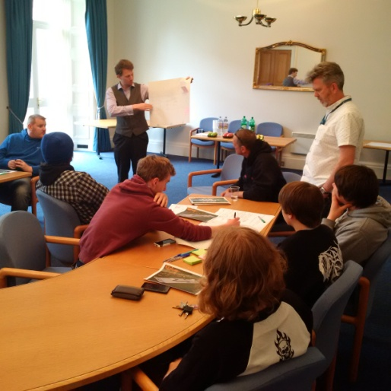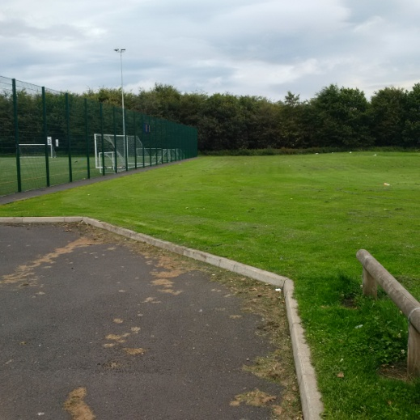

Proposal to allocate funding for a 5 day RUTS Project for Knox Academy Pupils

Background
RUTS (Rural and Urban Training Scheme) was established in 1981, by a group of enthusiastic motor-cycling youth workers to provide activity based group work projects for young people. These projects used off-road motorcycling as an activity which took the interest of the young people involved and encouraged involvement, but at the same time provided opportunities for useful growth experiences such as team-work and taking instruction.
RUTS aims to equip young people with the confidence and skills required to achieve their highest potential and raise their aspirations. This is achieved through motorcycle and bicycle based programmes that are tailored to the individual needs of clients. Through this a positive difference is made to young peoples’ lives and the communities they live in. The activities are an extremely successful model of excellence for moving young people into positive destinations. Their programmes enable the acquisition of skills and qualifications producing more confident and assured transitions towards employment for vulnerable 14-19 year olds on the margins of society.
For more info please see www.ruts.org.uk/

Proposal
The ELC Safer Communities Team wish to run the RUTS “Use and Care of handtools “ course for 8 young people during the week 12-16th Oct 2015 (School holidays) and are proposing to do this outside the Corn Exchange in Haddington using a collapsible workshop tent, where two motorbikes are used to work on. The course programme consists of 4 days workshop and tool handling modules followed by a final day of off-road motor biking at Lamancha in the Borders. Participants will also have the opportunity to gain a qualification accredited to SCQF Level 4. This has already been run very successfully in Prestonpans and Wallyford.
The aim is to identify 8 young people who currently attend Knox Academy (through discussions with the school) and selection will be focussed on those who are currently experiencing behavioural difficulties as well as those who lack confidence. This links to the Draft Area Plan through STRATEGIC OBJECTIVE 2 / PRIORITY 1 – “Supporting our Young People to fulfil their potential within the Community”.
The course is being offered at a total cost of £200.00 – a considerable saving on the normal cost of £500. With refreshments and meals the Safer Communities Team are therefore seeking a total of £400.00 from the H&L Area Partnership.

