

**Report on the first**

**ANNUAL PUBLIC MEETING**

**of the**

**Haddington & Lammermuir Partnership**

**7pm Wednesday 21st October 2015**

**Knox Academy, Haddington**

**Haddington & Lammermuir Area Partnership** is one of 6 Area Partnerships across East Lothian operating as the local voice of the East Lothian Partnership to deliver community planning across the county.

You can contact Haddington & Lammermuir Area Partnership at

[h&l-ap@eastlothian.gov.uk](mailto:h&l-ap@eastlothian.gov.uk) or on 01620 827871

Find meeting dates and minutes at

[http://www.eastlothian.gov.uk/meetings/committee/109/east_lothian_partnership-Haddington & Lammermuir area_partnership](http://www.eastlothian.gov.uk/meetings/committee/109/east_lothian_partnership-Haddington%20&%20Lammermuir%20area_partnership)

**The Haddington and Lammermuir Area Partnership, formed in 2014, covers Samuelstone, Humbie, Saltoun, Haddington, Garlvald, Athlelstaneford, Bolton, Elvingston, Morham, Gifford, and everywhere in between.**

**Who is representing Haddington and Lammermuir on the Area Partnership?**

* Elected members from East Lothian Council
* Garvald and Morham Community Association
* Haddington and District Community Council
* Humbie, East & West Saltoun and Bolton Community Council
* Nungate Tenants & Residents Association
* Riverside Tenants & Residents Association
* Bolton Steading Tenants & Residents Association
* Primary School Parent Councils
* Knox Academy Parent School Partnership
* Haddington Community Development Trust
* Haddington Business Association
* Haddington Community Sports Hub
* East Lothian Health Network
* Support from the Start Haddington

If you have anything you would like to raise with the Area Partnership contact any of the organisations above or e-mail [h&l-ap@eastlothian.gov.uk](mailto:h&l-ap@eastlothian.gov.uk)



**Haddington & Lammermuir Area Partnership** -

**Annual Public Meeting**

**The Haddington and Lammermuir Area Partnership is using our first Annual Public Meeting to begin consulting with the wider community about our draft Area Plan.**

After looking at the evidence and working with residents and stakeholders across this local community the Haddington and Lammermuir Area Partnership has identified 9 priority areas for action across the three strategic objectives of the East Lothian Plan which will help deliver these outcomes locally.

The priorities are supported by an Action Plan which details how the Area Partnership will work with public services, voluntary sector agencies, communities and local people to achieve each priority’s outcomes; priorities that focus on the real differences we want to make.

**Our local priorities:**

**Strategic Objective: Sustainable Economy**

Our 3 priority areas for action are:

**PRIORITY 1** - **Enhancing our town centre and supporting a robust local economy.**

* Establish Haddington High Street as ‘The Best Town Square in Scotland’ with a vibrant shopping centre.
* Develop and deliver a successful access strategy for Haddington Town Centre.
* Make the most of Haddington’s assets including buildings and public spaces.
* Effectively market all that Haddington & Lammermuir has to offer.

**PRIORITY 2 - Improving the availability of high speed broadband across the ward**

* Superfast broadband established throughout the areas of the ward out-with the planned roll-out.
* Businesses enabled to take advantage of better broadband access with more home working and more start-ups throughout the ward.

**PRIORITY 3 - Improving options for sustainable travel across our communities**

* Increased use of active modes of travel (i.e.: walking and cycling) for trips within the Ward.
* Public transport provides the Ward with reliable, accessible and regular services appropriate for the Community’s needs.

**Strategic Objective: Resilient People**

Our 3 priority areas for action are:

**PRIORITY 4** - **Supporting our children and young people to fulfil their potential**

* Ensuring children and young people feel safe in their area.
* Ensuring children and young people can access appropriate facilities and services by sustainable means.
* Ensure children are able to play and interact in safe and appropriate environments.
* Ensure young people in the ward have spaces to hang out and socialise, and access to recreation facilities.
* Ensure young people have positive professional and educational opportunities after school.
* Ensure young people have a voice within the Area Partnership.

**PRIORITY 5 - Ensuring Health and Mental Health care services in the Ward effectively meet everyone’s needs.**

* The Ward, and the County are served by an excellent community hospital at Roodlands.
* Improved awareness of mental health within the community and effective local services.

**PRIORITY 6 – Older people in the community are supported to live happy and independent lives.**

* Health services throughout the ward are accessible for older residents.
* Suitable housing for older residents is provided throughout the ward where required.
* Social opportunities for >65s are enhanced and developed where needed throughout the ward.
* Where older people throughout the ward require support this is delivered within their communities wherever possible.

1. **Enhancing our town centre and supporting a robust local economy**

**What the Haddington and Lammermuir Area Partnership is doing to achieve this goal ...**

**The Town Centre Project**

Across Haddington there are a number of groups and services who are working to improve the town centre as a place where visitors, residents and businesses can all thrive.

The **Haddington Town Centre Sub-Group** brings together representatives from:

* Haddington Community Council
* Haddington Community Development Trust
* Haddington and District Amenity Society
* Haddington Business Association
* NHS Lothian, East Lothian Community Hospital team
* Haddington and Lammermuir Area Partnership
* East Lothian Council’s Economic Development and Planning Services

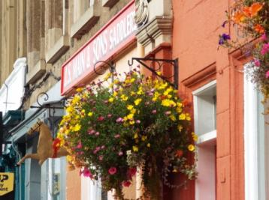to focus on delivering the goals set out in **The Haddington Vision** in a coordinated way. In this way, while each group or service will still continue to take forward their own projects, we will know we are working in partnership towards the same overall outcomes.

1. **Establish Haddington High Street as ‘The Best Town Square in Scotland’ with a vibrant shopping centre.** We want Haddington’s High St to be vibrant and attractive focus for town centre activity: where local businesses are well supported and residents and visitors can easily access the shops and services they need.
2. 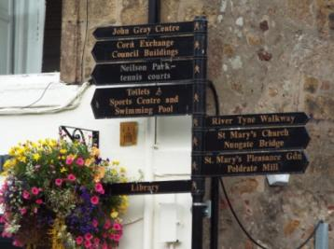**Develop and deliver a successful Access Strategy for Haddington Town Centre.** We believe the best way to achieve a balance between people, vehicles, environmental quality and town centre vitality is to prepare a dedicated Access Strategy for the town centre. This would look at the inter-relationships between access, parking, pedestrian comfort and safety, public transport, cycling and public space.
3. 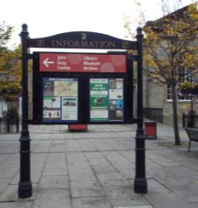**Make the most of Haddington’s Assets – natural, built and historic.** We think it needs to be easier for visitors and locals alike to come to Haddington and find the good things that the town has to offer - the river and its bridges, the riverside path, Neilson Park, St Marys Church, Church Street, St Mary’s Pleasances and more.
4. **Effectively market all that Haddington & Lammermuir has to offer.** We know that we need to improve the information that is available to visitors to Haddington and market the charms of the area to a wider audience.

|  |  |  |
| --- | --- | --- |
| **Town Centre Improvement Projects** | | |
| **Renewing the black and gold finger-point signage with clearer, accurate signs** | 5 | |
| **DSCF1401.JPG**  **Improve planting and trees within the town centre and provide more seating** | 2 | |
| **Establish a Park-and-Ride site for commuters**  to free up existing town centre parking | 7 | |
| **Signage from the A1 showing Haddington as a destination**  (brown tourist signage similar to signs to East Linton) | 5 | |
| **Improve signage from all town entrances to the town centre and local attractions** | 6 | |
| **DSCF1394.JPGIncrease turn-over of high street parking** | 7 | |
| **Re-design High Street parking**  to widen pavements and create more public space. | 3 | |
| **Establish a coach drop off point in the town centre**  (linked to longer term coach parking site out of the centre) | 4 | |
| **Improve Shop Frontages**   * re-visit and implement the shop front / building colour and signage scheme | 8 | |



**Proposed projects...**

**Please help the Area Partnership set its priorities for the next year by voting for the projects you think will have the most impact on achieving this goal.**

1. **Enhancing our town centre and supporting a robust local economy**
2. **Improving the availability of high speed broadband across the ward**

|  |  |
| --- | --- |
| **Marketing and Tourism Projects** |  |
| **Promote Haddington and surrounds as a walking destination**   * **DSCF1415.JPGestablish, signpost and promote** - river trail, gardens trail, history trail etc | | 11 |
| **Establish a new tourist info point to compliment info**  **available a the library when it is closed**  – possibly electronic portal on the High St (like Dunbar), phone box info point | | 8 |
| **Monthly town centre markets** | | 2 |
| **Develop a multimedia show of Haddington’s history at St Mary’s** | | 4 |
| **Establish a ‘whole town website**  covering: tourism information, community information, a local ‘what’s on’, links to local groups etc | | 14 |
| **Establish a ‘Haddington Weekend’**  – possibly featuring John Knox | |  |
| **Develop a specific branding for the town and design new leaflets**  DSCF1412.JPG– in a clear series to highlight different aspects of the town’s history/ environment (like the existing Closes leaflet) | | 5 |
| **Establish a campsite** | | 2 |
| **DSCF1417.JPGDevelop an on-going programme of history tours**  – not just during festival time | | 7 |
| **Improving the night-time economy**  – what are we offering to overnight visitors? | | 5 |

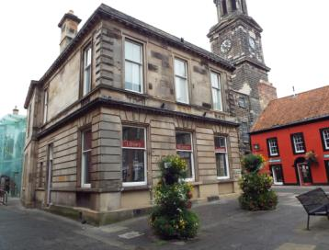

**Proposed projects...**

**Please help the Area Partnership set its priorities for the next year by voting for the projects you think will have the most impact on achieving this goal.**

***‘Slow upload speed causes intermittent faults with our operation which if our business is to continue to grow, may well mean our having to move outwith the area in search of faster and more reliable broadband’***

**2) Improving the availability of high speed broadband across the ward**

***‘We have passed the point where Broadband is an essential public utility, like electricity, gas, water etc. Really feel strongly that rural residents are disadvantaged by this***

**Good broadband connectivity is becoming increasingly important in people’s lives. We need it for work, learning, accessing services, leisure and keeping in touch with family and friends.**

**Connectivity varies across East Lothian and people in rural areas can find it difficult to take full advantage of digital opportunities**

**To support a sustainable economy across the Haddington and Lammermuir area we need to improve internet connectivity and ensure high speed broadband is available in all possible parts of our ward.**

In February 2015 a survey was organised by the Haddington and Lammermuir Area Partnership, in collaboration with community representatives from other rural areas of East Lothian. It was designed to find out more about the demand for superfast broadband in areas of the county which are not likely to see significant improvements in the broadband speeds they receive through the existing commercial roll out plans (mainly covering larger towns) or the current Digital Scotland programme (which aims to ensure fibre broadband is available to 95% of Scottish properties by the end of 2017).

**As a result of this survey the Area Partnership has begun working with Community Broadband Scotland - a Scottish Government project that supports and empowers remote and rural communities across Scotland to establish community broadband networks – on a project to deliver superfast broadband to rural areas of East Lothian.**

They have now begun to identify the areas that could be covered by this project and, following a period of technical analysis and commercial consultation, a decision is expected to be taken in early 2016 to finalise the coverage of this innovative project which it is hoped will deliver improved broadband coverage to our rural areas from late 2016.

**Results from our survey**

* 528 responses were received to the survey
* Together these households and businesses cover 1516 broadband users and/or potential users – 1158 adults and 358 children.
* 80% reported that they were dissatisfied with their current broadband provision
* 99% stated they would be interested in having access to superfast broadband in the future

***‘We have passed the point where Broadband is an essential public utility, like electricity, gas, water etc. Really feel strongly that rural residents are disadvantaged by this’***

***‘Slow upload speed causes intermittent faults with our operation which if our business is to continue to grow, may well mean our having to move outwith the area in search of faster and more reliable broadband’***

**What the Haddington and Lammermuir Area Partnership is doing to achieve this goal...**

***‘We have passed the point where Broadband is an essential public utility, like electricity, gas, water etc. Really feel strongly that rural residents are disadvantaged by this’***

***‘Slow upload speed causes intermittent faults with our operation which if our business is to continue to grow, may well mean our having to move outwith the area in search of faster and more reliable broadband’***

1. **Improving options for sustainable travel across our communities**

**What the Haddington and Lammermuir Area Partnership is doing to achieve this goal...**



The Area Partnership is working with East Lothian Council at the moment on the **East Lothian on the Move** project – which aims to make it easier for people

throughout the area to choose to use smarter forms of transport when they travel.

East Lothian Council is already demonstrating a commitment to making improvements that support more sustainable travel choices in the area (as illustrated below). This project however takes things a step further by working directly with the community to ensure that the projects and initiatives that local people identify as being able to make a difference are incorporated into the Council’s Local Transport Strategy and Active Travel Improvement Plan – and therefore have a better chance of being delivered.

**Recently completed Core Paths, Walking and Cycling Route improvements**

* The River Tyne Path: Creation of a new core path from Haddington to East Linton
* Improvements to the Haddington – Longniddry Railway Walk (NCN76)
* Construction of a new core path from Haddington to the Garleton Hills
* Construction of a new core path from Haddington to Bolton
* Construction of a new core path through Yester Estate near Gifford
* Construction of a new core path connecting Gifford to Garvald
* Improvements to The Clarty Loan core path from Morham towards Gifford
* Improvements to the route by the Donolly reservoir between Gifford and Garvald

**Improvement works programmed for 2015-16**

* Replacing stiles with pedestrian gates between Athelstaneford and Drem
* Improvements and signposting of the core path between Gifford and Garvald

**Recent improvements to bus services through Supported Bus Service contracts**

* a 6 day a week ‘health link’ service between East Lothian and the Edinburgh Royal Infirmary (122)
* Services 122, 120, and 121, now all carry pupils to and from school who have had their Young Scot card adapted to operate as a pass on the service

**... and still planned for 2015-16**

* Introduction of a Humbie ‘shopping bus’ a couple of times a week
* A review of services 121 and 123 to see if there are ways of providing better access to health facilities and greater inter connectivity between services (including trains)
* **Find out more about East Lothian on the Move at** [**www.eastlothian.gov.uk/smartertravel**](http://www.eastlothian.gov.uk/smartertravel)

**There are a number of potential projects to improve options for walking and cycling in the area that have already been identified to be explored and possibly progressed in future years including:**

* Improvements to the core path at Letham near Haddington
* Core path from Humbie village to kirk
* Improvements to surfaces of both Haddington to Longniddry and Pencaitland Railway Walks
* Extend Pencaitland Railway Walk to Gifford
* Knowes Farm to Monksmuir – A199 - cycle route surface improvement
* Improved town centre cycle parking

**As part of the East Lothian on the Move project however we want to know what would encourage you to use different forms of travel more often for your commute, school run or to access local services.**



|  |  |
| --- | --- |
| What are the barriers to travelling by bike? | What could encourage you to cycle more often? |
| I’m not fit enough  Dangerous roads? (more cycle lanes)  Bike storage/shelter racks  Dangerous roads and distance  Clear & safe routes – particularly when cycling with children | Joined up transport eg bike shelters next to bus stops?  Map of cycle routes (digital) |



|  |  |
| --- | --- |
| What are the barriers to walking more often for local journeys? | What could encourage you to walk more often for local journeys? |
| Dangerous roads and distance | Create and develop a Walk/Run/Cycle network through Haddington & Lammermuir. This could be colour coded and clearly signed. All routes could start/finish in Neilson Park and a trail run around Neilson Park that has exercise stations (like Inverleith Park in Edinburgh) would be a great addition. |

1. **Improving options for sustainable travel across our communities**
2. **Improving options for sustainable travel across our communities**

**There are a number of potential projects to improve access to public transport in the area that have already been identified to be explored and possibly progressed in future years including:**

* The establishment of a Park-and-Ride facility in Haddington
* Whether some school bus services could become shared use and opened up to other local residents
* Demand responsive mini-bus service for young people in the rural villages on weekends and during holiday times
* Improvements access to Longniddry and Drem railway stations

**As part of the East Lothian on the Move project however we want to know what would encourage you to use different forms of travel more often for your commute, school run or to access local services.**

|  |  |
| --- | --- |
| What are the barriers to travelling by bus? | What could encourage you to use the bus  more often? |
| Car Parking in Haddington to get bus to town  Early time of last bus and poor connections to Edinburgh buses for 123 Gifford circle  No bus service  More express services and for longer/later at night  Cost and timings  trainsymbol.png | Access to digital app to see bus times etc  A bus service  Lower prices |

* 

|  |  |
| --- | --- |
| What are the barriers to travelling by train? | What could encourage you to use the train more often? |
| No train station close by  Time is too precious to waste waiting on late trains  Not enough trains to/from London stop at Dunbar  Doesn’t compete with the cost of a car. Too expensive  Lack of joined up buses/ticketing | More bus connections rurally  More parking space at Drem  More parking at the various local stations as Haddington commuters have to drive to them to use the trains.  London-Edinburgh train stopping at Dunbar, so don’t have to go into Waverley |

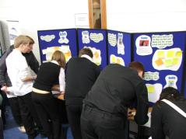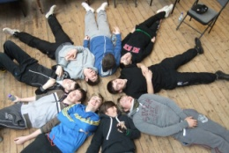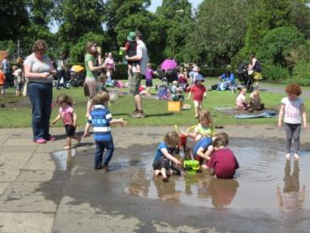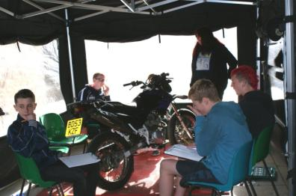

**From the outset the Partnership agreed that supporting opportunities for children and young people should feature strongly in our Area Plan, and that young people themselves should have the opportunity to contribute to its development.**

**Youth led meeting of the Area Partnership**

Staff from East Lothian Council supported a group of 4th year pupils from Knox Academy to lead our November meeting which would focus on the needs of young people in the ward.

In preparation for this the group worked with staff to:

* look back at the previous consultations done with young people as part of developing the Haddington Vision and identify which priorities remained un-met;
* survey a representative sample of 2nd, 4th and 6th year pupils at Knox about the facilities they used in the area and their views on local transport and safety;
* prepare a presentation for the evening showing their findings and raising questions for discussion.

At the meeting the youth representatives gave a number of suggestions for actions to be included in the Area Plan that would improve things for young people.

* More lighting along dark footpaths;
* Somewhere for S2s to go at lunch;
* Better opening times for the Astroturf and gym;
* Better bike security at school and in town;
* Opportunities for young people to learn in different ways and develop new skills;
* More places for young people to gather and socialise (indoor and out, day and evenings);
* More events for young people – movie nights, music events etc;

**Other things we are doing...**

**Expanding our membership to ensure the interests of children and families are represented.** Last November all Parent Councils were invited to become members of the Area Partnership – and Yester, Humbie, Haddington Infants and Knox Parent Councils are now members. Recently Support from the Start, focusing on 0-8yr olds has also joined.

* **Activities for young people**

At the request of the ELC Safer Communities Team the Partnership provided funding to run a RUTS

(Rural and Urban Training Scheme) ‘Use and Care of handtools’ course for 8 young people during the October school holidays. RUTS use off-road motorcycling as an incentive to engage the young people, while also providing opportunities for useful growth experiences such as team-work and taking instruction. Participants also have the chance to gain a qualification accredited to SCQF Level 4.

**What Haddington and Lammermuir Area Partnership is doing to achieve this goal...**

1. **Supporting our children and young people to fulfil their potential**
2. **Supporting our children and young people to fulfil their potential**

|  |  |
| --- | --- |
| **50s Diner Style Cafe in Haddington:**  Give young people a place to hang out at least 1 evening a week. | 6 |
| **A what’s on when guide to activities for children and young people**  Distributes through all schools and covering youth clubs, sports, music, uniformed groups and other activities | 9 |
| Assist schools and local agencies working with young people to **provide targeted interventions that and help support vulnerable young people** | 4 |
| **Install secure cycle storage at Knox Academy:**  Issues of bike vandalism and theft have meant young people are concerned about cycling to school. Safe storage facilities are needed to minimise this concern. | 4 |
| **More opening times for young people at the gym:**  Establish additional opening times for young people at the Aubigny Centre | 2 |
| **Increase the availability of play and family learning opportunities in the Nungate Centre** – supporting Support from the Start’s focus on establishing an effective Parenting Pathway in the area | 4 |
| **Regular Shuttle-Bus to Haddington for Young People in the Villages:**  providing a regular (perhaps weekly/ fortnightly Fridays) Shuttle-Bus service bring young people from rural areas into Haddington to participate in local activities | 10 |
| **More open-pitch time at Aubigny Astroturf:**  Establish additional open-pitch times at Aubigny Astroturf – particularly during school holidays | 3 |
| **Mobile under 12s rural movie night:**  hosted in various villages in the ward showing family friendly films. | 2 |
| **Pilot a ‘Play Ranger’ for Neilson Park**  providing a year round play programme for early years and primary aged children. | 7 |
| **Youth Workers to work with u-12s in the villages in outdoors environment:** youth workers on 6-week blocks could oversee informal play in outdoor spaces to encourage children to engage with the outdoors. | 5 |
| **Homework Club for Young People:**  Work with Knox Academy to re-establish a regular Homework Club at the Nungate centre | 1 |
| **Provide additional fold/roll away seating for Knox’s social space** to meet the need for comfortable hang out places at lunchtimes within the school |  |
| Support **opportunities for young people to gain accreditation** outside of the regular school curriculum | 10 |

**Do you have any ideas that would help achieve this goal?**

Make **better** and **more** use of Nungate and Corn Exchange for young people/ Aubigny Sport Centre gym needs a large refurb – use Knox gym? Use Rugby Club gym?/ Community transport specifically to serve rural areas to allow groups like Active Schools to visit rural schools and to transport kids to Haddington and area for movie nights, homework clubs, rainbows etc/ Meeting and leisure space for S4+ pupils/

**4. Supporting our children and young people to fulfil their potential**

**Proposed projects...**

**Please help the Area Partnership set its priorities for the next year by voting for the projects you think will have the most impact on achieving this goal.**

1. **Ensuring health services in the ward meet everyone’s needs**

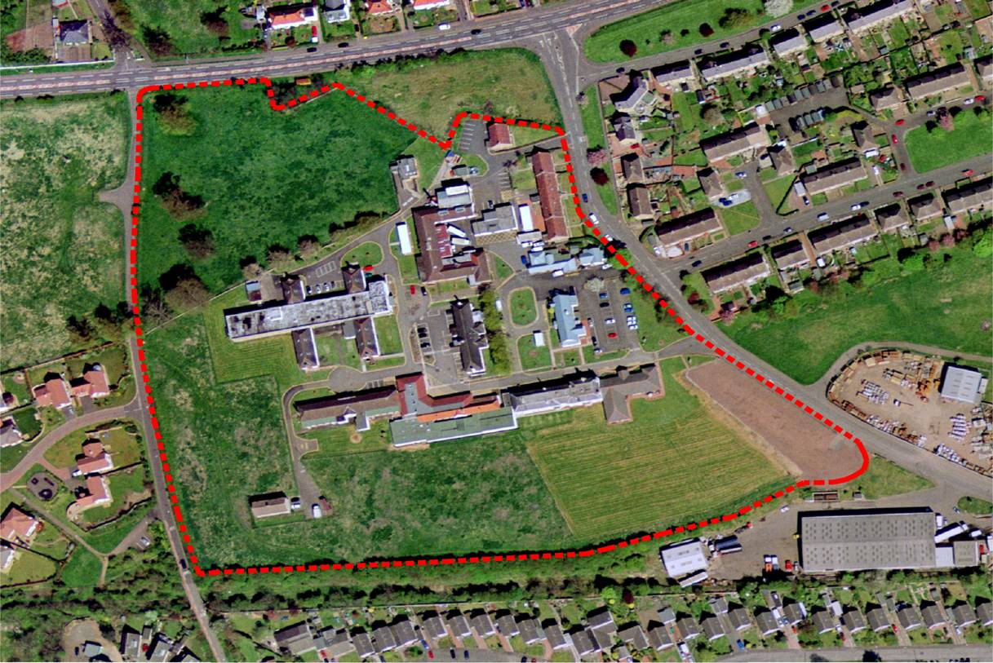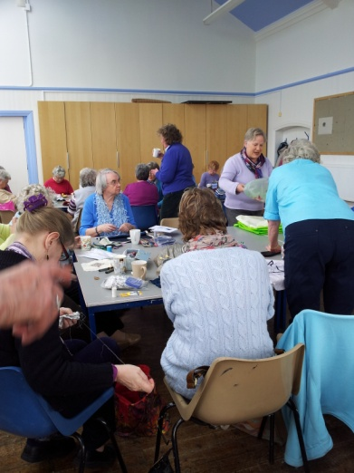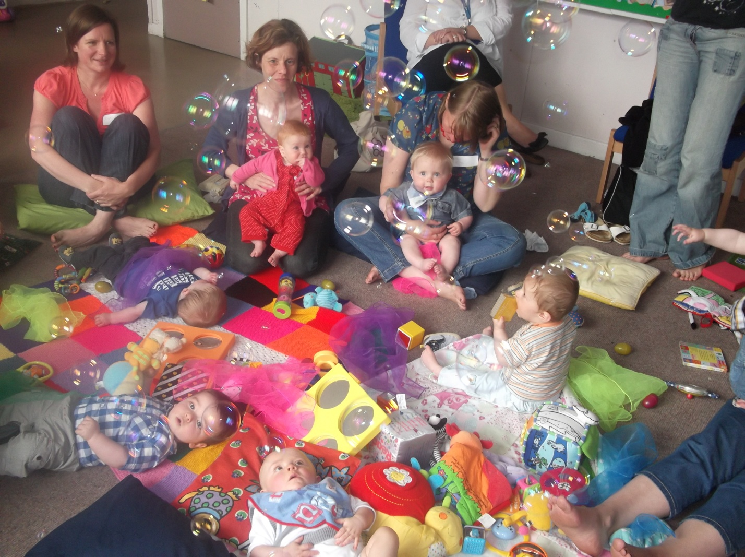

**There are a lot of changes underway across East Lothian in the way health and well-being services are going to be provided in the future, some of which will have a particular impact on the Haddington and Lammermuir ward.**

**To ensure we are well informed about new developments and able to have an influence on the decisions that are being made Haddington and Lammermuir Area Partnership is working with many different organisations and services to try and ensure that health and well-being services in the ward effectively meet everyone’s needs.**

* **Briefing on plans for the East Lothian Community Hospital**

In September 2014 David Small, Director of Health and Social Care Partnership and Andrew Milne, Project Director Hub Initiatives, NHS attended the Area Partnership meeting to provide information on the plans for the new hospital site. They also addressed questions about the services to be provided there, parking and public transport considerations, and concerns about

the possible relocation of local GPs and community based mental health services into this facility.

* **Consultation on the integration of Health and Social Care**

The December meeting of the Area Partnership was given over to consultation on the strategic objectives for the new models of delivering adult health and social care services in East Lothian which are emphasising prevention, early intervention and providing care closer to home. Here discussions focussed on the growing number of older people living in our communities and challenges to accessing services caused by rural isolation.

* **Links between town centre plans and the new hospital site**

We are working closely with colleagues from the NHS and the Scottish Futures Trust (an independent company, established by the Scottish Government in 2008 with a responsibility for delivering value for money across all public sector infrastructure investment) on the new East Lothian Community Hospital to ensure that the benefits from investment in the area spread throughout the town.

* **Widening the definition of health and well-being**

We are also interested in supporting initiatives that encompass a wider definition of health and well-being including:

* Support from the Start;
* Improving levels of physical activity;
* Dementia Friendly projects;
* Supporting child and adolescent mental health;

and examples of work in some of these areas can be seen in other parts of the plan.

**What Haddington and Lammermuir Area Partnership is doing to achieve this goal...**

Ideas from the Annual Area Partnership Meeting:

* Carers of East Lothian
* Walk in health care/advice (Leith Community Hospital)
* Local Housing Plans and neighbourhood development for care and wellbeing
* Home delivery of prescriptions – better communication between health centres and pharmacies
* Create strong links with local and national charities for support and guidance eg Parkinsons UK, Alzheimers Scotland etc
* Walking and cycling routes to school/nursery

1. **Improving community facilities throughout the ward**

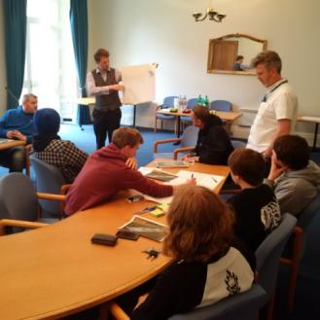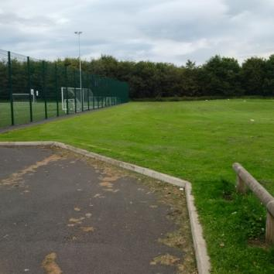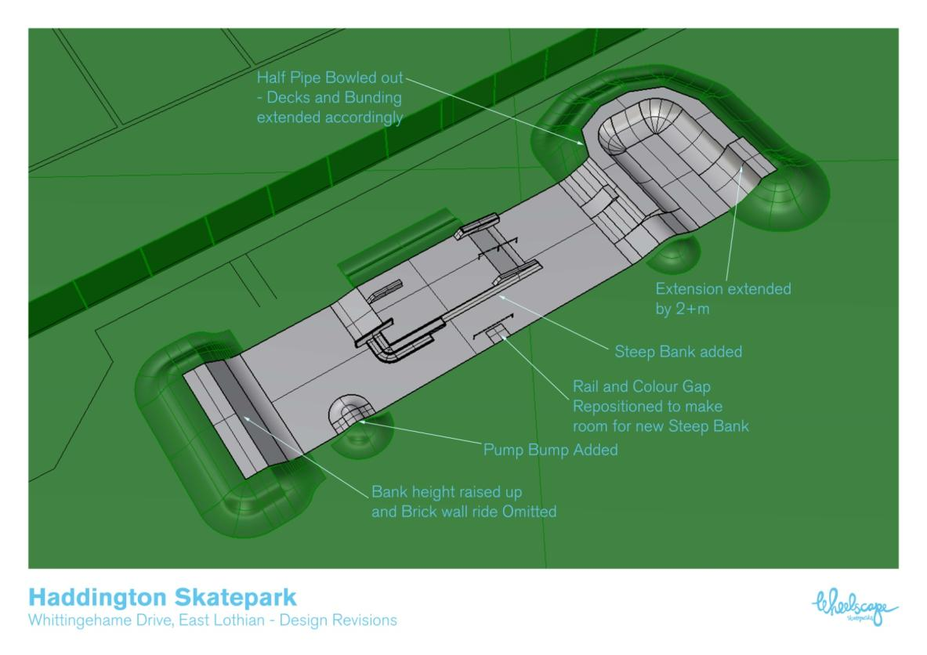

**Haddington Skatepark**

**Since April 2015 the Haddington and Lammermuir Area Partnership has taken on a lead role in Haddington Community Council’s project to build a high quality skatepark in the town - beside the existing football pitches in Whittingehame Drive – driving the project forward as a key priority within the Area Plan.**

In a survey carried out in 2011 by Urban Animation (on behalf of what subsequently became Haddington Community Development Trust) a skatepark was identified by young people in the area as a primary requirement. Haddington Community Council (HCC) subsequently became involved in trying to deliver this for the area after a young person wrote to them asking for their support. Following this a skatepark working group was formed which began raising funds, developing design ideas and generating support for the project.

Young people have been closely involved in this project from the start and over the summer period a number of workshops have been held with young people to develop a design brief to meet the needs of skateboarders and also those who use roller blades, scooters and bikes. Throughout the design process particular emphasis has also been given to make sure this an inclusive facility so that wheelchair users can also benefit. This led to ELC Amenity Services carrying out a tender / procurement exercise for the design. The winning design from Wheelscape can be seen below.

Following the success of a recent bid to Viridor Credits for £50,000, and a small contribution from the Area Partnership, all of the funding for this £108,000 project has now been secured.

Work is now underway to obtain planning permission and it is hoped that construction will begin in January - with the skatepark ready for use by Easter 2016.

**What Haddington and Lammermuir Area Partnership is doing to achieve this goal...**

1. **Improving community facilities throughout the ward**

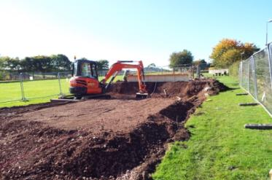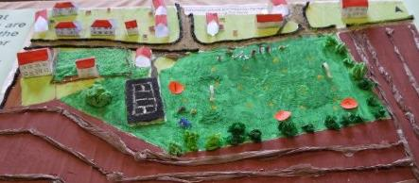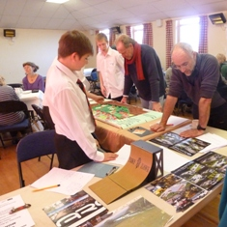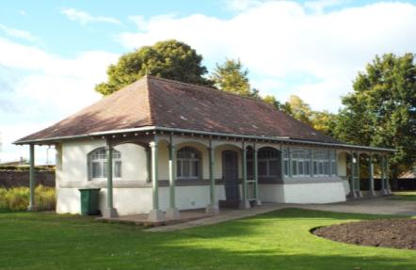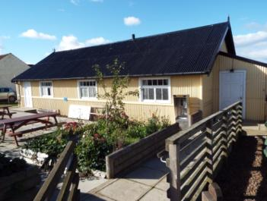

**Developing Neilson Park Pavilion as a multi-use facility**

Knowing that there were a range of different groups with ideas for how this building could be better used the Area Partnership brought together the Friends of Neilson Park, Support from the Start (who have used the pavilion for a number of successful play events) and the East Lothian Council staff responsible for the building. Together we are now exploring the possibility of re-developing this space as a focus for play and casual recreation in the park – while still meeting the current and future changing room needs of the sports clubs based there.

**Directory of Community Facilities**

Earlier this year the Partnership began an audit of what

facilities were available for community use across the ward and how you book them.

We are hoping to compile this information into a useful, 1-stop guide for residents that will be available on-line, from the library and in other local venues.

**Athelstaneford Skatepark**

Young people from Athelstaneford campaigned for a skate park and carried out a community consultation. They received support from Athelstaneford Parent Council who, after several years of fundraising and gathering evidence of the need, managed to secure a grant of £45,000 from Viridor Credits to provide a modest skate park in the village. In June the Haddington and Lammermuir Area Partnership provided the final £2,297 they needed to enable the project to go ahead.

We have 4 key priorities in relation to improving community facilities in this area:

1. We want to ensure that there are high quality community facilities available throughout the Haddington and Lammermuir ward – both indoor and out;
2. We want to make sure that these facilities are easy to use by groups and individuals across our communities;
3. We want to ensure that information about facilities and activities is readily available in user-friendly formats;
4. We want to ensure that where buildings are currently unused or under-used that they are revitalised in ways that bring benefits to the local community and the local economy.

**What Haddington and Lammermuir Area Partnership is doing to achieve this goal...**

**Proposed projects...**

**Please help the Area Partnership set its priorities for the next year by voting for the projects you think will have the most impact on achieving this goal.**

|  |  |
| --- | --- |
| **Promotion of local community facilities available for use**  – including how you book them and what facilities they offer | 8 |
| Better coordination of **bookings for ELC owned community facilities in the ward**   * At present there are a variety of different booking procedures in use | 7 |
| Investigate options for **improving the park/basketball court in the Nungate** to encourage wider use | 7 |
| Support the local community in their efforts to secure a sustainable future for **Fletcher Hall in Saltoun**. | 5 |
| **Developing Neilson Park Pavilion as a multi-use facility** – changing facilities, cafe, play hub etc | 9 |
| * **Bring the Old School in Gifford back into community use** |  |
| * Support the Haddington Community Development Trust’s ambition to create a **‘community hub’ in Haddington** | 4 |
| * Support **Haddington Boxing Club’s** endeavours to secure a permanent base for the club | 8 |
| **An on-line what’s on guide**  - including sports, community events and activities in local village halls | 5 |

**Do you have any ideas that would help achieve this in this ward?**

ELC owned community facilities central booking – should include village halls

Website – what’s on guide bookings/contacts for facilities

Set up a live screen display of “What’s On” possibly in the Window of the John Gray Centre

1. **Improving community facilities throughout the ward**
2. **Ensuring people can live and travel safely in this community**

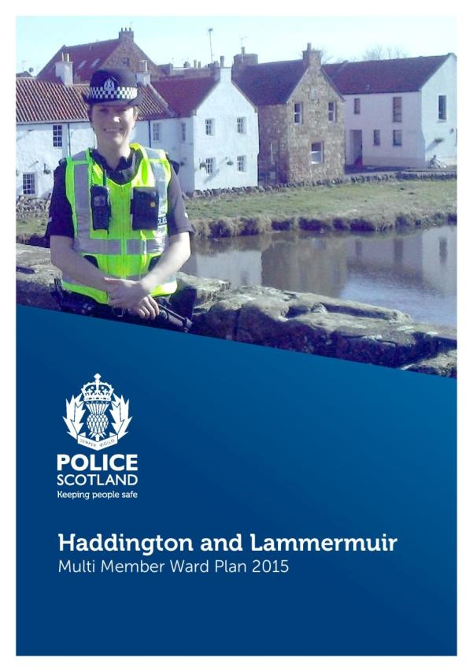

**Haddington and Lammermuir Area Partnership will work alongside the CAPP (Community and Police Partnership) in our ward to look at how the community can:**

* **play a greater role in reducing antisocial behaviour and tackling road safety in our areas particularly; and**
* **contribute to meeting the other objectives identified in the Police Scotland’s Multi-Member Ward Plan for Haddington and Lammermuir.**

**Police Scotland’s Multi-Member Ward Plans** outline the priorities the community identified during their consultation and inform the community of how the police plan to address these throughout the year. These priorities have also been adopted by the Haddington and Lammermuir Area Partnership and integrated into our draft Area Plan as they are issues that we all need to help address if we want to make the ward a safe place to live, work and travel in.

The community priorities identified in the Police Scotland Multi-Member Ward Plans for this area are:

1. **Antisocial Behaviour**

You told us there were problems with violent conduct, young people causing disturbance and rowdy drunken behaviour.

1. **Substance Misuse**

You told us that people using and dealing drugs in the Haddington area, and their subsequent offending concerned you.

1. **Road Safety**

You told us that there were issues with speeding motorists and inconsiderate driving, especially near schools.

1. **Housebreaking**

You told us you were worried about security and people breaking into houses.

**What the Haddington and Lammermuir Area Partnership is doing to achieve this goal...**

1. **Ensuring people can live and travel safely in this community**

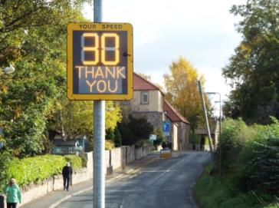

**Haddington and Lammermuir Road Safety Sub-group**

In June the Area Partnership established a sub-group to look at specific locations across the ward that could benefit from traffic calming, improved lighting or other interventions to improve road and pedestrian safely.

The Area Partnership has already allocated funding to buy and install a speed reactive sign outside Saltoun Village Hall and is looking at a number of other potential actions including:

* Traffic calming measures on Whittinghame Drive – to slow traffic and make crossing safer, particularly when the new skatepark is established there.
* Improved road markings and measures to reduce speeds at the narrow bridge on the B6368 at Gilchriston/Humbie Station
* Installation of street lamps between Garvald and Nunraw Barns
* traffic calming measures in Bolton to address the increase in traffic in the area
* establishing a path on Pencaitland Road to Letham Mains Holdings turnoff to improve pedestrian safety

If you have other ideas that could help improve road safety in the area please contact one of the Area Partnership members or email

[H&L-AP@eastlothian.gov.uk](mailto:H&L-AP@eastlothian.gov.uk)

**The Police Scotland Multi-Member Ward Plans also highlight some of the actions that the Police have been taking locally to address these priorities.**

**Antisocial Behaviour**

We have staff embedded in East Lothian Council’s Antisocial Behaviour Team (based at Tranent) which targets those who commit antisocial behaviour and warn tenants, issue ABAs or ASBOs. In some cases this led to eviction. East Lothian Community Policing Teams also patrol ASB ‘hotspots’, sometimes jointly with Community Wardens. One Team is based in Haddington. It patrols Haddington regularly and also takes action on drugs intelligence.

**Substance Misuse**

Investigating drug dealing in Haddington and surrounding areas has taken a large amount of resourcing. Significant recoveries of illegal drugs have been made including cannabis cultivations in remote areas such as Humbie. We have also been raising awareness of the risks of New Psychoactive Substances in Schools and with partners to reduce the supply.

**Road Safety**

Community police officers are trained in the use of Speed Detection equipment, and have targeted ‘hotspot’ areas for speeding. We also have used the specialist resources from the Traffic Department and Trunks Roads Policing to enforce Road Traffic legislation especially on the A1.

We challenged dangerously parked drivers around all schools in the Haddington area. We have also enforced the driving restriction around Haddington Infant School.

**Housebreaking**

East Lothian now has its own Housebreaking Investigation Team based at Musselburgh. The Team has been successful in catching housebreakers especially those who travel into the area from elsewhere to commit crime. East Lothian also has its own Community Safety Team based at Tranent which monitors crime on a daily basis and implements prevention strategies to reduce crime. This team can give crime prevention advice, on request from home owners, business managers or crime victims.

1. **Ensuring people can live and travel safely in this community**

**The Haddington and Lammermuir Area Partnership supports all of the initiatives Police Scotland have put in place to address these community concerns.....but we want to know what else you think would make a difference in addressing these problems in our area.**

|  |  |
| --- | --- |
| **Addressing Antisocial Behaviour** | Ensure PSP meetings happen regularly  3 votes |
| **Combating Housebreaking** | Not helped by changes made by intro of Police Scotland |
| **Preventing Substance Misuse** | Removal of Court and DTTO from Haddington is not aiding prevention.  More training for PRO’s/teachers/social workers  More education for young people  Move methadone clinics to the new hospital  GPs encouraged to promote local groups like Friday Friends |
| **Tackling Speeding and inconsiderate Driving** |  |
| **Are there any priorities missing?**  There aren’t enough police on the street in view and being seen patrolling. | |

1. **Sustaining strong and inclusive communities throughout the ward**

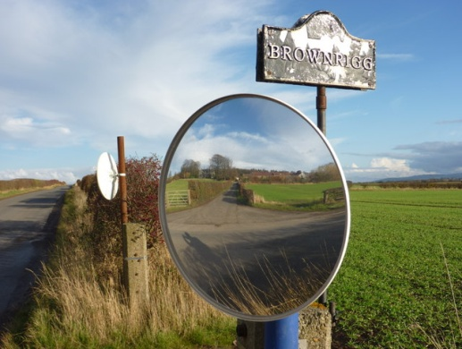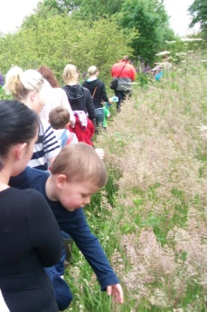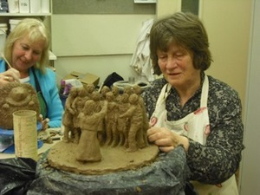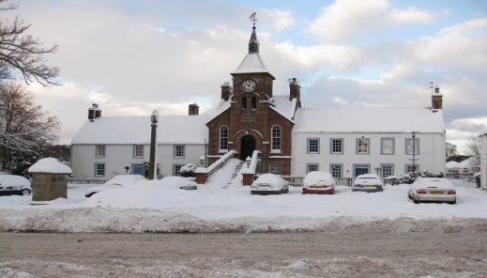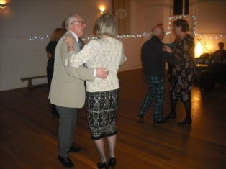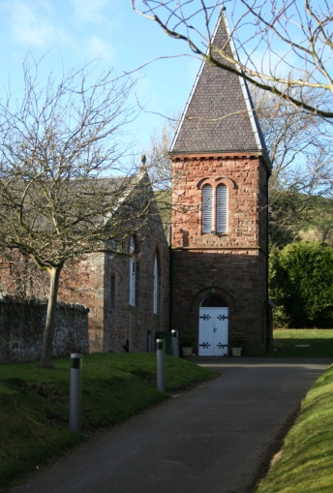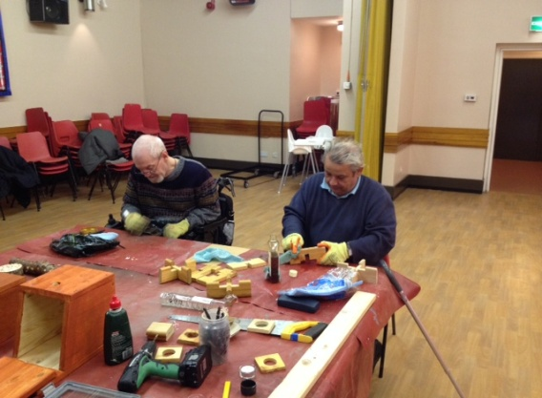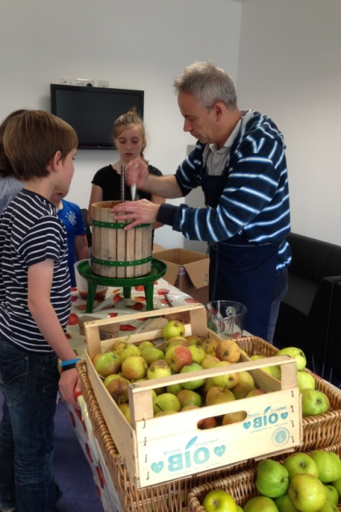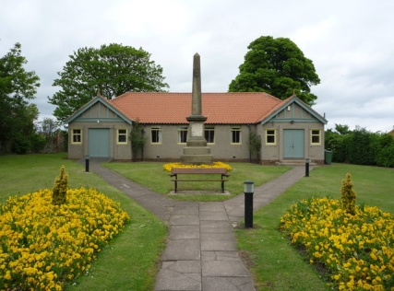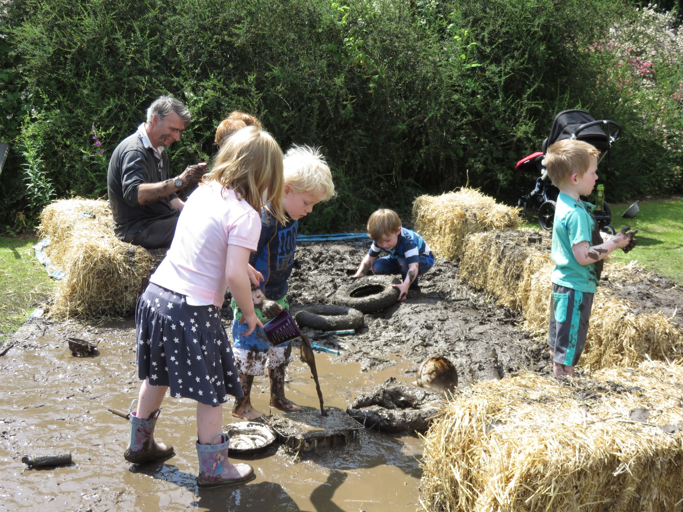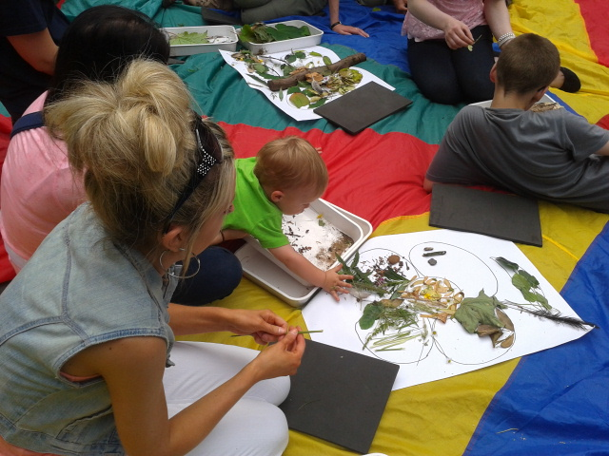

**Across the Haddington and Lammermuir ward we recognise that there are a diverse range of strong local communities across our town and villages.**

**Each of these communities have their own needs and local aspirations and our goal is to support them to become even stronger and more sustainable.**

Some of the goals already identified include:

* Ensuring each community has a strong local hub that supports the social needs of its residents.
* Supporting the development of Community Resilience Plans across our villages that provide a co-ordinated approach to assisting vulnerable residents in times of severe weather.
* Encouraging a catchment review to overcome the current boundaries that cut across villages and split Primary School classmates.
* Helping older residents remain living independently in their local communities for as long as they choose to remain.
* Opposing the Boundary Commissions proposals to change the ward boundaries and break up natural communities.
* Thinking creatively about community transport options that will help reduce the social isolation that can affect people without access to their own transport.
* Ensuring children living in smaller settlements do not miss out on social, recreational and development opportunities available to their peers in the town.

**What Haddington and Lammermuir Area Partnership is doing to achieve this goal...**

* 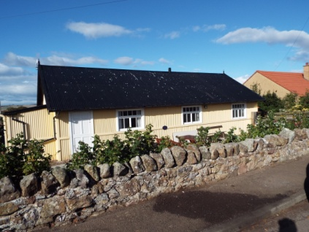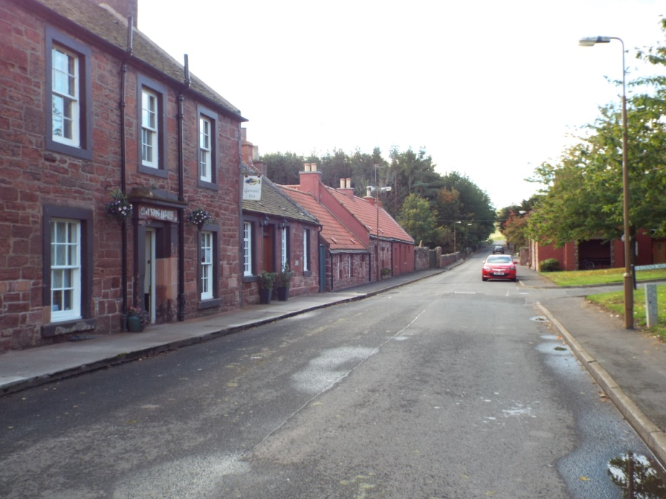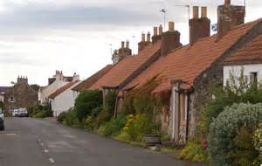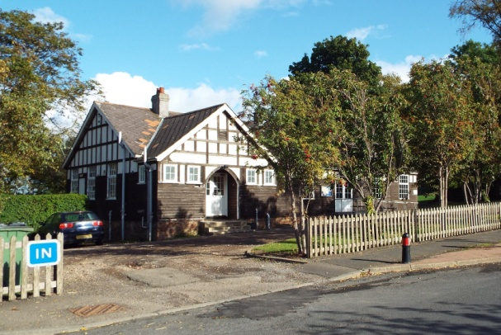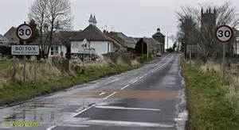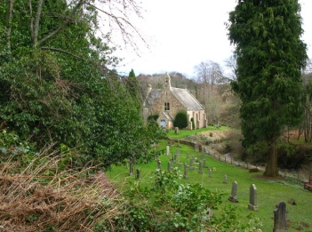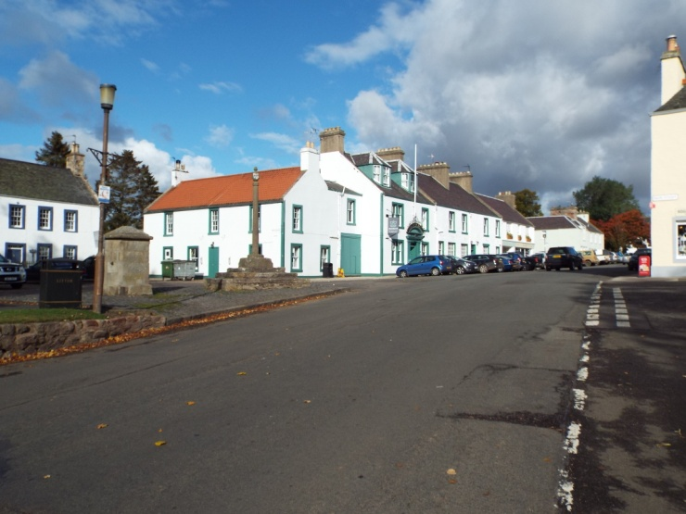

Play Rangers “rotate” around outlying areas

* Volunteer coordination for befriending/visiting isolated older residences – survey to see if that’s what people would want
* Coordinate volunteers for driving minibuses that are hired out at minimal rates to help with social isolation

Play bus for rural communities

**Do you have any ideas that would help build stronger, more inclusive sustainable local communities across this ward?**

**Please help the Area Partnership set its priorities for the next year by letting us know what you think would make a difference in your local area.**

1. **Sustaining strong and inclusive communities throughout the ward**