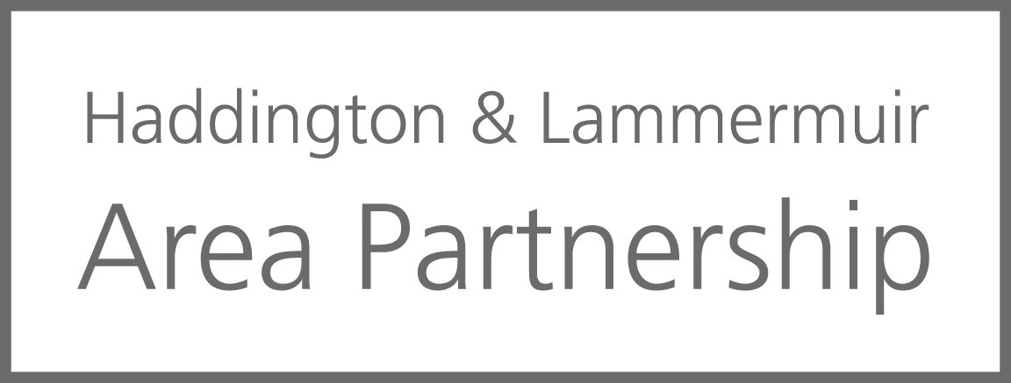**Notes of meeting of the Haddington & Lammermuir Area Partnership**

**24th April at 7pm, Haddington Bridge Centre**

**Chaired by:**

Craig McLachlan (CM)

**Members (and substitutes members) present:**

Margo Hodge, Humbie, E&W Saltoun & Bolton C Council (MH)

Heather Bowsher (HB)

Phillip White, Garvald & Morham Community Council (PW)

Loreen Pardoe, Support from the Start, Haddington (LP)

Cllr Tom Trotter, ELC Elected Member (TT)

Louise Begbie, Haddington Rotary (LB)

**Others in attendance:**

Diann Govenlock, ELC Connected Communities (DG)

Stuart Baxter, ELC Connected Communities (SB)

Mandy Harrington, VCEL (MHa)

Justine Bradd, ELC CDO Connected Communities (JB)

Lucy Higgingson, Community Planning Officer (LH)

Jill Hyslop, Gifford C Council (JH)

**Apologies received:**

Lorna Bellany, NHS Public Health (LB)

Stuart Pewin (vice Chair) (SPW)

Cllr Shamin Akhtar, ELC Elected Member (SA)

Cllr John McMillan, ELC Elected Member and Rotary (JMc)

James Weddell, Yester Parent Council (JW)

Cllr George McGuire, ELC Elected Member (GMc)

Philip Ross, Knox Academy Parent Council (PR)

Adam White, Gifford C Council (AW)

|  |  |  |
| --- | --- | --- |
|  | **Key Discussion points** |  |
|  | **Welcome and Introductions** |  |
|  | CM welcomed everyone to the meeting. The meeting is quorate. |  |
|  | **Apologies** |  |
|  | Apologies as noted above. |  |
|  | **Declarations of Interest** |  |
|  | CM reminded everyone that we leave our ‘hats’ at the door, although no applications have been received. | ALL |
|  | **Approval of notes of previous meeting** |  |
|  | Accepted as read. |  |
|  | **Matters arising: Resilience Workshop on 1st March**  MH attended this event, there were several speakers and identifying different issues across East Lothian. There were reps from the MET office, looking at flooding and how areas work together. The Eyemouth presentation was an excellent approach to resilience. Noticeboards still an effective method of communication. |  |
|  |  |  |
|  | **Update from community groups (please send in before the meeting)**  The Rotary are holding a fundraising car boot sale this Saturday. The community chest has funded the CAB to cover costs for financial status, as there is a small charge for individuals to have a financial check. |  |
|  | **Budget update**  **General Budget 25/25**  The general Budget is £45, 000. This is the same amount as for 24/25.  The Amenities budget remains at £100, 000  Roads budget at £47,500.  Holiday Hunger £4800. |  |

|  |  |  |
| --- | --- | --- |
|  | **Lucy Higginson, Community Planning Officer presentation and update of LOIP( Local Outcome Improvement Plan) / East Lothian Partnership.**  Lucy presented a powerpoint presentation which will be shared separately.  Community planning is about how public bodies work together, and with local communities, to design and deliver better services that make a real difference to people's lives. Especially those who need the services most.  A Community Planning Partnership (or CPP) is the name given to all those services that come together to take part in community planning. Each CPP focuses on where partners' collective efforts and resources can add the most value to their local communities, with particular emphasis on reducing inequality. In East Lothian we have the East Lothian Partnership.  CPPs are responsible for producing two types of plan to describe their local priorities and planned improvements: Local Outcome Improvement Plan for whole council area and Locality Plans, which cover smaller areas within the CPP area, usually focusing on areas that will benefit most from improvement. We have East Lothian Plan (LOIP) and 6 Area Plans through Area Partnerships.  There have been several self-assessments including one with the community. Things have not been working well and feedback has been largely negative.  The next steps will include working with the Improvement Service to identify further improvements from the self-assessment.  Meet with community partners to reflect on their feedback and Improvement Plan actions, and to support them to carry out their own community engagement. If there are engagement opportunities please get in touch with Lucy at the email address below.  Keep updated at our Community Planning webpage. <https://www.eastlothian.gov.uk/community-planning>    [elp@eastlothian.gov.uk](mailto:elp@eastlothian.gov.uk)  It was suggested that the partnership come back together to discuss this at a future meeting prior to any meetings about the LOIP. |  |
|  | **Parking Review**  There has been an initial information gathering meeting about the parking issues in Haddington. There were concerns about how the parking charges were implemented in North Berwick and the resulting community resistance.  There will be further consultation in Haddington but there are no details yet.  Again, an area the area partnership may want to get together to discuss prior to the consultation. |  |
|  | **Asset Review**  Asset review workshops being held in all 6 main towns. Haddington was the first. The buildings up for discussion:   * Haddington Town House (Common Good) * John Muir House including the Court * Nungate Community Centre * John Gray Centre   This project was led by consultants ‘ Clear Futures’. Local context was missing. There are several community groups exploring options for alternative accommodation and there was some interest particularly in the Court and Haddington Town House.  More to follow but as yet no details. |  |
|  | **Annual Public Meeting**  This is being held on 15th May at 7pm in the Alistair Grant Hall. Evaluations are still outstanding on some of the 14 projects funded during 23/24.  Discussed setting the room up theatre style at the far end of the hall for a couple of presentations and powerpoint presentation. |  |
|  | **Area Plan**  SB still working on including what has been funded by the area partnership over the years. Lucy to share resources on easy read/ accessible.  The area plan to be shared with Lucy. CM to write introduction. |  |
|  | 1. **Children & Youth Network –** met on 27th February with an input from the Haven but funding for this project was only for a 2-year pilot period. There is a campaign for support to continue but it is a challenging time for organisations as there is not enough resources or funding. Date of next meeting is 19th June at 3.30pm (Apologies from Rab Moran). 2. **Health & Wellbeing Network –** met on 3rd April with input on East Lothian Equality Outcomes 2025 – 2029 by Kate Thornback.   Date of next meeting is 26th June at 10am.  Parvine Woodger Ageing Well Coordinator is back from maternity leave. |  |
|  | **Any other business: please notify the Chair prior to the meeting.**   1. Battle of the Bands is being held on Sunday 25th May at Haddington Bridge Centre. Band winners will support headline acts at the Corn Exchange and have the opportunity to perform on the Lighthouse stage at Fringe by the Sea. Tyneside Tavern available for pizza. 2. Haddington West TRA being set up shortly. 3. PVG changes already been introduced, period of grace till June. |  |
|  | **Date of the next meeting – all meetings will start at 7.00pm**   |  |  | | --- | --- | | 15th May 2025 – Annual Public Meeting    12th June 2025 next area partnership full meeting |  | |  |

**Contact**: [handl-ap@eastlothian.gov.uk](mailto:handl-ap@eastlothian.gov.uk)