GUIDANCE NOTES ON How to add UNIQUE addressES
Once you have clicked on “New Proposal” the following screen appears
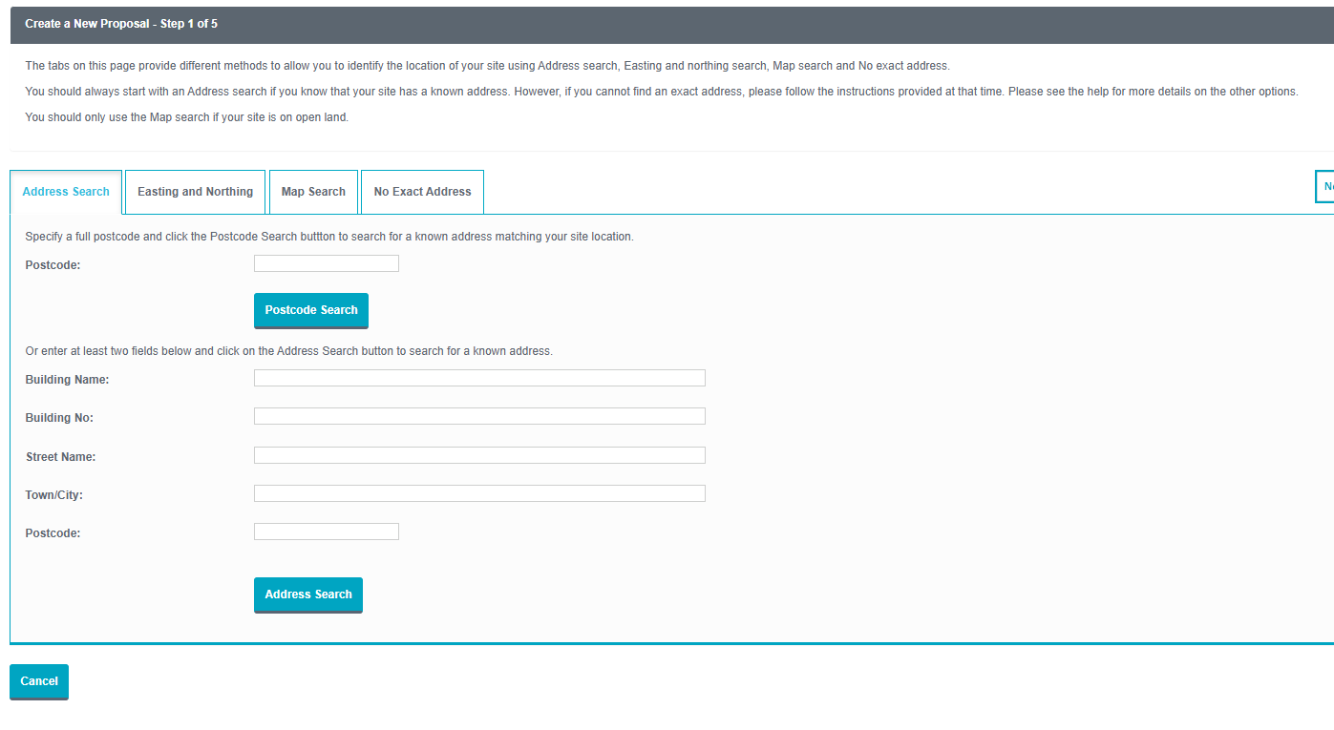Click on the “No Exact Address” tab which will take you to the following screen
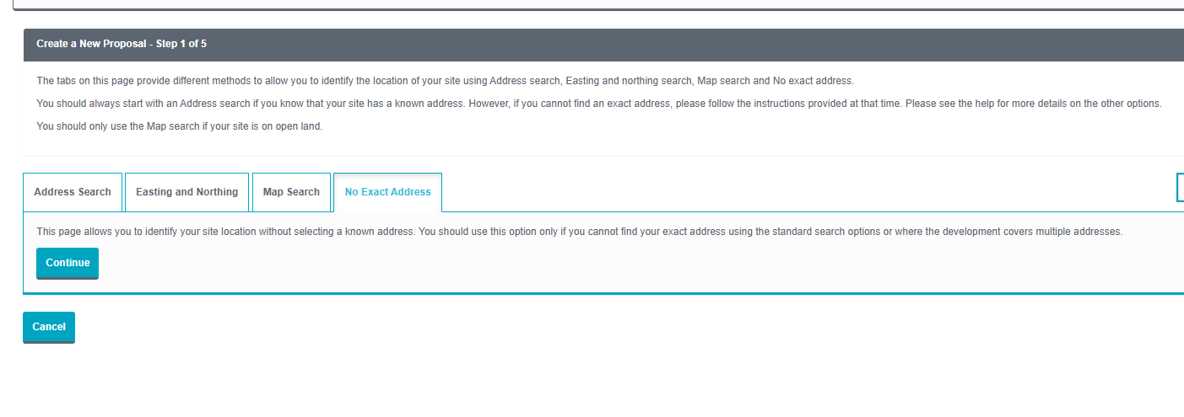
Click the “Continue” button which will then take you to the following screen where you can choose either option. I have picked the second option “I cannot use the non-accessible Mapping Tool”
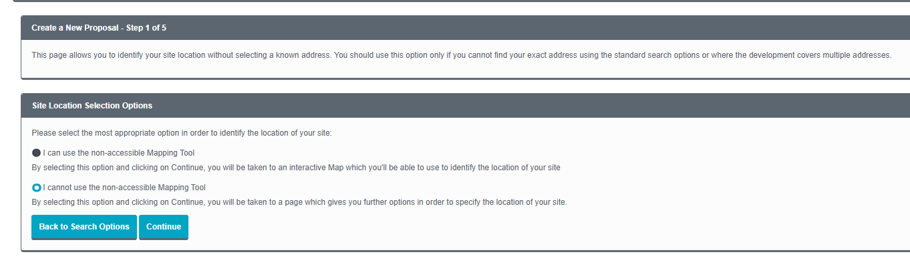
Click the “Continue” button which will then take you to the following screen and click the first option “Yes”
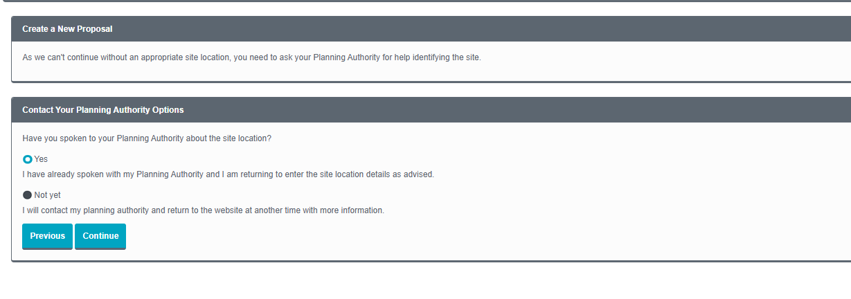
Click the “Continue” button which will then take you to the following screen. Pick “East Lothian Council” from the dropdown menu and then enter the address you wish to use
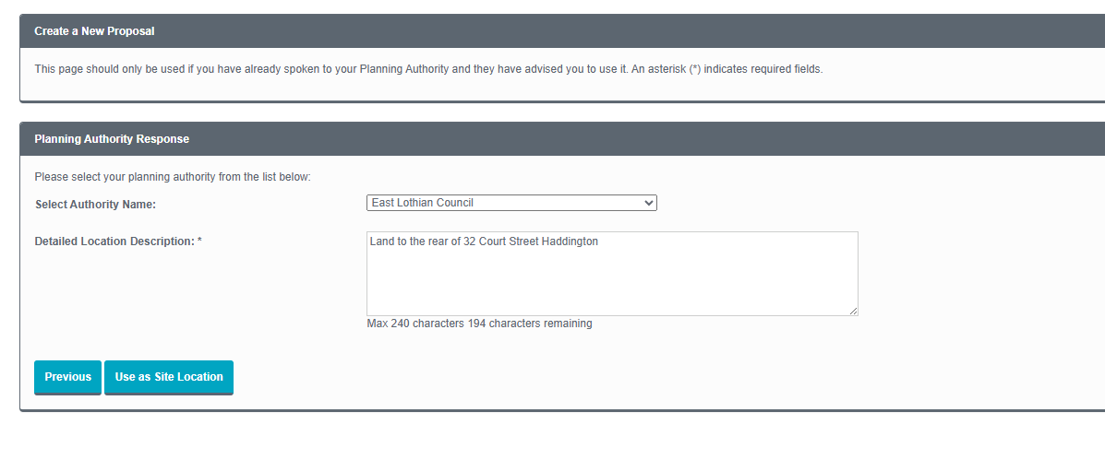
Click the “Use as Site Location” button which will then take you to the following screen and click the “Confirm Address” button which will take you to another screen and click the “Next” button.
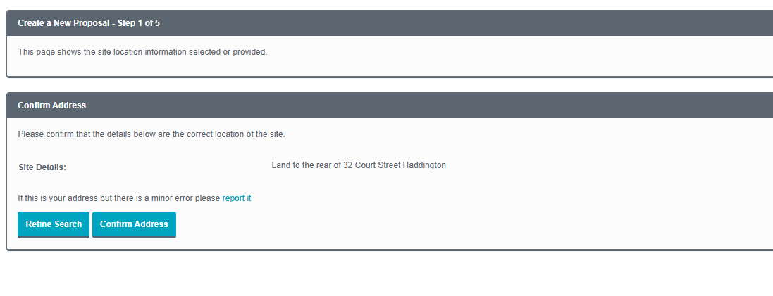
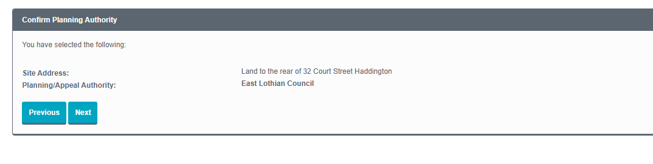
You will then be taken to the following screen where you should enter the “Proposal Name” and “Proposal Details” and press the “Confirm Details” button
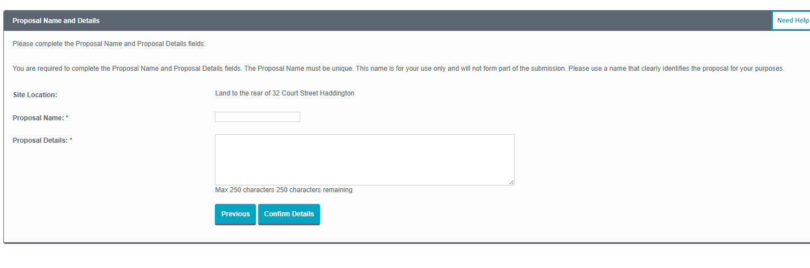

This will then take you to the screen to Select Online Forms
