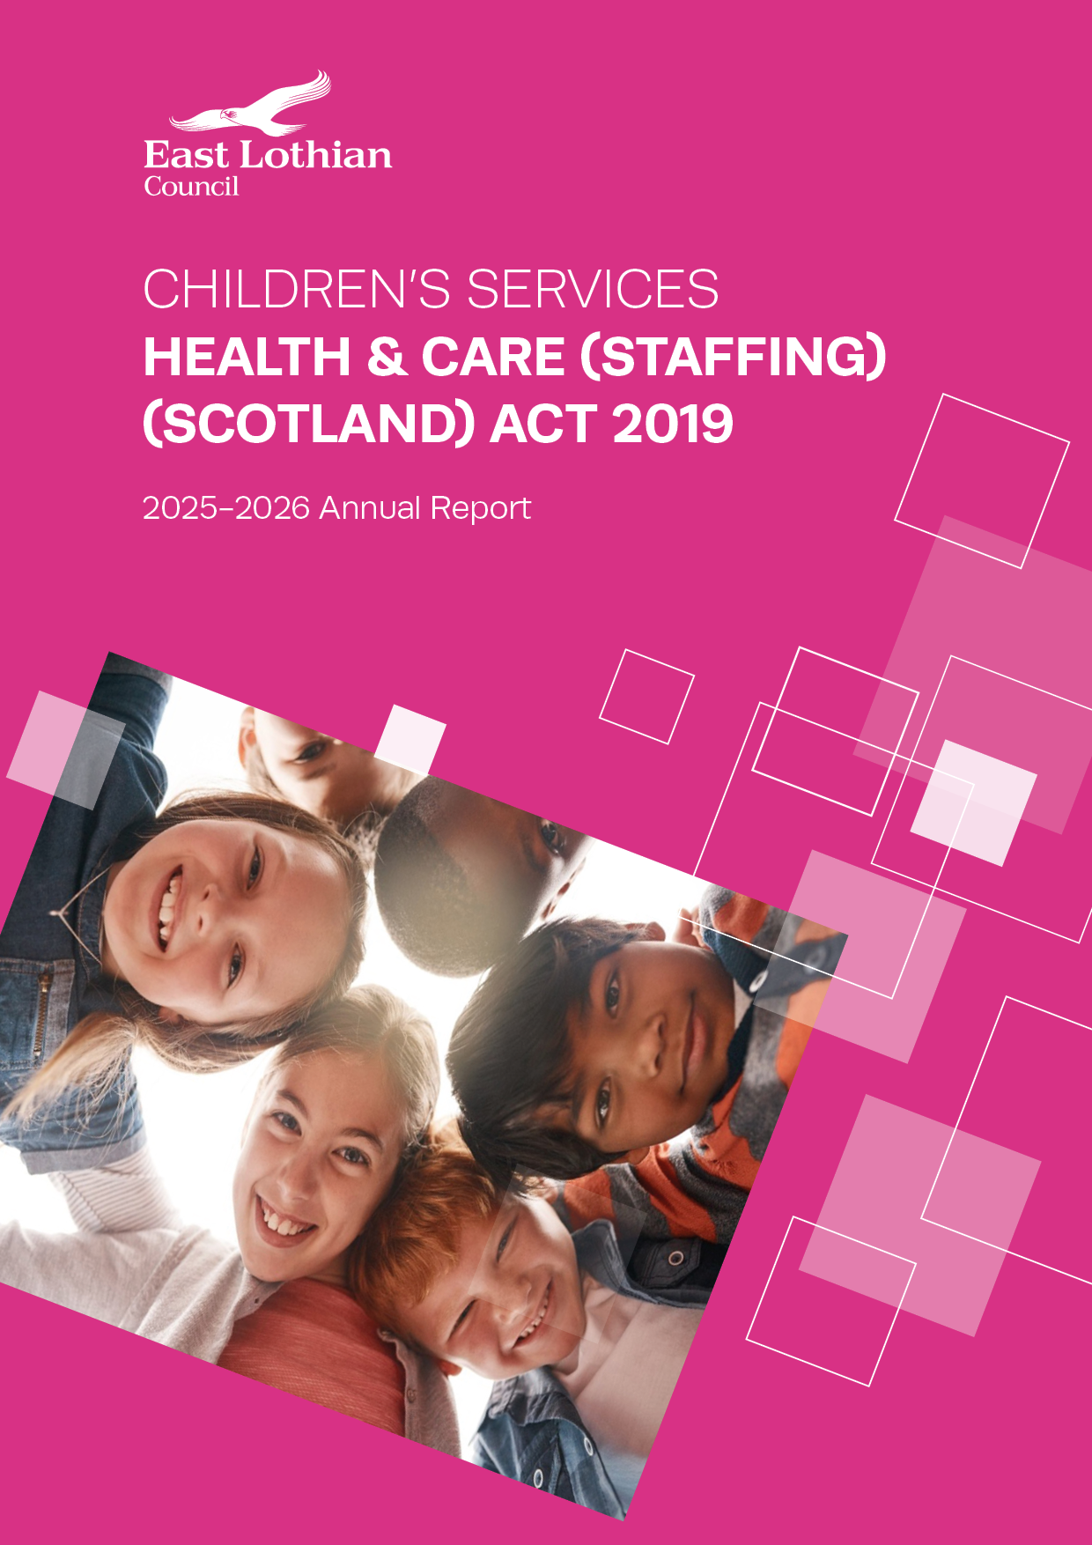

Health and Care (Staffing) (Scotland) Act 2019

2025-2026 Annual Report

East Lothian Council, Children’s Services

Contents Page

Overview 3
Legislative responsibilities 4
Compliance with Section 3 (2) of Health and Care (Staffing) (Scotland) Act 2019 6
  - Commissioned Care at Home Contract 6
  - Support Services 7
  - Residential Respite 9

Ongoing risks that may affect your ability to comply with the duty 10
  - Commissioned Care at Home Contract 10
  - Support Services 10
  - Residential Respite 10

Overview

The Health and Care (Staffing) (Scotland) Act 2019 provides a statutory basis for the provision of appropriate staffing in health and care services, enabling safe and high quality care and improved outcomes for service users. The provisions of the Act came into force on 1st April 2024.

The Health and Care (Staffing) (Scotland) Act 2019 places duties on local authorities in Scotland to ensure appropriate staffing levels in health and care services, focusing on safety, quality, and the wellbeing of both staff and service users. The Act also requires Local Authorities to publish annual reports detailing how they have met their staffing duties in relation to newly commissioned services in the relevant financial year.

This report relates to services newly commissioned by Children’s Services within the 2025/2026 financial year only and refers to the planning and securing of services.

Legislative responsibilities
Under section 3(2) of the Health and Care (Staffing) (Scotland) Act 2019 (“the Act”), every local authority and integration authority must have regard to a number of listed factors when planning or securing the provision of a care service from a third party:
- the guiding principles in the Act (section 1 of the Act);
- the requirement on care service providers to have regard to the guiding principles (section 3(1) of the Act);
- the duty on care service providers to ensure appropriate staffing (section 7 of the Act);
- the requirement on care service providers with regard to training of staff (section 8 of the Act);
- the requirement on care service providers to have regard to guidance issued by the Scottish Ministers (section 10 of the Act);
- the duties on care service providers under Chapter 3 of Part 5 of the Public Services Reform (Scotland) Act 2010, for example with regard to registration of care services; and
- the duties on care service providers under Chapter 3A of Part 5 of the Public Services Reform (Scotland) Act 2010, for example with regard to the use of any prescribed staffing methods or staffing tools. Note that the Health and Care (Staffing) (Scotland) Act 2019 inserted chapter 3A into the Public Services Reform (Scotland) Act.

Section 3(6) of the Act states that relevant organisations must publish information annually on the steps they have taken to comply with the requirement in section 3(2) regarding the planning and securing of care services and any ongoing risks that may affect their ability to comply with this requirement.

This template should be used by local authorities and integration authorities to publish the information required and should be read in conjunction with the statutory guidance that accompanies the Act, specifically chapter 15.
The information in this template relates to the financial year, i.e. 01 April to 31 March 2026. All reports must be published by 30 June at the latest each year.
In order to collate the information published, the Scottish Government also requests that you send the completed template to hcsa@gov.scot.

Declaration

Name of local authority / integration authority | East Lothian Council, Children’s Services.
Report authorised by | LINDSEY BYRNE  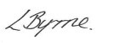
Designation | Head of Children’s Services and CSWO
Date | 23/03/2026
Details of where the report will be published

Please mark all relevant boxes to show which services have been taken account in this report:
X | Support services
 | Care home services
 | School care accommodation services
 | Nurse agencies
 | Child care agencies
 | Secure accommodation services
 | Offender accommodation services
 | Adoption services
 | Fostering services
 | Adult placement services
 | Child minding
 | Day care of children
 | Housing support service

1.Compliance with Section 3 (2) of Health and Care (Staffing) (Scotland) Act 2019

Information Required
Please detail the steps you have taken as an organisation to comply with section 3(2) of the Health and Care (Staffing) (Scotland) Act 2019:
3(2) In planning or securing the provision of a care service from another person under a contract, agreement or other arrangements, every local authority and every integration authority (within the meaning of section 59 of the Public Bodies (Joint Working) (Scotland) Act 2014) must have regard to—
(a) the guiding principles for health and care staffing, and
(b) the duties relating to staffing imposed on persons who provide care services—
(i) by virtue of subsection (1) and sections 7 to 10, and
(ii) by virtue of Chapters 3 and 3A of Part 5 of the Public Services Reform (Scotland) Act 2010.

  - Commissioned Care at Home Contract

Responsibility for Care at Home services within East Lothian Council’s Children’s Services sits within our Children’s Disability Service. Care at home seeks to provide care and support to children and young people within their home and communities centred around Getting It Right For Every Child indicators.

Currently, Children’s Services has one provider supplying this service through our Care at Home contract. The service commissioned is ELCAP with the contract beginning 4/11/2025. This service is provided under Option 3, Social Care (Self-Directed Support) (Scotland) Act 2013. In addition to this, the Council may access the service at the direction of those child\young person’s choosing a provider to help them achieve their outcomes (SDS Option 2).

With reference to both the contract and additional Option 2 provision, the following Safer Staffing requirement is included in the planning and securing of the Care at Home contract.

Care Inspectorate Registration
- Services will be appropriately registered by the Care Inspectorate. The Provider should ensure they have the appropriate registrations required to deliver the relevant Care and Support Service.
Compliance with the Health and Social Care Standards
- All services will comply with the Health and Social Care Standards.

Scottish Social Services Council (SSSC)
- Staff involved in the provision of the service will either be registered with the Scottish Social Services Council and/or any other appropriate body. The provider and their staff will comply with the SSSC Codes of Practice, available from the SSSC.

Self-directed Support (SDS)
- All services will be delivered in line with the Social Care (Self-directed Support) (Scotland) Act 2013.

Health and Safety
- As detailed in the conditions of contract, all services will be delivered in line with Health and Safety legislation and best practice. The provider will ensure their staff are appropriately trained in health and safety requirements to be able to support people.
PVG compliance
- All staff will hold an appropriate PVG.
Recruitment of staff
- Ensuring attainment of qualifications, training and supervision. Registration of staff with relevant bodies. Appropriate staffing levels including ratios as assessed. Safer Recruitment regarding the protection of children and vulnerable adults and Child Protection.
Data protection
- Services will be delivered in line with data governance processes.

Quality Assurance and contract monitoring
A Quality Assurance approach is taken to the monitoring of commissioned services with Safer Staffing requirements. Our contract and service specifications state the Council shall monitor and review the outcomes to be achieved, management and operation of the service throughout the duration of the contract.

1.2 Support Services

East Lothian Council’s Children’s Services commissions one third sector organisation which will be considered under the Health and Care (Staffing) (Scotland) 2019 Act. This organisation is Can Do. This service implements specialised provision for children and young people with complex disability providing holiday day care undertaking a variety of activities and providing social opportunities for child and young people affected by disability.
The service is commissioned through a one-year grant which runs from 1st April 2025 to 31st March 2026. Applications for grants are invited to meet the service priorities of Children’s Services department. Applications are assessed by council staff from a range of departments as well as a Lived Experienced Panel.

There is a variety of quality assurance and contract monitoring processes in place in addition to the assessment of grant applications that take account of the Guiding Principles (Section 1) of the Health and Care (Staffing) Act as well as Section 7 (appropriate staffing) and Section 8 (appropriate training).

Our Commissioning Strategy sets out intentions in our approach to commissioning:
- We will focus our commissioning on preventative and early intervention approaches that are outcome focused
- We are committed to ethical commissioning in terms of decisions that take into account factors beyond price, including fair work, terms and conditions, career pathways, trade union recognition and sustainability of services and the environment
- Seek to address inequalities and promote equity of access to services regardless of geography or population
- Third sector colleagues are recognised as key early intervention/prevention services; early intervention funding and investment supports this role.

Contract monitoring with the provider:

Monitoring includes a review of performance to the required quality standards set out in the grant application. This gathers information on staffing, recruitment issues, staff training and support. Ongoing monitoring includes reviews of any recent inspection/ changes of Care Inspectorate grades.

End of Year Report:
This focuses on a review of how outcomes have been met and collation of data to include in service planning.

Due Diligence checks:

Additional checks around the organsiations we fund will be carried out to ensure the robustness of the organisation in terms of staffing, policy, process and structure. Services will be appropriately registered by the Care Inspectorate. The Provider should ensure they have the appropriate registrations required to deliver the relevant Care and Support Service. All staff will hold an appropriate PVG.

  - Residential Respite

East Lothian Council, Children’s Services commission one provider for the requirements of delivering the provision of Short Breaks in residential care through a dedicated service for children and young people who have multiple and complex needs, and for whom provision of a short-break in residential care is the best means of getting the right break at the right time and so improving outcomes for them and their parents or carers. The provider commissioned is Aberlour with a 2 year contract beginning on 1/4/25. Residential respite sits within the Children’s Disability team within Children’s Services.
With reference to Safer Staffing requirements included in the planning and securing of the Residential respite contract the following is relevant.

Care Inspectorate Registration
- Services will be appropriately registered by the Care Inspectorate. The Provider should ensure they have the appropriate registrations required to deliver the relevant Care and Support Service.

Compliance with the Health and Social Care Standards
- All services will comply with the Health and Social Care Standards.

Scottish Social Services Council (SSSC)
- Staff involved in the provision of the service will either be registered with the Scottish Social Services Council and/or any other appropriate body. The provider and their staff will comply with the SSSC Codes of Practice, available from the SSSC.

Self-directed Support (SDS)
- All services will be delivered in line with the Social Care (Self-directed Support) (Scotland) Act 2013.

Health and Safety
- As detailed in the conditions of contract, all services will be delivered in line with Health and Safety legislation and best practice. The provider will ensure their staff are appropriately trained in health and safety requirements to be able to support people.
PVG compliance
- All staff will hold an appropriate PVG.
Recruitment of staff
- Ensuring attainment of qualifications, training and supervision. Registration of staff with relevant bodies. Appropriate staffing levels including ratios as assessed. Safer Recruitment regarding the protection of children and vulnerable adults and Child Protection.
Data protection
- Services will be delivered in line with data governance processes.

In addition to this ongoing quality assurance takes place through regular monitoring of the contract. KPIs are reviewed to ensure the contract is achieving positive outcomes for children and their families as well as oversight of operations and staffing to ensure good practice.
2. Please detail any ongoing risks that may affect your ability to comply with the duty set out in section 3(2).

2.1 Commissioned Care at Home
The prominent ongoing risk is the challenge of recruitment and retention of high-quality staff. Linked to this in the local area is the challenge of the limited number of providers able to implement the skill level required to meet the individualised needs for children and young people affected by disability. This directly impacts the capacity of services to meet the level of need required and the subsequent limited choice and flexibility families can access. The shortage in number of service providers results in risk around limited choice in planning and securing services.
2.2 Support Services
There is a risk around the limited number of providers which limits choice in planning and securing services.

2.3 Residential respite

There are a very limited number of services able to provide a residential respite service to children with disabilities in East Lothian and in addition to the level of support they can provide. This can result in children travelling out with East Lothian to access residential respite and being further from home and their community.



