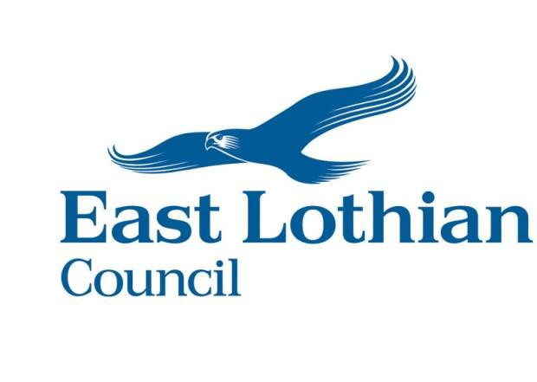

EAST LOTHIAN
SAFETY ADVISORY GROUP (SAG) POLICY

Contents

1. Introduction 4
2. East Lothian Safety Advisory Group Strategy 4
3. East Lothian Safety Advisory Group Terms of Reference 4
4. Strategic Event Safety Oversight Group (SESOG) 5
Aim 5
Primary Focus 5
Guiding Principle 6
Status and conflicts of interest 6
SESOG Composition 6
SESOG Administration 7
5. East Lothian Safety Advisory Group (SAG) 7
SAG Aim 7
SAG Objectives 7
SAG Composition 8
Appendix – 1: – Safety Advisory Group Process 9
Appendix – 2: Event Category & Size 11

1. Introduction

1.1 East Lothian Council recognises that public events positively promote tourism, community development, social cohesion, civic and cultural identity and can enhance community life as well as benefit the local economy.

1.2 East Lothian Council recognises this value in hosting events and encourages their undertaking whilst operating safely and in consideration of those affected by the event. To aid this, East Lothian Council maintains a Safety Advisory Group (SAG) process for public events, see Appendix - 1. – Safety Advisory Group Process.
1.3 The East Lothian SAG process is a multi-agency approach towards ensuring that organisers of events plan for and then implement these in a manner that is safe for everybody involved with, and impacted by, the event.

1.4 All SESOG and SAG meetings will be minuted, but attendance will be restricted to the agreed list of attendees and/or by invitation of the Chair and thus not open to the public. (see para 4.9 and 5.4)

2. East Lothian Safety Advisory Group Strategy

2.1 The Safety Advisory Group (SAG) Strategy comprises two main elements:

  - Strategic Event Safety Oversight Group (SESOG)
  - Safety Advisory Group (SAG)

2.2 The SESOG will be chaired by Head of Infrastructure, East Lothian Council or delegated to another senior officer as required.

2.3 Chair of the SAG will be carried out by ELC, Emergency Planning and Events Officer.

2.4 The Events Officer will maintain and make available an Events Directory (spreadsheet to include event RAG Assessment) on behalf of the SESOG.

2.5 Figure 1 below provides a brief summary of the SAG process.

2.6 The SAG process will be managed and administered by Protective Services.

3. East Lothian Safety Advisory Group Terms of Reference

3.1 The East Lothian Safety Advisory Group (SAG) will operate in accordance with the following Terms of Reference:

1. To provide a multiagency forum within which SAG members will develop a co- ordinated approach to achieving high levels of public safety.
2. To promote good practice in safety and welfare planning.
3. To consider the advice published in all available statutory guidance documents and impart to event organisers.
4. To receive and assess proposals for public events within East Lothian as detailed in the Notification of Event form, with the emphasis on minimising the risk to public safety. Where deemed proportionate arrange a SAG Meeting.
5. To ensure that event organisers are aware of the roles of individual SAG members.
6. To ensure that those events subject to the SAG process, have in existence, adequate planning and documentation, to include agreed contingency and emergency plans for dealing with major incidents before the event takes place.
7. To receive reports relevant to de-briefs, visits and / or inspections of the venue or event, with the aim of improving safety.
8. Events Officer will ensure that SESOG are aware of events via access to the Events Directory and are apprised of any subsequent new events that have not been subject of the RAG Assessment process.
9. To ensure that a list of notified events is maintained for public awareness.

3.2 The Core Members of the SAG must declare any material conflict of interest in relation to any item put before the Group, prior to any discussion on that matter. If the interest could be considered prejudicial, then the person should consider if they should withdraw and be replaced by an appropriate party agreed by the group.

3.3 Any Agency or ELC service, within the SAG process may recover costs incurred in supporting an event by charging Event Organisers for services in line with their own policies and procedures. Such matters are independent from the scope of the SAG.

4. Strategic Event Safety Oversight Group (SESOG)

Aim

4.1 The Strategic Event Safety Oversight Group (SESOG) is established to determine, oversee and review the East Lothian Safety Advisory Group Strategy and process. It will ensure that the Safety Advisory Group process is followed by member agencies and event organisers.

Primary Focus

4.2 The primary focus of the SESOG is the safety of all people working at, participating in, or attending an event and to the safety of members of the general public who may be impacted by that event.

4.3 SESOG will review risks associated with notified events listed on the Event Directory, as defined by Event Organisers and agree on the risk grading and subsequent necessity for SAG scrutiny.

4.4 SESOG will compile, and make this publicly available on the Council’s website, a list of events based on their assessment, which require to progress through the SAG process.

Guiding Principle

4.5 The guiding principle for determining which events are covered by the SAG process are those events that may impact on public safety or the wellbeing of the community, considered on a risk-based approach through the following criteria:

- The status of the principal attending
- The status of the event organisers
- The profile of the event
- Event category and size – Appendix 1
- Type of Activity
- Event site
- Whether alcohol is available, or any other license is required
- Transport implications
- Impact upon local community
- Event safety concerns raised by a SAG representative

4.6 The SESOG will keep and make available, as appropriate, records of its activities in order that it effectively carries out its function ensuring the transparency of decision making. All records are subject to Freedom of Information requests and could be released publicly subject to the exemptions provided.

Status and conflicts of interest

4.7 The SESOG will have no direct involvement in the SAG process.

4.8 The ultimate responsibility for the event safety lies with the event organiser and event management team.

4.9 Members of the SESOG must declare any material conflict of interest in relation to any item put before the group prior to any discussion on that matter. If the interest could be considered prejudicial, then that person should consider if they should withdraw and be replaced by an appropriate person agreed by the group.

4.10 All members of the SESOG will retain a high degree of professionalism and probity at all times and will not at any time act in any way which may compromise the position of the Group or members of the Group.

SESOG Composition

4.11 The SESOG shall consist of persons with sufficient seniority / experience / competency/ knowledge of their service / agency and authority over resource deployment, to be able to advise members on behalf of their service / agency. Membership will include, but will not be limited to:

- A Chair (East Lothian Council, Head of Infrastructure or delegated to another senior officer as required)
- East Lothian Council Head of Communities.
- East Lothian Council Environmental Health Service Team.
- East Lothian Council Emergency Planning and Events Officer.
- East Lothian Council Roads Team.
- East Lothian Council Team Manager, Emergency Planning and Resilience.
- East Lothian Council Licensing Team
- Police Scotland (Senior Officer)
- Scottish Fire & Rescue Service (Senior Officer)
- Scottish Ambulance Service (Senior Officer)
- Transport Scotland

4.12 Invited representatives may be drawn from anybody which the SESOG considers appropriate.

4.13 The SESOG may create focused sub-groups for specific events of a large or major nature. These Sub-Groups, which includes the SAG, will be convened to deal with specific operational issues or events as required. These Sub-Groups will only involve those representatives relevant to the issues in question. The Chair or any other core member may request the setting up of a Sub-Group, and the Chair shall invite such representatives as are considered appropriate to meetings of such a Sub-Group.

4.14 The SESOG will appoint an event command structure as appropriate.

SESOG Administration

4.15 The Chair will ensure that:

- Meetings of the SESOG take place February of each calendar year. Any member may request an additional meeting or meetings of the group, whether in response to a particular event or otherwise.
- Due account is taken of the views of all members of SESOG.
- Minutes are taken at each meeting and those minutes are kept.
- East Lothian Council will provide the administrative support to the SESOG.
- All relevant agencies should be represented at a meeting of the SESOG and representatives must be fully briefed to ensure a consistent approach and at a rank or level to enable decisions to be made and implemented where necessary.
- Each meeting of the SESOG will be prearranged to an agenda published in advance of the meeting with minutes recorded The minutes of the meetings will be circulated to all SESOG members, and to such other parties as may be determined by the Chair.

5. East Lothian Safety Advisory Group (SAG)

SAG Aim

5.1 Event Organisers who have been invited to a meeting with the Safety Advisory Group, will be expected to attend. SAG meetings are arranged as required.

5.2 So far as is reasonably practicable, through the provision of specialist advice, the aim of the SAG is to ensure that event organisers uphold the highest standards of public safety at public events. Where SAG members have concerns regarding any event they should immediately bring these to the attention of the SESOG through the SAG Chair.

SAG Objectives

5.3 The SAG will:

- Provide specialist advice to Event Organisers to help them discharge their public safety functions.
- Encourage the safety and wellbeing of the public and staff at public events.
- Ensure as far as possible that any inconvenience to residents, businesses and the general public arising from events is minimised.

SAG Composition

5.4 The SAG shall consist of persons with sufficient experience / competency / knowledge of their service / agency to be able to advise members on behalf of their service / agency. Membership will include, but will not be limited to:

- A Chair (East Lothian Council, Emergency Planning & Events Officer, or delegated to another senior officer as required.
- East Lothian Council Environmental Health Service Team
- East Lothian Council Emergency Planning and Resilience Team
- East Lothian Council Roads Team
- East Lothian Council Transport Team
- East Lothian Council Economic Development
- East Lothian Council Sport, Countryside & Leisure
- East Lothian Council Licensing Team
  - East Lothian Council Connected Communities
  - East Lothian Council Community Protection Team
- Police Scotland
- Scottish Fire & Rescue Service
- Scottish Ambulance Service
- Transport Scotland

SAG Administration

5.5 The Chair will ensure that:

- Meetings of the SAG and any supplementary meetings will take place as required.
- Each meeting of the SAG will be prearranged to an agenda published in advance of the meeting.
- Due account is taken of the views of all members of the SAG.
- Minutes of each meeting will be taken and circulated by email to the event organiser, all SAG representatives, and to such other parties as may be determined by the Chair, following the meeting. This minute will include the decision made by the SAG members at the meeting.
- East Lothian Council will provide the administrative support to the SAG
- All relevant agencies will be invited to attend at every meeting of the SAG and it will be incumbent on them to decide if their presence is required.
- All SAG members will have access to all relevant documents and information pertaining to the event to facilitate informed decision making.

Appendix – 1: – Safety Advisory Group Process

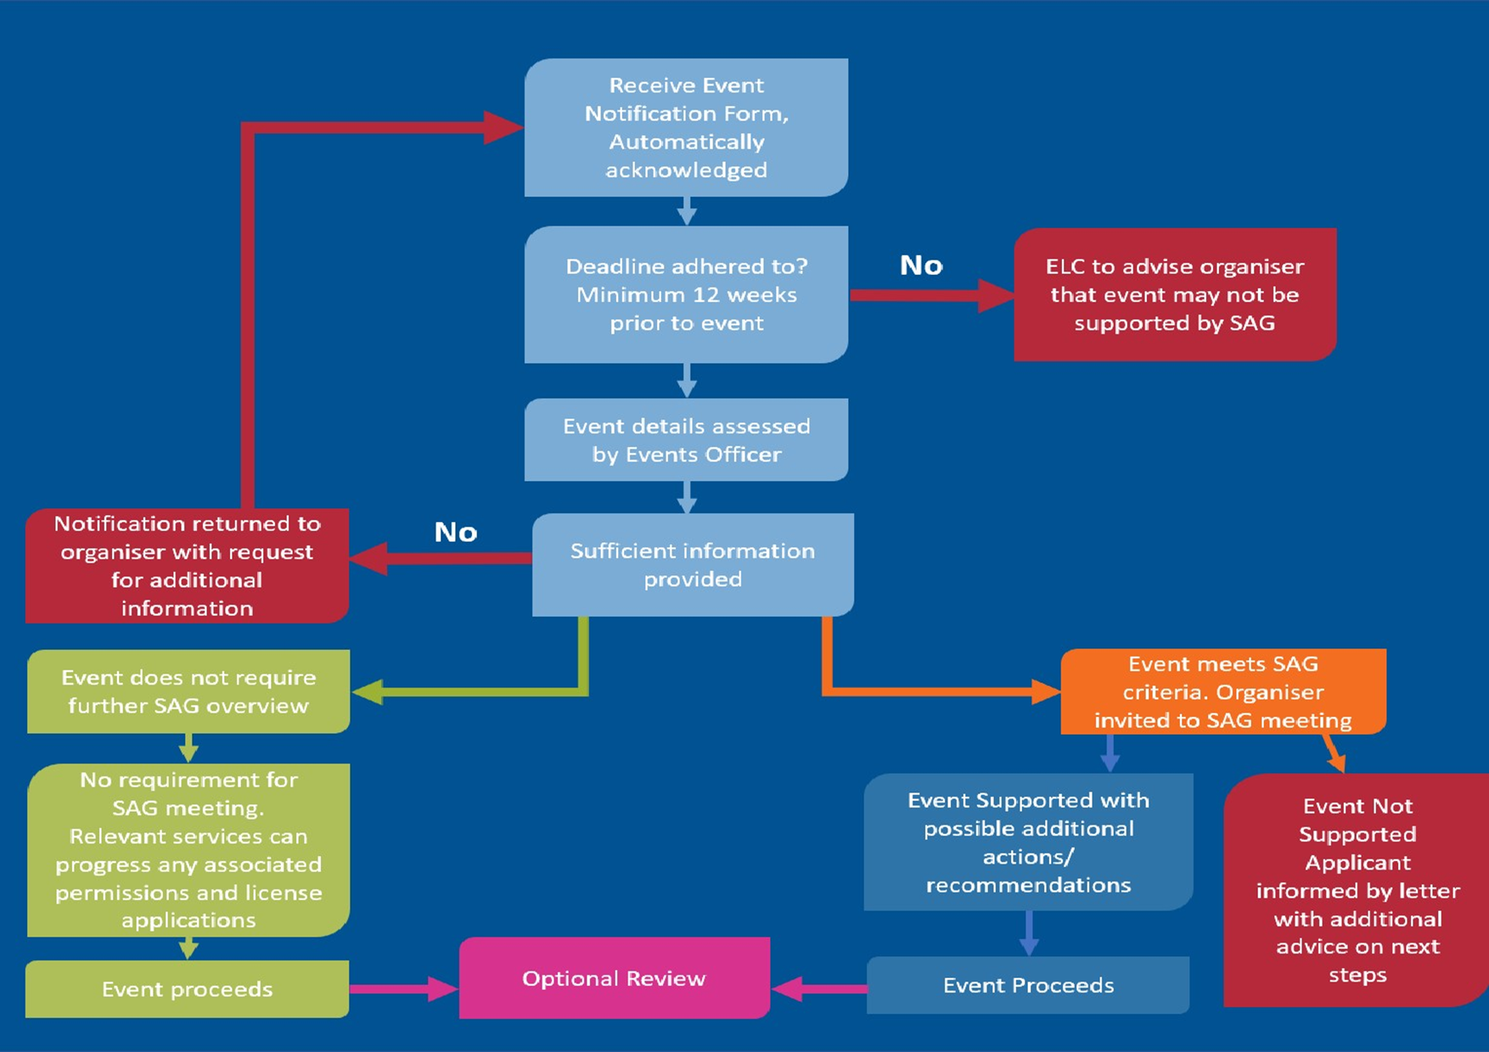

Appendix – 2: Event Category & Size

East Lothian Council will assess applications for all types of events. Applications are considered from all sections of the community. In order to allow us to give the best level of support and to help direct our resources better, East Lothian Council will use the following set of categories:

Category | Description
Active Recreation | These events encourage those who regularly participate in active lifestyles to engage in activities such as active play, recreational walking, running or cycling. These are free events, community focused, non-competitive and led by volunteers.
Charity (National) | This category covers those operated by national charities for the purpose of fundraising for the benefit of the charity.
Charity (Regional) | This category covers those operated by regional charities for the purpose of raising the profile and fundraising for the benefit of the charity.
Commercial | These events provide a commercial benefit to a profit-making business or operation including product launches, corporate events, music festivals, concerts, and fun fairs as the principal component of the event, one-off boot fairs and trade shows.
Community | Any event organised by community or voluntary groups that directly benefit the residents and visitors to the area or the group members and do not provide significant advertising or other commercial benefit to a profit-making business or organisation. They are aimed at a social group, specific locality and have a common cultural or heritage link. There is no principal entry fee, activities are free or at reasonable costs. This includes village fetes, parades (e.g. Remembrance Day), community sports, fireworks, holiday celebrations and parades.
Not for Profit /  Enthusiast | This category covers not for profit events, including specialist interest subjects such as motor vehicles and re-enactments. It could also cover specialist sports events. Likely to have small scale commercial activity for which money received is fully re- invested into the activity or not for profit group.

We recognise that some events may not exactly fit into these categories and Council Officers reserve the right to choose the category for the event. Events will be assessed on the information the Event Organiser provides in the Events Notification Form and organisers informed in the initial stages of planning.

When considering events there is also a scale by their size:

Event Size | Numbers in Attendance  (Participants & Spectators)
Small | Less than 500
Medium | 500-999
Large | 1000-4999
Major | 5000+

