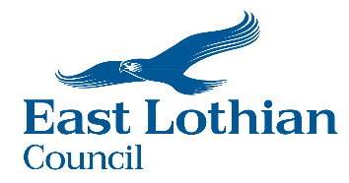

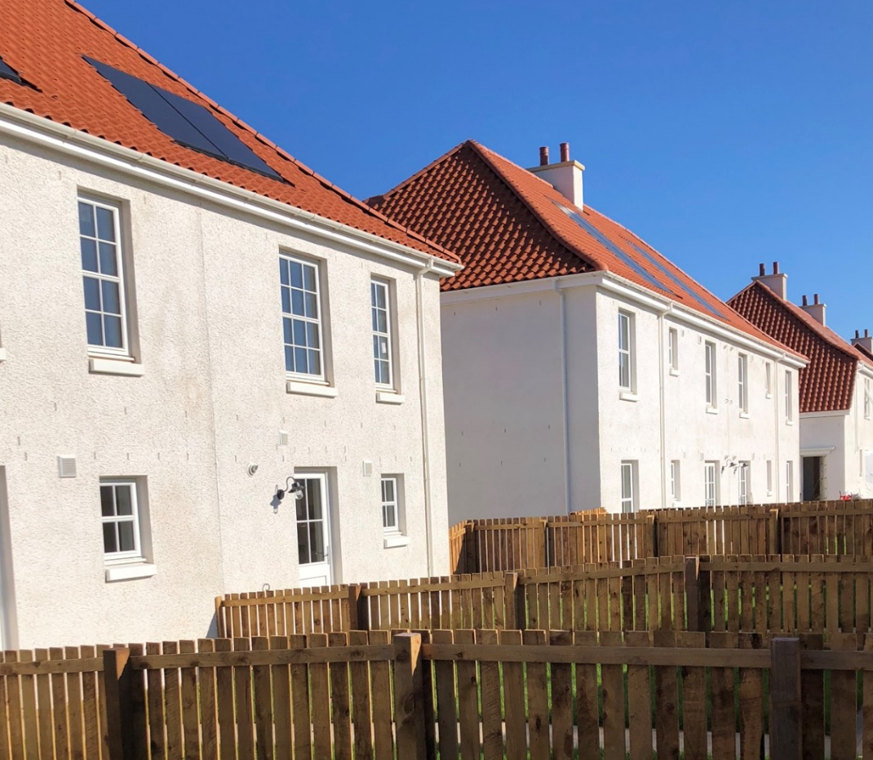
East Lothian Council
Strategic Housing Investment Plan
2026/27– 2030/31

1. Introduction 4
2. Summary 5
3. The East Lothian Context 7
3.1 Overview 7
3.1.1 Demographic Context 8
3.1.2 Housing Stock Profile 9
3.2 National & Regional Policy Context 10
3.3 Local Policy Context 11
3.3.1 East Lothian Council Plan 11
3.3.2 Statement of alignment with LHS 12
3.3.3 Housing Need and Demand 12
3.4 Achievements 14
3.5 Gypsy/Travellers 15
3.5.1 Local Development Plan and NPF4 16
3.5.2 Rapid Rehousing Transition Plans 17
3.6 Child Poverty (Scotland) Act 2017 19
3.7 Economy 20
4. Affordable Housing Supply Programme 22
4.1 Site Prioritisation Methodology 22
4.2 Housing Tenure 23
4.3 Investment priorities in Town Centres 24
4.4 Affordable Housing Delivery Profile 25
5. Resources and Funding 29
5.1 Resource Planning Assumptions 29
5.2 Developer Contributions 29
5.3 Council Tax Income for Affordable Housing from Second and Empty Homes 30
5.4 Empty homes 30
5.5 Housing Revenue Account (HRA) Prudential Borrowing 31
5.6 Innovative Financing Models 31
5.7 Open Market Acquisitions 32
5.8 Discounted Housing for Sale 32
5.9 Other available funds 32
5.9.1 Charitable Bonds 32
5.9.2 Housing Infrastructure Fund 32
5.9.3 Rural Housing Fund 33
5.9.4 Vacant and Derelict Land Investment Programme 34
5.9.5 Individual and organisational support 34
5.9.6 Risk Management 34
6. Offsite construction, procurement and energy efficiency 37
6.1 Offsite Construction and Procurement 37
6.2 Climate change and energy efficiency 37
6.3 Existing Projects 39
7. Consultation and collaboration 40
8. Equalities 41
9. Strategic Environmental Assessments 42
10. Monitoring 43
11. Conclusion 44
Appendix A – Housing Market Sub-Area Map 45
Appendix C – Prioritisation Tool 48
Appendix D – Prioritisation Exercise for Sites 49
Appendix E – Breakdown of High and Medium Priority Sites 50

Introduction
East Lothian Council’s Strategic Housing Investment Plan (SHIP) covers a five-year period from 2026/27 to 2030/31 and has been prepared in accordance with revised Scottish Government Guidance for All Local Authorities on Preparing Strategic Housing Investment Plans (July 2025). This SHIP details how affordable housing tenures will be delivered to achieve the outcomes of the Local Housing Strategy (LHS) 2024-2029.
The purpose of the SHIP is to set out East Lothian’s strategic housing investment priorities over a 5-year period, specifically affordable housing, and Gypsy/Traveller accommodation. It aligns with the Council’s adopted Local Housing Strategy (LHS) 2024-29 and the most up to date Housing Land Audit, demonstrating how investment in affordable housing will be targeted. It is reviewed and updated yearly. It is the key document for identifying the strategic housing projects, which will also help to inform the preparation of Council budgets, Registered Social Landlord (RSL) borrowing and funding support through the Scottish Government’s Strategic Local Programme Agreement.
The SHIP is an operational working tool to improve long-term strategic planning and direct investment to:
- Reflect and align with the Local Housing Strategy (LHS).
- Reinforce the role of the local authority as the strategic housing authority.
- Inform Scottish Government investment decisions.
- Inform the preparation of a Strategic Local Programme Agreement for all providers.

Summary
This year’s SHIP has been prepared in yet another challenging year. Following the declaration of a National Housing Emergency and Local Affordable Housing Emergency in 2024, affordable housing continues to be critically pressurised- with demand far outstripping supply and outpacing the rate of development. The delivery of affordable housing in East Lothian faces extreme challenges, including construction costs, constrained funding and a reliance on Section 75 orders reducing the level of control over site programme.
The development of this SHIP included a review of the existing SHIP, taking account those projects already committed by partners and the Scottish Government. This review also acknowledged the current challenges and constraints, including the reduction in future investment. The Council will receive an approximate resource allocation of just over £27m for the period of this SHIP, averaging just over £5.4m per annum. If we compare with the previous last 4 years allocation of over £63m, averaging over £15m a year, together with Charitable Bond funding, the reduction is severe. Whilst East Lothian Council acknowledges and welcomes previous allocations, including the reversal of funding cuts through the 2025-2026 Scottish Budget, East Lothian remains to face critical challenges in meeting the growing population’s housing needs. This has been highlighted through the declaration of an affordable housing emergency.
East Lothian Council is in a unique position with significant growth. As a result of the previous levels of investment, developers have been doing all they can to accelerate the delivery of affordable housing. The team were pushing ahead to maximise opportunities for affordable housing delivery, which has resulted in a number of developments ready to start on site but with no funds to enter into contractual arrangements. This puts East Lothian Council’s Affordable Housing programme at high risk, even more so in the context of the Housing Emergency. Whilst East Lothian Council will continue to work closely with the Scottish Government to support and maximise the delivery of new affordable housing, there is no doubt that this will result in a permanent loss of units.
The SHIP has been developed with an ambitious outlook, identifying the potential to commence construction on 1,197 new affordable homes over the next five years. It also estimates that, with an investment of £123 million, up to 1,365 homes could be completed within the same period. In addition, 36 unsubsidised homes are planned for delivery through the Council’s intermediate tenure options. However, the Council recognises that securing £123 million in funding is unlikely and will continue to work collaboratively with the Scottish Government to explore innovative solutions to maximise housing delivery.
The Council also understands that the ability to deliver this ambitious programme is dependent on a number of other factors such as:

- Scottish Government’s The Cost of Living (Tenant Protection) (Scotland) Act 2022 and any further caps on increasing rent within the private sector which will affect the Mid-Market Rent tenures longevity.
- Prevailing interest rates and their impact on current borrowing
- New Building Regulations
- The Housing (Scotland) Bill
- Shortages in labour and material markets
- Site constraints
- Social housing net zero standards.
An exercise was undertaken to assess which high and medium priority sites, free from significant constraints, could realistically be delivered within the SHIP period, using the prioritisation methodology outlined in Chapter 4. The findings, presented in Table 1B ‘Deliverable AHSP’ in Appendix B, indicate that with £108 million in funding, up to 1,224 affordable homes could be completed over the next five years.
A further prioritisation exercise was undertaken to assess what could realistically be delivered based on the resource allocations East Lothian Council expects to receive from the Scottish Government’s Affordable Housing Supply Programme (AHSP) over the SHIP period, including an allowance for 25% slippage. This appraisal, detailed in Table 1C ‘ASHP Resource’ in Appendix B Table 1, estimates that £36.687 million in Scottish Government subsidy would enable 301 site starts and 474 completions over the next five years. When compared to the total number of homes identified in the SHIP, this represents a potential shortfall of 750 homes. An additional 141 homes remain in the pipeline, with further opportunities anticipated through new land releases in the forthcoming Local Development Plan 2 (LDP2).
As noted earlier East Lothian Council are in a unique position where we have a number of sites that the council is committed to maximising the supply of new affordable housing, and will continue to work with partners and the Scottish Government to try and mitigate the loss of affordable housing as far as possible. This will include a suite of options such as securing serviced land, swapping sites, delivering through innovative finance models as well as exploring creative use of other funds. However, due to the current status of several sites, the Council will have no option but to take a commuted sum resulting in the permanent loss of much needed affordable housing. While the Council will explore innovative ways to maximise these commuted sums, this will not allow the Council to deliver the same number of units as could have been delivered on site and within this parliamentary period.
At the time of writing, this SHIP has been shared with the Cabinet Spokesperson for Housing. The SHIP will however be submitted to East Lothian Council’s Members Library in due course and will be publicly available and published on the Council’s website once approved.

The East Lothian Context

Overview
East Lothian is part of the wider South-East Scotland housing market area, located to the east of Edinburgh’s suburban edge. East Lothian measures approximately 270 square miles in area and includes 43 miles of coastline. The area has six main towns, extending from Musselburgh in the west to Dunbar and beyond to the area’s administrative boundary, with Scottish Borders in the east.
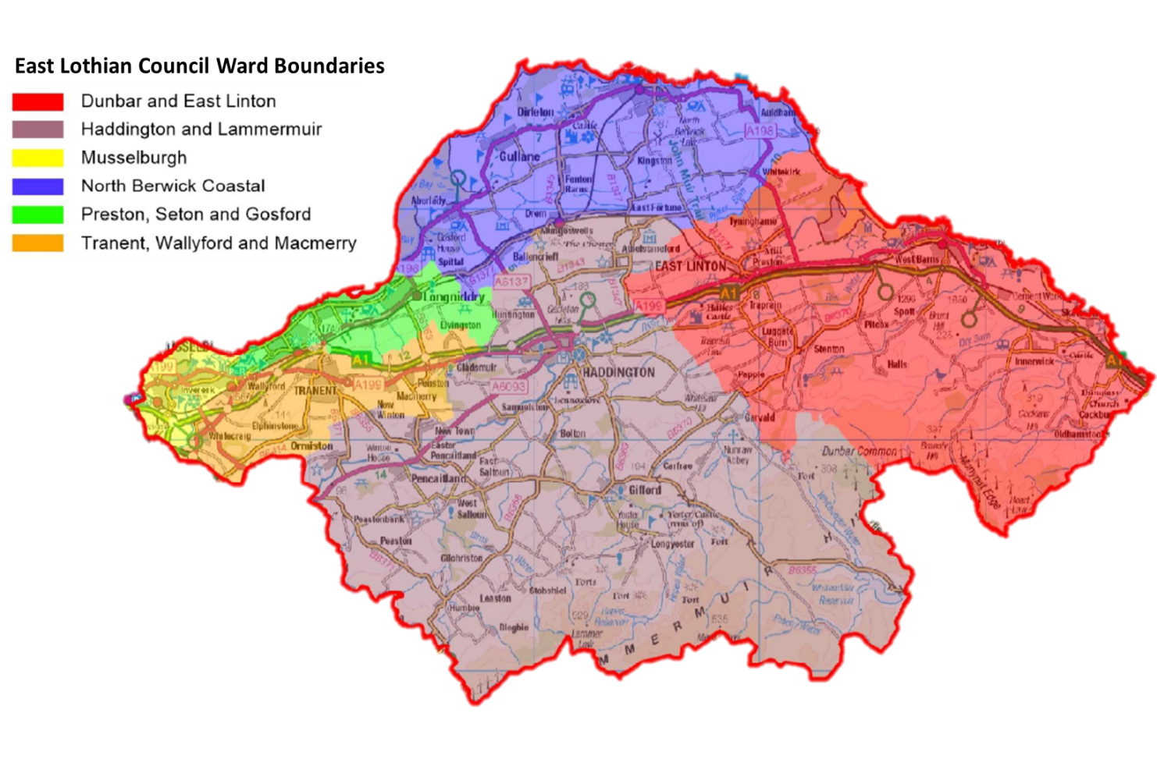
Figure 1: East Lothian Council Ward Boundaries
The population of East Lothian is growing and changing; the average house price is almost 60% higher than the national equivalent , and the county is generally considered affluent. However, the desirability of East Lothian as a place to live and a rapidly growing population places increasing demands on infrastructure and housing. Significant inequalities exist both within and between communities and pockets of deprivation are evident, particularly in the west of East Lothian. Increasing the supply of affordable housing is critical to addressing inequalities and alleviating poverty across the county.

Demographic Context
East Lothian currently has an estimated population of 112, 460, there has been a 12.6% increase since the last census in 2011 in comparison to 2.7% growth across Scotland. Between 2018 and 2030, the population of East Lothian is projected to increase by 8.5%, which compares to a projected increase of 2% for Scotland as a whole. The county is projected to have the 2nd highest percentage change in population size out of the 32 Council areas in Scotland.
East Lothian had an estimated 49,902 households, a 13.9% increase between 2013 and 2023, in comparison to the Scottish average of 5.9%. East Lothian’s household growth has been more than double the Scottish average. Between 2018 and 2028, the number of households in East Lothian is projected to increase by 10.5%, which compares to a projected increase of 4.9% for Scotland as a whole. From 2018-2043, it is estimated that East Lothian will see an increase in household numbers of 37%.
This growth in the number of households within East Lothian can be explained by the increased number of dwellings and population growth, whilst the household sizes have decreased. It is estimated that East Lothian had 52,327 dwellings in 2023, a 29% increase since 2003, whilst the national average lies at 15.5%. East Lothian’s households are predominantly two person (35.8%), followed by one person households (31%). Three person (15%) and four person (13.4%) make up smaller proportions. The proportions are largely similar to that of Scotland, especially for households with 5+ members. There is projected to be an increase of 29.1% of single person households, an overall increase of 4,254 households or 185 per annum. This compares with a 14.9% increase projected across Scotland.
In terms of age, the largest increase in household numbers is projected for those headed by people aged 75 and over. East Lothian is projected to have the third largest increase across Scotland at 86.2% by 2040 compared with a 64.7% increase nationally. By 2040, 45.8% of households in East Lothian are projected to be headed by a person aged 60 and over. Nationally the figure is expected to be 42.6%. It is projected that by 2040 only 18.1% of households in East Lothian will be headed by someone under the age of 40, a fall from 21% in 2018.
These changes have major implications for housing, housing support and specialist provision as the need and demand for homes and infrastructure increases. A range of house types will be required to ensure accessibility to meet the growing and changing needs of the population in particular to cater for the large increase in older households, and a proportionally higher older population than the majority of Scotland.

Housing Stock Profile
As of August 2025, East Lothian Council’s housing stock consists of 9,307 properties used for mainstream accommodation. In September 2025 the local authority’s housing list had 4,238 applicants- 21% of which are transfer applicant and 79% are ‘wait list’ applicants. Despite significant levels of investment in affordable housing and an increase in supply in recent years, the number of applicants for Council and RSL properties remains high.
A breakdown of East Lothian Council Housing stock set out in Table 1 shows the largest proportion of social housing is held in Musselburgh Area Partnership (28.2%), followed by Fa’Side (22.9%), which combined contain over 50% of East Lothian Council housing stock. There is also a significant proportion of stock (20.4%) in Preston, Seton and Gosford. This means that around 70% of Council Stock is within the west of East Lothian.
Table 1: Location of Council Stock in East Lothian by Area Partnership
Area Partnership | Total Council Stock | Percentage (%)
Dunbar and East Linton | 974 | 10.5%
Haddington and Lammermuir | 1,025 | 11.0%
Musselburgh | 2,626 | 28.2%
North Berwick Coastal | 638 | 6.9%
Preston, Seton and Gosford | 1,909 | 20.5%
Fa’side | 2,135 | 22.9%
Total | 9,307 | 100%
Source: East Lothian Council, 2025

Two-bedroom properties account for 50.2% of East Lothian Council’s housing, the next highest proportion is three-bedroom properties accounting for 25.4% of stock. There are no 5+ bedroom properties provided in the North Berwick Coastal Area Partnership by East Lothian Council, but a small amount is provided by RSLs.

Table 2: East Lothian Council Social Housing Stock by Area Partnership and number of bedrooms
Area Partnership | Number of Bedrooms
Area Partnership | 1 | 2 | 3 | 4 | 5+
Dunbar and East Linton | 149 | 513 | 285 | 25 | 2 | 974
Haddington and Lammermuir | 277 | 423 | 287 | 37 | 1 | 1,025
Musselburgh | 583 | 1,359 | 607 | 73 | 4 | 2,626
North Berwick Coastal | 143 | 333 | 145 | 16 | 0 | 637
Preston, Seton and Gosford | 376 | 962 | 491 | 64 | 4 | 1,909
Tranent, Wallyford and Macmerry | 429 | 1,101 | 548 | 53 | 4 | 2,135
Total | 1,966 | 4,691 | 2,363 | 271 | 16 | 9,307
Percentage (%) | 21.1% | 50.4% | 25.4% | 2.9% | 0.2% | 100%
Source: East Lothian Council, 2025

The greatest demand from those on the housing list comes for one-bedroom properties, accounting for just over 50% of all applicants. This is followed by 2-bedroom properties, accounting for almost 30%. While the demand for the number of 4+ bedroom homes is smaller, this has been increasing in recent years. With some families increasingly needing larger properties for multiple people with disabilities.
Table 3: Applicants by Area and Bedroom Size (including transfer and housing list)
Ward | Number of Bedrooms
Ward | 1 | 2 | 3 | 4 | 5 | 6 | Total
Dunbar and East Linton | 618 | 356 | 149 | 34 | - | - | 1157
Haddington and Lammermuir | 821 | 474 | 158 | 35 | 2 | 1 | 1491
Musselburgh | 1501 | 736 | 341 | 92 | 2 | - | 2672
North Berwick Coastal | 644 | 389 | 135 | 27 | - | - | 1195
Preston, Seton and Gosford | 1271 | 745 | 317 | 70 | 3 | - | 2406
Tranent, Wallyford and Macmerry | 1064 | 628 | 228 | 52 | 2 | 1 | 1975
Total | 2352 | 1340 | 647 | 133 | 6 | 2 | 4480
Percentage (%) | 52.5% | 29.91% | 14.44% | 2.97% | 0.13% | 0.04%
Source: East Lothian Council, 2023

National & Regional Policy Context
In March 2021, the Scottish Government published its 20-year housing strategy “Housing to 2040” with the aim to ensure that:
“By 2040, everyone will have a safe, high quality home that is affordable and meets their needs in the place they want to be.”
Housing to 2040 (H2040), continues the More Homes Scotland policy approach first introduced in 2016, and commits to a long-term ambition on the completion of the existing 50,000 affordable homes target and a further 110,000 affordable homes over the following ten years up to 2032. At least 70% of these homes will be for social rent and 10% will be delivered in remote, rural and island communities. H2040 also sets out plans to pursue a range of innovative approaches to delivering affordable housing tenures such as Open Market Shared Equity and Mid-Market Rent options. Other aspects that H2040 seeks to achieve are better quality and energy efficient homes across tenures; more accessible and adaptable homes as well as improving the spaces around homes. This is hugely challenging to delivery now.
The Housing Planning Delivery Framework reinforces the links between planning and housing requirements to support the provision of the right homes in the right places to create and sustain thriving communities. The strategy shows how integral housing is to the Scottish Government’s objectives of tackling poverty and inequality, creating and supporting jobs, meeting energy efficiency and decarbonisation aims as well as delivery of fuel poverty and child poverty targets, creating connected, cohesive communities.
The Edinburgh and South East Scotland City Region Deal reflects the joint commitment of city region partners and the Scottish Government to deliver the regional housing programme, transforming regional housing supply and driving economic and inclusive growth across Scotland. The regional housing programme aims to accelerate the delivery of affordable housing and housing across all tenures, enable the development of seven major strategic housing sites and drive efficiencies across the public sector estate.

Local Policy Context

East Lothian Council Plan
The East Lothian Council Plan 2022-2027 was adopted in August 2022 and continues the Council’s vision of achieving:
“an even more prosperous, safe and sustainable East Lothian, with a dynamic and thriving economy that enables our people and communities to flourish.”
The following five years will focus on the current challenges of:
• Recovery and renewal from COVID
• Reducing poverty and inequality
• Responding to the Climate Emergency
The Council Plan acknowledges that there is a myriad of strategies which help to achieve the Council’s strategic vision, including LHS. It also recognises that plans and strategies which are currently under revisions should reflect the new ambitions of the Council Plan. The plan acknowledges the local pressures on housing affordability and makes direct links to the current LHS 2024-2029.
In 2024, East Lothian Council approved an update to the East Lothian Council Plan, to consider the significant pressures faced by the local authority. Three new corporate priorities were set out as follows:
- Ensure financial sustainability by delivering approved savings and transforming service delivery.
- Prioritise statutory services and focus on high-risk areas.
- Deliver infrastructure, economic development, and environmentally sustainable projects.
To support the revised priorities and ensure focus, in Augst 2025 the Council approved changes to the Council Plan- Action Plan. The Action Plan has now been condensed from 68 actions to 36 high-impact actions. The provision of suitable housing to support health needs, the delivering of affordable homes and alignment with the LHS 2024-2029 remain within priority actions of the Plan.

Statement of alignment with LHS
The Local Housing Strategy (LHS) underpins the alignment between housing and planning authorities and encourages local authorities to demonstrate how they are supporting new and existing neighbourhoods based on Place-Making principles. The LHS promotes housing’s role in the building of successful sustainable places. The LHS sets out the strategic approach of the local authority and its partners in delivering high quality housing and housing related services across all tenures, to meet identified need, with the LHS directly informing the SHIP.
The 2024-2029 LHS was adopted in April 2024 and informs this version of the SHIP.
East Lothian Council’s vision for housing in the LHS 2024-29 is that:
“People in East Lothian have access to warm, high quality, affordable homes which meet their needs and enables them to live in communities with the support and services they require.”

To achieve this vision and mitigate some of the impacts contemporary events have had on East Lothian, five priority outcomes were developed.
- Communities are supported to flourish, be distinctive and well connected.
- Housing Supply is accessible, affordable and provides a range of choices to meet the needs of households across East Lothian.
- Homelessness is prevented as far as possible, where unavoidable a rapid response with appropriate accommodation and support is provided.
- Housing and support services are effective, accessible to, and will meet the needs of those most vulnerable in the community.
- All homes within East Lothian are maintained to a high standard, are energy efficient and contribute to meeting East Lothian’s climate change targets.

Housing Need and Demand
A housing need and demand assessment (HNDA) is a key part of the evidence base for the LHS. The purpose of the LHS is to provide strategic direction to tackle housing need and demand (as identified through the HNDA) and inform future investment in housing and related services across a local authority area.
East Lothian is one of the six local authorities along with the City of Edinburgh, Fife (West & Central), Midlothian, the Scottish Borders and West Lothian who come together to produce the South-East Scotland HNDA. The most recent HNDA carried out across the South-East Scotland area is HNDA3, approved by the Scottish Government as ‘robust and credible’ and subsequently published in July 2022. HNDA3 uses the Scottish Government HNDA tool to calculate housing estimates for South-East Scotland, adjustments to the calculation can be made to reflect different growth scenarios.
On the basis of the above, a project team was established through the SESHOF (South East of Scotland Housing Forum) representing the six local authorities, to research, analyse and deliver the core outputs of HNDA3. The project team reported progress to the Edinburgh and Southeast Scotland City Deal Regional Housing Partners and consulted with the Edinburgh and South East Scotland City Deal Regional Housing Board and the SESplan Board.
A wider housing market partnership was also established, allowing the project team to draw on the expertise of other housing, planning, economic development, health, and regeneration partners, linking to specialist housing providers, letting agents, tenant organisations, house builders, etc.
HNDA3 determined that a total of 476 new homes per annum are required within East Lothian over a 20-year period, of which 66% i.e. 314 should be affordable and 34% market housing.
In accordance with Scottish Government LHS Guidance, the HNDA figures are taken as a starting point to set a Housing Supply Targets which gives full consideration given to those factors which may have a material impact on the pace and scale of housing delivery including:
- Economic factors which may impact upon demand and supply.
- Capacity within the construction sector.
- The potential interdependency between delivery of market and affordable housing.
- Availability of resources.
- Likely pace and scale of delivery based on completion rates.
- Recent development levels.
- Planned demolitions.
- Planned new and replacement housing and housing brought back into effective use.
The LHS 2024-29 set an affordable housing supply target of 891 homes over the five-year plan, with a market housing supply target of 3,563 units. This represents a shift from the annual figure used in the previous LHS. The figure provides a benchmark for monitoring performance against the overall target over the five-year period, allowing for longer term planning and recognising that no two years will be the same.
The last LHS (2018-23) identified 40 units for the Health and Social Care over its lifetime. This number was exceeded and a new target of up to 60 units has been set under the Housing Supply Target within the current LHS, this will be used to inform this year’s SHIP. Delivery is dependent on both the AHSP and funding from H&SCP to provide care and support within the properties.
In line with this, the SHIP aims to support all groups as defined within section 10 of the LHS guidance. Therefore, a variety of sizes and types of housing should be provided. However, it is likely that this target will be further reviewed and updated in light of this SHIP and available future resources. This is likely to result in a reduced 5-year target.
Affordable Housing Emergency
As a direct result of the challenges highlighted in the SHIP 2024/2025 – 2029/2030, East Lothian Council declared an Affordable Housing Emergency in November 2024. The SHIP 2024/25 identified that, due the proposed funding cuts from the Scottish Government, there was a high risk of being unable to deliver affordable housing contributions within private developments. This would result in the permanent loss of affordable homes. Whilst the cuts were subsequently reversed, risk continues due to high cost and the rate of private development within the county.
To address the Affordable Housing Emergency East Lothian Council is bringing together the Homelessness Emergency Action Plan and Local Housing Strategy (LHS) 2024-2029 Action Plan and will continue to review and monitor through the Housing Partners Board. Actions focus on improving access to affordable housing, ensuring the best use of stock, improving quality of homes and the strategic planning of homes. Progress is monitored through planned updates and key achievements have been seen. However, homelessness remains high and affordable housing need remains critical, challenges in delivering new supply can risk reducing and even reversing positive outcomes.
Wheelchair and Accessible Housing
East Lothian Council supports increasing the delivery of wheelchair accessible housing. A Strategic Needs Assessment for Wheelchair and Specialist Housing in East Lothian was carried out in September 2021. To meet current unmet need and existing demand for social rented wheelchair accessible housing, the LHS commits to 10% of the total supply of new affordable housing being wheelchair accessible, with a minimum of at least 100 units to be delivered over the five years. This will ensure the SHIP takes account of a variety of specialist housing needs by including the delivery of housing for people who are ambulant disabled, people who require wheelchair housing and housing to meet the needs of an ageing population.
This SHIP proposes to provide 363 accessible units over the next 5 years which equates to 52% of all high priority completions. This increase is due to several Town Centre developments providing accommodation for older persons and Herdmanflat, Haddington providing a significant number of dementia friendly homes.
There is currently no mechanism to record the number of private homes which are wheelchair accessible. New build properties are not built to Housing for Varying Needs Standards or wheelchair accessible standards. As a result, any accessibility provisions found in private sector homes are often the result of the owner adapting the property. The proposed changes to Building Standards and guidance in 2025/26 through the all-tenure Scottish Accessible Homes Standard will ensure a new minimum standard in private homes.
The Council intends through LDP2, to establish mechanisms to ensure a target of 5% of new build market housing is built to wheelchair accessible standards.

Achievements
Over the past five years, a total of 572 new affordable homes have been delivered by East Lothian Council in the social rented sector. Of these 76 were either wheelchair accessible housing or ambulant disabled (Table 4). This represents just over 13% of all new build social housing provided by the Council. Table 4 provides an overview of the number of affordable units of social housing delivered within East Lothian over the past five financial years. This also includes core and cluster housing for specialist needs, provided for Health and Social Care Partnership.
Table 4: Number of New Build Wheelchair and Ambulant Disabled Units by Town
Year | Town | Total units | Wheelchair | Ambulant disabled
2020/21 | OMAs Various | 13 | 0 | 0
 | Dunbar | 7 | 0 | 0
 | Haddington | 43 | 2 | 2
 | Musselburgh | 12 | 0 | 4
 | Tranent | 12 | 0 | 0
 | Ormiston | 30 | 0 | 0
 | Prestonpans | 6 | 3 | 2
 | Total | 123 | 5 | 8
2021/22 | OMAs Various | 20 | 0 | 0
 | Longniddry | 39 | 0 | 0
 | Ormiston | 37 | 2 | 4
 | Musselburgh | 18 | 0 | 4
 | Total | 114 | 2 | 8
2022/23 | OMAs Various | 23 | 0 | 2
 | Tranent | 60 | 4 | 0
 | Musselburgh | 16 | 0 | 0
 | Macmerry | 26 | 2 | 0
 | North Berwick | 23 | 0 | 3
 | Blindwells | 60 | 0 | 4
 | Haddington | 25 | 0 | 0
 | Macmerry | 26 | 2 | 2
 | Wallyford | 15 | 0 | 0
 | Total | 274 | 8 | 11
2023/24 OMAs Various |  | 25 | 0 | 0
 | Haddington | 37 | 1 | 4
 | East Linton | 28 | 3 | 5
 | Haddington | 17 | 0 | 4
 | Musselburgh | 48 | 2 | 4
 | Tranent | 49 | 1 | 4
 | Pencaitland | 30 | 0 | 4
 | Total | 209 | 7 | 25
2024/25 | OMAs | 5 | 0 | 0
 | Whitecraig | 27 | 2 | 6
 | Elphinstone | 23 | 0 | 1
 | Tranent | 11 | 0 | 0
 | Haddington | 18 | 0 | 0
 | Musselburgh | 9 | 0 | 0
 | Total | 93 | 2 | 7
Source: East Lothian Council, 2025 | Cummulative Total | 813 | 24 | 52

Gypsy/Travellers
Appropriate housing is critical to the health, education and employment opportunities of Gypsy/Travellers. Gypsy/Travellers are a distinct ethnic group and were included as such for the first time in the 2011 Census. Of the 3,343 individuals identifying as Gypsy/Travellers in Scotland, 61 were living in East Lothian. Notwithstanding the size of this relatively small community, which fluctuates with the seasons, formally assessing and subsequently addressing the accommodation needs of Gypsy/Travellers remains important.
Up until 2020, East Lothian and Midlothian Council shared a Gypsy/Traveller Site on the border between East and Midlothian. A reduction in the number of tenants on site to zero, followed by extreme vandalism including fire raising, resulted in the site being closed.
Scottish Government have made available £20million for the Gypsy/Traveller Accommodation Fund over 2021-2026 using demonstration projects across Scotland. The fund is intended for both significant renovation and improvements of standards on existing sites and the building of new sites. In 2025, the Scottish Government announced that the Gypsy/Traveller Accommodation Fund will now be included in the Affordable Housing Supply Programme- as part of Resource Planning Assumption. Further information and guidance are expected. Concerns have been raised across Local Authorities around changes to the Fund and risks for its use- or lack of.
At present, there has been little evidence of need and demand for the site in East or Mid Lothian, with most need being met through City of Edinburgh’s site and two private sites in East Lothian. Nevertheless, East Lothian Council continues to monitor the situation and engage with Gypsy/Traveller families where possible to ensure their needs are met locally. For these reasons, East Lothian has not applied to the Gypsy/Traveller Accommodation Fund but does intend to work closely with the Scottish Government over the coming months to find a resolution for the current site. A Needs Assessment on the Gypsy/Traveller Site was completed in 2024 and is currently being considered by Senior Managers before further action is taken.

Local Development Plan and NPF4
The Local Development Plan 2018 (LDP) is East Lothian Council’s land use plan, setting out a development strategy for the future of East Lothian to 2024 and beyond as well as a detailed policy framework for guiding development. It sets out where development should and should not occur, including housing, education, economic and retail development, new transport links and other infrastructure. It sets the current policy position for East Lothian and decisions on planning application will be made in accordance with this Plan. The LDP also seeks to ensure that an adequate 5-year housing land supply is maintained within East Lothian. The next LDP2 is currently being developed and is in the evidence reporting stage which will align the policy approaches being proposed through National Planning Framework 4 and other National Strategies.
National Planning Framework 4 replaces NPF3 and Scottish Planning Policy and will cover Scotland’s long term strategy to 2045.
Within the currently LDP Policy HOU3 of the LDP sets out an affordable housing quota of 25%. It states that a 25% affordable housing contribution is required from developers of new housing developments consisting of five or more units, with the exception of Blindwells and Letham Mains, Haddington, for which contributions will be 30% and 17% respectively.
The LDP is also concerned with the design of development and a development’s influence on sustainability and place making. In line with this, the LHS 2024-29 builds upon this with the priority outcome “Communities are supported to flourish, be distinctive and well connected.”.
Housing cannot be seen as just bricks and mortar. Wider service provision and the promotion of sustainable places is crucial. This includes: ensuring accessible, well-managed greenspace; encouraging attractive environments with pleasing facilities for people to live and work in; creating a network of paths with associated active travel routes and conserving bio-diversity. There is a focus on the people who live in East Lothian’s communities, ensuring places are welcoming, accessible, easy to move around and inclusive for everyone, i.e. accommodating differently-abled bodies. There is also an emphasis on health, i.e. promoting physical activity, promoting positive mental health and reducing carbon emissions.
Provision of a range and choice of good quality housing plays an important role in promoting quality and opportunity and sustainable communities. It also helps to enhance the environment and its positive impact on health and general wellbeing is recognised. While the current priority is the delivery of social rented housing, it is anticipated that the majority of alternative forms of tenure will come forward as Mid-Market rent (MMR) or low cost home ownership (LCHO). Notably, Policy HOU4 of the LDP supports a good variety of affordable housing based on the needs of the locality.

Rapid Rehousing Transition Plans
East Lothian’s Rapid Rehousing Transition Plan (RRTP) is based around the aim that homeless households can access appropriate settled accommodation as quickly as possible, moving away from the use of temporary accommodation as an automatic first response to homelessness. The RRTP reaches across multiple services within the Council and is strongly aligned with the LHS 2024-2029- particularly within the priority outcome which seeks to prevent and respond to homelessness.
A key focus of the RRTP has been and remains reducing temporary accommodation and to ultimately replace B&B - this was acknowledged as always being an immense challenge. Homelessness in East Lothian remains a structural issue, with a lack of affordable housing supply across the county, limited land supply and substantial costs required for infrastructure.
There have been key changes in legislation that have had a direct impact on the delivery of the RRTP and homelessness services in East Lothian.
Unsuitable Accommodation Order (UAO)
The extended Unsuitable Accommodation Order 2020 (UAO) came into force in October 2021 and placed a legal duty on all local authorities that required any homeless households not be placed in ‘unsuitable accommodation’ for more than seven days. East Lothian Council was one of several local authorities that faced a high level of breaches from the outset but has made steady progress over the last twelve months to reduce these numbers.
Local Connections
Legislation around local connections were changed in November 2022 by the introduction of the Homeless Persons (Suspension of Referrals between Local Authorities) (Scotland) Order 2022. Local authorities no longer have the power to refer an applicant to another local authority in Scotland based on their local connection to the area. The Council continues to closely monitor and report the impact of the changes to the Scottish Government monthly. Whilst the numbers are relatively small, the operational impact these additional cases have on resources cannot be underestimated.
Temporary Accommodation
Despite a wide range of mitigating actions in recent years, the level of demand from homeless applicants for temporary accommodation in East Lothian remains high. The balance between supply and demand is such that the Council, even with a significant pool of around 165 temporary units & 100 emergency accommodation spaces, continues to use unsuitable accommodation. Approximately 10% of temporary accommodation is deemed unsuitable as per the extended Order.
Despite high levels of housing allocations to homeless households, waiting times for re-housing can be significant depending on individual requirements. Whilst the ambition of rapid rehousing is within scope for couples and small households in East Lothian, this is not a reality for single homeless households due to the low number of 1 bedroom properties. As of September 2025, single homeless applicants make up 83% of all homeless households owed a rehousing duty. In 2024/2025, single households spent on average 396 days in temporary accommodation, compared with the Scottish average of 217 days).
East Lothian has second highest average total time spent in temporary accommodation for closed cases in Scotland.
Table 5: Average total time (days) spent in temporary accommodation for all cases that closed
 | 2017/18 | 2018/19 | 2019/20 | 2020/21 | 2021/22 | 2022/23 | 2023/24 | 2024/25
East Lothian | 347 | 346 | 345 | 339 | 391 | 423 | 342 | 357
Scotland | 175 | 183 | 187 | 204 | 207 | 223 | 226 | 238
Source: Homelessness in Scotland 2024/25

The Council and key partners are committed to transforming the way we prevent and tackle homelessness and work towards a rapid rehousing approach. Despite progress within rapid rehousing actions, the Council’s planned response to homelessness and rapid rehousing has been placed under pressure in recent years. This has come as result of many factors including the pandemic, Ukraine crisis and a raft of legislative change in respect of homelessness. Notwithstanding ongoing challenges, a reduction in temporary accommodation stock, and in particular ‘unsuitable accommodation’ will continue to be prioritised in 2025/26 and beyond, with a key aim being to reduce breaches of the Unsuitable Accommodation Order and ensure compliance.

Refugees and Asylum Seekers
The UK and Scottish Government have committed to a range of resettlement schemes to enable refugee and asylum seekers to be accommodated safely in the UK, including the Asylum Dispersal Scheme; Afghan Refugee Scheme; Homes for Ukraine; Super Sponsor Scheme; Family Visa Scheme and Homes for Ukraine Extension Scheme. At the time of writing the SHIP, circa 150 Ukraine households had been accommodated in East Lothian via local authority facilitated schemes and it is estimated up to a further 500 Ukraine households could be living across the county.
There have been several positive outcomes for displaced people from Ukraine. For example, over 50 households have been supported into settled housing in the private rented sector; circa 150 host placements have been facilitated, and only two households have presented as homeless. A small number have been housed in Council and mid-market tenancies. However, this increased need and demand for housing and related services from Ukraine households continues to place pressure on the housing system. There are concerns regarding the Council’s ability to accommodate the potential growth in demand from refugees and asylum seekers more broadly, i.e. additional households anticipated via the Asylum Dispersal Scheme/Afghan Refugee Scheme in 2025/26 and beyond.
The focus to date has been on meeting the immediate accommodation needs of displaced people from Ukraine, in accordance with the ‘Warm Scots Welcome’. However, a longer-term focus is required on wider integration and sustainable housing options to enable refugees and asylum seekers to live full and independent lives. The move to a ‘Warm Scots Future’ is challenging, within the context of a shortage of affordable housing and competing priorities in respect of other vulnerable groups. In accordance with the Warm Scots Future, an application for grant funding was successfully made to the Ukraine Longer-Term Resettlement Fund (ULTRF) for financial assistance regarding the refurbishment of seven properties in Haddington. The properties were previously used as temporary homeless provision for over a decade and required extensive works, however with assistance from ULTRF, these newly refurbished properties were brought back into use from mid-2024 for seven single female households from Ukraine.
Housing First

Housing First provides mainstream settled housing as a first response for people with multiple complex needs. It recognises a safe and secure home as the best base for recovery and offers flexible, open-ended support, tailored to the needs of the individual. The model separates the provision of housing and support, offering choice and control to tenants and works to the principles of harm reduction.

East Lothian Council acknowledges that progress with the delivery of a Housing First approach has been limited in the county. This is due to the competing priorities and significant pressures within the homelessness system. The Housing First target set in the initial RRTP stated that we would deliver 50 new tenancies over the life of the Plan – success has been limited and less that 50% of this target has been achieved. The Council will place additional emphasis on delivery of Housing First tenancies going forward.

Child Poverty (Scotland) Act 2017
The role of housing is critical in helping to reduce child poverty. As part of the Child Poverty (Scotland) Act 2017, local authorities and NHS Boards must jointly report annually on the activity they are taking and will take to reduce child poverty. Best Start, Bright Future published by Scottish Government highlights that affordable housing is a major contributor towards tackling child poverty. However, with the rising inflation and current economic uncertainty, it is likely that child poverty will rise again after seeing a drop in recent years. As part of this, the AHSP should strengthen to focus on housing needs by size and location to ensure larger family homes are being delivered.
A Joint Strategic Needs Assessment with Children’s Services on the housing and support needs of children and young people including, looked after children, children at risk of homeless, children experiencing homelessness, young carers and disabled children was completed for the current LHS 2024-29. Detailed actions on young people can be found in the LHS and include a review of all supported accommodation for young people. The LHS 2024-29 included a Children’s Rights and Wellbeing Impact Assessment. The LHS also aligns with key outcomes of government policy such as increasing the supply of affordable housing, reducing homelessness, improving standards of gypsy traveller accommodation, support people with disabilities to maintain their independence, and reducing fuel poverty are all indicators within the action plan to help reduce child poverty.
The East Lothian Poverty Plan 2024-28 incorporates East Lothian’s Child Poverty Action Plan ensuring there is a co-ordinated and strategic approach to tackling child poverty. The Plan sets out a wide range of actions to reduce poverty within the county. It states that 21% of children in East Lothian live in relative poverty and that 393 households including 150 children were in temporary accommodation during 2022-23.
The key outcomes of the plan are: good quality jobs that pay fairly, enough money from benefits, a good life with access to the essentials, and climate change ready.

Economy
Economic conditions in Scotland remain challenging as inflation and interest rates continue to impact economic performance. In recent months inflation has fallen but this has been a slower than expected decrease.
Although East Lothian is the second fastest growing authority, the demographics of the population is also changing with the highest growth in both older population and younger population. This brings its own challenges with higher support needs and higher needs for more accessible homes. The working age population is however decreasing as a result of high house prices, high rents and lack of affordable housing resulting in those ‘keyworkers’ having to move out with the area.
Challenges in delivering our affordable housing programme are greater than they have ever been with less investment together with the continuing increase in construction costs, constrained HRA budgets and increasing standards across the sector.
With updates to Building Regulations and the requirement to decarbonise new build properties along with provide fire suppression and Electrical Vehicle charging points, this additional cost increases pressures on already tight budgets and allocated grants along with pressures on infrastructure potentially putting developments under further constraints to deliver.
In terms of the effects of the economy on tenants, the Cost of Living crisis and in particular the sharp increase in food and energy prices will have had a significant effect on tenants and any disposable income they may have, having to stretch it further.

Affordable Housing Supply Programme
The focus of the SHIP is to deliver the outcomes set out in the LHS and maximise the use of the Scottish Government’s Affordable Housing Supply Programme (AHSP) resources. The affordable housing programme is currently over committed and will not be in a position to deliver all units through the SG programme. The Council will however continue to examine other alternative opportunities with its RSL partners and the Scottish Government to ensure as many units are delivered as possible. The SHIP identifies a shadow programme in the first year and will continue to do so for future years, which will provide future opportunities should projects be delayed during the period of the programme. These shadow developments will be made up of some high priority sites which may be accelerated and those medium priority sites, should opportunities arise to accelerate them.
The programme also takes account of:
- Projects already on site and expected to complete shortly;
- Projects that are progressing through various stages of the planning process;
- New projects that have been identified through the LDP process;
- Timescales identified through the Council’s HLA; and
- Increased Resource planning assumptions.
We would like the SHIP to deliver a minimum of 693 completed affordable units over the next 5 years with a further 36 unsubsidised units (outlined in Table 6a in Section 4.4 below). This number is based on those high priority projects highlighted in Appendix G that could start on site during the period 2026/27 – 2030/31. However, if all projects are included, i.e. if we include all projects prioritised as high, medium and low, then the SHIP shows that East Lothian could potentially see a total of 1,365 completions (excluding 36 unsubsidised).
The reality however is that the current resource allocation will only allow us to deliver 474 units over the next five years. It is therefore critical that we explore and collaborate to identify new innovative ways to maximise the delivery of much needed affordable housing.
Site Prioritisation Methodology
ELC is a diverse area with several different housing priorities, even within the same area. The Council is developing a Local Investment Framework as part of the new LHS to improve the Council’s intelligence at an area based level. This will focus on ward areas, and housing need will be assessed with related indicative targets for each ward to help address any imbalances occurring in the investment programme.
All projects included within this SHIP have clear links to the outcomes of the LHS. Housing development projects will only be taken forward where they assist in the delivery of those outcomes.
All projects have been prioritised to reflect deliverability in terms of strategic priorities, local need (including specialist housing), site availability / constraints, statutory consents as well as funding availability both from affordable housing providers programmes and private housing developers own financial capacity. It will be essential to ensure close collaboration continues between the Council and its RSL partners to mitigate any potential knock on effects.
The following housing needs are included within any considerations:
    - Existing stock in each area;
    - Housing list data, showing the demand to live in particular areas;
    - Specialist housing data, showing the need for a variety of particular client groups;
    - The level of recent development in each area and the impact this has had on current housing lists;
    - Allocations in each area;
    - Turnover of stock through transfers;
    - Levels of affordability; and
    - Wider regeneration priorities.
The deliverability of sites including land supply, constraints and funding include considerations on:
- The level of subsidy per unit available;
- Financial capacity of affordable housing providers as a result of increasing costs, rising interest rates and potential rent freeze;
- The availability of land within the Council’s control is a key issue and the majority of sites are reliant on delivery from the Private Sector.
- In East Lothian, there are challenges with respect to infrastructure costs as the majority of new housing development in East Lothian requires associated infrastructure investment. This is predominantly funded through Section 75 developer contributions. An example of this is for education.
- Housing Land Audit (HLA)
- Existing Planning Consent
Appendices B–D outline the different steps and considerations taken to prioritise sites and the outcome of the site prioritisation process is attached at Appendix E.

Housing Tenure
The SHIP projects that in total, based on those high priority sites, a split between the delivery of completed Housing Association social rent and Council projects be around 60/40. The delivery of all high priority completed affordable tenure projects are split between social rent and intermediate to be 59% social rent with 41% delivering intermediate tenures. The delivery of an increased number of intermediate tenures is due to the town centre sites within the Strategic sites that we have available, delivering intermediate tenures.
In addition to this, it anticipates a mix of 36 MMR delivered without subsidy. Adding these figures to the overall project completions total, a tenure balance of 78% social rent and 22% intermediate will be delivered. Whilst we acknowledge this is in breach of our current affordable housing policy which sets a target of 80% social rent and 20% intermediate tenures, our priority is to deliver affordable units in any way we can.
Further work to improve our understanding of new financial models and opportunities as well as a reappraisal of our own borrowing capacity, may result in a change to the balance of housing delivered between the Council and RSL partners as well as a change in the tenures delivered. The provision of a range and choice of good quality housing plays an important role in promoting quality and opportunity and sustainable communities. It also helps to enhance the environment and its positive impact on health and general wellbeing is recognised. While the current priority is the delivery of social rented housing, it is anticipated that the majority of alternative forms of tenure will come forward as mid-market rent (MMR) or low cost home ownership (LCHO).

Investment priorities in Town Centres
East Lothian is home to a number of distinct and popular High Streets and Town Centres. To ensure regeneration, development and to maintain its commitment to the Town Centre First Principle, ELC continues to explore opportunities to maximise investment in town centres.
The Dunbar Conservation Area Regeneration (CARS) scheme runs from 2022-2027 with anticipated investment of circa £3million (both public & private funding), with just over £1.11m from Historic Environment Scotland (HES). The scheme formally launched in April 2023 and has already delivered significant repairs to a number of key High Street properties. 15% of the HES funding commitment will be put towards training for traditional skills in collaboration with East Lothian Works and the locally based Ridge Scottish Charitable Incorporated Organisation (SCIO). Dunbar CARS includes financial support towards the repair of four “Priority” buildings in the town centre, identified as having a detrimental impact on the High Street. There is also grant support for repairs to around 20 other town centre buildings to action repairs to external fabric defects and, in some cases, bringing empty, uninhabitable properties (residential and commercial) back into use. A small public realm improvement project will be developed with the community along with heritage education activities to enhance the local knowledge of the town’s rich history and heritage.
Prior to this successful CARS project focussed on Tranent town centre concluded in March 2021 with 19 building repair projects funded by the scheme (including 7 shopfront repairs).
To compliment the work of the CARS project, the Council also acquired a brownfield site within the town centre area with plans to deliver housing. The project as of September has completed, which has provided 28 units (8 of which were designed with H&SC colleagues).
Hillcrest Housing Association also acquired a brownfield site in the same area which will deliver a further 25 flats to come forward in future years. Development of these sites will contribute to the wider regeneration of Tranent town centre, bringing much needed residential accommodation to the area.
The Council have also acquired a site off Haddington High Street which has been unoccupied for a number of years. Once delivered this would provide approximately 9 affordable residential units including an accessible flat, enhancing a key gateway to the town centre which has for a number of years been used as a town centre car park.
Place Based Investment funding from the Scottish Government and UK Shared Prosperity Funding from the UK Government have been utilised to support a number of town centre improvement projects across the county, identified and delivered with community support, including award winning improvements to Prestonpans Civic Square, coordinated grant support for Shopfront Improvements in Haddington Town Centre, and pedestrian/vehicular improvements to North Berwick High Street.
A CARS initiative was also completed in Cockenzie in April 2023 which addressed building defects within the conservation area.

Affordable Housing Delivery Profile
The anticipated funding levels are based on those sites that have a prospect of achieving tender approval in the timescales stated. The Council and its partner Registered Social Landlords (RSLs) have been through a process of considering a number of sites and eliminating others, particularly in the case of Affordable Housing Policy sites, where there has been no recent contact with the developer.
It is important to note that private developers and RSLs are both expressing concern due to the rise in costs and shortage of labour along with the requirement to provide additional elements for building regulation updates such as decarbonised heating systems, electric vehicle points, sprinkler systems along with looking to the future for a growing aging population and possible changes to the Housing for Varying Needs standards. We find that the sites that come to planning with affordable housing, the mix, house types and specifications are fitted within the developer’s house types and don’t necessarily reflect the mix, house type and specification that is required in East Lothian. This is where pre planning discussions have been vital in securing properties which our RSL partners and Council development team are happy to accept to ensure that these fit the requirements for grant funding.
Windfall projects come forward from time to time throughout the term of this SHIP and the Council will continue to work with its partners to identify opportunities to secure as many units for affordable housing as possible.
Additional funding was provided in 2025/26 of £0.746m for purchasing off the shelf properties specifically to be used to reduce the number of people within temporary accommodation. It is hoped that this additional funding will continue in future years.
There will be many changes in the timing of projects, even to those included in this year’s programme, but it is important to be ambitious and identify as many opportunities as possible to address the clear and pressing need for affordable housing. The delivery of the programme is flexible and subject to change; some developments may not proceed, while others may come forward.
Table 6a indicates that, over the next five years, 430 affordable homes are expected to commence construction on high-priority sites, with 693 homes projected for completion. Additionally, 36 unsubsidised homes are planned. The decline in site starts and completions in the later years of the SHIP reflects a reduced land supply, as the new Local Development Plan (LDP) 2 has yet to be published.
Table 6a: Summary of High Priority Site Starts and Completions
Year | Site Starts | Completions | Unsubsidised starts | Unsubsidised completions
2026/27 | 100 | 124 | 0 | 36
2027/28 | 134 | 243 | 0 | 0
2028/29 | 188 | 45 | 0 | 0
2029/30 | 4 | 277 | 0 | 0
2030/31 | 4 | 4 | 0 | 0
Total | 430 | 693 | 0 | 36
Table 6b compares the number of high-priority sites that could be started and completed with the number achievable under the current Scottish Government Resource Planning Assumptions over the next five years. Based on this comparison, without additional funding or alternative delivery methods, there could be 129 fewer site starts and 219 fewer completions.
 |  |  | Table 6b: Summary of High Priority Site Starts and Completions with comparison to Resource Assumptions sites (includes medium priority)
Year | High Site Starts (a) | AHSP Assumptions starts (b) | High Completions (c) | AHSP Assumptions completions (d) | Unsubsidised starts | Unsubsidised completions
2026/27 | 100 | 147 | 124 | 30 | 0 | 36
2027/28 | 134 | 89 | 243 | 290 | 0 | 0
2028/29 | 188 | 65 | 45 | 32 | 0 | 0
2029/30 | 4 | 0 | 277 | 122 | 0 | 0
2030/31 | 4 | 0 | 4 | 0 | 0 | 0
Total | 430 | 301 | 693 | 474 | 0 | 36
Difference between a and b, c and d |  | 129 |  | 219
In terms of tenure and supplier mix for high priority starts, (see Table 7) 192 dwellings are to be developed by Housing Associations and 189 by East Lothian Council. Furthermore, 49 MMR properties are planned.
Table 7: Tenure / Supplier Mix (High Priority Site Starts)
Year | Housing Association | Local Authority | MMR | LCHO | Total
2026/27 | 0 | 100 | 0 | 0 | 100
2027/28 | 62 | 61 | 11 | 0 | 134
2028/29 | 130 | 20 | 38 | 0 | 188
2029/30 | 0 | 4 | 0 | 0 | 4
2030/31 | 0 | 4 | 0 | 0 | 4
Total | 192 | 189 | 49 | 0 | 430
In terms of tenure and supplier mix for high priority completions (see Table 8), 429 dwellings are to be completed by Housing Associations and 264 by East Lothian Council. Furthermore, 186 MMR properties are planned to be completed. No low cost home ownership properties are planned at this moment in time.

Table 8: Tenure / Supplier Mix (High Priority Site Completions)
Year | Housing Association | Local Authority | MMR | LCHO | Total
2026/27 | 29 | 34 | 61 | 0 | 124
2027/28 | 122 | 121 | 0 | 0 | 243
2028/29 | 41 | 4 | 0 | 0 | 45
2029/30 | 151 | 77 | 49 | 0 | 277
2030/31 | 0 | 4 | 0 | 0 | 4
Total | 429 | 264 | 186 | 0 | 693
While the primary focus remains on delivering housing through the highest priority projects, the SHIP also considers sites across all priority levels. As shown in Table 9, a total of 1,197 homes are projected to begin development over the next five years, with 1,365 completions anticipated. The table also compares these figures with the number of homes that could be delivered based on the current Scottish Government Resource Planning Assumptions, revealing a shortfall of 896 site starts and 891 completions.
 |  |  |  |  | Table 9: Summary of all Site Starts and Completions with comparison to Resource Assumptions
Year | Site Starts (a) | AHSP Resource Site starts (b) |  | Completions (c) |  | AHSP Resource Completions (d) | Unsubsidised starts | Unsubsidised completions
2026/27 | 168 | 147 |  | 158 |  | 30 | 0 | 36
2027/28 | 333 | 89 |  | 331 |  | 290 | 0 | 0
2028/29 | 305 | 65 |  | 191 |  | 32 | 0 | 0
2029/30 | 246 | 0 |  | 367 |  | 122 | 0 | 0
2030/31 | 145 | 0 |  | 318 |  | 0 | 0 | 0
TOTAL | 1,197 | 301 |  | 1,365 |  | 474 | 0 | 36
Difference between a and b, c and d | 896 |  |  | 891
Although the SHIP includes sites that do not currently have planning consent, it only includes sites which either the Council or RSLs consider are likely to obtain tender approval and site starts within the next five years. There are therefore some differences between sites included in the SHIP and those included in the draft Housing Land Audit (HLA).
The Council’s land use planning policy for Affordable Housing aims to deliver onsite, either through units or serviced land for affordable housing and the Council is committed to working with private developers to assist in the delivery of both market and affordable housing. Opportunities are being explored for a mix of delivery mechanisms from taking serviced land and procuring directly or providing alternative tenures to enable delivery.
The SHIP will inform next year’s programme. Importantly, the SHIP is fluid, and the programme will require to adopt a flexible approach in order to address any potential slippage. The Scottish Government have suggested a minimum slippage factor of 25% is applied on an annual basis to the AHSP element of the SHIP. Appendix F allows for ample slippage within the East Lothian programme, helping to ensure that any additional resources that become available can be effectively utilised
Table 10 below shows that there is ample opportunity for a healthy, ambitious shadow programme well above the 25% slippage factor over 5 years if all medium priority sites were to be delivered. Many of these medium priority sites are within our large strategic sites which can deliver a significant number of affordable units. The programme is oversubscribed, with grant unavailable to enable delivery of all sites, there is the potential to lose units if on site delivery is not possible which would in turn require the local authority to take a commuted sum. With the demand in East Lothian setting precedence that is unique to other areas of Scotland, this remains a concern.

Table 10: Summary of Medium Priority Site Starts and Completions
Year | Site Starts | Completions | Unsubsidised starts | Unsubsidised completions
2026/27 | 66 | 34 | 0 | 0
2027/28 | 106 | 66 | 0 | 0
2028/29 | 117 | 106 | 0 | 0
2029/30 | 242 | 57 | 0 | 0
2030/31 | 122 | 304 | 0 | 0
Total | 653 | 567 | 0 | 0

The appended SHIP spreadsheets have been checked against the draft Housing Land Audit (HLA) to ensure consistency. Anomalies can arise due to information being presented in different ways. The HLA is based on the land available as of March 2025.

Resources and Funding

Resource Planning Assumptions
To support strategic planning, the Scottish Government have provided our Resource Planning Assumption (RPA) for the period between 2026/27 to 2027/28. A total of £27.119 has been allocated for East Lothian, as shown in Table 5.1. However, we do not have any resource planning assumptions beyond 2027/28, therefore have used similar allocations for the remaining 3 years of the SHIP to help with our planning assumptions.
Table 5.1: Resource Allocation
Financial Year | 2026/27 | 2027/28 | 2028/2029 | 2029/2030 | 2031/2031 | Total
RPA | £9.386 | £7.040 | £4.693 | £3.000 | £3.000 | £27.119

We have based the remainder of the SHIP period on a reduced RPA with an additional slippage built in around 27%. The SHIP will ensure AHSP funding is allocated to support the LHS and ensure the Council has a realistic and practical plan for delivering investment priorities.
East Lothian Council’s contributions towards delivering affordable housing in East Lothian was at its highest in 23/24 with 243 new homes delivered for social rent at a contribution of £17.8m. In 24/25 a further 43 homes for social rent with a contribution of £11.505m was provided by East Lothian Council.
It is expected that with current levels of grant available and the high number of sites that can deliver, along with increase costs of development, further contributions would be required in the future.
Developer Contributions
The Local Development Plan 2018 (LDP) sets out an affordable housing quota of 25%. It states that a 25% affordable housing contribution is required from developers of new housing developments consisting of five or more units. Currently two exceptions can be found in East Lothian, within the Blindwells development, where contributions lie at 30% and at Letham Mains, Haddington which is nearly at completion, where a 17% affordable housing contribution was made.
The Supplementary Planning Guidance (SPG) for Affordable Housing, approved in February 2019, provides a framework for the implementation of East Lothian Council’s Affordable Housing Policy and outlines the mechanisms by which affordable housing can be delivered within a broader economic context. Notably, alongside the forthcoming LDP2 there will be a full revision of the SPG.
Developer contributions can be delivered by a variety of means and are usually enforced by planning obligations, in accordance with Section 75 of Town and Country Planning Act. Contributions can include social rented housing, intermediate housing in the form of mid-market rented housing or Low-Cost Home Ownership options (provided the current market allows) or the payment of commuted sums.
East Lothian Council prefers the securing Affordable Housing using the mechanisms in following order:
- on-site provision;
- off-site provision;
- commuted payment;
Commuted Sums are obtained through the Council’s land use policy for Affordable Housing, when on site provision cannot be achieved. These sums contribute towards the provision of affordable housing within East Lothian. It is likely the Council will have to secure more commuted sums due to our allocation of funding to deliver onsite which is less than the total projected. The Council will use this fund to help deliver affordable housing on other sites where possible. The Council currently does not have any available funds from Commuted Sums contributions as of 24/25. This fund contributed towards providing 33 new social rented homes.

Council Tax Income for Affordable Housing from Second and Empty Homes
As of October 2025 the Council had accumulated around £2.379m in additional monies for affordable housing from the higher level of Council Tax applied to second homes and properties which are long term empty. Local authorities may continue to use this income themselves and have flexibility to disburse these funds to other organisations and individuals including RSLs. This income can be used by local authorities to support revenue and capital expenditure related to a range of affordable housing activity including (but not limited to):
- Providing new-build affordable housing through Registered Social Landlords (RSLs) or new Council house building;
- Funding of specified elements of water and sewerage infrastructure for new homes;
- Bringing empty properties back into affordable housing use – including topping up or establishing an Empty Homes Loan Fund;
- Land acquisition for affordable housing development;
- Purchasing off-the-shelf houses from private developers for affordable housing use – including the purchase of developers’ part-exchange properties.
To date, this fund has used £508,000 to enable developments in Dirleton and Wallyford between our RSL partners and Council developments.
The Council will explore how this fund could be used to help maximise overall funding to help deliver affordable homes.

Empty homes
The number of long term empty homes within East Lothian as of September 2025 stood at 462, a 10% increase from 420 in September 2024. There is an initial 6 month exemption for unoccupied and unfurnished properties, followed by a 10% discount for 6 months, after which unoccupied properties stop receiving discount and the 100% premium is applied. Figures from Council Tax show that in September 2025, 602 properties were granted empty property relief in East Lothian. In September 2025, Council Tax figures show that 1,309 homes were vacant in East Lothian, including properties with exemptions.
East Lothian Council no longer have a dedicated Empty Homes Officer. The remit is now part of the Housing Enabler’s role, who continues to work closely with Shelter Scotland and the Empty Homes Partnership to provide advice and assistance to owners and neighbours of empty properties.
East Lothian Council renegotiated the terms of its Empty Homes Loan with the Scottish Government to ensure maximum uptake. The Loan is due to be paid back to the Scottish Government, however, the funds have not been utilised.

Housing Revenue Account (HRA) Prudential Borrowing
Local Authorities are in a position, where appropriate, to make additional funding for housing investment available through the Prudential Borrowing Regime. The Council took a decision in 2004 to commence its own new build programme and to March 2024, has delivered 1,403 units. HRA’s are however becoming more constrained and East Lothian Council are close to breaching their financial strategy which is to ensure the debt to income ration remains below 40%. To enable the Council to carry on delivering new affordable housing as well as ensuring existing stock meets current standards, it is likely that rents will need to increase more than budgeted for last year. Modelling work is currently being undertaken with a consultation planned with our tenants in November.

5.6 Innovative Financing Models
In May 2019, East Lothian Mid-Market Homes LLP was established. The company has delivered 60 units to date for mid-market rent without the need for subsidy. The model has been delivered through an arrangement with an Investment Company who arranged institutional investment by a pension fund to develop the properties, leasing them back to the East Lothian Mid-Market Homes LLP over a 40 year period, with the option for the units to be sold to the Council for £1 each at the end of the 40 year period. The Council holds the responsibility to manage and maintain the units by retaining an agreed amount of the rent collected, before making the lease payment back.
We continue to explore innovative financial models to assist with delivering more affordable housing in East Lothian.
5.7 Open Market Acquisitions
East Lothian Council does not distinguish between Open Market Acquisitions (OMAs) and Buy Backs from general new build; all additions to stock are recorded as New Supply. Over a five year period, between 2020/21 and 2024/25, 88 open market purchases for social rent were carried out across the local authority.
The Council has made good use of this delivery mechanism to provide social housing. With the recent allocation of £746,000 for 2025/26, the Council hope to acquire a further 4 units this financial year. This is dependent on borrowing capacity as these units were not part of the budget development work.

5.8 Discounted Housing for Sale
In January 2015, Cabinet approved the Council’s own model for discounted sale. This discounted housing for sale model helps to deliver the Affordable Housing Policy’s ‘Unsubsidised Low Cost Home Ownership’ tenure.
The model is administered by the Council and the Section 75 agreements that secure the provision of affordable housing secure properties at a discounted price below the open market value. This tenure is offered mainly to first time buyers and those on modest incomes. The percentage difference between the discounted price and the open market value price is secured by a standard security in favour of the Council. The purpose of the standard security is to ensure that the property can remain affordable to future first time buyers and there will be conditions attached to the property. The standard security will be ranked after any granted by the mortgage provider.
To date, the Council has approved and delivered 137 units and have continued to retain these units as affordable housing through recent resales. A further 28 units have since been delivered under the Low Cost Home Ownership model in Musselburgh, providing much needed homes for first time buyers stepping onto the ladder.

Other available funds

Charitable Bonds
Charitable bonds funding was required in lieu of grant to deliver a number of RSL projects which were for social rent. The use of bonds enabled East Lothian Council to deliver its extensive programme. Charitable bonds enabled delivery of 101 social rented units in 2023/24 with an additional fund totalling £11.592m.

5.9.2 Housing Infrastructure Fund
As part of Housing to 2040 strategy the Housing Infrastructure Fund (HIF) will run to at least the end of the parliamentary period to March 2026. The fund helps support the delivery of housing through loans and grants. Priority will be given to those projects delivering affordable housing which cannot proceed or have stalled due to exceptional infrastructure works to unlock these sites for delivery.
Currently no projects have been identified by ELC. We will continue to review sites within the SHIP, in parallel with the planning approval process, to identify and update the Scottish Government with any other opportunities where this fund may assist in unlocking and accelerating significant delivery of new allocated housing sites over the period of this plan.
5.9.3 Rural Housing Fund
To help address the difficulties building in rural communities, the Scottish Government has launched a £25m Rural Housing Fund, which has been available from April 2016. The fund aims to increase the supply of affordable housing of all tenures in rural Scotland and will contribute to the 50,000 affordable homes target. Areas eligible are to be located within the 4-6 of the urban rural classification levels. As shown in Figure 1 below East Lothian is 80% is considered rural.
Figure 1: Scottish Government Urban Rural Classification 2016 – East Lothian
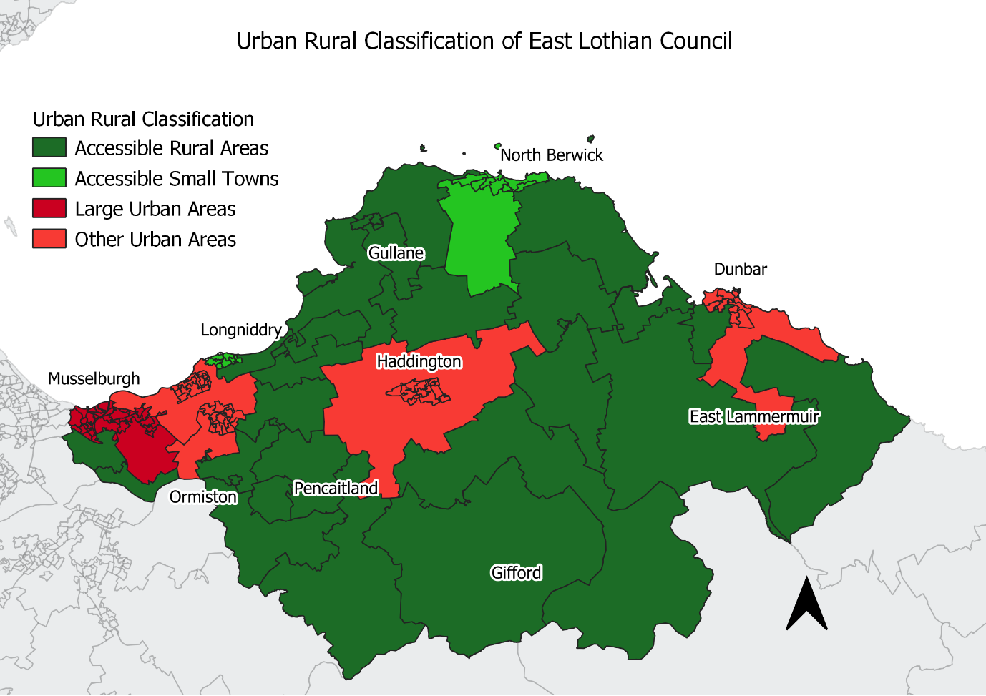
The Rural Housing Fund is available to a wide range of applicants, including community organisations, development trusts, private landowners and private developers, as well as the more traditional housing providers, enabling them to take a more active role in meeting the housing needs of their communities.
The fund has two components. The main one offers capital support (grant and loan) to enable the direct provision of new affordable housing and refurbishment of existing empty properties. A second, smaller component provides a contribution to feasibility studies. So far, no opportunities have arisen in East Lothian to use the fund, but the Council will continue liaising with stakeholders.
In October 2023 the Scottish Government published a Rural and Island Housing Action Plan which includes a commitment to work with local authorities to deliver the Rural affordable Homes for Key Workers Fund to ensure that there is effective local engagement with local employers and RSL partners to support the identification of additional homes for key workers. East Lothian Council is currently undertaking a Key Workers needs assessment to define the term ‘key workers’ in East Lothian.
The provision of and need for rural homes will be explored for the LDP2 and future SHIPs, through ongoing evidence-based work including the Key Work Needs Assessment and Local Investment Framework (LIF).

Vacant and Derelict Land Investment Programme
East Lothian are currently undertaking some feasibility studies for the redevelopment of some vacant and derelict sites. We will continue to evaluate sites and explore applying for funding within 2025/2026, should sites by appropriate.

Individual and organisational support
There are a variety of funding and support options provided by the Scottish Government which are available to individuals and other organisations. All these schemes help towards the provision of more affordable housing, although they are considered non-AHSP financing models:
- Low Cost Initiatives for First Time Buyers (LIFT)
- Open Market Shared Equity (OMSE)
- New Supply Shared Equity (NSSE)
- New Supply Shared Ownership
- Self-Build Fund
- Building Scotland Fund
- Housing Association investment drawn down from the private sector

Risk Management
Risk Management is the process of identifying, assessing and mitigating risks as best we can. This helps to establish a consistent approach to programme and project risk management. As with any long term, financial planning there is a need to keep the projections and assumptions used under constant review to ensure that the level of investment that has been assumed can actually be delivered.
East Lothian Council has had a clear long-term strategy in place to increase the delivery of affordable housing in the county. Much of this delivery is dependent on funding and the Local Development Plan, which specifies that 25% of new housing should be affordable. Through ongoing programme meetings with Housing Associations and East Lothian Council’s new build team project meetings, the main risks to the SHIP programme are monitored and consideration given to mitigate against them.
Securing sites has never been so challenging, particularly when the majority of sites are in the control of the private sector through S75 obligations. The nature of the sites and the large sums of money associated with infrastructure works often results in complex discussions around delivery, as a result of record levels of funding and high growth, the Council were in a unique position whereby a number of sites were ready to begin over the next two to three years. The lack of funding has resulted in a negative impact on the delivery of affordable housing with no funding to secure those site starts, meaning a high risk of losing units to commuted sums. The Council is maintaining open dialogue with developers looking for solutions and opportunities to secure as many affordable housing units as possible.
In addition to these, the Cost of Living (Tenant Protection) (Scotland) Act 2022, provided temporary powers to cap social and private rents and introduce an eviction ban until March 2024. The draft Housing (Scotland) Bill was introduced to Parliament in March 2024 and is currently within Stage 3 of the Parliamentary process with further amendments to the Bill being proposed and to be debated. Within the Bill is a focus on Rented Sector Reform to improve accessibility, affordability choices and standards within the whole rented sector. The Council, RSLs and Mid-Market Providers have all expressed concern about the knock-on effects of their new build program as a result of this legislation, in addition to the existing risks within the housing and economic market conditions. We continue to work in partnership and explore alternative financial mechanisms to deliver affordable housing in East Lothian without grant funding.
As mentioned previously, the economic pressures and rate of development places extreme challenges on delivering the Affordable Housing Programme. Market homes are out of reach for those with low to median incomes in a highly competitive market. The private rented sector is small and relatively expensive. East Lothian’s aging population who are living longer but in poorer health, have placed high demands on adaptable and wheelchair accessible homes with the social sector becoming the only option for many due to lack of wheelchair targets in the private sector. The Housing (Scotland) Bill is expected to bring a large number of legislative changes. As the Bill is taken through parliament and amended further uncertainty is felt across all tenures, with concerns raised about how to meet new standards and duties within the current funding pressures. Collectively, this has placed significant pressures on East Lothian’s housing system which was already almost at breaking point.
The key risks identified in the delivery of the SHIP are as follows:
- Potential long term rent controls for the Private Sector;
- Financial capacity of all providers as a result of the inflation, and volatile market;
- Fluctuating interest rates;
- Insufficient land in control of affordable housing providers;
- Development Constraints such as infrastructure requirements and educational capacity;
- Financial assumptions - insufficient Prudential Borrowing capacity to fund the Council’s programme;
- Continuing challenges for first time buyers to secure a mortgage and deposit;
- Legal and procurement constraints;
- Planning constraints;
- Land constraints such as wayleaves and drainage;
- Scottish Water constraints;
- Ground conditions and constraints;
- Lack of skilled trades people and capacity within the construction industry;
- Building Standards changes and requirement for decarbonised homes;
- Uncertainty around the Housing Bill
Appendix B assesses the likelihood and potential impact of the key risks and what actions can be taken to address these.

Offsite construction, procurement and energy efficiency

Offsite Construction and Procurement

In line with Housing 2040, East Lothian Council will strive to work with developers on possibilities to build affordable housing off-site.
On larger sites where there is likely to be more than one affordable housing provider, the Council appreciates that collaborative working and sharing services is likely to be a more efficient way of achieving best value and best practice through the delivery process and will continue to work closely with our partners to consider all opportunities.
East Lothian has also recently joined the Regional Delivery Alliance (RDA) (formerly Edinburgh Home Demonstrator Programme), a collaborative business model for the construction of affordable housing in partnership with South-East Scotland’s Local Authorities, Scottish Government and other academia and industry partners. The aim is to develop 1,000 homes which are as close to net zero as possible, right across the SES region, using modern collaborative procurement models. The house designs and typologies offered by EHD are centred on modern methods of construction and would be constructed off site. The first pilot project has been delivered in Edinburgh at the Granton Waterfront with homes utilising zero emissions heating and being zero carbon.^{[1]}
East Lothian’s New Build Team is working closely with partners and have identified a site in East Lothian to develop housing under this programme to deliver approximately 60 units. These homes will be delivered to a lifetime home standard and some of them will be made fully wheelchair accessible. The project (former Wallyford Primary School site) has Planning consent and a Stage 1 Building Warrant is currently pending. Site start for this project is estimated as March / April ’26.

Climate change and energy efficiency
Scottish Government has set out the target to achieve net zero emissions by 2045 to tackle climate change and has set duties on public bodies to contribute towards achieving this target. In East Lothian, domestic energy consumption represents 29.4% of the total energy consumption with gas (19.4%) being the main energy type.
The Scottish Government has designated both the decarbonisation of homes and buildings, and the reviewing of energy efficiency standards as national priorities, as they are key to meeting the ambitious climate change targets and to tackling fuel poverty. Improved energy performance of housing and reduced energy consumption will improve standards of living and contribute towards eradicating fuel poverty, whilst also cutting carbon emissions. By tackling fuel poverty through energy efficiency measures, owner occupiers and private renters can make their homes more affordable.
East Lothian Council’s Climate Change Strategy 2025-2030 sets out the Council’s the Council’s response to the climate emergency, adaptations to climate change and how reductions to emissions will continue to be made- working towards Net Zero targets. The Strategy is centred around 4 key themes: Governance, Services, Assets and Place.
The Climate Change Strategy aligns with the priorities of the LHS 2024-2029 highlighting the aims of creating sustainable and well connect neighbourhoods and developing an approach to reaching net zero in Council social stock.
Progress continues to be made to improving the energy efficiency of homes and supporting residents across the social and private sectors. East Lothian’s Energy Advice Service supported 240 residents in 2024/25.
In 2024/25, East Lothian Council installed within stock:
- 235 roof insulations.
- 54 cavity wall insulations (CWI).
- 3 Solar PV and batteries.
Energy Efficiency Standard for Social Housing (EESSH) aims to improve the energy efficiency of social housing in Scotland. It will help to reduce energy consumption, fuel poverty and the emission of greenhouse gases. It is based on the minimum Energy Performance Certificate rating (EPC). Updates to the proposed EESSH2 are no longer going ahead with the Social Housing Net Zero Standard likely to replace this, with interim guidance for landlords available in the meantime.
East Lothian Council published the Local Heat and Energy Efficiency Strategy (LHEES) and delivery plan in 2024 LHEES which sets out East Lothian Council’s long-term vision for improving energy efficiency and decarbonising heat in both domestic and non-domestic buildings. LHEES sets out the vision for all properties in East Lothian to have access to affordable, reliable and low carbon heat. To achieve this vision, the following priority outcomes were identified:
- East Lothian’s communities and property decision makers are engaged and empowered to deliver net zero heating targets.
- Every property owner will be supported to make a decision on their Net Zero heating solution.
- East Lothian’s homes and buildings are as energy efficient as possible.
- Heat solutions are delivered to tackle fuel poverty and meet 2045 net zero target.
- A significant proportion of the benefits of Net Zero investment remain within the East Lothian economy.
The feasibility of the LHEES delivery plan continues to be explored and monitored. The increasing changes within energy efficiency policy/approaches and net zero targets continues to risk adding financial pressures to the HRA budgets, limiting the delivery of new supply.

6.3 Existing Projects
The Council is continuing to explore project opportunities to improve the energy efficiency of existing stock across all domestic tenures through measures such as external wall insulation and cavity wall insulation as mentioned above. The Council is also offering solar PV & batteries to households in fuel poor areas.
The improvement of private housing stock is delivered by the Scottish Government Energy Efficiency: Area Based Scheme (EES:ABS) fund. East Lothian Council received just over £1m of funding in 2024/25 and delivered 43 Solar PV & battery systems and two battery-only installations to private sector homes. In addition, installations of cavity wall and loft insulation in mixed tenure properties resulted in improved energy efficiency.
A successful application has been made for £1.1m of funding for the financial year of 2025/26 which will allow ELC to continue work to reduce fuel poverty within East Lothian. This funding has been approved by the Scottish Government. We are currently involved in identifying areas to target and in the procurement of a contractor to carry out the works.
Energy Company Obligations (ECO) 3 has now been replaced by ECO 4 (2022-2026). ECO puts obligations on suppliers to promote measures which support heating low income homes under the Home Heating Cost Reduction Obligation (HHCRO), the Carbon Emissions Reduction Obligation (CERO) and Solid Wall Minimum Requirement (SWMR). Homeowners are eligible for ECO funding if they are on certain benefits or if they are being referred by certain organisations such as the NHS and Citizens Advice.
East Lothian Council is also currently in discussions with energy suppliers about potential schemes which could be delivered across the county. Unfortunately, the new ECO4 schemes do not allow for the blending of EES:ABS and ECO anymore, which will pose administrative challenges. RSL and PRS landlords may be eligible under ECO4 for funding if they meet the criteria.

Consultation and collaboration
A draft Strategic Housing Investment Plan was prepared for consultation with Registered Social Landlords who are currently developing or are considering development in East Lothian. It has also been informed through discussions with East Lothian Council’s Planning Department to ensure alignment with the Housing Land Audit along with information through ongoing discussions with private developers.
The draft SHIP was circulated to the following:
    - Places for People
    - Wheatley Housing Association
    - East Lothian Housing Association
    - Hillcrest Housing Association
    - LAR
    - Development Team, East Lothian Council
    - East Lothian Health & Social Care Partnership
    - Children Services
    - Community Housing & Homelessness, East Lothian Council
    - Planning, East Lothian Council
Comments and feedback received were used to inform and help finalise the plan for the next 5 years and help to inform the draft program for the following years to come.
A wide range of engagement and consultation activities were undertaken to inform and develop the LHS 2024-2029. Over 1,000 people across East Lothian took part, including local residents and key stakeholders across East Lothian Council, the Health and Social Partnership Care (HSCP) and the third sector. A flexible approach was taken- focused on meeting people where they are- such as community spaces, Youth Groups and Walking Football clubs. Equalities workshops were delivered in partnership with East Lothian Council Planning and HSCP colleagues. This captured challenges faced particular groups/communities, including older people, those experiencing homelessness and persons with learning disabilities and autism. Focus groups for persons with lived experience were also delivered, ensuring the LHS is shaped by those vulnerable within the Housing. A draft version of the LHS 2024-2029 was shared with stakeholders, allowing actions to be developed further and added. A Health Inequalities Impact Assessment of the draft LHS was undertaken as part of an overall impact assessment facilitated by NHS Lothian’s Partnership and Place Team to multi-agency stakeholders. Overall, this ensured that the LHS 2024-2029 is inclusive and representative- highlighting a wide number of challenges faced within Housing and Housing related services across the county.

Equalities
East Lothian Council has an overarching commitment to ‘reducing inequality within and across our communities’, set out in the Council Plan. The LHS aligns with the approach set out in the Council Plan and clearly links with the Equality Plan 2021-2025, which demonstrates how the Council and its partners aim to reduce the impact of poverty and inequality and meet the requirements of the Equality Act 2010.
East Lothian Council is fully committed to equalities and diversity and the SHIP plays a significant role in promoting this agenda. The planning and delivery of good quality housing with a range of choice, embraces the principle of equal opportunities.
People with specialist housing needs should have, wherever possible, the opportunity to live independently in their own homes and community, where this is appropriate. The aim is for all social rented housing to be built to Housing for Varying Needs specification with some designed to full wheelchair standard.
The SHIP will increase access to affordable housing and contribute to improved health and wellbeing, by increasing the supply of well-designed good quality homes, which are accessible and provide flexibility for future adaptation. These homes will also be more energy efficient, contributing to a reduction in fuel poverty.
An integrated impact assessment covering equalities, human rights and sustainability has been carried out on the LHS 2024-2029 , reflecting SHIP guidance.
A Health Impact Assessment Screening Exercise has also been carried out on the draft LHS 2024-2029, with the Council working in partnership with NHS Lothian to facilitate this exercise across Housing, Health and Social Care.

Strategic Environmental Assessments
The Environmental Assessment (Scotland) Act 2005 requires that all public plans, programmes and strategies are considered for any likely environmental effects. Where these are likely to be significant, opportunities to avoid or minimise adverse impacts are sought and positive impacts enhanced. A meaningful SEA can challenge those responsible for preparing plans to identify and explore alternative approaches and different options, highlighting the best options for the environment. This helps to provide protection for Scotland’s unique environment.
The Council has previously determined that the LHS and by association the SHIP does not require a full SEA. The SHIP is operational and therefore will not change the policy directions set out in the LHS and LDPs. The East Lothian Council Local Development Plan 2018 was subject to a full SEA and covers all housing projects. Furthermore, any housing development will go through the planning application process where an Environmental Impact Assessment may be requested if deemed necessary. It is therefore considered that the suggested investment projects have in terms of SEA been covered by the Local Development Plan.

Monitoring
The SHIP is reviewed every year against LHS outcomes and Local Outcome Improvement Plans to identify how LHS policies are being translated into operational delivery.
A range of ongoing activities will ensure projects are monitored and are progressing as planned to ensure resources are maximised to their full potential. These activities include:
- ELC’s programme board;
- RSL programme meetings;
- Scottish Government liaison meetings; and
- Regular meetings with relevant Council services, RSL’s and private developers
This allows any slippage or new opportunities to be identified early to ensure the programme meets its targets and maximises investment.
The SHIP is also available to the public on the East Lothian Council’s online webpage.

Conclusion
Census data from 2022 shows that East Lothian’s population has grown to 112,284—an increase of 12.6% since the 2011 Census. This upward trend is expected to continue in the coming years. The population growth is mirrored by rising house prices, with East Lothian now ranking as the second most expensive Council area in Scotland. In 2024/25, the median house price reached £275,000, highlighting the area’s growing desirability as a place to live.
However, this increasing demand places significant pressure on local infrastructure and the availability of affordable housing. While East Lothian is an attractive place to live, it also faces notable inequalities both within and between communities, with pockets of deprivation particularly evident in the western part of the county. Expanding the supply of affordable housing is therefore essential to addressing these disparities and tackling poverty.
This year’s Strategic Housing Investment Plan (SHIP) outlines the potential to start 1,197 new affordable homes over the next five years, with an estimated 1,365 completions during the same period. An additional 36 unsubsidised homes are planned through the Council’s innovative intermediate tenure schemes.
To deliver 693 of the highest-priority units, along with the 36 unsubsidised homes, the SHIP requires £47.581 million from the Scottish Government’s Affordable Housing Supply Programme (AHSP). However, current resource allocations will only support the delivery of 474 units through the AHSP. The Council remains committed to maximising delivery and will continue to work closely with partners and the Scottish Government to explore alternative funding solutions and delivery models to realise the remaining 891 potential homes.
This SHIP has been prepared in line with the Scottish Government’s More Homes Division guidance issued in May 2025 and aligns with the priorities set out in East Lothian Council’s Council Plan and the Local Housing Strategy 2024–2029.

Appendix A – Housing Market Sub-Area Map
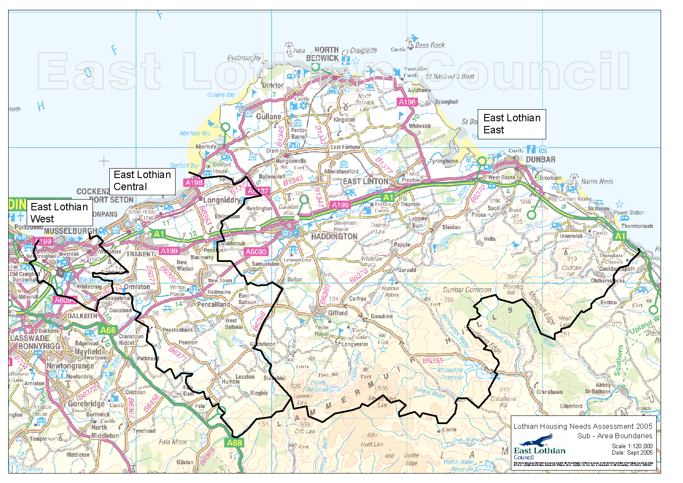

Appendix B – Risk Register *Probability: 3 high, 2 medium, 1 low **Impact: 3 high, 2 medium, 1 low

Risk Description | Probability* | Impact** | Risk Score | Mitigating Actions | Process Owner
Land is not available to develop for affordable housing. | 2 | 3 | 6 | - Sites included in SHIP are sites most likely to be delivered.  - ELC/RSLs to buy land for development whenever possible. | ELC/RSLs
Delivery of units, especially through AHSP, dependent on prevailing market conditions and decisions of private developers and lenders in terms of their investment appetite. | 3 | 3 | 9 | - Try and purchase sites at an early stage whenever possible  - Agree allowance for windfall and AHSP sites in future SHIPs | ELC/RSLs  ELC/CS
Potential negative impact of Scottish Government’s Housing (Scotland) Bill in terms of reducing private sector investment in new affordable housing | 4 | 3 | 12 | - May need to reconsider/re-profile development programme to maximise grant on schemes  - Consider opportunities to deploy Second Homes Council Tax funding and Commuted Sums where required  - Consider other means of Private finance to deliver without subsidy | ELC/RSLs
Economic impacts of potential UK Government/HM Treasury and Bank of England policy changes | 3 | 3 | 9 | - May need to reconsider/re-profile development programme  - Consider opportunities to deploy Second Homes Council Tax funding and Commuted Sums where required | ELC/RSLs
Educational capacity is insufficient. | 3 | 3 | 9 | - Discuss with Education service interim measures to increase capacity to avoid risk of delays.  - Continue to engage with developers regarding funding infrastructure | ELC
Transportation capacity i.e. road networks. | 3 | 3 | 9 | - Secure funds through the Scottish  Government’s Infrastructure  Fund  - Continue to engage with developers | ELC
Sewerage capacity is insufficient. | 3 | 2 | 6 | - Continue to engage with developers regarding funding infrastructure  - Meet with Scottish Water to identify and plan for issues with water capacity. | ELC
Electricity capacity is insufficient for renewable heating and EV charging systems | 3 | 2 | 6 | - Continue to engage with developers and SP Energy Networks | ELC/RSL’s
Changes in funding regimes. | 3 | 2 | 6 | - Identify innovative and more cost effective development solutions | ELC/RSLs

Appendix C – Prioritisation Tool
Method for Calculating Priority

Housing Need
High [3] - Little opportunity & Highest demand
Medium [2] - High Demand
Low [1] - High Demand, but a lot of opportunity

Project Deliverability
High [3] – No constraints and consents in place
Medium [2] – No major constraints, but need consents
Low [1]– Constraints and no consents

Priority = Housing Need x Deliverability

3 | 6 | 9
2 | 4 | 6
1 | 2 | 3

Appendix D – Prioritisation Exercise for Sites

PROJECT NAME:

Criterion | Sub elements and Comments | Weighting |  | Score
1. Housing Need | Area  Current and future development | 20  5 | 25
2. Deliverability | Constraints  Confidence regarding delivery | 5  5 | 10
3. Value for Money | Cost/m2 / unit as 3p equivalent  s.75 contributions | 15  10 | 25
4. Environment | Location  Surroundings | 5  5 | 10
5. Status | Planning Consent  LDP Allocation | 10  10 | 20
6. Time / Resources to date | Discussions with Developers | 5 | 5
7. Ownership | Site in ELC ownership | 5 | 5
Comments
Total |  |  | 100

Approved by ______________________________
Date _____________________________

Appendix E – Breakdown of High and Medium Priority Sites

Project | Sub-Area | Constraints | Housing Need | Deliverability | Priority
Letham (site 6) - SR | Haddington | 1 | 1 | 3 | Medium
Letham (site 6) - MMR | Haddington | 1 | 1 | 3 | Medium
Letham M&M Ph 3 | Haddington | 1 | 1 | 3 | Medium
Courier Building 2 | Haddington | 3 | 2 | 3 | Medium
Herdmanflat 1 | Haddington | 1 | 3 | 2 | High
Herdmanflat 2 | Haddington | 2 | 3 | 1 | Medium
Brown Street | Haddington | 1 | 1 | 1 | Low
Mall Avenue | Musselburgh | 3 | 3 | 3 | High
Mansfield Road | Musselburgh | 1 | 1 | 1 | Low
Craighall Phase 4 – SR | Musselburgh | 2 | 3 | 3 | High
Craighall - Oldcraighall Ph 1 | Musselburgh | 3 | 3 | 1 | Medium
Project | Sub-Area | Constraints | Housing Need | Deliverability | Priority
Craighall - Oldcraighall Ph 2 | Musselburgh | 3 | 3 | 1 | Medium
Craighall - Whitehill Ph 1 | Musselburgh | 3 | 3 | 1 | Medium
Wallyford - Area 1 | Wallyford | 2 | 3 | 2 | High
Wallyford - Area 6 | Wallyford | 2 | 3 | 1 | Medium
Wallyford - Area 5a | Wallyford | 3 | 3 | 3 | High
Wallyford - Area 5b | Wallyford | 3 | 3 | 3 | High
Dolphinstone Ph 2A | Wallyford | 2 | 3 | 2 | High
Dolphinstone Ph 2B | Wallyford | 1 | 3 | 1 | Medium
Wallyford Primary School | Wallyford | 2 | 3 | 3 | High
Dolphinstone Ph 2C | Wallyford | 1 | 3 | 1 | Medium
Whitecraig South - MMR | Whitecraig | 2 | 2 | 1 | Low
Whitecraig South - SR | Whitecraig | 1 | 2 | 1 | Low
Schaw Road | Prestonpans | 1 | 1 | 1 | Low
Church Street | Tranent | 1 | 3 | 2 | High
Church Street Ph 2 | Tranent | 1 | 3 | 2 | High
Windygoul South – SR Phase 2 | Tranent | 2 | 3 | 1 | Medium
Windygoul South – SR Phase 3 | Tranent | 2 | 3 | 1 | Medium
Tranent site | Tranent | 1 | 3 | 1 | Medium
Project | Sub-Area | Constraints | Housing Need | Deliverability | Priority
Elphinstone West Phase 2 | Elphinstone | 2 | 3 | 3 | High
Blindwells Area 5 ph 1 - SR | Blindwells | 2 | 3 | 2 | High
Blindwells Area 5 - ph2 – SR | Blindwells | 2 | 3 | 2 | High
Blindwells Area 5 ph 2 - MMR | Blindwells | 2 | 3 | 2 | High
Blindwells Town Centre | Blindwells | 2 | 3 | 2 | High
Blindwells area 4a | Blindwells | 2 | 3 | 3 | High
Blindwells area 6 | Blindwells | 2 | 3 | 1 | Medium
Blindwells 7 | Blindwells | 2 | 3 | 1 | Medium
Blindwells area 9 | Blindwells | 2 | 3 | 1 | Medium
Blindwells area 10 | Blindwells | 2 | 3 | 1 | Medium
Bayswell Road ph 2 | Dunbar | 2 | 2 | 1 | Medium
OMPs | East Lothian wide | 3 | 3 | 3 | High

Rettie (2025)
NRS Mid-Year Population estimates (2025).
Scotland's Census 2022: Population change, 2011 - 2022, council areas, Scotland
Downloads | Improvement Service
NRS Households and Dwellings in Scotland (2022)
Census Scotland, 2022
NRS 2019 based population projections – ibid.
NRS 2019 based population projections – ibid.
Scotland’s Census 2022
[1] https://www.be-st.build/media/fp3n5ik1/edinburgh-home-demonstrator-clf.pdf
The full assessment can be found at the following link: https://www.eastlothian.gov.uk/downloads/file/27647/supporting_paper_3_integrated_impact_assessment
The full assessment can be found at the following link: https://www.eastlothian.gov.uk/downloads/file/27648/supporting_paper_4_health_impact_assessment

