
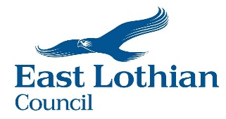
Employee Consent Form
Access to myHR (Employee Self Service) Portal & Issuing HR Contractual Documentation
Name
Employee Number
Post Title
Division
Personal E-Mail Address (please enter clearly)

myHR is the East Lothian Council employee self-service portal.
Through myHR, you can:
- View and download your payslips
- Update personal details (e.g., home address, bank details)
- Request special leave
- Submit travel claims and overtime claims directly to your manager
You can access myHR using any computer, smartphone, or tablet.
To set up your myHR account, we need your personal email address. We will only use this email for myHR purposes, such as sending you system messages as new features become available, for example, emails confirming annual leave requests. We will also use this email address to send you any documents related to your employment.
If you share your email address with a family member, they may be able to see any messages sent from myHR, including notifications or documents about your employment. However, they cannot access your myHR account unless they know your password.
If you use a shared device, such as a family computer or a public device, please do not download your payslip onto it. Make sure you log out of myHR completely as soon as you are finished to keep your information safe.
Please let us know that you agree to us using your personal email address for these purposes. To do this, complete the form and return it to hrsystemitrent@eastlothian.gov.uk or send the form to HR, John Muir House, East Lothian Council.

Signed: ……………………….……………………………. Date: ……………………………..

East Lothian Council uses the personal data you provide for purposes associated with the delivery of our services.
For more information the Privacy Statement is available from your manager / in the depot
Personal data will be retained in line with East Lothian Council retention policies.
Data Protection Officer, East Lothian Council, John Muir House, Haddington, EH41 3HA
Email: dpo@eastlothain.gov.uk

