

Minutes of the North Berwick Coastal Area Partnership Meeting
Tuesday 25th February 2025, 7-9 pm
North Berwick Community Centre & TEAMS

Voting Members present: | Substitute members present:
Hilary Smith, Chair (HS)
Liz Forsyth, Aberlady Community Association (LF)
Kenny Miller, North Berwick Community Council (KM)
Mairi Benson, North Berwick Community Council (MB)
Eric Martin, Dunpender Community Council (EM)
Zena Trendell, Gullane Area Community Council (ZT) | Frank Neate, Gullane Area Community Council (FN)
Olwyn Owen, NB Environment Trust and Heritage Trust (NBEHT) (KT)
Fred McClintock, Dirleton Village Association (FMc)
Janice MacLeod, Support from the Start (JM)
Katherine Sellar, Gullane School Parent Carer Partnership (KS)
Mitchell Stevenson, VCEL (MS)
 | Ros Richardson, NB District Assoc of Churches (SM)
Alex Hutchison, North Berwick - In Bloom Groups (AH) | Carole Murray, North Berwick – In Bloom Groups (CMurray)
Brett Walker, Chair On The Move (BW)
Nicky Fox, NB Community Centre Management Committee (NF)
Katie Reid, Support from The Start (KR)
Robin Grant, North Berwick Coastal Area Health & Social Care Charity (RG)
Gordon Docherty, North Berwick High School pupil council (GD)

Others in attendance:
Doug Haig, Connected Communities Manager (DH)
Shirley Gillie, Unified Business Support – ELC (SG)
Laura Chant, Population Health Project Manager – NHS Lothian (LChant)
Ian Malcolm, Aberlady Conservation & History Society (IM)
Marilyn McNeill, IJB (MM)
Sue Jardine, Aberlady Community Association (SJ)

Apologies:
Cllr Carol McFarlane, Elected Member East Lothian Council (CM)
Sadia Ward, Aberlady Community Association (SWard)
Sharon Wellwood, North Berwick High School Parent School Partnership (SWellwood)
Lorna Scott, Gullane Village Association (LS)
Tim Harding, Lime Grove TRA Community Group (TH)
Simon Metzner, NB District Assoc of Churches (SM)
Carole Glover, North Berwick Coastal Community Connections (CG)
Kathy Duncan, Sustaining North Berwick (KD)
Kirsty Towler, NB Environment Trust and Heritage Trust (NBEHT) (KT)
Sally Eagan, North Berwick Community Council (SE)
Beth Smith, North Berwick Youth Project (BS)
Amanda Clelland, Bridge Centre Motorcycle Project (AC)
Alan Fraser, Gullane Area Community Council (AF)

AGENDA ITEM |  |  | KEY DISCUSSION POINTS, DECISIONS  Actions |  |  |  |  | FAO
- Welcome, Introductions and Apologies
 |  |  | HS welcomed everyone to the meeting. Round the table introductions were made.
- Minutes Previous Meeting
 |  |  | SG confirmed that the North Berwick High School Pupil Council did send apologies for the previous meeting and records have been updated accordingly.  Local Place Plan action progress. HS acknowledged that she hadn’t yet contacted Planning and relevant Council Officials. She advised she would as a matter of priority before the April meeting.  The Minutes from the meeting held on the 21.1.25 were agreed and accepted as a true and accurate reflection of the meeting. |  |  |  |  | HS
- Declaration Of Interest
 |  | This is a standing item on the agenda. Please declare any conflict of interest when voting. HS advised that if anyone was in any doubt if their vote or input to discussion created a conflict of interest, please advise.
- Matters Arising
 |  |  |  | Defibrillators - HS stated that the meeting would come back to this if time allowed. Post meeting note: - Time did not permit.
- Budget Report
HS/DH explained the budget spend so far and highlighted the challenges faced this evening in allocating remaining funds.
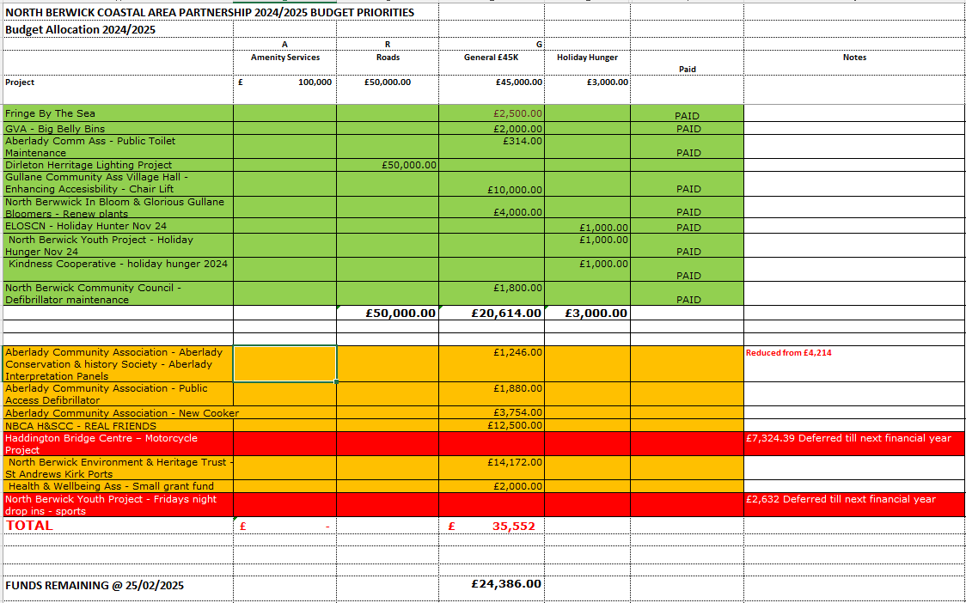

- Applications
HS thanked everyone who had sent in their scores for the applications. She explained the running order for taking applications would be based on Members pre-scoring, and used as a mechanism for viewing, discussing and then voting. If the last application of the evening is approved in full, any funding coming to the Partnership for 2025-2026 will be prioritised for it. What funds are left at the end of the evening will have no bearing on decision making.

HS also confirmed that North Berwick Youth Project and Haddington Bridge Centre have deferred their applications until next financial year

- North Berwick Youth Project – Friday Night Drop In – Free Sports - £2,632 – Deferred until 2025-2026 financial year

- Haddington Bridge Centre – Motorcycle Project £7,324.39 – – Deferred until 2025-2026 financial year

Members agreed that neither application needed to be scored or commented on a second time. The applications would be accepted and discussed at the next funding meeting.
HS advised her conflict of interest regarding the application to create a small grant fund for the H&WA and asked DH to provide Members with relevant background information. DH stated that the need for a small grant fund had been identified whilst the H&WA had been working on its priorities for the forthcoming Area Plan. He spent time advising Members how priorities had been ascertained and then distilled into clear and concise objectives.
Both DH/HS spent time explaining how small sums of money can make big differences particularly when it comes to H&W activities. It is hoped that the proposed surgeries to be delivered by VCEL will further support and compliment the small grant fund. DH advised that the initiative had already been launched that morning utilising £1,200 from existing HW&A finance. Following a discussion on scrutiny and audit procedures, Members voted as follows.
- NBC AP HWA (Small Grant Fund) £2,000
Members voted: 17 YES 0 Against/Abstain 1 Conflict

FN/MS/BW queried the process for taking applications and allocating funds. HS again advised as above, reassuring that if there wasn’t enough funds for the last applications of the evening, that this should not interfere in the decision making process as funds would be allocated utilising the 2025/2026 budget.

After a short presentation and Q & A session regarding the Public Access Defibrillator application, Members voted as follows.

- Aberlady Community Association – Public Access Defibrillator 2025 – £1,880
Members voted: 15 YES 0 Against/Abstain 3 Conflict

LF highlighted the importance of a catering size cooker to the village hall and its potential for generating income. It was acknowledged that the cost included ‘works’ as well as the cost of the cooker. Members voted as follows.

- Aberlady Community Association – New Cooker - £3,754
Members voted: 14 YES 0 Against/Abstain 1 Conflict

RG did a short presentation highlighting the value and importance of First Responders and the service that they provide to rural communities such as the Coastal ward. Members were supportive of the application but however felt the amount requested was considerable. It was suggested that 2 bags should be voted on, and then following a successful evaluation, a 3rd bag should then be considered.

HS advised all that the procedure for voting should be consistent throughout the evening and suggested that the vote should be taken for the full amount applied for in the first instance. Members voted as follows.

- NBCA H&SCC – REAL FRIENDS - £12,500
Members voted: 6 YES 7 Against 2 Abstain 1 Conflict

Discussion then took place regarding the opportunity to vote again for 2 bags only. Members agreed to vote on £9,500 for 2 bags and come back next financial year for 3rd bag on receipt of a successful evaluation.

- NBCA H&SCC – REAL FRIENDS - £9,500
Members voted: 13 YES 0 Against 3 Abstain 1 Conflict

IM delivered a short presentation outlining the need for Interpretation Panels. He stated that there was a need to display new and relevant information. MS queried why the sum being requested this evening was less than the sum requested in the original application. IM explained how he’d approached a local crafts man to undertake the work and had received a better quote.

- Aberlady Conservation & History Society – Aberlady Interpretation Panels - New Figure £1,246
Members voted: 18 YES 0 Against/Abstain 1 Conflict

OW presented some artists visuals and background information to the Kirk Ports initiative. OW provided detailed responses to all questions and concerns that were raised during Members scoring the application prior to the meeting. She acknowledged the high costs involved, and highlighted the way in which funds for the Scottish Sea Birds Centre had been raised in stages. She advised that North Berwick Trust were supportive of the proposal. She finished by advising Members that a lease was currently being pursued with ELC, but progress had been disappointing slow. She highlighted the importance of preserving the site now before it falls into further disrepair and is fenced off. After a short Q & A, Members voted as follows.

- North Berwick Environment & Heritage Trust – St Andrews Kirk Ports - £14,172
Members voted: 0 YES (Against votes weren’t taken due to no YES votes being delivered) Against/Abstain 1 Conflict

Members discussed and agreed that a further vote should be taken with a view to allocating the remain £6,006 in the General Budget towards the Kirk Ports application. Members voted as follows.

- North Berwick Environment & Heritage Trust – St Andrews Kirk Ports - £6,006
Members voted: 3 YES 12 Against 1 Abstain 1 Conflict

HS asked Members if they were happy to vote on £3,000 going to the REAL FRIENDS project for a 3rd bag, highlighting that the application could then be funded in full from this years budget. Members agreed.

- NBCA H&SCC – REAL FRIENDS – (Remaining) £3,000
Members voted: 13 YES 0 Against 1 Abstain 1 Conflict

HS declared stated that the remaining £3,006 in the General Budget should be utilised by the Children and Youth Networks Bursary Scheme, as had been the case in previous years when funds remained. AH and JM said that they would appreciate seeing the evaluations from funds allocated to the scheme in previous years.
- A.O.C.B.
 |  |  | N/A
Dates of Next Meetings |  |  | 2025 Meeting Dates  29.04.2025 - 24.06.2025 - 23.09.2025 AGM – 11.11.2025 |  | Apologies to  nbc-ap@eastlothian.gov.uk

