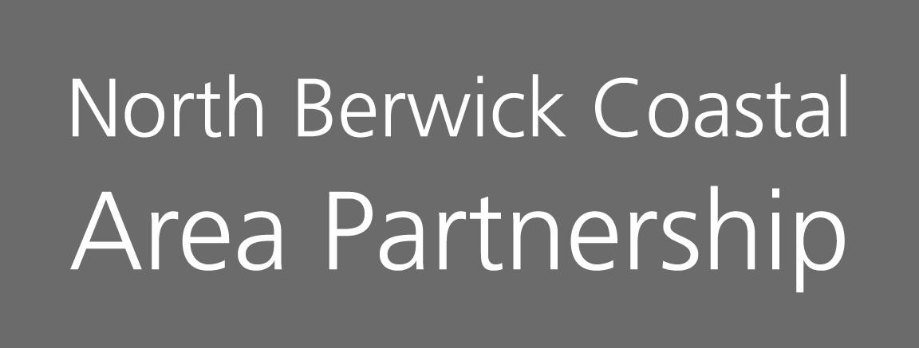

Minutes of the North Berwick Coastal Partnership Meeting
Tuesday 19th March 2024, 7-9 pm
North Berwick Community Centre & ZOOM

Voting Members present: | Substitute members present:
Hilary Smith, Chair (HS)
Cllr Carol McFarlane, Elected Member East Lothian Council (CM)
Mairi Benson, North Berwick Community Council (MB)
Gordon McLelland, Gullane Area Community Council (GM)
Liz Forsyth, Aberlady Community Association (LF) | Sadia Ward, Aberlady Community Association (SW)
Brett Walker, Chair On The Move (BW)
Fred McClintock, Dirleton Village Association (FMc)
Sharon Wellwood, North Berwick High School Parent School Partnership (SWe)
Derek Carter, Dirleton Village Association (DC)
Janice McLeod, Chair of the children and Youth Network (JM)
Carole Glover, North Berwick Coastal Community Connections (CG)
Carol Murray, North Berwick In Bloom (CM)
Mitchell Stevenson, VCEL (MS)

Others in attendance:
Doug Haig, Connected Communities Manager (DH)
Shirley Gillie, Unified Business Support – ELC (SG)
Marilyn McNeil, IJB (MM)
Daisy Elder, ELOSCN (DE)
Nicky Campbell, ELOSCN (NC)

Apologies:
Frank Neate, Gullane Area Community Council (FN)
Katie Reid, Support from the Start (KR)
Kathy Duncan, Sustaining North Berwick (KD)
Laura Chant, Population Health Project Manager – NHS Lothian (LCh)
Lauren Cowie, Children & Youth Network (LC)
Nicky Fox, North Berwick Community Centre Management Committee (NF)
Cllr Liz Allen, Elected Member East Lothian Council (LA)
Simon Metzner, NB District Assoc of Churches (SM)

AGENDA ITEM |  |  |  | KEY DISCUSSION POINTS, DECISIONS  Actions |  |  |  |  | FAO
- Welcome, Introductions and Apologies
 |  |  |  | HS welcomed everyone to the meeting. Round the table introductions were made and apologies were noted.
- Minutes Previous Meeting
The Minutes from the meeting held on the 23/01/2024 were agreed and accepted as a true accurate reflection of the meeting.
DH advised that in the minutes from 14.11.2023 had been amended. Section 4. Equity Officer changed to Equality Officer. DH also advised that Sharon Wellwood would now be identified as SWe and Sadia Ward would now be identified as SWa.
- Declaration Of Interest
 |  |  | This is a standing item on the agenda. Please declare any conflict of interest when voting. BW, LF, SWa, JM, HS, DC all declared conflict of interest as all had been involved in the submission of applications.
- Matters Arising
- Community Benefits Joint Themes: Update
Lot of suggestions put forward, each Area Partnership to identify 3 projects to be taken forward at this time. DH will contact each area NBC, Aberlady, Gullane to ask for 1 priority.
MS suggested looking at the Community Benefit NHS portal which could help with a few of the priorities. MS will forward information to DH to share with members.

- DH again advised that the list was still open. Identified projects will be discussed at the next Connected Community Managers meeting. The Members should contact DH if there are any more suggestions for themes.

- Self-Evaluation of Area Partnership: Proposed focus on future meetings.
HS discussed options to make each meeting themed. Suggestions 30/04/24 – Sharing information
18/06/2024 – Funding
24/09/2024 – AGM
12/11/2024 – Funding
Jan 2025 – Sharing information & look at funding if funds still available
March 2025 – Sharing information
HS advised that applications would be considered out with the agreed funding meetings if they were time dependant e.g. matched funding time constraints.
BW/SWe expressed their disappointment regarding Cllr Findlay comments regarding Area Partnerships. HS stated that it was not her intention to politicise Partnership meetings. She stated that she believed the role of the Partnership should be focussed on addressing inequality and community priority/needs in line with the Area Plan. BW again reiterated his disappointment.
HS/DH discussed the new funding application form which is under review. DH will share with members and asked for any feed back and comments. Changes can still be made but this has been approved by the East Lothian Councils Audit Team. Members asked if it would be going on the ELC website. DH advised that application forms were not available on the web site due to the number of inappropriate applications, or phishing during the early days of Area Partnerships. Those interested in making an application are asked to make contact with the appropriate Connected Communities Manager in the first instance.
A discussion took place about again going over applications during a meeting. This is after they have already been sent out to Members to look. Those round the table acknowledged and suggested that a time limit be put on the sharing of background information to applications at meetings e.g. 5 mins.
HS advised that this had been a consideration during the self evaluation process and that meetings would alternate between looking specifically at funding applications and looking at local priorities. She advised that she was keen to make more time for Community Councils, Village Associations and Community Associations and their work.
HS hoped that either a proportion of the April meeting or the June meeting might be used to show case where communities had got to with drafting Local Place Plans.
- Membership – Gilsland Grange Mews Association (GGMA)
 |  |  | The Partnership were asked to vote on potential new Members, however as no representatives from Gilsland Grange Mews were in attendance we will remove this item from the agenda just now but happy to look at this again once they have representatives in place.
- Action Plan for Active and Sustainable Transport: North Berwick Coastal Ward: Report attached
 | BW advised Members that there are paper copies now available of the North Berwick Coastal Ward Action Plan for Active Travel and Sustainable Transport. It was launched at the East Lothian Green Futures event at QMU and shared through social media. Digital copies can also be shared and if anyone would like a paper copy please just ask.
- Reports from Subgroups
 |  |  |  | Due to the high volume of applications that had been received, HS differed reports from subgroups to the April meeting.
- Reports from Community Councils
 |  | Due to the remaining time, it was decided to get updates from the Community Councils at the next meeting.
- Reports from Village Representatives
 |  |  |  | Due to the remaining time, it was decided to get updates from the Village Associations at the next meeting.
- Budget Report
DH presented the budget and spend to date.

General Budget (Capital to Address Priorities)
2023-2024 Allocation - £50k
Fringe By the Sea - Free Fringe - £5,000
Haddington & District Swimming Club - French Exchange - £2,807.04
Carers of East Lothian – North Berwick Group - £872.75
North Berwick in Bloom – Aberlady, Gullane & North Berwick - £5,500
Aberlady Community Association - £1,439
Planning Advisory Service – OTM - £1,285
Creation of North Berwick Local Place Plan - £5,000
Keep The Heid – Mental Health Café - £3,300 (General)
NBC Area Partnership On the Move Group – £1,350 Stage 1 Coastal Path (General)
North Berwick Coastal Children & Youth Network - Out of school activities - £12,000
Spend to date - £38,553.79

Pending Applications this evening: -
- Dirleton Village Association – Dirleton Community Store - £1,200
- NBC OTM – Way markers - £500
- ELSCON – Storage - £733
- NBC H&W – Kindness Cooperative - £6,000
- NBC H&W – Connecting Community Day - £1,500
- Aberlady Community Association – Local Place Plan - £2,035
- Holiday Hunger Funding - £3,000 for NBC ward
- Applications General Budget 2023/2024
HS thanked everyone who had returned their scores which provided a framework for the discussion tonight.

The following applications were discussed:-

The Children & Youth Network has recommended supporting the following projects for Holiday Hunger:-

ELOSCN - £1,000
North Berwick Youth Project - £1,000
NB H&W Kindness Cooperative - £1,000
Members voted 10 YES 0 Objections/Abstain

- Dirleton Village Association – Dirleton Community Store - £1,200
Members voted 5 YES 4 Objections

- NBC OTM – Way markers - £500
Members voted 10 YES 0 Objections

- ELSCON – Storage - £733
Members voted 11 YES 0 Objections

- NBC H&W – Kindness Cooperative - £6,000
Members voted 11 YES 0 Objections

- NBC H&W – Connecting Community Day - £1,500
Members voted 11 YES 0 Objections
Members agreed to partially fund £978.21
Members requested Breakdown of costs before funds released

- Aberlady Community Association – Local Place Plan - £2,035
Members voted 8 YES 0 Objections
Members requested conditions added – Breakdown of fees before funds released
- A.O.C.B.
HS thanked everyone for coming along tonight and for their time and effort with all the funding applications.

HS advised it was GM last Area Partnership meeting tonight and wished to express her personal thankyou for his commitment and great work for the NBC AP. Very much appreciated.
Dates of Next Meetings |  |  |  | 2024 Meeting Dates  30/04/2024, 18/06/2024, 24/09/2024 APM, 12/11/2024 |  | Apologies to  nbc-ap@eastlothian.gov.uk

