

Minutes of the North Berwick Coastal Area Partnership
Tuesday 20th January 2026, 7-9 pm
North Berwick Community Centre

Voting Members present: | Substitute members present:
Zena Trendell, Chair (ZT)
Liz Forsyth, Aberlady Community Association (LF) | Sadia Ward, Aberlady Community Association (SWard)
Katie Reid, Support from The Start (KR)
Fiona Constable, Dunpender Community Council (FC)
Lorna Scott, Gullane Village Association (LS)
Cllr Carol McFarlane (CM)
Frank Neate, Gullane Area Community Council (FN)
Janice MacLeod, Chair Children & Youth Network (JM)
Carole Glover, North Berwick Coastal Community Connections (CG)
Carole Murray, North Berwick - In Bloom Groups (CM)
Brett Walker, Chair On The Move (BW)
Sally Egan, North Berwick Community Council (SE)
Nicky Fox, NB Community Centre Management Committee (NF)
Glyn Taylor, Gullane School Parent Carer Partnership Comm (GT)
Kathy Duncan, Sustaining North Berwick (KD)
Robin Grant, North Berwick Coastal Area Health & Social Care Charity (RG)
Claire Jones, North Berwick High School Parent Council (CJ)

Others in attendance:
Doug Haig, Connected Communities Manager (DH)
Shirley Gillie, Unified Business Support – ELC (SG)
Patricia Laing, Gullane Bloomers (PL)

Apologies:
Craig Sneddon, NB Community First Responders (CS)
Lauren Cowie, North Berwick Youth Project, (LC)
Tim Harding, Lime Grove TRA (TH)
Kenny Miller, North Berwick Community Council (KM)
Sharon Young, VCEL (SY)

AGENDA ITEM |  |  |  |  | KEY DISCUSSION POINTS, DECISIONS  Actions |  |  | FAO
- Welcome, Introductions and Apologies
 |  |  |  |  | ZT welcomed everyone to the meeting. Introductions were made and apologies noted.
- Minutes Previous Meeting 11.11.2025
DH thanked KR/SG for their joint effort in producing the Minutes.
Minutes were then accepted and approved.
- Declaration of Interest
 |  |  |  | ZT asked if anyone had any conflicts of interest. SW/CM declared a conflict of interest in the application tonight. North Berwick Bloomers - Gullane Glorious Bloomers.
- Matters Arising
 |  |  |  |  |  | DH again presented summary information in relation to the Place Making Project, highlighting those buildings that would become available to community to take on under a Community Asset Transfer or lease. DH advised that the timescales involved were lengthier than originally envisaged, with a progress report now being timetabled to be presented to Council in December of this year.
- NBC AP Area Plan 2025-2030
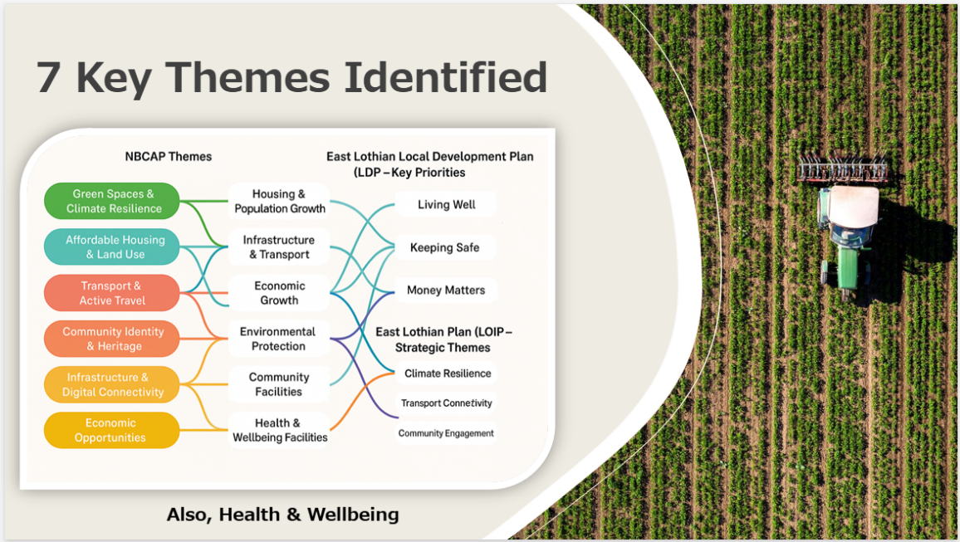

ZT advised that she, HS and DH had been keeping up to date with the development of the Local Outcome Improvement Pan (LOIP) which will inform the NBC Area Plan 2025-2030. ZT/DH already working on this. Key themes identified from the Local Place Plans include:-
- Transport
- Digital Connectivity
- Sustainability
- Climate
ZT advised that she had produced a short questionnaire and respectfully asked Members if they could fill it out as a matter of priority to ensure that the groundwork done so far was agreeable.
- Subgroup Updates
 |  |  |  |  |  | On The Move  BW advised the next meeting of OTM was scheduled for next week. The agenda has been issued. BW advised that there were several contentious issues causing Members concerns. In addition to the ongoing Car Parking Management implementation, he expressed concern at the way in which the Area Partnership Roads Budget is now influenced. In his opinion, it wasn’t in line with the devolved budgets originally given over to Area Partnerships, in line with the 2015 Community Empowerment Act.  DH explained to those present that the policy in relation to the Roads Budget influence was changed and adopted by Council in 2024. DH advised that he would provide Members with a slide at the next meeting to highlight and explain what these changes were. He went on to say that these changes were out with the control of Roads colleagues and that devolved budgets and their allocation to community and Area Partnerships was an issue that should be taken up with policy makers. ZT offered support to move this forward.  BW went on to share his further concerns with regards to the projects that were being presented to the Area Partnership for consideration by Roads. These were largely roads resurfacing projects. He expressed frustration with the priorities being identified and presented by the Partnership’s On the Move Group to Roads were being ignored and weren’t even being acknowledged. DH/ZT to take forward.  BW finished by saying there was 13 items on the agenda for next OTM meeting. Anyone interested, please come along.  Health & Wellbeing Association  SE advised that the next meeting of the HWA was scheduled for the27th of January. Applications continue to come in slowly for the Small Grants Initiative.  Concerns have been raised as to the availability of nebulisers, previously available through the Edington Hospital.  Together in Health and Robin Grant continue to develop the defibrillator initiative, with several new units being added and maintenance and servicing schedules being revised and updated for all units. RG continuing to work with First Responders to identify and train new volunteers.  VCEL  DH advised no VCEL reps present. SE mentioned that there was a capacity issue with VCEL and SY couldn’t fit in all the meetings. VCEL networking breakfast to be held on the 5th of February 8am-9.30am. DH will circulate invite.  Children & Youth Network  JM advised that the Children’s Activity Fund (CAF) is going from strength to strength. KR applied for Lottery (Small Grants) funding last autumn and the initiative was awarded £19,000 just before Christmas. JM expressed delight as the initiative was fast running out of funding, due to its success in supporting children of low-income families access extracurricular activities. Partnering with Enjoy Leisure is making a real difference, supporting many children to access swimming and gymnastics. JM considering supporting the over 12’s who are moving into high school as don’t want them to be disadvantaged, but this will generate more work and place greater pressure on funds available.  KR updated Members that the Angel Tree (initiated by the Rotary Club of North Berwick) project had been a real success in the lead up to Christmas. The processes for the Angel Tree and Christmas Cheer becomes more streamlined and simpler each year. 47 households, 97 children and 69 adults were supported in the lead up to Christmas. Rotary provided 100 selection boxes. £2,036 of Aldi vouchers were distributed for Christmas dinners and to combat holiday hunger in low-income households. Very humbling to meet parents when they picked up vouchers and gifts, and to hear what a difference this initiative is making to their lives. KR expressed thanks you to everyone who took a tag from the tree and donated a present. ZT thanked all involved for their hard work. |  | DH/ZT
- Community Councils updates
Gullane Area Community Council
ZT advised that the Community Council weren’t meeting until next week. Parking is on the agenda. FN advised of the chaos surrounding roadworks that were put in place by Scottish Water and the length of time it took for them to conduct essential repairs and then remove road works.

Dunpender Community Council
FC advised that she was representing Dunpender Community Council and the Whitekirk community in particular as they are within the Coastal ward. Whitekirk update:-
- Not had any street lighting since September last year. Scottish Power due to start work next week. DH suggested taking up with Keith Scott, ELC Roads Officer.
- Whitekirk defibrillator. Training in East Linton is scheduled for the 28th of February.
- Whitekirk notice board is in a dilapidated state. Looking to replace with a similar style.
- Concerns over road signs as excessive amount have recently appeared.

North Berwick Community Council
SE advised that North Berwick would like to establish a football team for senior competitions. The proposal is in its infancy but is gaining much positive support. Those involved are looking at potential funding sources and working through the requirements for having a competitive senior team, a suitable pitch and changing facilities. There was a lot of enthusiasm by Members for the proposal.

Car parking took up most of the last meeting. North Berwick Community Council no longer have confidence in East Lothian Council. Not being listened to is causing frustration and concern. KM has highlighted this to the Association of Councils.

CM highlighted she has had lots of emails regarding the car parking notice poles that have gone up. Seems far too many. She has manged to get several poles outside people’s houses removed and are now going to be replaced with signs.

NF mentioned that the parking meters now don’t leave a lot of space for wheelchairs or buggies etc. SE stated that a member of the public has been out with their tape measure to check if they are following the correct guidelines.

SE went on to say Members new to Community Council have been offered good quality induction training, and suggested that this should be offered to new Area Partnership Members as it was beneficial. DH confirmed he was co-facilitating the training and added that the training is being offered to Community Councils just now, and that elements could potentially be offered to Area Partnerships in the future.

- Village & Community Associations updates
Aberlady Update (Pre Meeting Note provided by LF)
The Village Hall
Aberlady Community Association is hoping to start work in a couple of months on the first phase of the refurbishment project after being successful in its application for a grant of £20,000 from the SUEZ Communities Fund, managed by Grantscape.
ACA continues to apply for grants for the planned refurbishment and many volunteers tirelessly fund raise.
A number of groups and activities take place in the main hall including a newly formed children and adult choir.

Aberlady in Bloom
Gillian Brydon has stepped down from her role as Secretary and David Wishart has taken over from her.
The team has been quiet this month although a significant tidy up took place after the hedge in the Memorial Garden was cut back.

Liaising with Aberlady Community Association
A free Community Lunch was held in the Village Hall after the Remembrance service in Church.
The Christmas Fair took place on 22nd November. Nearly £1800 was raised which will be used for the Hall Refurbishment project and Aberlady in Bloom also raised nearly £160 from its own stall.
East Lothian Council’s work team has replaced and repainted the back door of the pavilion on the football pitch.

Aberlady Flock
This group has now achieved charity status and will be looking for a range of new volunteering roles. Their promised meat boxes will soon be available to purchase. Sheepskin and fibre products will soon follow.
A new regular hands-on session will begin on the second Sunday of the month starting in February. Further information: hello@aberlady-flick.org

Aberlady Community Association
The Thursday afternoon Drop-in continues and caters for between 10-20 people. A very happy Christmas themed afternoon took place where party games were played and entertainment was provided by Neil Simpson and his lovely trio.

The free annual Christmas Song Book was organised again with a variety of very talented local singers and musicians taking the stage.

A Burns Family Ceilidh with a traditional supper will be held next weekend.

A Yoga morning took place at the end of November with an afternoon barre class described as funky ballet. These were fund raising activities for the village hall refurbishment.

Aberlady Parish Church
Lis Stenhouse the current minister has announced her retirement which will take place from Easter. A full time minister is sought to replace her.
The minister has been registered to allow same sex marriages to take place in Aberlady Church
Recent Sunday Community services have included a St Andrews Day celebration with a local ceilidh band and on Christmas Eve, an adult Nativity spectacular.

Aberlady Primary School
Having had to cancel the Christmas concert for Elderly residents in the village because of the flu outbreak, the concert was rescheduled at the beginning of January. A very happy audience enjoyed the tea and cakes and the joyous sound of children’s voices and musical accomplishments in the School hall.
The Gala committee ran a wreath making class in the village hall to raise funds for the annual summer gala.

Gullane Village Association Report (Post Meeting Note by LS)
The Gullane Village Association(GVA) has been working with ELC Place Making Team (PMP) regarding the future of the Recreation Hall and have had two meetings with Mark Nelson and Ross Macdonald to this effect. Some of our initial research into the potential of a Community Asset Transfer has proven to be useful both from the perspective of the PMP (ELC) and ours. We have discussed the potential of a Community Asset Lease in preference to a full transfer giving the ability of the GVA to apply for grant funding to make improvements to the building, such as installing new windows and upgrading the kitchen. The PMP team are aware from our survey compiled by Strathclyde University that the Social Capital Value of the hall community usage is high, and it is the GVA’s intention that we grow this going forward. The Trustees of the GVA now feeling more positive about guarding the Recreation Hall for future generations.
The Recreation Hall was well utilised by community during 2025, as can be seen on the GVA’s website’s ‘Hall Bookings’ calendar.
GVA trustees focus for 2026 is showcasing Health & Wellbeing in our community. In addition to existing groups & events, we will be organising some GVA run sessions including promoting the weeklong ‘Move to Life’ festival end of April currently being compiled with the team led by Hilary Smith.
Currently compiling the Gullane Spring Newsletter to promote these Health & Wellbeing events, as well as other general local events, to all the village households.

Dirleton
JM advised they are coordinating with Scottish Power to ensure that the issues experienced with street lighting is now resolved
- Key Partner Organisations updates
Together in Health (RG)

RG gave an update regarding defibrillators.
ZT praised RG and Together in Health for the progress made in a relatively short period of time. She had also read the reports circulated, and agreed that the information contained within would further assist in evidence health and wellbeing inequalities in the Coastal ward. The data provides evidence of rapid population growth in the ward over the past 2 years. An aging population, incidents of cancer, heart attacks and strokes are all evidenced. GPs are under increasing pressure due to the increase in population and people in general living longer.

- Budget Report
DH updated Members on the current budget allocation for 2025-2026. He confirmed the funding already allocated/spent and money remaining.

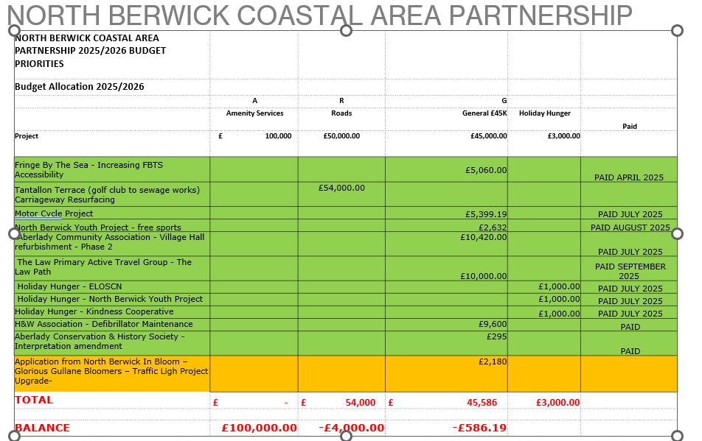
- Applications
Application from North Berwick In Bloom – Glorious Gullane Bloomers – Traffic Light Project Upgrade- £2,180.
DH highlighted we do not have enough money left in the budget to fund this project fully. If agreed could only be part funded.
PL had come along tonight to discuss this funding application. A great discussion took place. It was agreed that more information was needed before this could be voted on.
Members voted to wait for more information
14 YES 0 NO 0 ABSTAIN
During the discussions that took place, Members believed that the following information would be needed prior to making a vote:-
- Clarity regarding ownership of the land
- Clarity on the amount being sought and what it is for
- Visual sketch or diagram would be helpful
- Members were not inclined to provide funding for planting?

- A.O.C.B.
 |  |  |  |  | None
Meeting dates for 2026 |  |  |  |  | 24/02/2026, 28/04/2026, 23/06/2026, 29/09/2026, 10/11/2026 |  | Apologies to  nbc-ap@eastlothian.gov.uk

