

Minutes of the North Berwick Coastal Area Partnership Meeting
Tuesday 24th June 2025, 7-9 pm
North Berwick Community Centre & TEAMS

Voting Members present: | Substitute members present:
Hilary Smith, Chair (HS)
Liz Forsyth, Aberlady Community Association (LF) | Sadia Ward, Aberlady Community Association (SWard)
Sally Egan, North Berwick Community Council (SE)
Carole Glover, North Berwick Coastal Community Connections (CG)
Kirsty Towler, NB Heritage (KT)
Alan Fraser, Gullane Area Community Council (AF)
Katie Reid, Support from The Start (KR)
Janice MacLeod, Chair Children & Youth Network (JM) | Lauren Cowie, North Berwick Youth Project, (LC)
Frank Neate, Gullane Area Community Council (FN)
Alex Hutchison, North Berwick - In Bloom Groups (AH)
Brett Walker, Chair On The Move (BW)
Zena Trendell, Gullane Area Community Council (ZT)
Kenny Miller, North Berwick Community Council (KM)
Ros Richardson, NB District Association of Churches (RR)
Katherine Sellar, Gullane School Parent Partnership Committee (KS)
Layla Gurney, North Berwick High School Parent Council (LG)

Others in attendance:
Doug Haig, Connected Communities Manager (DH)
Shirley Gillie, Unified Business Support – ELC (SG)
Laura Chant, Population Health Project Manager – NHS Lothian (LChant)
Justine Bradd, Haddington Bridge Centre Motorcycle Project (JB)
Helen Reece, Haddington Bridge Centre Motorcycle Project (HR)
Michael McKinnon, Specialist Youth Worker, North Berwick Youth Project (MM)
Emily Burt, Law Primary Active Travel Group (EB)
Euan Revell, Law Primary Active Travel Group (ER)
Marjory Hatvany, Coop Community (MH)

Apologies:
Glyn Taylor, Gullane School Parent Partnership Committee (GT)
Nicky Fox, NB Community Centre Management Committee (NF)
Simon Metzner, NB District Assoc of Churches (SM)
Sharon Wellwood, North Berwick High School Parent Council (SWellwood)
Tim Harding, Lime Grove Association (TH)
Lorna Scott, Gullane Village Association (LS)
Sharon Young, VCEL (SY)
Krish Bissoonauth, Gullane Village Association (KB)
Kathy Duncan, Sustaining North Berwick (KD)
Ian Malcolm, Aberlady Conservation & History Society (IM)

AGENDA ITEM |  |  |  |  |  | KEY DISCUSSION POINTS, DECISIONS  Actions |  |  |  |  |  | FAO
- Welcome, Introductions and Apologies
 |  |  |  |  |  | HS was “blown away” by how many individuals were in attendance. HS welcomed everyone to the meeting and round the table introductions were made.
- Minutes Previous Meeting
 |  |  |  |  |  | The Minutes from the meeting held on the 29.4.25 were agreed and accepted as a true and accurate reflection of the meeting. HS again thanked ZT for stepping in as Chair.
- Declaration Of Interest
Conflict of Interest Declarations
This is a standing item on the agenda. Members are reminded to declare any conflicts of interest prior to voting or participating in discussions. If there is any uncertainty regarding a potential conflict, please raise it with the Chair.
The following declarations were made:
- BW, KT, KM, and LC declared a conflict of interest regarding the North Berwick Community Development Company application for membership.
- JM and LC declared a conflict of interest regarding the Holiday Hunger fund allocation.
- LC declared a conflict of interest regarding the NBYP application.
- LF and Sward declared a conflict of interest regarding the Aberlady Community Association application.
- BW declared a conflict of interest regarding the Law Path application, due to prior collaboration with the Law Primary Active Travel group.
Members are reminded to declare any conflicts of interest as applications are discussed during the meeting.
- Matters Arising
HS updated Members on the matters arising from the previous minutes:-

- Minutes from 25.2.25 HS confirmed they were approved by email 2.5.25
- Fringe By The Sea – Increasing Accessibility £5,060 HS confirmed this had been approved by urgent email votes 2.5.25. HS thanked Members for their very quick response time.
- Gullane to Drem Path – BW explained he would like the NBC AP endorsement and support, as not quorate at last meeting. BW proposed and AF seconded. AF explained 20 year campaign for a safe active travel route from Gullane to Drem. Various options been looked at over the years. Discussions are on going with the landowner of what could potentially be the last section of path as it enters Drem.
Members voted: YES 15 Against 0 Abstain 0 Conflict 0

- Community Defibrillators –HS explained that the working group were looking to identify need across the ward for community defibrillator maintenance and upkeep. H&W agreed to help support and hold any funds in bank account for maintenance. It was hoped that RG would be able to provide an update at the next meeting.
- Local Place Plans – HS explained some are still having difficulty getting their plans accepted. Further discussion is required.
- HS expressed her opinion that the Local Place Plans should be regarded as a cornerstone for Community Planning, including the LOIP.
- New Membership Request – North Berwick Community Development Company
KM gave some background information as to how the company came into fruition. It was set up as a vehicle to support the unsuccessful community asset transfer of the Lime Grove site. Resurrected as seen to be of use for future CATs and for raising funds for community projects in NB. Looked at Police Station as possible Community Asset Transfer. Timescales against them. Current projects being looked at by the company include new toilets at the railway station and a coastal path from North Berwick heading towards Tantallon. BW added he was trying to work with the landowner. The Company can access funds that the Council can’t. They want to work in partnership with the Council to get bast value for Community. Take plans and proposals into reality.
HS asked Members to vote on North Berwick Community Development Company becoming a full Member of the NBC AP.
Members voted: YES 11 Against 0 Abstain 0 Conflict 4
- NBC AP Roads Budget Influence 2025-2026
BW reported on the 4 options given by ELC Roads for the £50,000 budget Influence. He advised that there had been a change to the originally identified priority. Reasons for this included – time pressure on the OTM group to make a quick decision, those present/those not present at the meeting where the decision was made and an accurate recording of the vote and decision made on the evening.
After much debate and discussion it was agreed that the resurfacing of the carriage way on Tantallon Terrace was the preferred option for 2025-2026.
Location | Town | Description of Works | Estimated Cost
Tantallon Terrace (golf club to sewage works) | North Berwick | Carriageway Resurfacing | £54,000.00
Law Road (Clifford Road to St Margarets Road) | North Berwick | Carriageway Resurfacing | £20,160.00
Kirk Road (east side-School Rd to High Street) | Aberlady | Footway Resurfacing | £19,800.00
Manse Road (west side-Castle Inn to East Lodge) | Dirleton | Footway Resurfacing | £27,000.00

- NBC AP Area Plan 2025-2030
HS stated that the Area Plan would be developed using a bottom up approach. She advised that the information gleaned during Communities undertaken their Local Place Plans was already being used to inform priorities for the Area Plan.
She advised that the Area Plan should be focussed on areas of work that the Partnership has the power to influence or generate change. She went on to say that she believed that the current structure of having 3 subgroups captured all necessary priorities, and that the need for any further sub groups would create unnecessary work. HS thanked the Chairs of the sub groups who had already spent time highlighting priorities for the new Plan.
HS shared a slide highlighting how HS had already grouped identified priorities into appropriate subgroup headings eg H&W, C&Y. Members thanked HS for her work to date and offered support on drafting the new Plan.
- Subgroup updates
On The Move
BW advised the minutes had been recently circulated from the last meeting.

Roads Budget Influence – At the June meeting of OTM North Berwick Community Council requested consideration for Tantallon Terrace resurfacing for the 2025/2026 Roads Budget Influence. Although, the previous meeting of OTM were of the opinion to ask Road Services to resurface the section of Law Road between the Clifford Road traffic lights and St Margarets Road as far as St Andrew Road, incorporating pavement. A vote had not been taken at this previous meeting. Those present at the June meeting voted Tantallon Terrace resurfacing should go forward, with 4 in favour and 2 against (who were in favour of Law Road). This will take up the entire £50k influence for 2025/26. Chair pointed out that there was nothing to stop OTM lobbying for the Law Road proposal for next year’s influence, 2026/27.
Safe Crossing Points in NB for Routes to School and Station - BW thanked ELCs Chris Milne and Stantec engineers for the consultation work that had already been done, and for the ‘walkabouts’ and presentations done earlier in the year. The three priority areas for proposed treatment are:
  - St. Baldreds Road crossing from the access lane to the Lodge Grounds to Lady Jane Road.
  - Pedestrian and cycle improvements along Dunbar Road including a crossing from Recreation Park.
  - Dirleton Avenue, west of Phillimore Square.

LF advised that representatives from Gullane Area Community Council, Aberlady Community Association and Aberlady Primary Parent Council would be meeting with ELC Road Services in July to discuss some of the ongoing traffic difficulties being experienced in Aberlady.

Children & Youth Network
JM advised Members of the decision last year to split the Holiday Hunger money between 3 projects. JM has seen the evaluations and how the money awarded supported children and young people most in need across the ward. Suggested this was sound evidence to award similarly for this year’s Holiday Hunger allocation.
- Holiday Hunger – ELOSCN - £1,000
- Holiday Hunger – North Berwick Youth Project - £1,000
- Holiday Hunger – Kindness Cooperative – £1,000
Members voted: YES 13 Against 0 Abstain 0 Conflict 2

Health & Wellbeing
HS reported that the minutes from the June meeting were on her to do list and they would be sent out in due course. She went on the say that there had been a small uptake for the new Small Grant Award Scheme. For those interested in applying for a small grant award (£200) to support health & wellbeing activities in their areas, please send an email to the AP address for the attention of Hilary outlining your proposal and costs.
HS advised that Trauma Information Training would be offered to the ward in the spring of next year and that a short input to the H&W group in the autumn would further help to explain what the training entails and why it is important for everyone to be aware.
- Community Councils updates
Gullane Area Community Council
Cala Feedback - FN stated that he is still waiting to hear if the 16 houses are to be progressed. The last update from Keith Dingwall is that the Sec on 75 is still not agreed. FN separately asked him if the sewage capacity is an issue as well. AF stated that Cala should not proceed until approval is obtained from Scottish Water. FN gave an update on the ongoing sewage issue/concerns. This information has previously been shared. He expressed concern that the works may take place despite the water/sewage issue.
- Village & Community Associations updates
Aberlady Village Association
LF provided the report below prior to the meeting
Notes from Aberlady June 2025

The AGM took place this month where it was unanimously agreed to move to the completion of the re-organisation to become Aberlady Community Association SCIO. The complication of completing bank transfer and disposition of the deeds means that the structure of new association will not be completed until later in the year.
Village Hall - The hall users are loving the fabulous newly installed cooker. The recent Gala Community soup and scone lunch was a great success with multiple pots of soup able to be heated at the same time. A Spring Fair, a local choir concert and a Swish event has raised £3000 along with other community events.
Aberlady Community Flock - 4 lambs and their mothers are enjoying life in Coo Park. Lots of residents have enjoyed seeing them.
Aberlady in Bloom - The team regularly meet in the Memorial Garden to tidy and maintain the flower beds dead heading the roses amongst other maintenance jobs. Thought is being given to tidy up the area behind the Pavilion. The tubs in front of Margiotta, around the village and at the entrance to Kilspindie have been planted up for the summer. The few hanging baskets that we maintain have also been planted up.
Aberlady Gala - The parents from the Primary School in Years 1 and 6 organised the annual Gala this year starting with a parade along the High Street and finishing the week in the Church on Kirkin Sunday.
Aberlady and Gullane Church - The Annual Plant Sale was again a busy and successful event.
Aberlady Resilience Planning - Following a successful workshop a draft plan for the village has been created. On completion it will be presented to Aberlady Community Association.
Aberlady Craft Group - The Open weekend of the group was highly praised as was the Open Studios Event on the same weekend.

The Aberlady History Society - The society was re-launched this month with some new committee members and a plan to conduct monthly meetings.
Other Events - Autumn Newsletter, Autumn Fair / Christmas Fair, Wreath Making and Children’s Clothes Swap.
Gullane Village Association
LS provided the report below prior to the meeting.
June 2025
The GVA AGM is taking place 23rd June 2025 & our guest speaker this year is the very talented young artist & sculptor Jack Handscombe who is currently working at the new Longniddry estate.
The very popular children’s science workshops hosted by Katie Reid are already fully booked over the 3 days in July.
In addition, GVA trustees are running 2 children’s summer sewing classes having previously run successful adult sessions.
Our Summer Newsletter went out in May to every household in the village and is available on the GVA’s website.
GVA trustees volunteered with the recent Gullane House Open Gardens and we have been asked to support future events.
The GVA are still working with ELC to try to secure the future of the Recreation Hall for the community.
- Key Partner Organisations updates
 | None given
- Budget Report
DH explained the budget for 2025-2026. Highlighted in green are the projects already allocated funds and orange are projects up for consideration tonight. DH explained the change of amount requested from the Motorcycle Project.

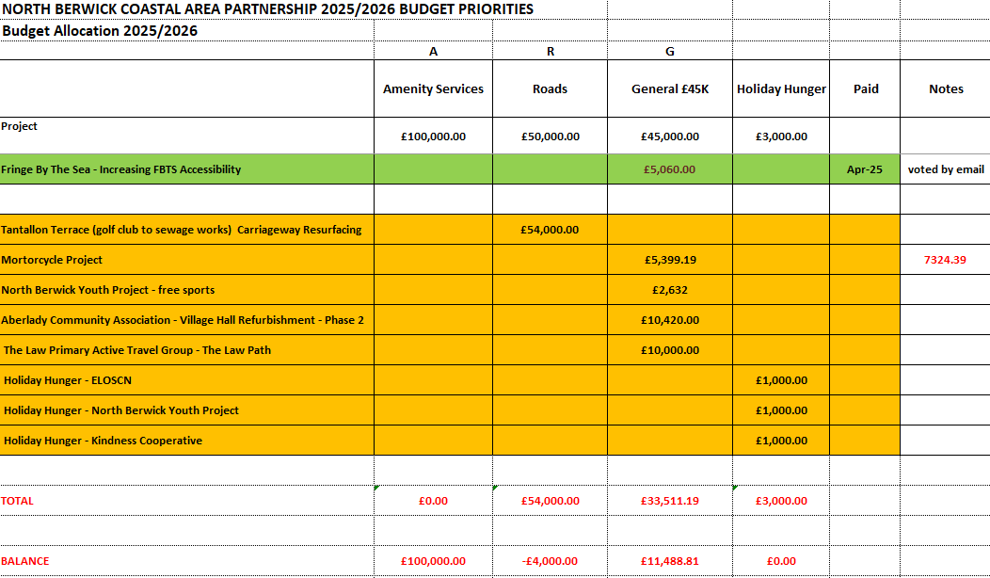

- Applications
DH explained that North Berwick Youth Project and Haddington Bridge Centre applications were deferred from last years budget. HS confirmed previous scores and comments were carried over and that there was no need to re score.

- North Berwick Youth Project – Free Sports £2,632
Members voted: YES 15 Against 0 Abstain 0 Conflict 1

- Haddington Bridge Centre – Motorcycle Project £5,399.19
Members voted: YES 14 Against 0 Abstain 1 Conflict 0

- Aberlady Community Association – Village Hall Refurbishment – Phase 2 - £10,420
Members voted: YES 12 Against 0 Abstain 1 Conflict 2

- The Law Primary Active Travel Group – The Law Path - £10,000
Members voted: YES 14 Against 0 Abstain 0 Conflict 1
The above was made conditionally. Should the proposal not receive the necessary funds to be brought into fruition, the £10,000 should be returned to the AP. The Active Travel Group were advised that they would be required to prepare an interim report and deliver a presentation to the AP in 12 months’ time.
- A.O.C.B.
 |  |  |  |  |  | Time did not permit due to building being closed.
Dates of Next Meetings |  |  |  |  |  | 2025 Meeting Dates  23.09.2025 APM – 11.11.2025 |  |  | Apologies to  nbc-ap@eastlothian.gov.uk

