
Minutes of Musselburgh Area Partnership Meeting
Monday 5th February 2024, 7pm – 9pm
Musselburgh East Community Learning Centre

Members (and substitute members) present:
Gaynor Allen, Chair (GA)
Alister Hadden, Vice Chair (AH)
Cllr. Andy Forrest, Elected Member (AF)
Cllr. Ruairh Bennett, Elected Member (RB)
Cllr Fiona Dugdale, Elected Member (FD)
Margaret Stewart, Musselburgh & Inveresk CC (MS)
Tanya Morrison, Whitecraig Community Council (TM)
Linda Finlayson, Beach Lane TRA (LF)
Shona Blakeley, Musselburgh Grammar School Parent Council (SB)
Natasha McInninie, Bridges Project (NM)
Christine Shaffer, Levenhall TRA (CS)
Pauline Crerar, Sustainability sub group (PC)
Tina Pollock, First Step (TP)
Laura Munro, Campie Primary School (LM)
Mandy Harrington, Volunteer Centre East Lothian (MH)
Callum Maguire, Queen Margaret University (CM)
Beryl Stevenson, Wallyford Community Council (BS)

Others in attendance:
Shirley Gillie, ELC (SG)
Scott McKail, ELC Connected Communities Manager (SMK)
Laura Chant, NHS (LC)
Linda, Loretto

Apologies:
Cllr. Cher Cassini, Elected Member (CC)
Cllr Leanne Menzies, Elected Member (LM)
Barry Turner, Musselburgh Conservation Society (BT)
Irene Tait, Musselburgh & Inveresk CC (IT)
Janice MacLeod, Support from the Start (JM)
Cathie McArthur, Vice Chair, Health & Wellbeing Network (CMc)
Fiona Barrett, Dementia Meeting Centre (FB)
Cllr. Shona McIntosh, Elected Member (SM)
Cllr. Kenny McLeod, Elected Member (KM)
Stephen Wands, Musselburgh Community Sports Hub (SW)
Emma Stewart, Musselburgh Churches Together (ES)
Lenka Smargiassi, Burgh Gate TRA (LS)

AGENDA ITEM | KEY DISCUSSION POINTS |  |  |  | ACTION
- Welcome , Introductions and Apologies
 | GA welcomed everyone to the meeting. Introductions were made and apologies noted.
- Conflict of Interest
This is a standing item on the agenda. GA asked members to declare any conflict of interest when projects are being discussed or when voting on funding applications.
Conflict of interests were declared.
- Approval of Minutes
 | Minutes from meeting 27.11.2023 were approved by CS/MS
- Matters Arising
 | Litter pickers – GA confirmed this is still ongoing and is in communication with Mark McGrath. Agreed to keep this on the agenda for next financial year.
- Connected Communities Manager Report
SMK gave members an update of the budgets, Connected Communities update and Active Travel.
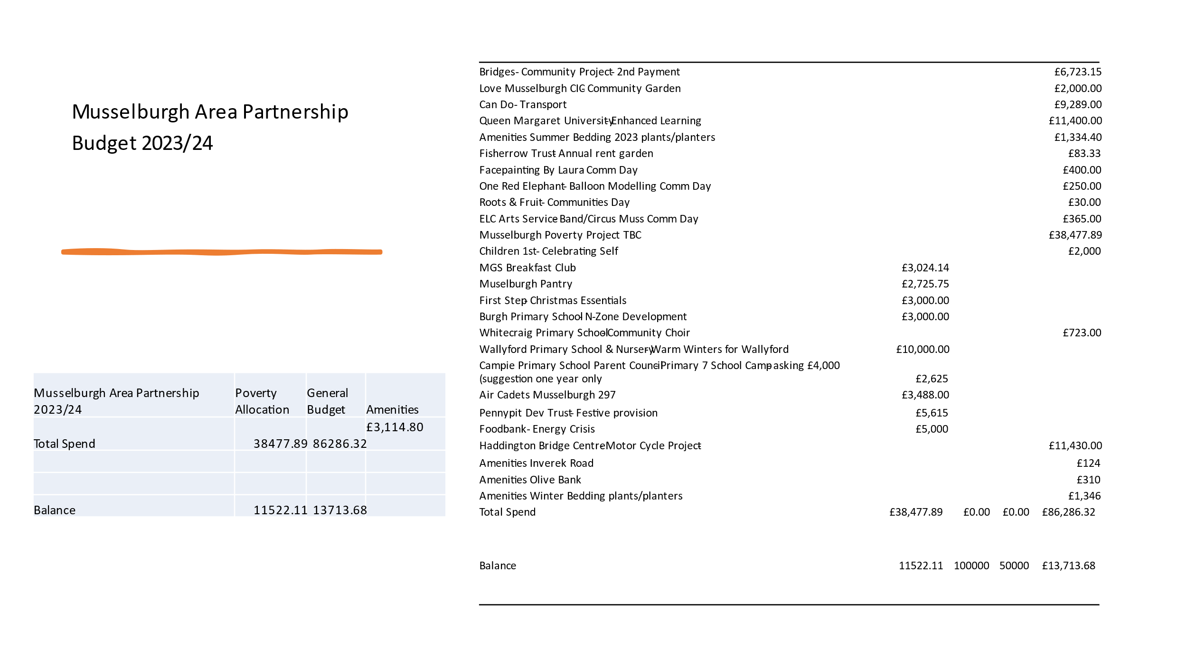
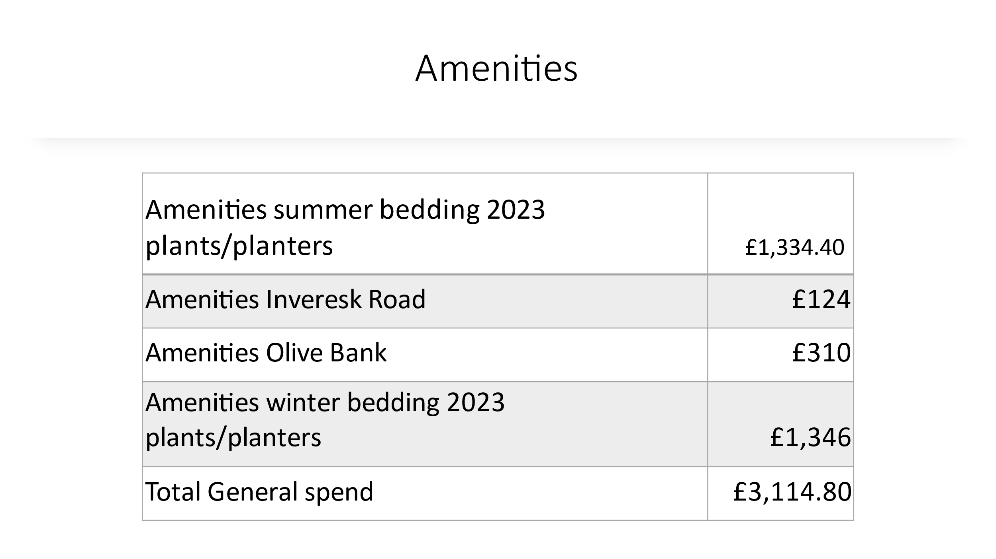

Connected Communities Update
Festive Provision
Number of Children and Young People supported through Cash for Kids: 187
Number of Families and Socially Isolated supported through festive provision: 117
Number of Jingle Bags distributed: 134
Number of NY Bags distributed: 105
Number of Winter Jackets Voucher given out: 95
Lessons learned – difficulty getting donations for older children (hairdresser vouchers used to supplement)
SPOC, shared space for referrals necessary

Musselburgh Area Partnership 10-year Anniversary, 31st March 2014

Specialist Youth Work report, SYW report

Wallyford Community Centre update,
Funding for transport of lunch clubs and social groups for older adults,
Programme of activities planned starting end of January 2024.
Youth clubs, lunch clubs, warm spaces and more..
CDA appointed
New centre launch event and Tour for members

Active Travel

Drop Kerb etc - Inveresk Road, Hedge and bin move to accommodate better clearance and sight.
MAT – consultation results being compiled results end of Feb 2024 - MAT_Masterplan_Addendum.pdf
Wallyford Toll Phase 7: Wallyford Toll Roundabout | Cross East Lothian Active Freeway | East Lothian Council, Prestonpans to Levenhall and Musselburgh Goose Green, planned for Spring start.

2 x Sheffield Stands have been installed at the entrance to Musselburgh Library

Locations provisionally scheduled for installation January to March 2024
New Street playpark
Musselburgh Leisure Centre

Locations proposed for installation later in 2024
Lewisvale Park
Musselburgh High Street West
Musselburgh High Street East

- Funding Applications for decisions
Burgh Primary School – N-Zone Development 2nd Payment - £2,000
Members voted to fund an additional award of £2,000

Wallyford Community Council – Football Kits - £1,444.90
SMK explained the application and the amendments that had been made. A discussion took place.
Members voted not to fund this application.

Sustaining Musselburgh – Warm Homes - £3,457.29
Majority of Members voted to fully fund this application. Members requested conditions be applied to ensure access and good quality information as part of delivery.

Tesco roundabout project - £5,500
GA advised Members about this project. A discussion took place.
Members voted to fund this project.

Remaining budget to support Amenities work, including upgrading Tesco roundabout, and additional new bins around Musselburgh. Members voted to support this.

- Sub Group Reports
Ending Poverty Subgroup
CS advised the group had been dealing with one funding application. Lucy Higginson, ELC poverty officer came along to a meeting to discuss ELC draft Poverty plan. The group are looking at consultation to review the poverty plan and at the next meeting will be looking at the East Lothian Plan.

Health & Well-being Subgroup
No update provided

Children & Youth Network
No update provided

Active Travel Subgroup
No update provided

Communities Day Subgroup
AH confirmed the date is 28th September 2024 for this years Communities Day at Fisherrow Community Centre 11am -3pm. The group are already planning and contacting shops, checking with the cook club, looking at banners, leaflets, posters etc. Lots of lessons learnt from the previous event and SMK is trying to arrange a “shared space” for sharing information which will help with communication.

Sustaining Musselburgh Subgroup
GA sent the following report:- Sustaining Musselburgh is now a constituted group so we would like people to vote on whether we can be a member of MAP. The group will cover the entire MAP area.
Things we are looking at –
Energy efficiency in terms of sustainability and poverty. So asked for money for thermal imaging cameras so people can find out if their homes are losing heat and what to do about this. We have already hooked up with the Home Energy Scotland (and Musselburgh Community Pantry) to create portals for people to get help making their homes more efficient. If we are successful in our AP bid, we will also have a retrofit roadshow event where organisations will be on hand to offer advice in simple fixes, what needs to be done and grants or loans available.
Making homes more energy efficient will also help if the District heating scheme comes in.
Community Orchard enhancing the existing orchard at Lewisvale park and creating new ones – maybe at the new Wallyford campus and Whitecraig plus the Haugh park and Mucklets.
Annual event – decided to make last year’s event an annual one.

Governance Scrutiny Subgroup
GA sent the following report: -The last meeting was to look at the new applications, but we will meet soon to put in writing the changes we have made and to see which of these need to go in the standing orders. The changes are already in writing, but we need additional information to make this more robust.
- Chair’s Report
GA advised been very busy with all off the above and at the next meeting in March, which is the 10th anniversary of the MAP, would like to look at getting more people involved and maybe setting the 1st hour to celebrate all the successful funding that has been awarded. Maybe get the press involved to raise awareness and promote the MAP. Need to discuss next year’s funding allocation and if we still would like to prioritise poverty and inequalities.
GA mentioned JM from C&Y network had suggested looking at a bursary scheme in future. This has been done in North Berwick. LC highlighted NB have done a mapping of all the clubs in the area that offer discounts etc on a spreadsheet and maybe using something similar would help.
- Consultations
GA encouraged members to look at East Lothian Councils Consultations Hub for information. The link is below:-

East Lothian Council - Citizen Space (eastlothianconsultations.co.uk)
- A.O.C.B.
- VCEL new locality worker for Musselburgh is Mandy Harrington. SMK welcomed MH to the meeting tonight.
- SB advised she had received some feedback on item choice for the community pantry. CS confirmed the pantry receive products from Fareshare and don’t always have a wide choice available. When they do purchase products, they do try to buy quality products. BS added the people she brings along to the panty are very grateful for everything they receive. A suggestion box is being looked at but CS confirmed if anyone would like to contact her direct she will definitely be happy to speak to them.
- AH added that the team effort by SMK and the Pennypit for the Christmas provision was amazing and wanted to thank everyone for their great achievement.

- 2024 Meeting Dates
25/03/2024  10/06/2024 - funding  26/08/2024  30/09/2024 AGM  25/11/2024 - funding |  |  |  |  | Apologies to be sent to Musselburgh-ap@eastlothian.gov.uk

